
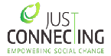


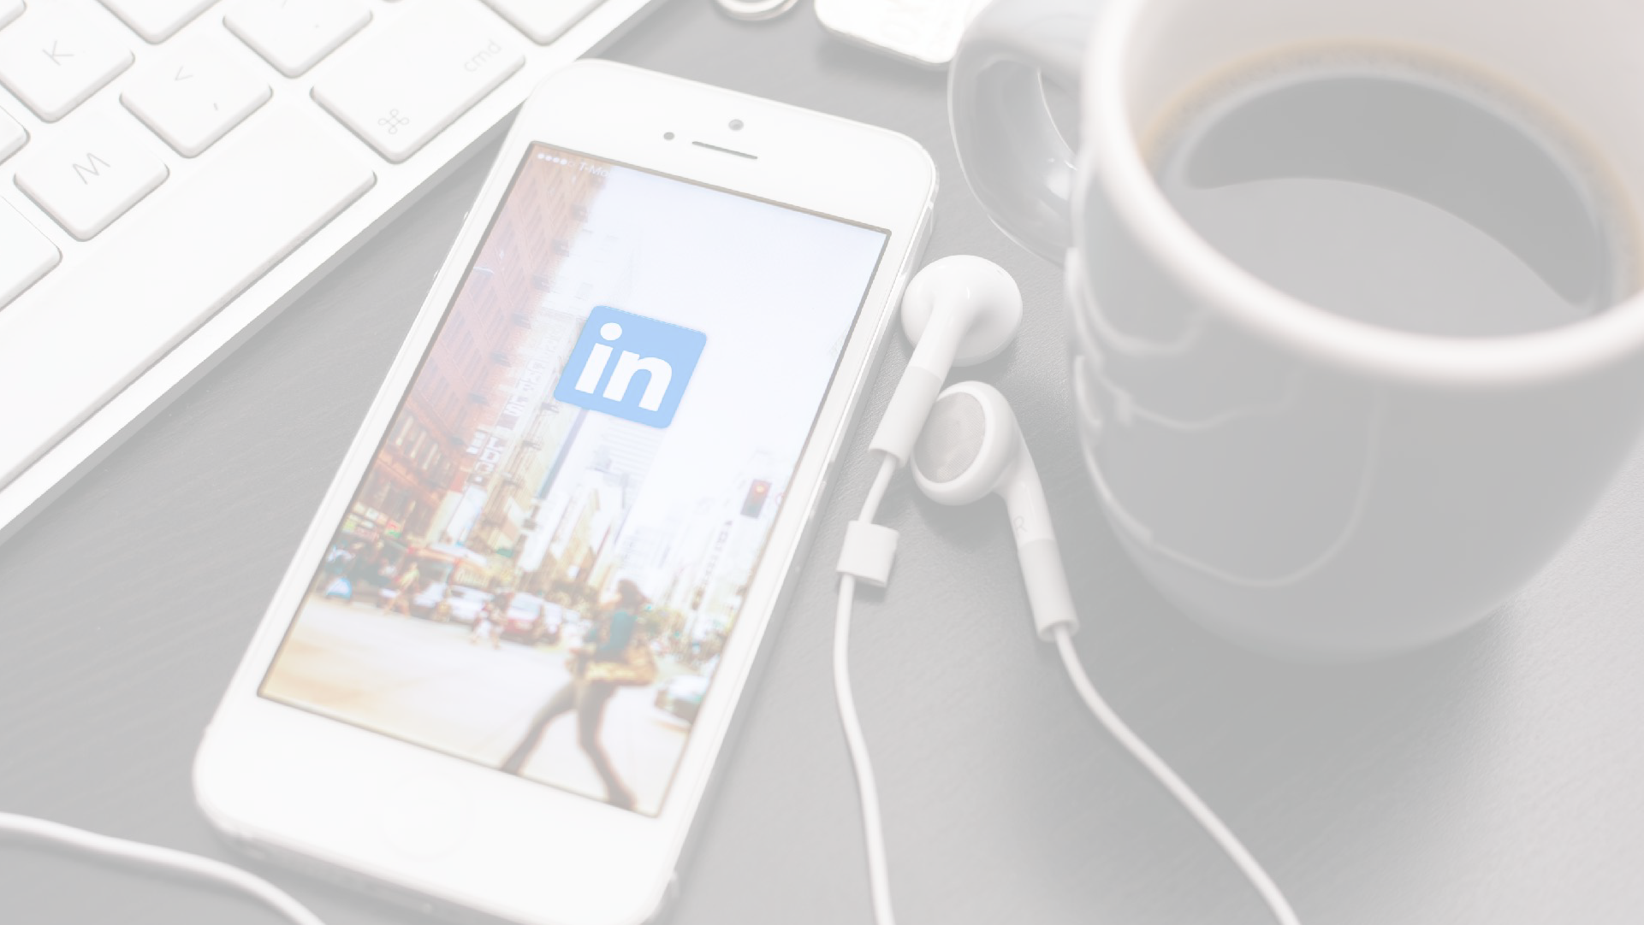
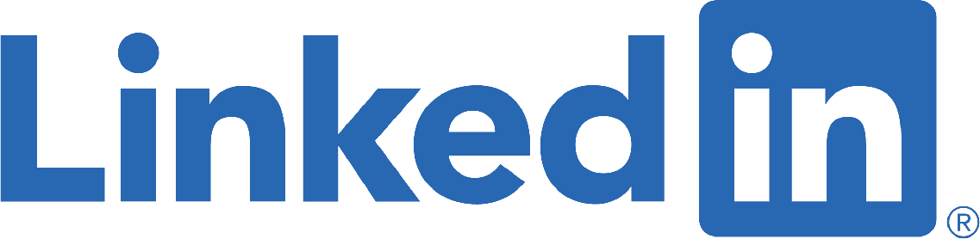
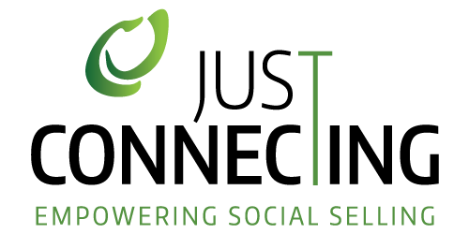

ALGORITHM RESEARCH OCTOBER 2020

1

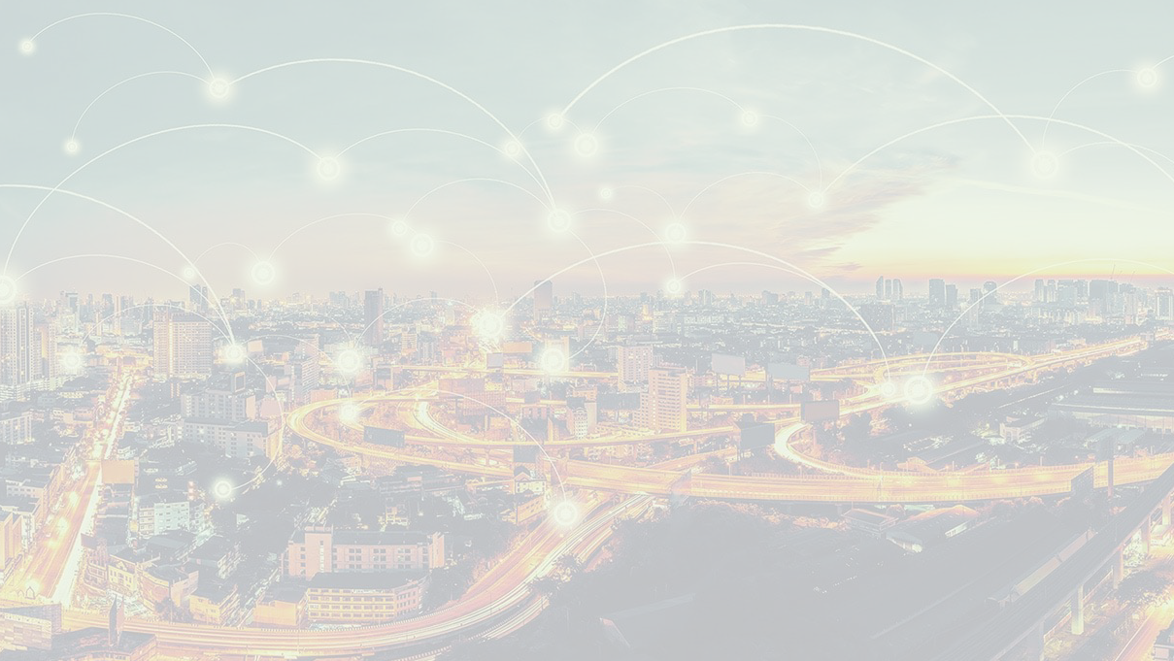
Disclaimer

LinkedIn Algorithm Research 2020

This research could never be done without the help of my network, the Open University, SproutSocial, Shield and some other specific market research tools. More than 4.500 posts were analyzed every 15 minutes (compared to 3.000 in 2019), with over 28.000 print screens.
The conclusions in this report are not absolute and are therefore freely interpretable. We admit that apart from the elements examined, several other factors play a role in the success of a post. However based on our research in 2019 (downloaded more than 12.000 times), many of our clients realized an increase in both engagement (6x more) and conversion (up to + 120%).

We hope this will make your “content” life on LinkedIn a bit less challenging. And remember, the most important element of the algorithm is having Quality Content!

Please note that if you want to share (some of the results of) this report outside LinkedIn, a message to me in advance would be appreciated.
2

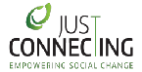

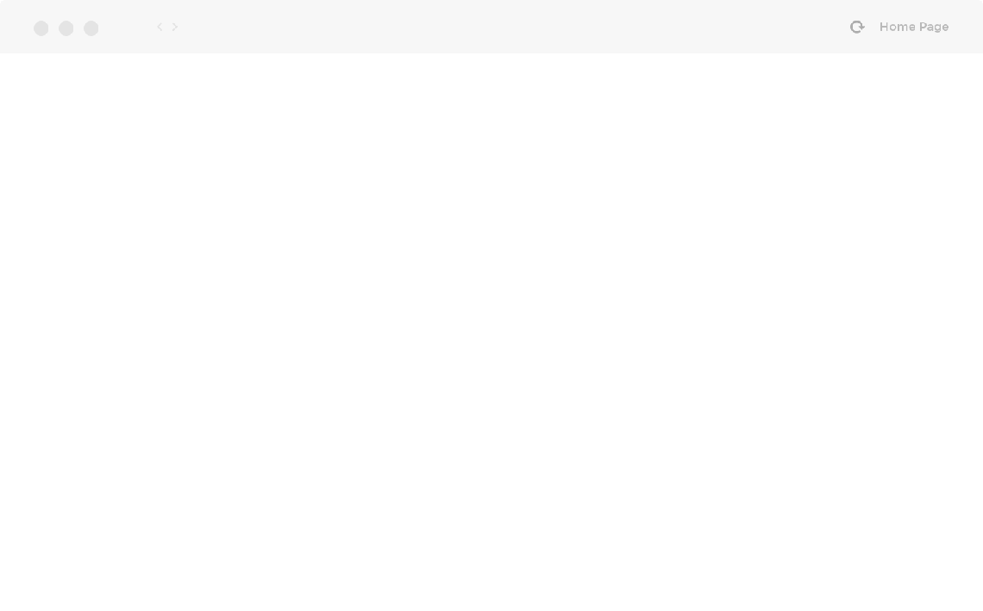
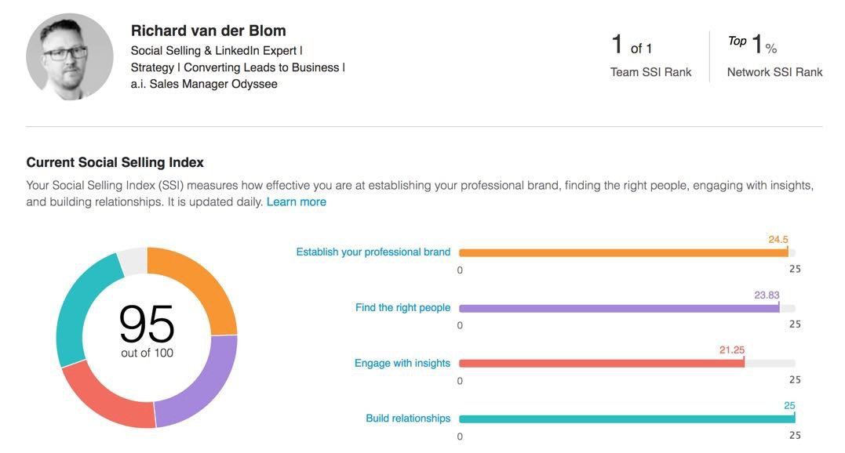
A higher S.S.I. Score results in more Reach

IMPACT OF SSI SCORE
The S.S.I. Index still influences your reach. Whenever you publish a post on LinkedIn, this will be shown to “a first organic batch”. The size of this batch depends on both your current SSI score and an “All-Star Profile” rating.

Still, the correlation between a higher SSI score and better performance of your content seems less than last year

Research shows the following:
> 90 = 150%
75 - 90 = 125%
60 - 75 = 100% (average reach)
45 - 60 = 75%
30 - 45 = 50%
< 30 = 25%

3


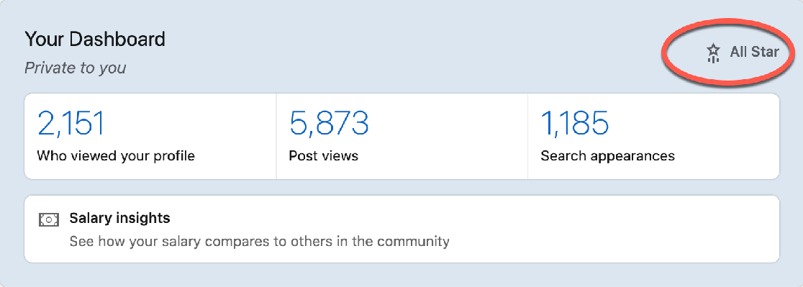
All - Star Profile is rewarded with higher visibility and reach

ALL-STAR PROFILE ROCKS!
LinkedIn rates your profile with a profile strength score. There are 3 diﬀerent levels:

- All-Star
- Intermediate
- Beginner

Depending on your level, LinkedIn will adjust the reach in your first batch as follows:

- All-Star 1,5x your normal reach
- Intermediate your normal reach
- Beginner 0,5x your normal reach

In order to increase the reach amongst your first batch we strongly recommend to increase your S.S.I. score and make sure your profile has an All-Star rating!

4

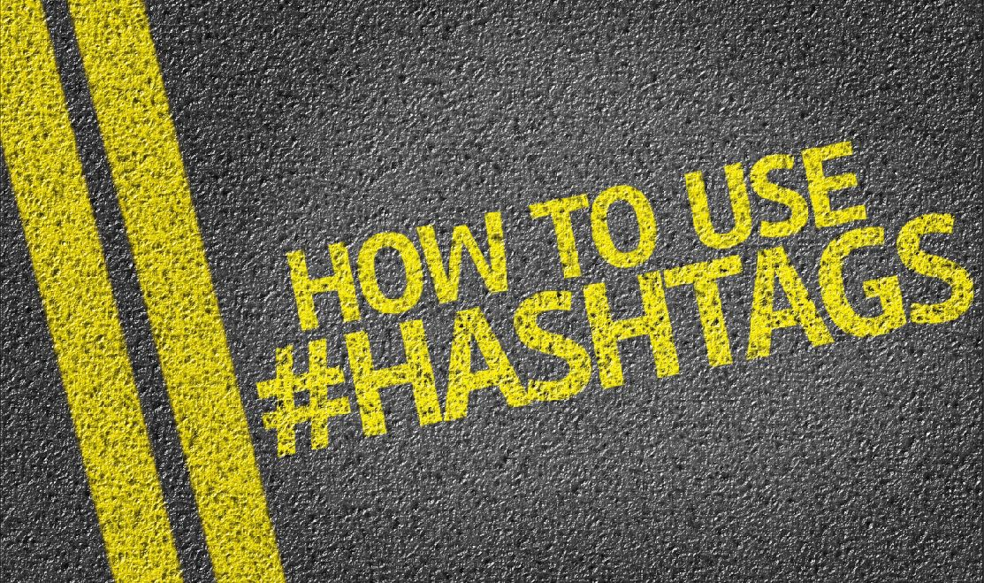
Use between 3 and 9 HASHTAGS for optimal results

USE HASHTAGS!
- Posts with less than 3 or more than 10 hashtags have 20 - 40% less reach than posts with 3 to 9 hashtags

- The position of the hashtags does not influence the reach

- Using hashtags with a high number of followers (+ 100.000) does have a positive eﬀect on the reach

- Followers of a specific hashtag get prioritized by the algorithm over followers of a person.

- Hashtags have the strength to become the new communities on LinkedIn, so use them strategically
#LinkedInByRichardvanderBlom

5

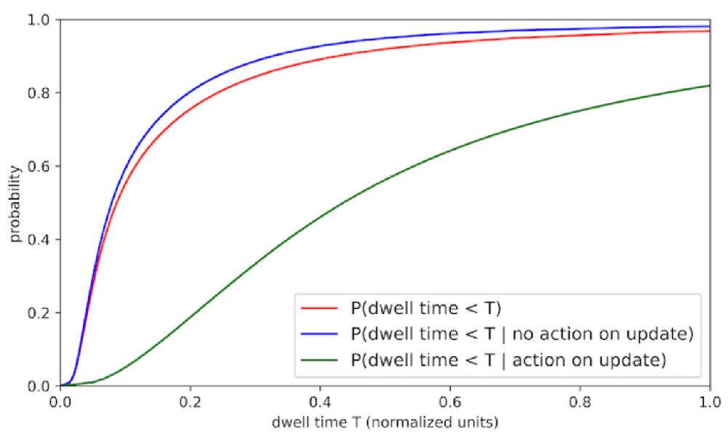
The Impact of Dwell Time on your Posts

DWELLTIME BOOSTS DOCUMENTS / VIDEO
May 2020 LinkedIn introduced dwell time in their algorithm. This measures 2 things:
- How long a post is shown in a screen
- If people click on the “see more” link in a post and after that again screen time

It is no longer about getting the attention, but about holding it!

Compared to last year the introduction of dwell resulted in the following changes:
  - posts with documents + 40 - 60%
  - posts with video + 20 - 40%
  - posts with external links + 15 - 30%
  - posts with less than 3 lines of text -/- 20%

CONCLUSION: create rich media posts with as many relevant text as possible (1.300 max)

6

The Golden Hour has become The Golden Two Hours

Post on Saturday or Sunday morning for unexpected results!

POSTING TIME IS CRUCIAL
- Posts are tested by the LinkedIn algorithm in the first 2 hours after publishing:
- Final views > 50.000 > had an average engagement of 100 in the first 2 hours
- 30.000 - 50.000 > 65 engagements
- 20.000 - 30.000 > 42 engagements
- 10.000 - 20.000 > 28 engagements

- Best time to post is between 08.00h and 10.00h in the morning (especially on tuesday)

- Saturday and Sunday on average 50% of the users active but only 25% post content

- Author needs to engage within 24 hours on comments to have a positive eﬀect on the algorithm and increase the reach even more



7

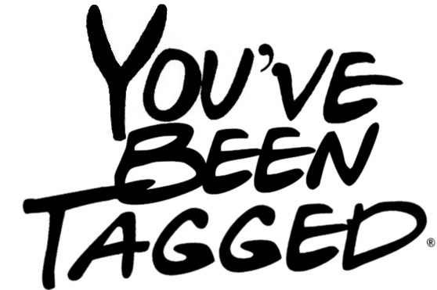
Tags can both increase or decrease the reach of your posts

USE TAGS WISELY!

- Tagging people or companies does not automatically increase the visibility of your post!

- Tagged people however will engage more often with your posts, which will increase your views

- The algorithm has started to punish us if people that have been tagged:
  - Do not engage!
  - Untag themselves in your post

- At least 50% of the people you tag need to engage to realize a positive eﬀect. If less than 25% is responding, then the tags will be rated as spam, and your post will slow down and gets 20 - 30% less views

8

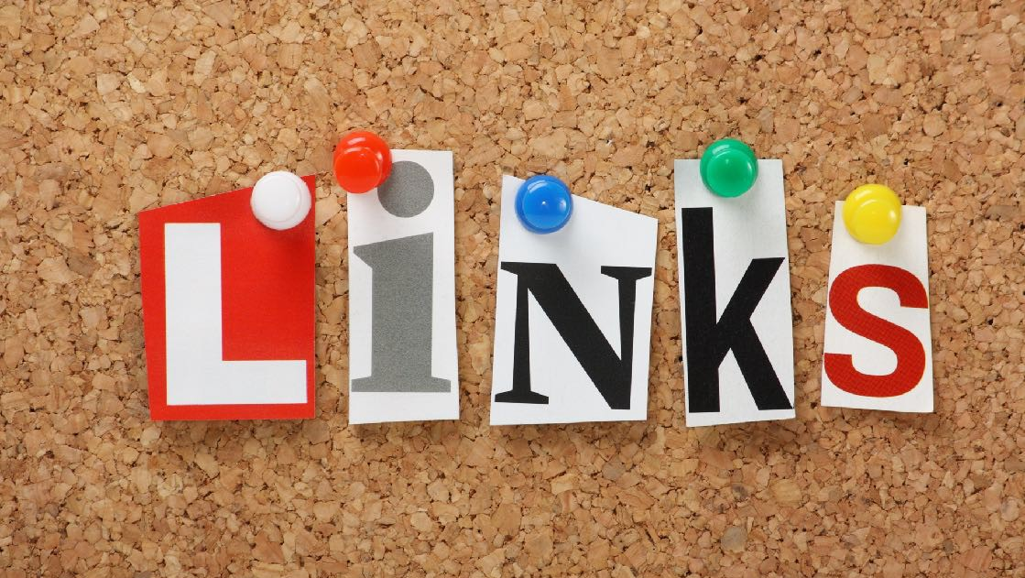
How to Use External Links in your Posts?

EXTERNAL LINKS
  - Since the introduction of "Dwell Time" we see a 10 - 25% increase in posts with external links

Where to Put it?
- Best results if you ad the link by “editing” your post just after you have published it
- Second best if you write the link in your original post (thanks to dwell time)
- Do NOT use the “1st comment method”. The disadvantage of extra clicks, and the disappearance of the first comment with more comments eliminates the benefit completely.

- Post with 2 links get 25% less views
- Post with 3 or more links drop 40%
- Don’t bother using more than 3 links ;-)

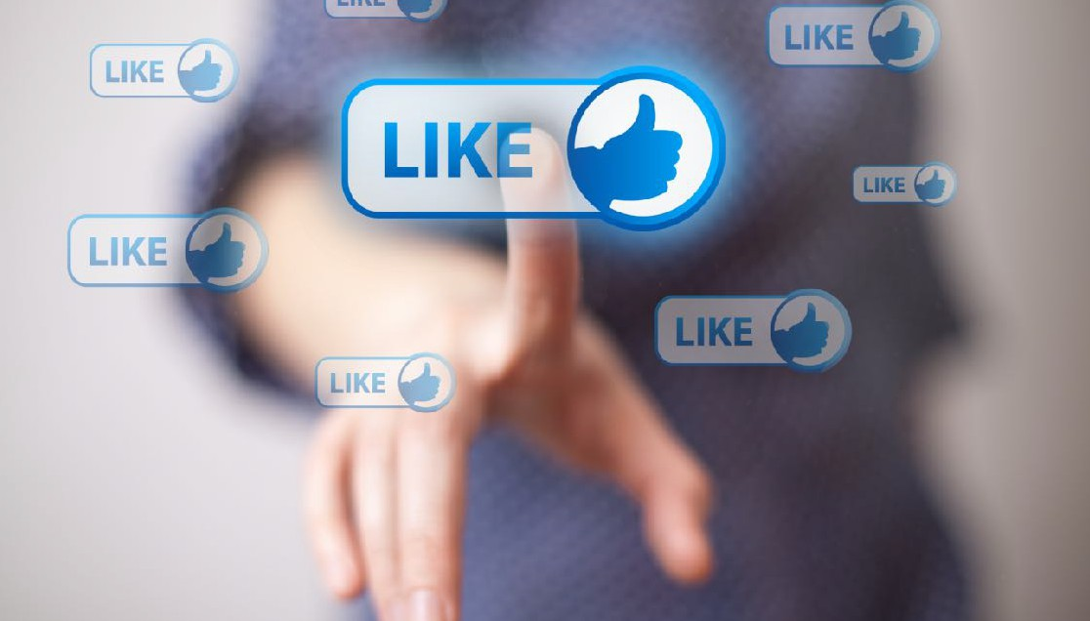
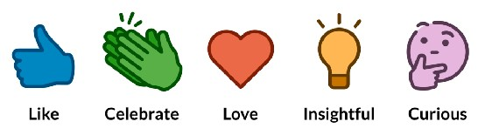
All you need to Know about Likes on LinkedIn

DO YOU LIKE IT?

- Likes trigger the algorithm in the first 2 hours after publishing your post. However with regard to reach they will have only 50% of the impact compared to a “Comment”

- In April 2019 LinkedIn introduced diﬀerent “Like” buttons. Research shows that the impact of “Celebrate, Love, Insightful and Curious” is the same as “Like”. However the more recently added “Support” button seems to result in 10% more views.

- You will realize a positive eﬀect on the algorithm if you respond to a received “Comment” with a “Like” within 24 hours after the comment was written. This is especially important if you want to increase the views on a Company Page!

10

Comments are still KEY in the algorithm!



Comments will Boost your Views!
Discussion on the Platform
is the Goal!

GET INTO A DISCUSSION!
  - Comments can still be seen as the fuel of your post! Compared to a “Like” they will result in two times more views. Compared to a “Share” up to 8 times more views!

  - Although the positive eﬀect of an author who responds with a "Comment" on received "Comments" is less than in 2019, we still see that the algorithm will show these posts longer in our timeline. It is important that the author responds within two hours!

  - TIP! You want to support your company, client or connection in receiving more views? Just leave a “Comment” on their posts!


Shares are useless, unless you know this “HACK”
SHARE = DUPLICATE CONTENT!
- As soon as you hit the “Share Button” LinkedIn knows you are about to share something that has already been posted on LinkedIn. As a result, a "Share" is rated poorly with about 10 - 15% of the views of a “Comment"

- TIP! As a Company Admin, do not ask your employees to “Share” your posts. Provide them with the original post, and ask them to publish it directly on their own profile or ask them to “Comment” on the content on the Company Page

- HACK! Thanks to Richard Bliss we were able to confirm that there is a hack to “Share” content successfully . All you need to do, is ask the original author to “Comment” directly on your shared post! As a result your shared post will get 3 - 4 times more views than a regular “Share”

12




VIDEO could make a difference again !

WHICH VIDEO SCORES?
Use YouTube material in your profile, but try to avoid posting YouTube vids on your timeline
LinkedIn loves native video (Vimeo video is treated as native) in our timeline. Dwell time has had a positive eﬀect on both views and engagement, +20 - 40% up since 2019

The ideal video post looks like:
- between 30 and 60 seconds
- square format (more screen space)
- subtitled (over 50% watches video with sound disabled)

Engagement when 30 - 60 seconds = 100%
1 - 3 minutes: | minus | 20%
3 - 6 minutes | minus | 45%
7 - 10 minutes | minus | 75%
> 10 minutes | minus | 90% (!)

We noticed 10 - 30% more engagement on video July 2020 compared to July 2019!

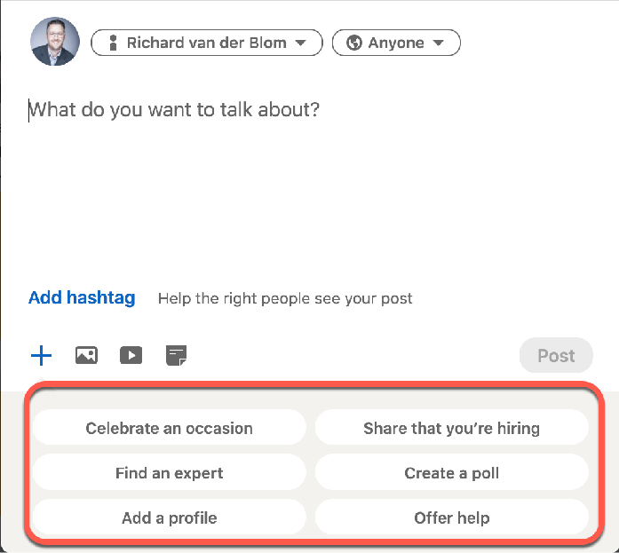
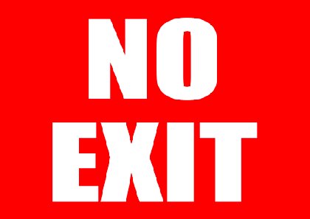
What are the best FORMATS to use for your Posts?

KEEP YOUR AUDIENCE ENGAGED!
In many cases, the packaging of your content partly determines the result in views. So it’s not only about creating quality content, it’s also about the way you are sharing this content. This is what LinkedIn seems to do with your first organic batch of reach:

- Text Only (or with Single Picture) | + 25 - 50%
- Text with Document (Slideshow) | + 40 - 60%
- Native video (or through Vimeo)* | + 20 - 40%
- Pre-programmed Options | - 25 - 50%
- Polls (compared to regular posts) | - 10 - 30%
- YouTube video | - 30 - 55%
- External links (in the post) | - 10 - 30%
- Articles (long posts on LinkedIn)* | - 70 - 90%

(*) the definition of a view with video and/or articles is that after opening the visitor needs to have the content in his screen for at least 6 seconds

14

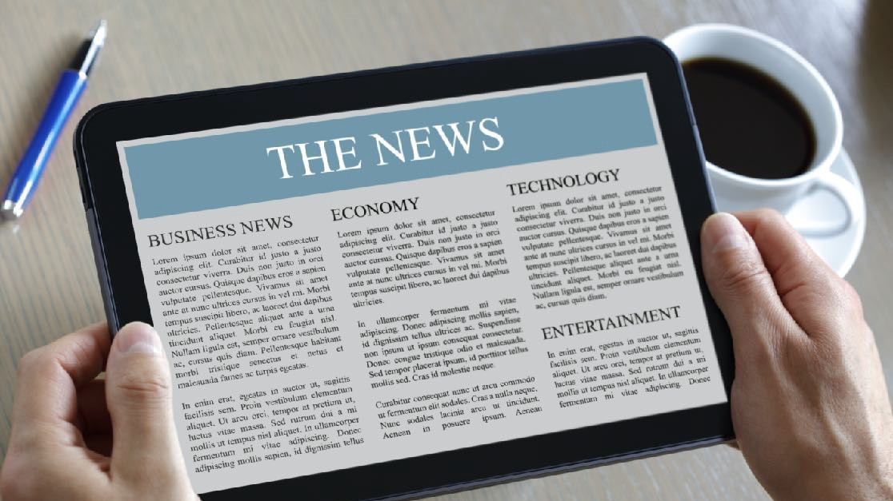
What about ARTICLES or NEWSLETTERS?

GAMECHANGER
Regular articles were introduced at the end of 2013. Since 2016 (together with the introduction of video) views went down dramatically.
Currently we see that articles with the same amount of engagement (likes & comments) score between 70 and 85% less views

At the end of 2019 LinkedIn introduced the “LinkedIn Newsletter”, which they are currently rolling out to all global members.

Members can subscribe to a specific newsletter, which will activate two triggers when a new article is published:
- Member will get a notification
- Newsletter will be sent to the email address

WOW! Views of Newsletter Articles are 4 times as high as regular articles

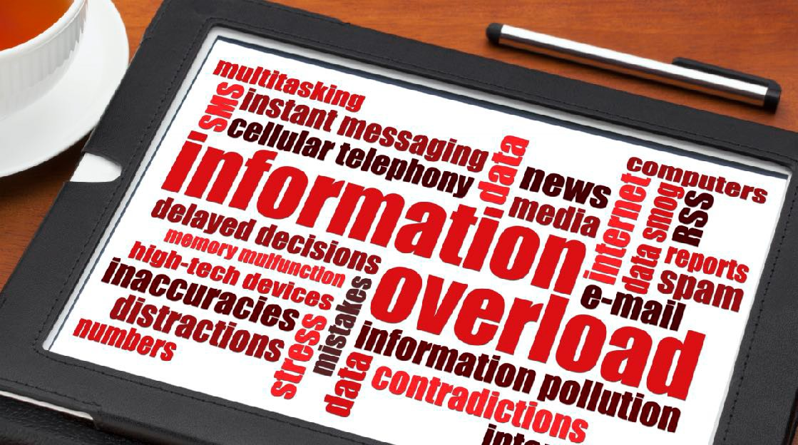
How much should you Post on LinkedIn?

TRACK THE
PERFORMANCE
- Some people share multiple posts on the same day, while others recommend a maximum of two per week. The truth is that your decision needs to be based on the performance of your content.

- LinkedIn does not want to show more than 2 pieces of content from the same author in the timeline. When you post your second message a day, LinkedIn will want to test it. This will temporarily make your first post less visible in the timeline. If your second post scores well, your first post will get an average of -50% views. If your second post does not score well, still -20%

- TIPS! If your post has a high engagement, do not post new content until you experience a serious drop in engagement. If you comment your self on the 2nd day (to reinforce it), you could get +15% more views in total.

16

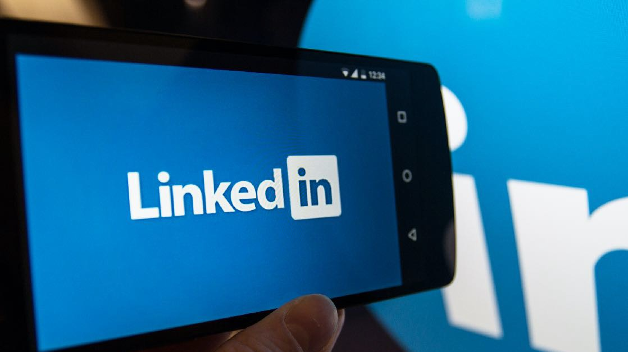
What about our Company Page?

BE AWARE OF…..
Here are the most important conclusions:

- Average reach in first batch between 2 and 6% of followers (!)
- Use “Targeted Audience” to have the same reach in numbers, but amongst your selected audience (more eﬀective)
- Do not ask your employees to #Share, but ask them to #Comment for 5x more reach
- There is no maximum of posts a day (like on an individual page), but if your company post less than once a month, your reach will drop to 2%
- “People Content” eg. content where your employees play an important role will result in 5 - 8 times more views and engagement
- 100% completed Company Pages are being given more reach!

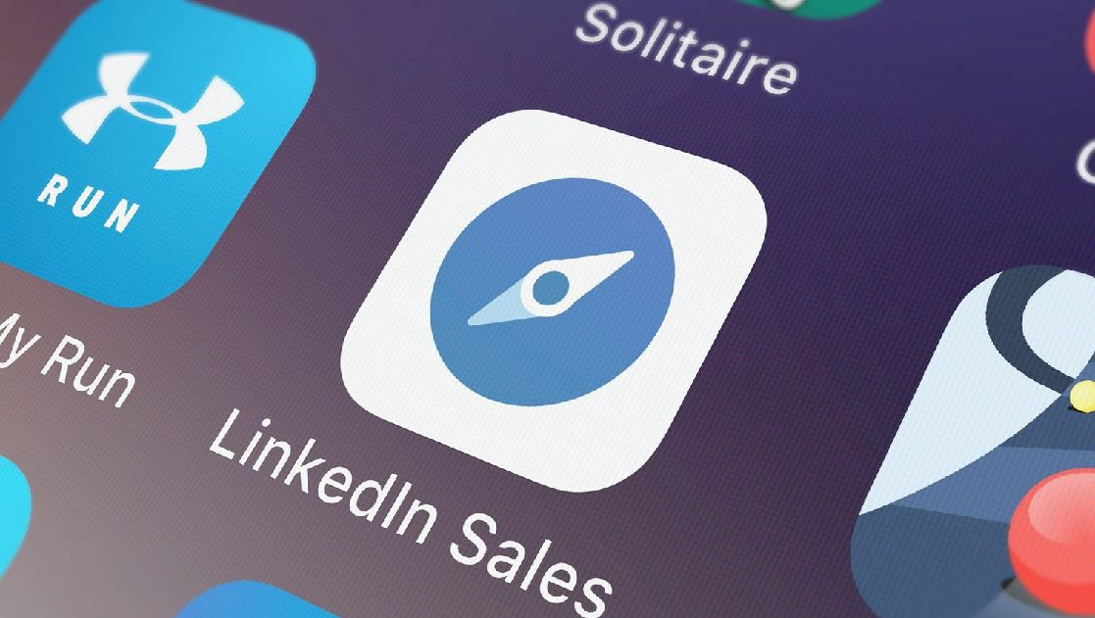
What else?

MORE TO COME….
- 3rd party scheduling software will have a slight negative impact on reach (minus 8 - 15%)
- To bring people back in your algorithm you need to perform 2 actions on that person’s profile within one week (message, endorse, engage or connect)
- LinkedIn Live has an average engagement of 2,2% (much lower than native video in the timeline)
- If you show a lack of engagement on other people’s content it does not badly influence your own content and/or engagement (!)
- Using other fonts (like bold or italic) from other external sites, has a negative impact on your post performance because of the Google indexation going wrong (!)
- Followers see less content than Connections

18

Contact me for:

  - Custom made LinkedIn & Social Selling Training Program for your Company
  - Sales Navigator Training
  - LinkedIn Marketing Training
  - LinkedIn Content Training
  - Employee Advocacy LinkedIn Training

In-Company Training (both offline and online) to increase your reach, conversion and Lead Generation



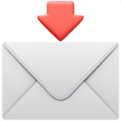
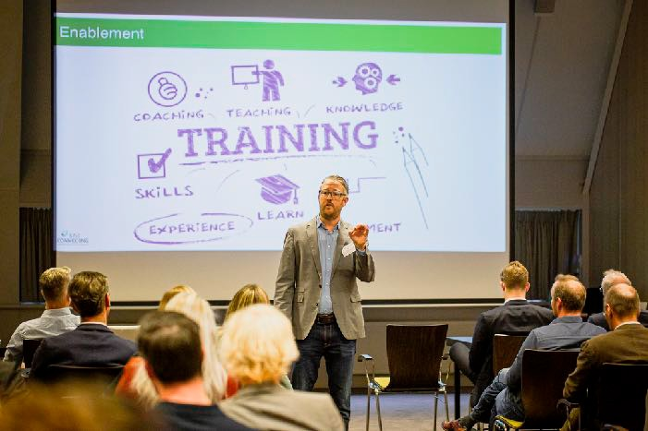
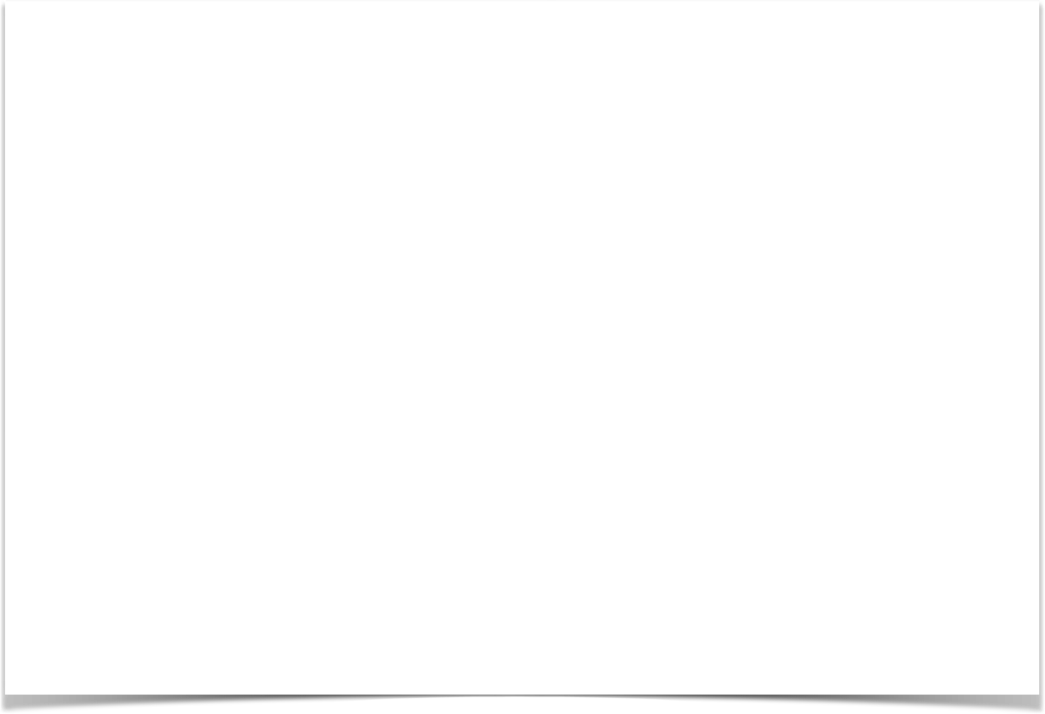
+31 6 5511 7282
19

richardvanderblom@justconnecting.nl






ABOUT
RICHARD VAN DER BLOM
Richard van der Blom (1977) is the founder of Just Connecting and currently working as Strategical Social Selling Trainer and Consultant for various international clients.

He developed the B.E.S.T. Social Selling method, currently used by many of our clients, as well as various Social Selling strategies within LinkedIn. As a member of an independent European LinkedIn Think Tank, he has extended knowledge and insights of different aspects of LinkedIn, such as the algorithm, product development and tooling.

As an inspiring Keynote speaker, he spoke at the Annual Sales Kick-off at 3M, Econocom, Mammoet, ING Netherlands and Philips. Provided LinkedIn training and consultancy since 2009 – as on of the first Dutch entrepreneurs – and trained over
35.000 professionals at more than 600 companies.

20
He has written over 100 articles and
essays about LinkedIn and #ModernSales or Marketing.

He is often invited to implement Social Selling into the sales and marketing strategy of his clients, or to analyze existing strategies in order to optimize both strategy and results. Therefor he uses the
S.T.E.P.S. Social Selling strategy.

Clients are based in Europe, United States, South-Africa, the Middle-East, Australia and various Asian countries.

Feel free to reach out via: www.linkedin.com/in/richardvanderblom www.justconnecting.nl
Or richardvanderblom@justconnecting.nl

