
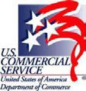

Introduction to United Nations Procurement
Carmela Mammas
U.S. Commercial Service New York, New York
www.trade.gov/united-nations Carmela.Mammas@trade.gov


U.S. Commercial Service

∗ The U.S. Commercial Service is part of the International Trade Administration, an agency of the United States Department of Commerce
- Trade specialists in over 100 U.S. cities and 70 countries worldwide
Our mission:
  - To promote the export of goods & services from the United States, particularly by small and medium-sized businesses
  - To represent U.S. business interests internationally
  - To help U.S. businesses find qualified international buyers, distributors and agents

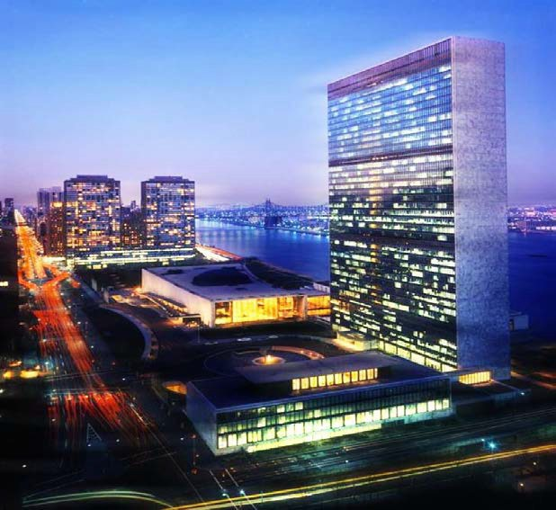
About the United Nations

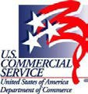
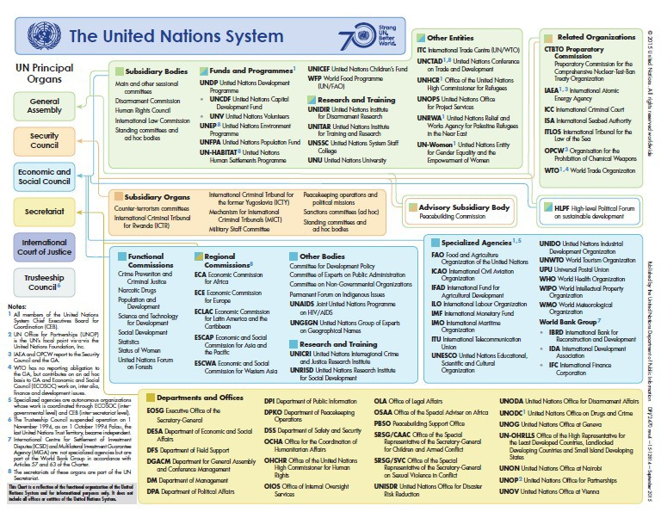

$19.9 Billion Annual Procurement Market
Figure 1. Total UN Procurement of Goods and Services (USD Millions), 2010-2019
7,075

7,066
7,210
7,469
8,564

20,000

18,000

10,440

16,000
6,808
7,634
8,450
8,713
8,525
8,796

9,055
9,453
9,730
9,826
9,004
8,955

14,000

12,000

10,000

8,000
8,620
8,709

6,000

4,000

2,000

0
2010 2011 2012 2013 2014 2015 2016 2017 2018 2019
Goods Services
2019 Annual Statistical Report on United Nations Procurement

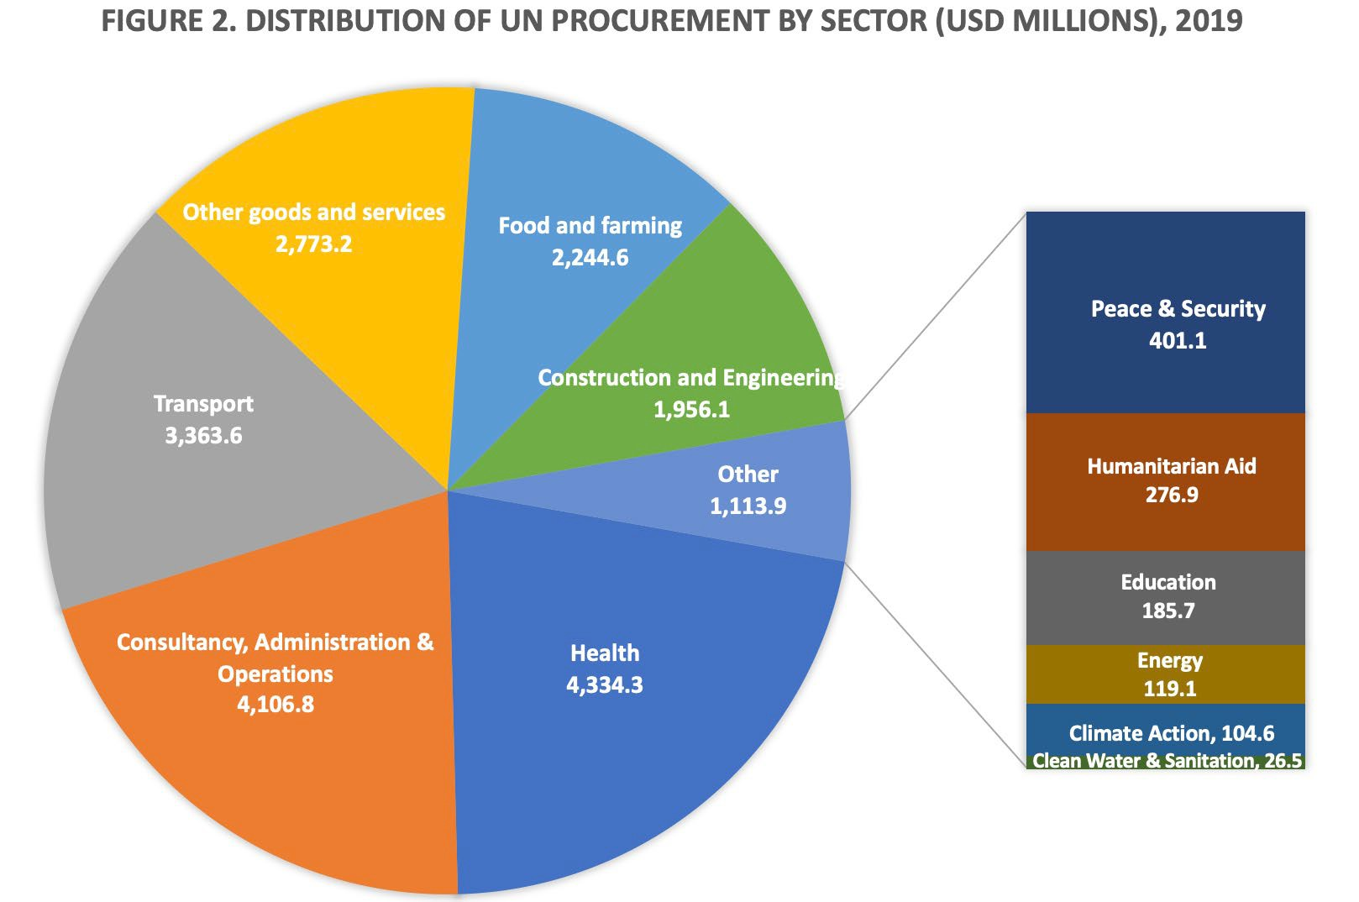
Distribution of Procurement by Sector

Categories of Procurement: Key Goods

Rank | Good | Total | %
 | Total | $8.25 billion | 41.45%
1 | Pharmaceuticals incl. Contraceptives and Vaccines | $3.23 billion | 39.28%
2 | Food and Beverage Products | $2.07 billion | 25.11%
3 | Medical Equipment and Accessories and Supplies | $740 million | 8.98%
4 | Fuels and Fuel Additives and Lubricants and Anticorrosive Materials | $599 million | 7.27%
5 | Information Technology Broadcasting and Telecommunications | $461 million | 5.59%
6 | Motor Vehicles and their Accessories and Components | $411 million | 4.98%
7 | Office Equipment and Accessories and Supplies | $210 million | 2.55%
8 | Laboratory and Measuring and Observing and Testing Equipment | $190 million | 2.30%
9 | Apparel, Luggage, and Personal Care Items | $176 million | 2.13%
10 | Structures and Building and Construction and Manufacturing Components and Supplies | $148 million | 1.80%

Categories of Procurement: Key Services

Rank | Service | Total | %
 | Total | $9.34 billion | 46.96%
1 | Transportation and Storage and Mail Services | $2.65 billion | 28.40%
2 | Management and Business Professionals and Administrative Services | $1.78 billion | 19.08%
3 | Building and Facility Construction and Maintenance Services | $1.37 billion | 14.67%
4 | Engineering and Research and Technology Based Services | $1.09 billion | 11.63%
5 | Travel and Food and Lodging and Entertainment Services | $572 million | 6.12%
6 | Financial and Insurance Services | $557 million | 5.97%
7 | Healthcare Services | $350 million | 3.75%
8 | Public Order and Security and Safety Services | $340 million | 3.64%
9 | Education and Training Services | $330 million | 3.54%
10 | Editorial and Design and Graphic and Fine Art Services | $298 million | 3.19%

U.S. Supplier Data 2019

4%
2% 2%
72%
1,000.0
800.0
600.0
400.0
200.0
0.0

2013 2014 2015 2016 2017 2018 2019
Goods Services

15%
17%
5%
U.S. Procurement by Category
22%
Goods
Goods and Services Distribution
(USD millions)
25%
2,000.0
1,800.0
7%
1,600.0
Management and Admin
Services
Engineering and Research Services
Transportation, Storage,
Mail Services
Travel, Food and Lodging
21%
1,400.0
8%
Building and Maintenance
Services
1,200.0

Services
Pharmaceuticals, Contraceptives, Vaccines
IT and Communications
Equipment
Medical Equipment
Office Equipment
Motor Vehicles and Parts

Top 4 UN Procurers – 61%

International Children’s Fund UNICEF | World Food Programme  WFP | Secretariat - UN Procurement Division UN/PD | UN Development Programme UNDP
$3.83 Billion | $3.64 Billion | $2.51 Billion | $2.08 Billion
- Vaccines  - Pharmaceuticals  - Nutrition  - Medical Supplies & Equipment  - International Freight  - Water & Sanitation  - Bed Nets & Insecticides  - Construction  - Education | Food Commodities  - Wheat  - Rice  - Maize Logistics  - Land  - Ocean  - Air Goods & Svcs  - Fuel  - Office/Admin Equipment & Svcs  - ICT Equipment & Svcs | - Air Transportation Services  - Fuels and lubricants  - Food Rations/Catering Svcs  - Engineering & Construction  - Related Svcs  - Freight Forwarding & Delivery Services  - IT and Communications Equipment | - Laboratory & Medical Equipment  - Vehicles  - Voter Registration Kits  - IT and Communications Equipment  - Consulting Svcs  - Construction Services  - Transportation Svcs

Top 10 Procuring Agencies

Rank | Agency | Total Spending
1 | UNICEF | $3.83 billion
2 | World Food Programme (WFP) | $3.64 billion
3 | UN Secretariat | $2.51 billion
4 | UN Development Programme (UNDP) | $2.08 billion
5 | UN High Commissioner on Refugees (UNHCR) | $1.14 billion
6 | UN Office for Project Services (UNOPS) | $1.10 billion
7 | Pan American Health Organization (PAHO) | $1.01 billion
8 | International Organization for Migration (IOM) | $960 million
9 | World Health Organization (WHO) | $893 million
10 | UN Population Fund (UNFPA) | $404 million

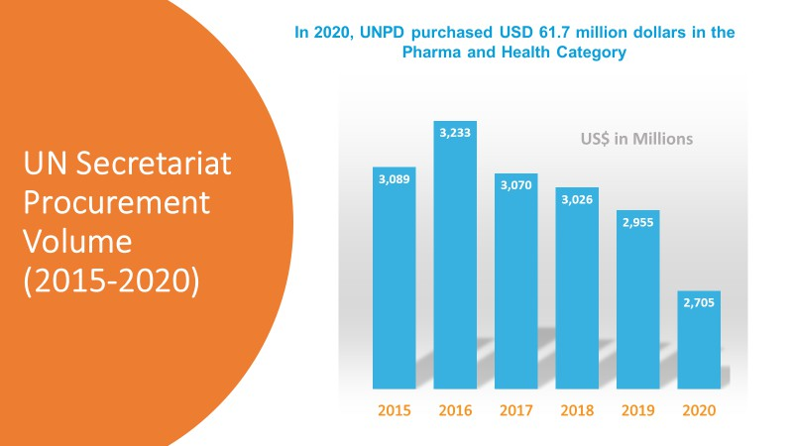
UN Procurement Division

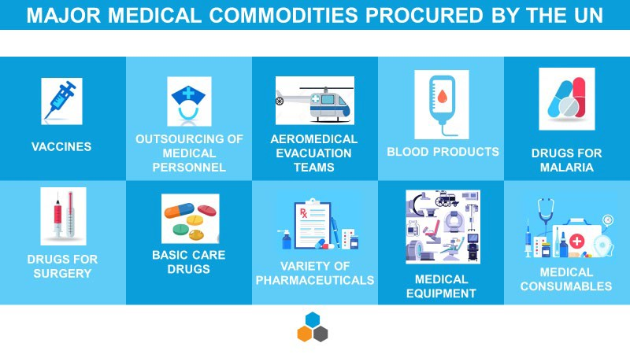
UN Procurement Division

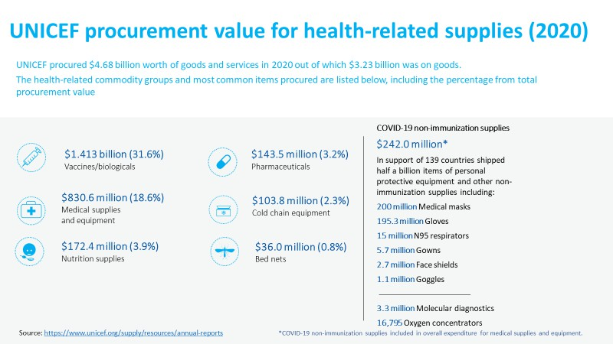
UNICEF

UNICEF
Current and Expected Trends

Covid Devices and Supplies
- Diagnostics, Oxygen Therapy, and Vaccines
- Digital Health Services for low resource settings

Evolution of UNDP health procurement
- UNDP’s procurement of medicines and other health products started in 2003 with the inception of the partnership with the Global Fund
- In line with and making strong contribution to 2030 Agenda, UNDP’s Strategic Plan, UNDP’s HIV, Health and Development Strategy and ‘leave no one behind’ pledge
- Building on successful experience and arrangements: increased country demand for support in accessing and delivering quality, affordable health products and strengthening their procurement and supply chain management capacities
- Primary focus of this procurement volume = medicines and diagnostics for communicable diseases + lab and hospital equipment. Increasingly, UNDP is asked to also procure medicines, diagnostics and medical equipment for non-communicable diseases (NCDs)

UN Development Programme

- Solutions and support services - capacity strengthening
- Always done in partnership with key UN partners – UNICEF, UNFPA, UNOPS/Stop TB/GDF, WHO
- Presents unique and significant risks --> requires specialized, integrated end-to-end support, and at the same time should be approached as being inseparable from capacity strengthening work to strengthen national systems and frameworks, in close collaboration with WHO and other partners
- Uniquely specialized: health products specialization + other technical (supply chain), policy aspects
- Integrated support (procurement and systems/capacities strengthening) generates economies of scale and best value

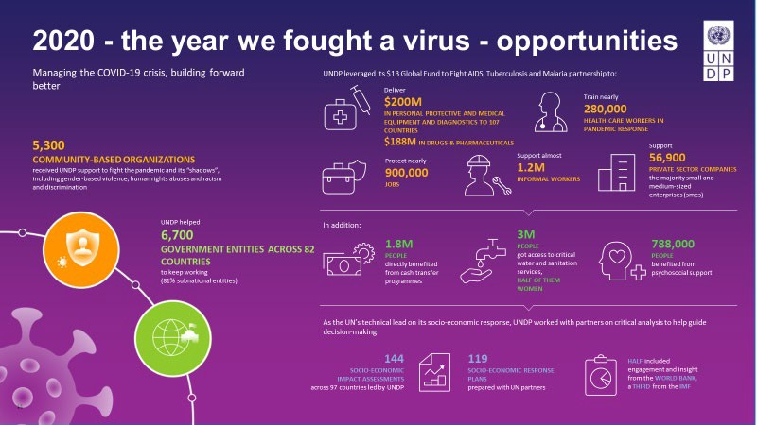
UN Development Programme

UN High Commissioner on Refugees (UNHCR)

Historical expenditure of Essential Medicines and Medical Supplies from January to December 2019:

- Medicines: USD 11,912,096

- Medical Supplies: USD 9,691,376

Is My Business a Fit for the UN?

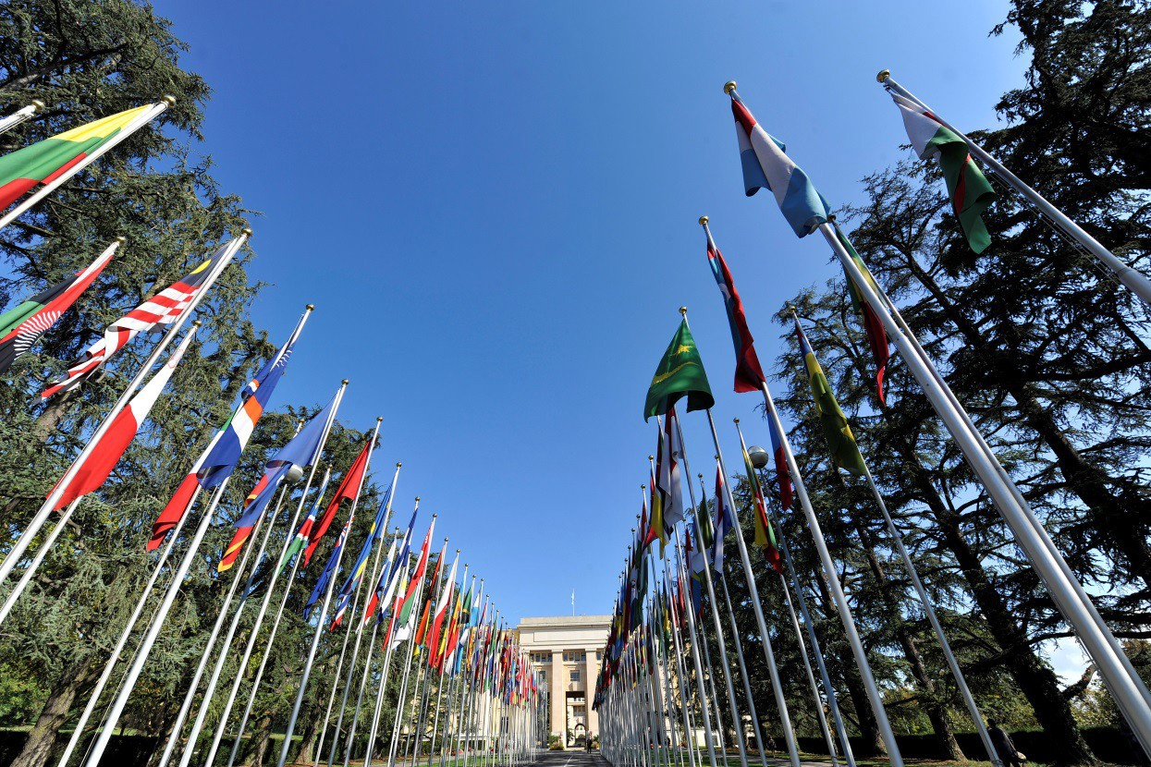
2
0

General Requirements

  - Company in business at least 3 years
  - Has financial standing to honor a contract – typically looking at revenues of some multiple of contract value
  - International capacity
  - Agree to the UN Supplier Code of Contact

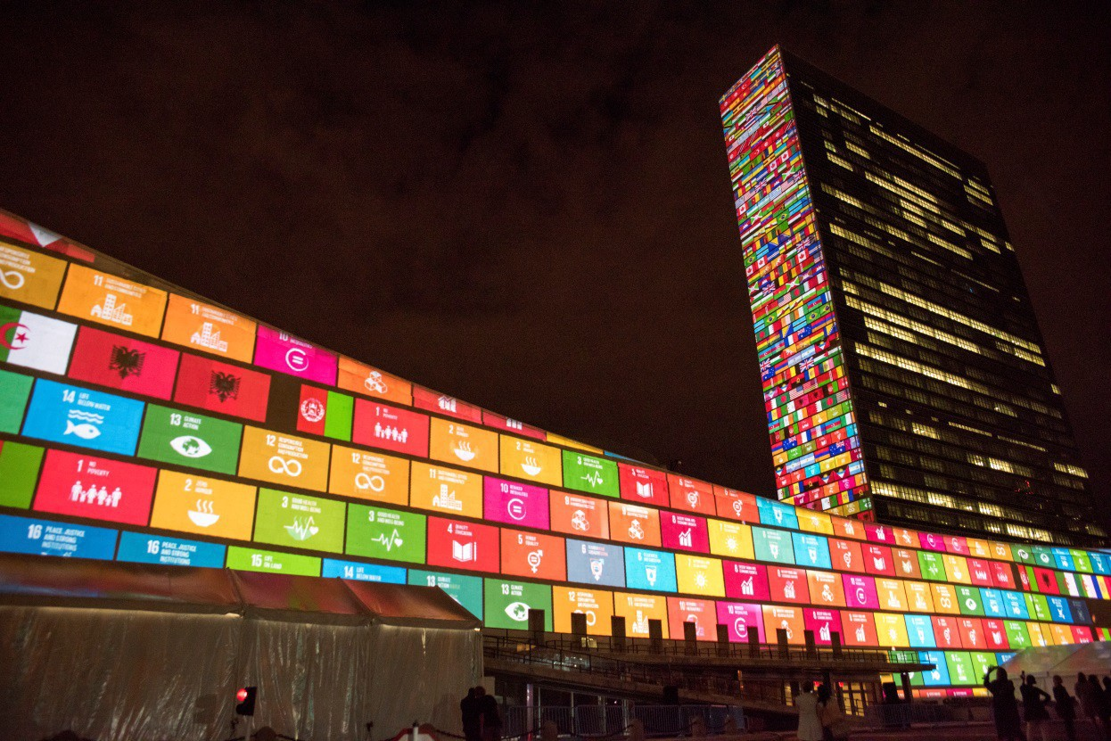
How to Find Out More?

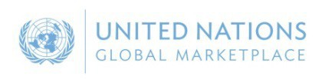


United Nations Global Marketplace
UNGM is the procurement portal of the UN system
UN procurement staff
Vendor community
regions
United Nations Global Marketplace – www.ungm.org
23

  - Potential vendors may register with any of the 26 UN organizations using UNGM as their vendor database (=99% of the total UN procurement spent)
  - UNGM provides and excellent springboard for vendors to introduce their products and services to many UN organizations, countries and

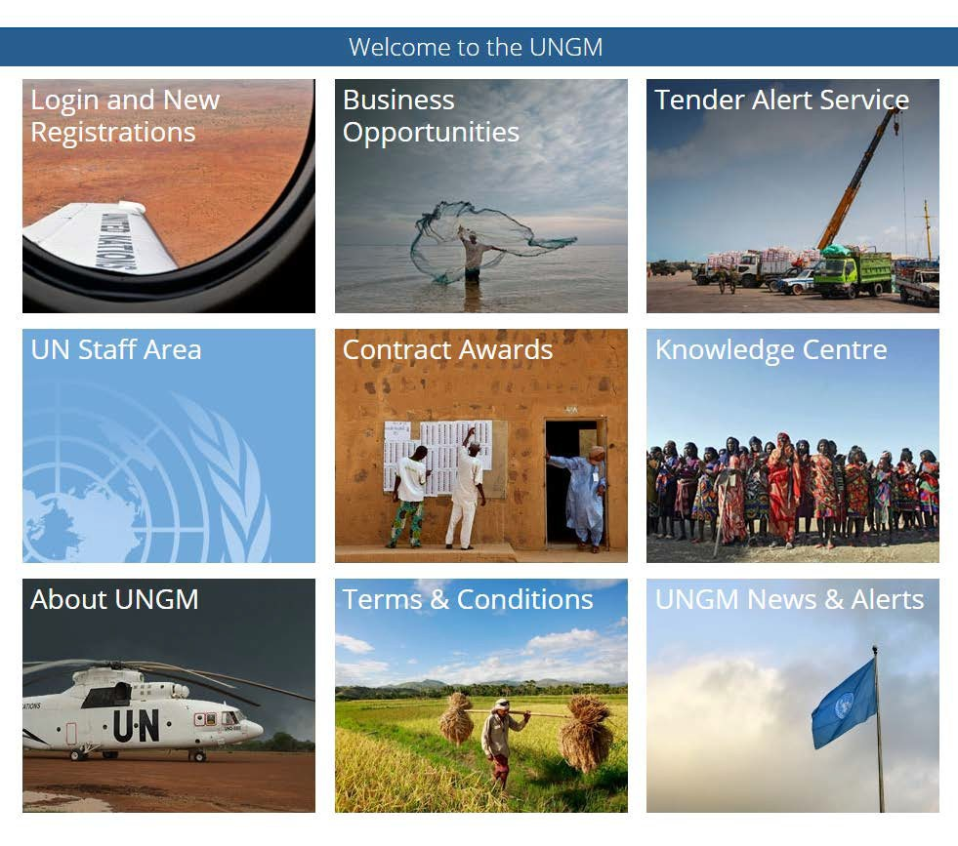
UNGM Homepage

United Nations Global Marketplace – www.ungm.org 24

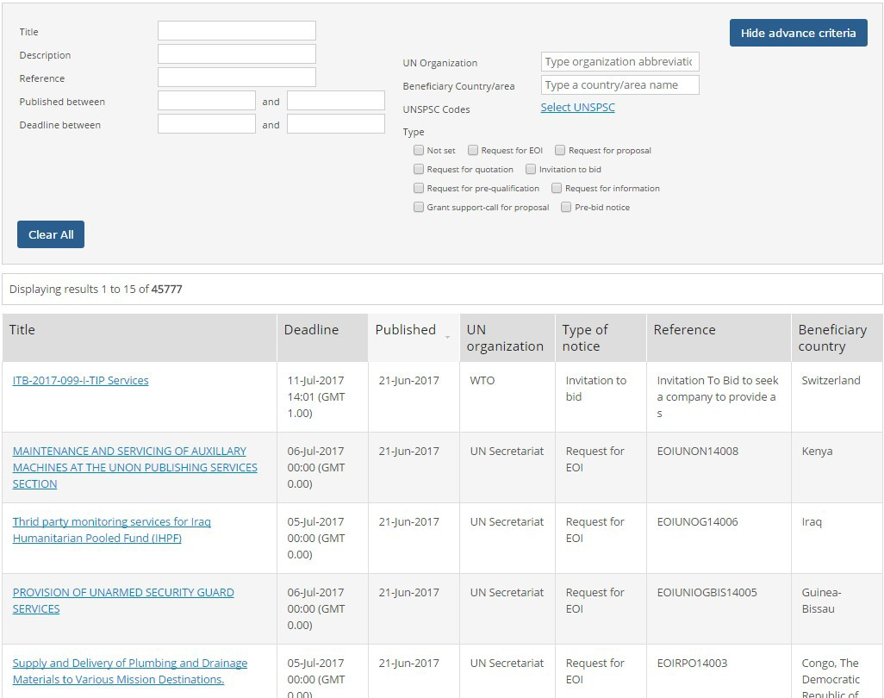
Business Opportunities → Tender Notices

25

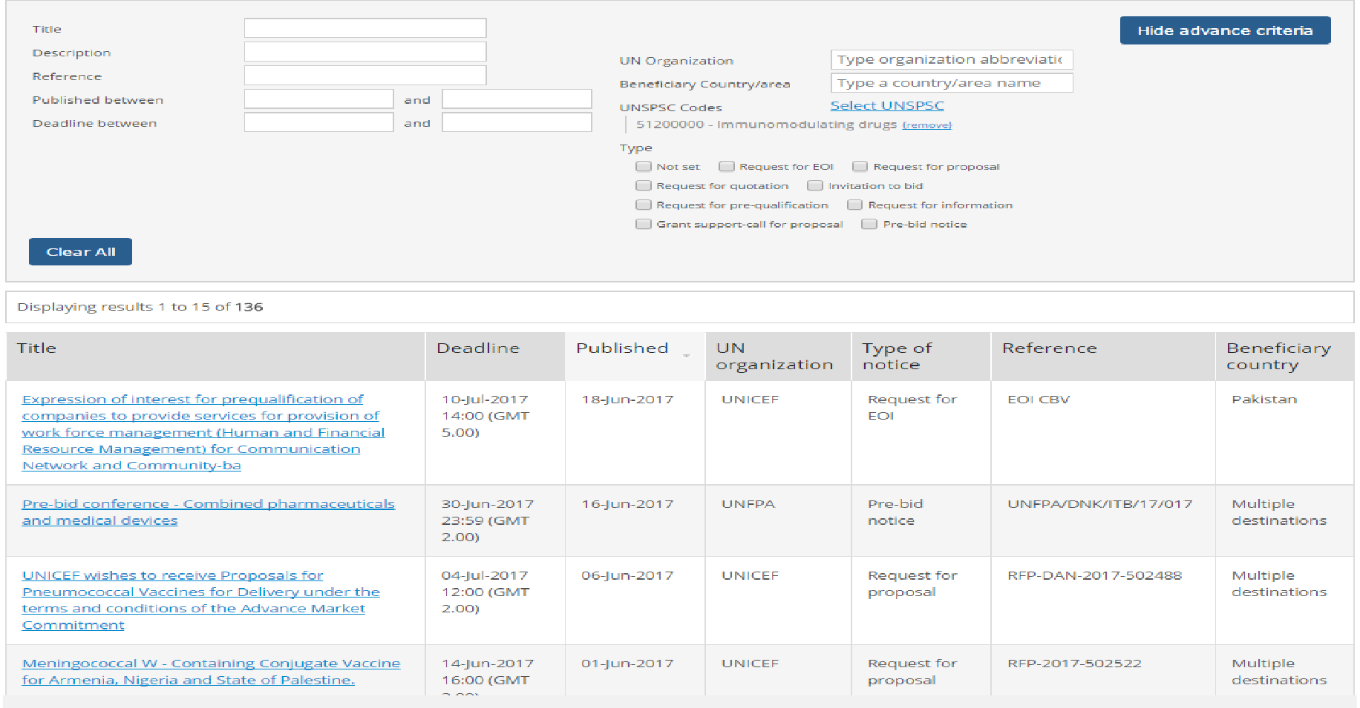
Current U.S. Opportunities

2

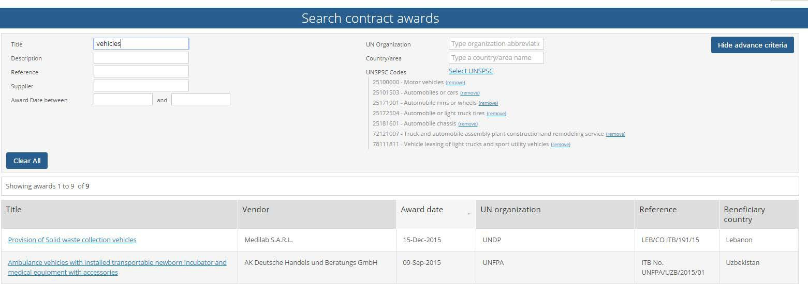


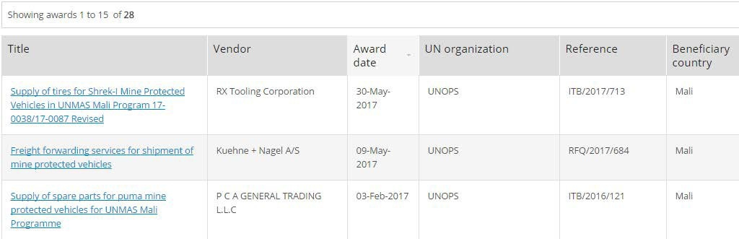
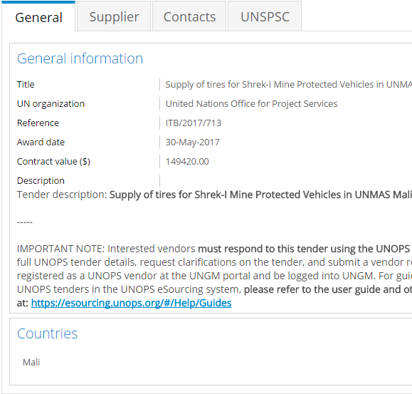

Contract Awards
- Search with keywords and UNSPSCs

- Click for Contract Details

Registration Process on UNGM
United Nations Global Marketplace – www.ungm.org
21
Reference letters & Financial statements
Certificate of Incorporation & References



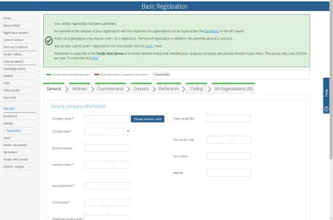
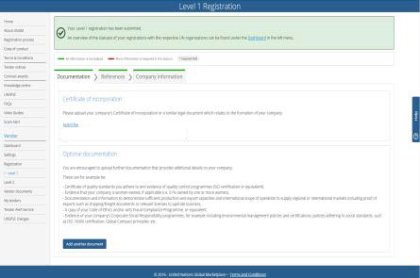
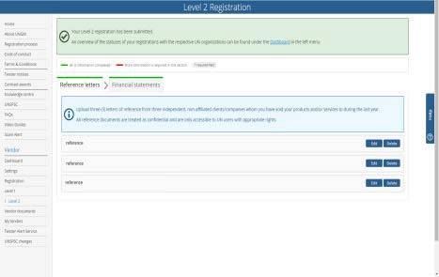
Common registration process Some UN organizations require additional information
United Nations Global Marketplace – www.ungm.org
3 registration levels
Level is determined by the monetary value of potential contracts
Basic registration
Level 1
Level 2

Basic Registration

Contract Awards Up to $40,000
  - Basic vendor information (name, address, etc.)
  - Acceptance of UN Supplier Code of Conduct
  - Information on countries in which you do business
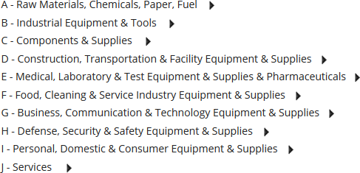
  - Classification of your goods and services (UNSPSC Codes):

Level 1 Registration

Contract Value Less than $500,000
  - The vendor has been in business for a minimum of 3 years
  - Current certificate of incorporation or equivalent document verifying legal status/capacity
  - Details and email addresses of at least 3 independent, non-affiliated references whom you have done business with
  - Names of owner(s) and principals (including parent company, subsidiaries/affiliates, CEO/Managing Director, and those with controlling interests, if applicable). The names of intermediaries, agents and/or consultants, (if any) used in relation to United Nations contracts or bids/proposals.

Level 2 Registration

Contract Value $500,000 and Above
  - Reference letters from three independent, non-affiliated clients/companies, you have done business with
  - Financial documents including Income Statements and Balance Sheet (audited/certified financial statements or equivalent) for the last three years, to be submitted with auditors report

More Information

  - www.trade.gov/united-nations
  - www.UNGM.org

Questions?

Carmela Mammas Director
U.S. Commercial Service New York

Carmela.Mammas@trade.gov www.trade.gov/new-york-new-york

