Food and Restaurant Industry Recovery and Resilience Project

Moving Forward With the Project

- After discussion between Ann and I we decided that the best way to share information with businesses is to make an online web page with resources and considerations for reopening
- This page would include:
  - Links to Official Guidance
  - Safety ideas:
    - What are the safest ways to clean the kitchen, tables, etc.
    - Reminding owners that they need to check their facility before reopening and don’t forget to maintain their facility despite being more occupied with COVID-19 safety
    - Considerations for takeout containers, cashless transactions, how to seat people, etc
    - How to help food producers keep their product safe and find places to sell it
- Still considering webinar ideas (any ideas are welcome!)
- The following pages contain a rough draft of the information and how we would present it

Resource Links

New York State Phase 2 Guidelines:
https://www.governor.ny.gov/sites/governor.ny.gov/files/atoms/files/OutdoorTakeoutDeliveryFoodServicesMasterGuidance.pdf

New York State Phase 3 Guidelines:
New York State Health Guildelines:
Phase 3 Reopening New York Guidelines:

https://www.governor.ny.gov/sites/governor.ny.gov/files/atoms/files/OutdoorTakeoutDeliveryFoodServicesSummaryGuidance.pdf

Read and Affirm Guidelines:

https://www.governor.ny.gov/sites/governor.ny.gov/files/atoms/files/OutdoorTakeoutDeliveryFoodServicesMasterGuidance.pdf

Business Safety Plan:

https://www.governor.ny.gov/sites/governor.ny.gov/files/atoms/files/NYS_BusinessReopeningSafetyPlanTemplate.pdf

Aspen Institute Safety Guidelines:
https://assets.aspeninstitute.org/content/uploads/2020/05/Safety-First-Serving-Food-and-Protecting-People-During-Covid-19.pdf?_ga=2.130213704.694963881.1589202258-28538854.1586193305

National Restaurant Association Reopening Guidance:

https://restaurant.org/downloads/pdfs/business/covid19-reopen-guidance.pdf

CDC Guidelines:

https://www.cdc.gov/coronavirus/2019-ncov/community/organizations/business-employers/bars-restaurants.html

Accounts and Lawyers

This is a very important time to get in touch with your accountant and your lawyer to discuss your business’s financial situation and how to hire people back. There are many aspects of reopening to consider such as:

- Cares Act PPP loan

- Selecting which employees to bring back

- Onboarding requirements when rehiring

- Employee eligibility for sick and other paid leave

- Contract renegotiation and navigation

The New York State Restaurant Association also provides a number of webinars that discuss these details further.

https://www.nysra.org/covid-19-webinars--education.html

Outdoor Chairs and Tables Suppliers

Customers will likely be attracted to outdoor seating, especially in the summer months while the COVID-19 pandemic runs its course. As such this may be a time to consider expanding outdoor seating areas if possible. When implementing outdoor seating remember to:

- Seat all parties 6 feet apart
https://maxsungroup.com/ https://www.restaurantfurniturewarehouse.com/shop/ https://chairup.com/
https://www.superiorseating.com/

- Patrons should wear face coverings when not seated

- You may offer indoor bathroom facilities

- Make sure your outdoor seating is 6 feet away from public sidewalks

- Considering purchasing a seasonal awning or canopy if local regulations allow you to use one
- Cover food while transporting it to the table

- Set the table after the party has been seated

The New York State Restaurant Association provides a webinar about how to best run outdoor seating with accordance to guidelines https://www.nysra.org/covid-19-webinars--education.html

PPE and Signage

You will likely need to buy signs and stickers to post around your facility to encourage social distancing. There are many suppliers out there that will provide floor decals, yard signs, banner, etc for social distancing purposes. You may be able to find local business to print some for you or order some online.
The CDC also provides some signs you can print yourself

https://www.cdc.gov/coronavirus/2019-ncov/communication/print-resources.html?Sort=Date%3A%3Adesc

You will also be required to provide masks for employees to wear to work. Make sure there are plenty so employees can change them throughout the day and week and that they are being adequately cleaned if they are cloth. Cloth face masks need to laundered in hot temperatures to kill microorganisms on them.

Cardless Payment Systems

If you have no already implemented a touch-free payment system, this is the time to do so. Cash is very good a transmitting all sorts of microorganisms so it would be best to avoid cash transactions. If you need to do cash transactions, make sure that employees are washing their hands immediately after the transaction. There are many different systems that can take can be integrated with delivery, take-out, and dine-in business. Hopefully your business is already using a credit card terminal with a chip reader, but if not this is the time to invest in one. In addition if you stop accepting cash, make sure your patrons know through social media and signs in the restaurant and make sure you wipe down credit card terminals often.
Near-Field Communications:

https://squareup.com/shop/hardware/us/en/products/chip-credit-card-reader-with-fc?gclid=Cj0KCQjwz4z3BRCgARIsAES_OVfcw6ZRs34LfG9aXCxCcChMA3H5Dq01I0F1xkNBRU2JsuZdf7VfAMsaAi72E ALw_wcB&gclsrc=aw.ds&mkwid=I7JSPEli%7Cdc_350699537243___product_11-2_&pcrid=350699537243&pdv=c&product=11-2

ttps://squareup.com/shop/hardware/us/en/products/terminal-credit-card-machine?gclid=Cj0KCQjwz4z3BRCgARIsAES_OVdaVxtq_AAwvCQ2aLT4CnoRzdX45cNpGHnWG3fYWzo_dbtr_ynPVmEa As11EALw_wcB&gclsrc=aw.ds&mkwid=hSOSpjY1%7Cdc_334991432541___product_16-2_&pcrid=334991432541&pdv=c&product=16-2

ttps://squareup.com/shop/hardware/us/en/products/register-os?gclid=Cj0KCQjwz4z3BRCgARIsAES_OVeFcLIeNPGCTShP-kMa-eabifIfwIl5UD72T53gtPaBB1dEGLtwrsaAu8yEALw_wcB&gclsrc=aw.ds&mkwid=CmW90Y5z%7Cdc_334991432544___pr duct_15-2_&pcrid=334991432544&pdv=c&product=15-2

nline-ordering
ttps://smallbiztrends.com/2018/03/restaurant-ordering-system.html ttps://swipe.by/
n

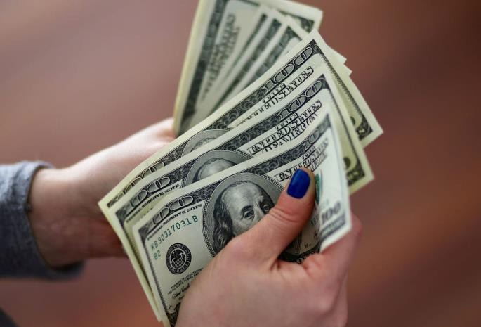
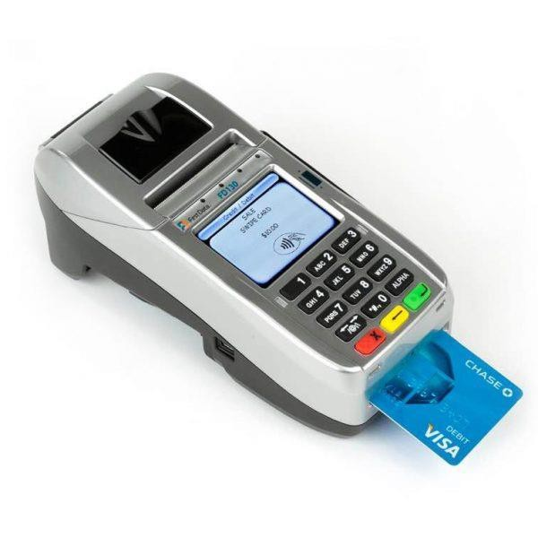
h

h p y o

o

h h

Take-Out Containers

Take-out containers have come very important during the COVID-19 pandemic and it’s important to consider that your takeout containers are accomplishing what you want them to accomplish. Several important factors need to be considered and you will likely to need to do some trial and error before finding exactly what works for you.

  - Heat tolerance:

Aluminum and styrofoam containers tend to keep food warm for longer than paper or plastic. Styrofoam is not environmentally friendly and some restaurants are shying away from using it. Cardboard and paper products may get soggy with warm food and plastic may melt.

  - Spill tolerance:

Packages need to be securely packaged to survive transport by the delivery driver or the customer. Make sure that containers close well and consider putting them in a structured bag to keep everything together.

  - Environmental impact:

Biodegradable and recyclable items are the best for the environment. There are many options out there including corn-based utensils and boxes that are more environmentally friendly than plastic or styrofoam.

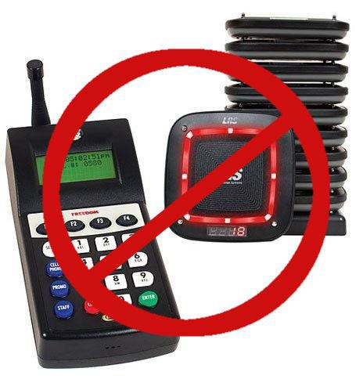
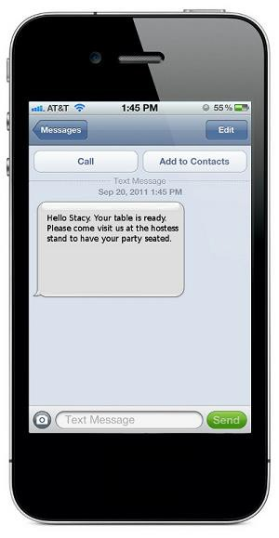
Reservation and Text Alert Systems

You will no longer be able to use buzzers to notify parties when their table is ready unless you disinfect each buzzer between use. Since this is more time intensive, distracting, and may irk some customers, it will make more sense to use a reservation system to avoid large crowds inside the restaurant and use an alternative methods of communication to let a party know that their table is ready. A quick Google Search will reveal many online reservation and text message notification systems. Some restaurants have considered using TV monitors to let people know when their table is ready but this may causing an unnecessary gathering in a small area. Alternatively others have started using announcements over speakers but this may disrupt guests that are already dining and would have to keep guests within hearing distance of the speaker.

Moving Forward

Things we want to cover:
- Measures for food production
- How to clean and sanitize a restaurant safely
- Using delivery systems and white-label ordering services

