

More content was created in the last two years than the previous 5,000 years of humanity.






82% of searchers will use their phone to help them make a decision about an in-store purchase.

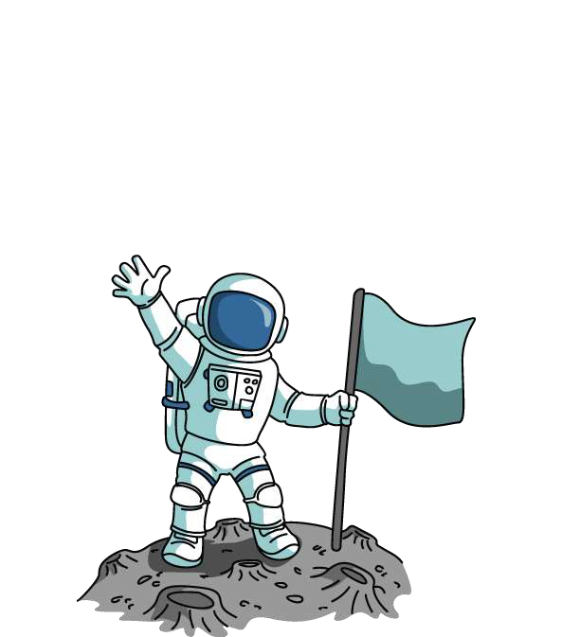
Powerful Moments
There is more computing power used to do a single Google search than all existing NASA computers used to land on the moon in 1969.

Infinite Noise
The average American had access to more than ten connected devices in their household. Each device can create and filter noise.

We've gone from being exposed to 500 ads a day back in the 1970's to as many as 5,000 a day today.


We cannot reach consumers with mass media if it is


filtered by algorithms on devices

30% of Internet users use

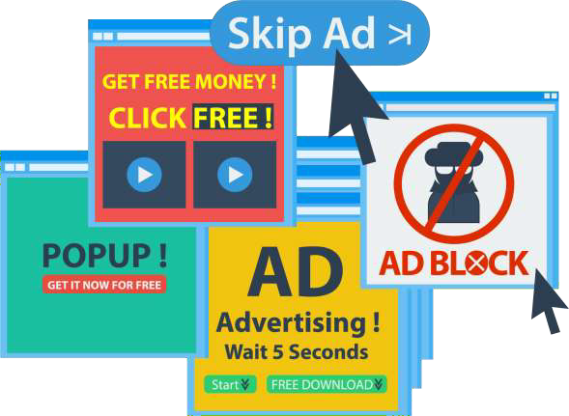
ad blocking software.

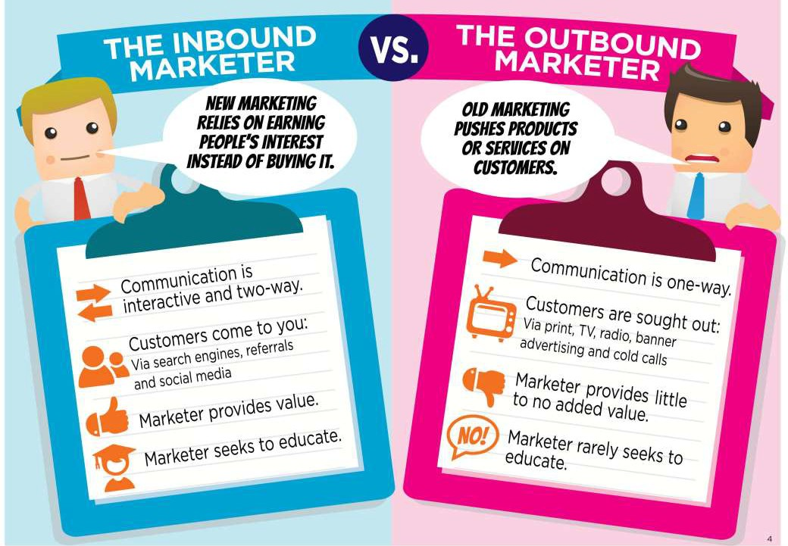


Your Website is a Billboard

Going by at 60 MPH!

What Defines A Good
Small Business Web Site?


What does my website
need to do in order for it to be successful?


Keep the noise down
to a
dull roar!!

A Good Web Site Has:
- A tagline that clearly identifies what you do
- Consistent design and navigation on all pages
- Clear hierarchy of information
- Footer links at the bottom of every page
- Keywords that identify your business
- Easy-to-find contact information
- A means to gather user data

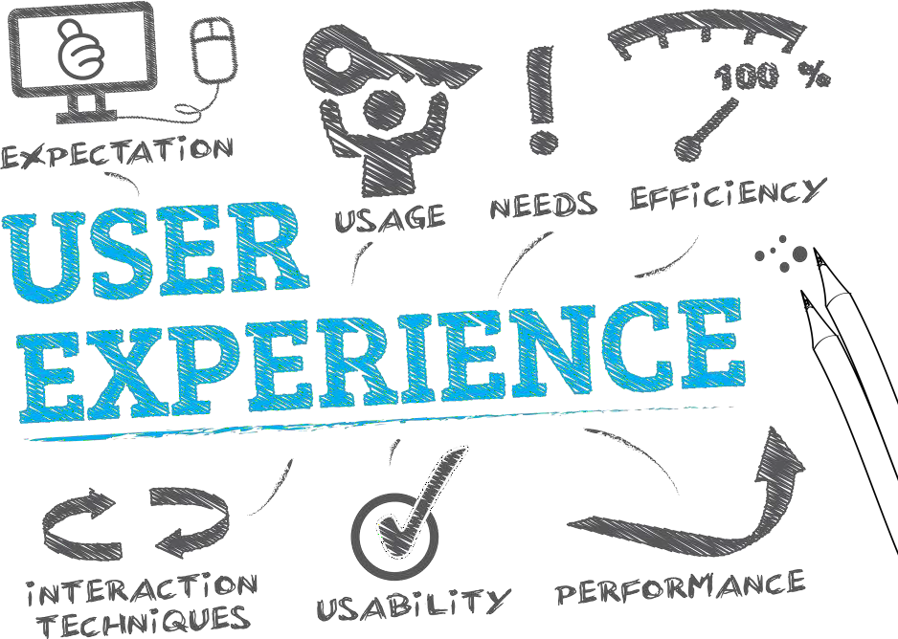

ADA Compliant

Does your website provide equal access for individuals with a disability?


Useful

Does your website do something people need done?

Learnable

Can people figure out how to use your website?

Effective

Does your website get the job done?

Efficient

Does it do it in a reasonable amount of time and effort?

Desirable

Do people want it?


Conventions are our friends!

Web Site Conventions
- They are useful. Conventions only become conventions if they work.
- Designers are reluctant to use conventions, they like to reinvent the wheel.
- Innovate when you KNOW you have a better idea, use conventions when you don’t.

Web Site Convention
Examples
- Navigation appearing along the top or running down the left side of the page
- Logo located in the upper left corner
- Hyperlinks are underlined

Things to Avoid
  - Splash or Intro Pages
  - Slow loading pages
  - Large blocks of text on the main site pages
  - White text on color background
  - Too much Flash and Music
  - Incomplete or outdated pages

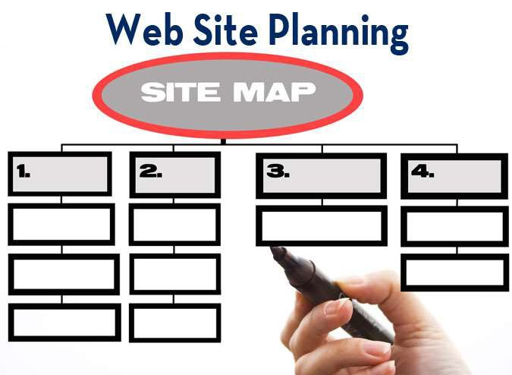

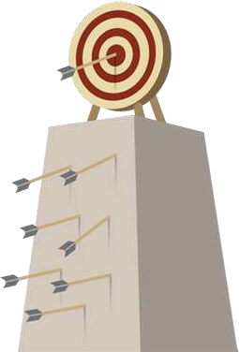


Understanding who our target audience is and where they spend their time, you can build an organic presence by focusing on content that speaks to their needs and wants.

Information Architecture
- Create Usable Navigation System
  - Easy to learn
  - Consistent throughout the site
  - Minimum number of clicks to destination
- What is the mission or purpose of the site
- Who are the intended audiences
- Determine the organizational structure
  - Hierarchy of information
  - Narrow and deep or broad and shallow
- Create a site map or blueprint of the site

3 Important Concepts Require Your
Attention
- What the audience wants from you
- What you want to say
- How you arrange the content to best meet your audience’s needs

Break up pages into clearly defined areas

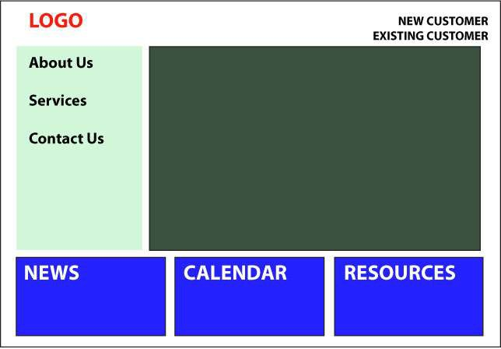


Make it obvious what is clickable

Important Considerations
- A clear, concise mission, vision, and values statement.
- Include photographs to add visual meaning to the site.
- All photos should be captioned to increase comprehension & SEO.

Important Considerations

- FAQ’s- improves users understanding of the information presented and reduces demand on your staff.
- Site Map—Helps users navigate and search your site.
- Page Footers offer the user a set of links to other pages in addition to essential data about the site.

Site Marketing
Your Web site should be an integral part of all marketing campaigns and corporate communications programs, and the URL for the site should appear on every piece of correspondence and marketing collateral.



Site Navigation
- Gives us something to hold on to
- It tells us what’s inside
- It instructs us how to use the site
- Consistent Navigation allows users to adapt easily and predict with confidence the location of information

Landing Pages

Landing pages, or “lead-capture pages,” are used to convert visitors into leads
by completing a transaction or by collecting contact information from them via a
Call-To-Action.

Landing Page Elements

- A strong Call-To-Action
- A brief description of the offer that clearly emphasizes its value.
- At least one supporting image.
- Supporting elements such as testimonials.
- Form to capture visitors' information.

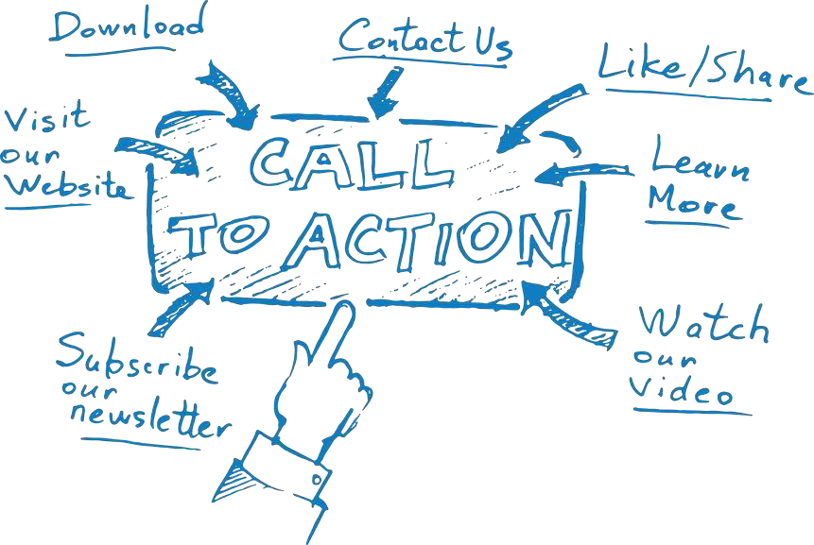



Call-To-Action (CTA)
- Your CTA is the action you want your website visitor to take.

- It doesn't matter if your landing page objective is increasing sales, generating email leads or developing customer relationships, we all want more conversions!

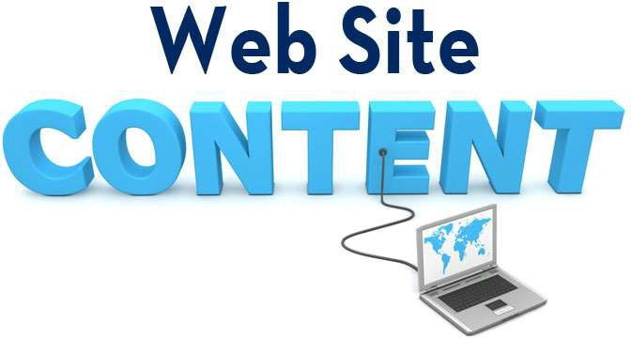

Omit Needless Words
  - Reduces noise level of the page
  - Makes useful content more prominent
  - Makes pages shorter, reduces scrolling

Kill the Happy Talk

  - Happy talk is like small talk, visitors to your site are not interested.
  - Contains no useful information

Chunk It
  - Few Web users spend time reading long passages of text on-screen
  - Chunking can help organize and present information in a uniform format
  - Concise chunks of information are better suited to the computer screen. Long pages tend to disorient readers and require users to scroll long distances

Kneel Before Google
  - Your content should be “Search Engine Friendly” Zero-Click Searches
  - Content should contain keywords that best describe your products and/or services
  - Use hyperlinks within your content to link to other pages on your site

Stock Photography
- Google Images is NOT a source of photos for your web site
- Royalty Free: Pay fee for variety of usage
- Rights Managed: Pay fee for very specific, one-time usage.
- ShutterStock, AdobeStock, iStock offer affordable plans for Royalty Free Stock Images.



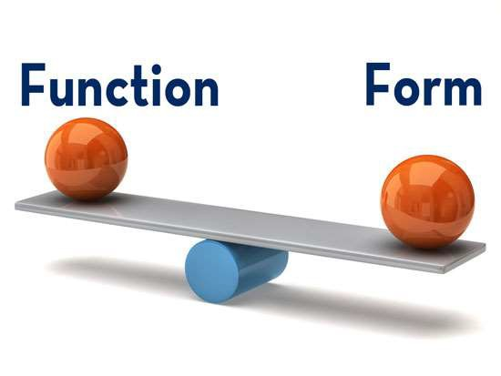

Responsive Design
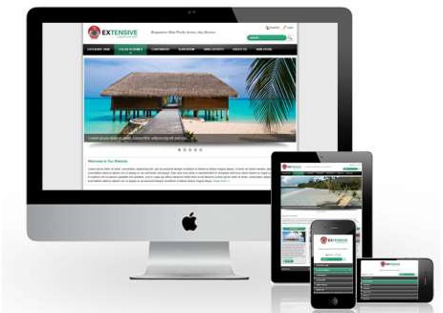
A Single Web Site That Works Effectively on Both Desktop Computers and Mobile Devices.

Design is Devine

The design of your site should offer relief to the eye by striking a balance between text and graphic elements.

Success Criteria
- Top of Mind Awareness within Marketplace
- Content is relevant, informative, and addresses the needs of the visitor
- Information is easy to find and read
- Increase unique visitor traffic to site
- Reduce demand on staff when handling inquiries
- Capture user data for future marketing
- Connectedness–link to other Web properties
- More product inquiries—MORE BUSINESS!



Design Your Own Site
  - WordPress, Wix, Squarespace and Shopify are CMS products that use templates so you can build your own Web Site and manage the content.
  - CMS allows you to add/edit and delete pages from your site

Benefits of DIY Web Sites
  - Saves you money
  - Template driven, plug-ins available to add functionality
  - Provides content management system (CMS) that archives content and allows you to easily upload new content to the site.
  - Manage site content via a Web browser

Benefits of Hiring a Pro
  - Saves you time, allows you to focus on core capabilities
  - A professional will know how to structure the site to make it visitor friendly and design the site to make the most of web technology
  - Customized approach to meet your specific needs
  - Employ SEO strategies

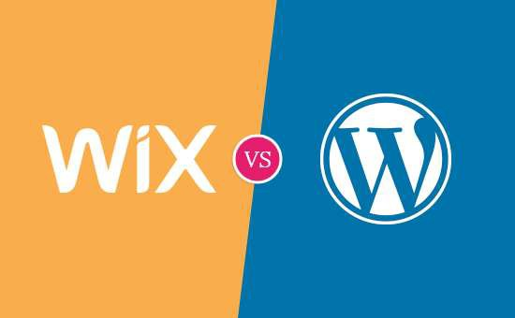



- Used by 1.0% of all the websites
- Basic website builder for free
- Simple drag and drop interface
- 500+ pre-made templates
- Nearly 200+ apps available
- Offers e-Commerce with paid plans
- Used by 32.5% of all websites
- Software is available for free
- Visual editor to write content
- 1,000s of free and paid themes
- 55,000+ free plugins available
- Powers over 42% of all e-Commerce sites

Your Website is a Billboard

Going by at 60 MPH!



VGL.COM

Presentation available:

www.slideshare.net/hbram

