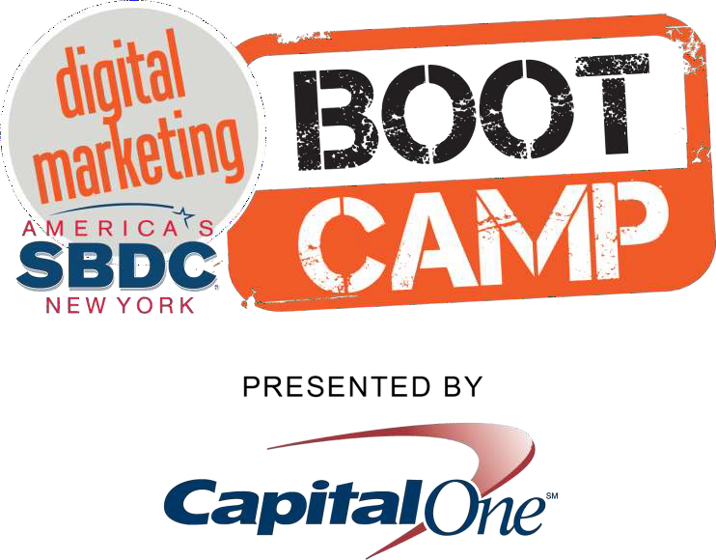

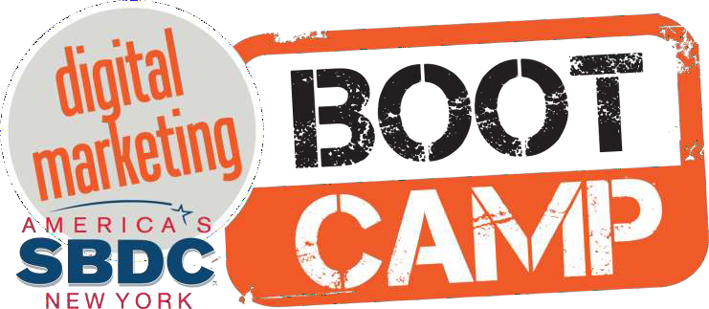
#sbdcbootcamp


Social Media Explained with Bacon

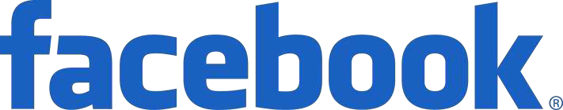

I like bacon



I am eating #bacon



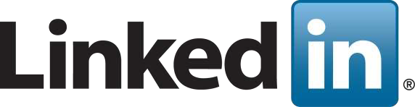
I am good at eating bacon


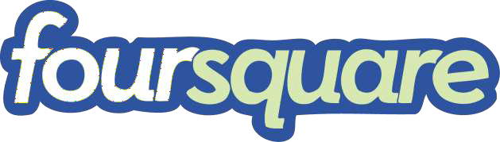

This is where I eat bacon



Watch me eat my bacon



Here’s a vintage photo of my bacon

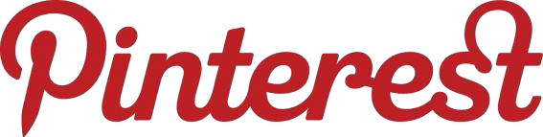

Here’s a recipe with bacon



In 2019:
90.4% of Millennials
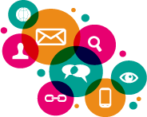
77.5% of Generation X
48.2% of Baby Boomers were active social media users.

Drives traffic to your web site


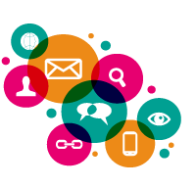
Improves SEO with keyword rich content

Gain better understanding of clients’ perceptions of your business

Increased awareness of your business

Social Media is for B2B & B2C

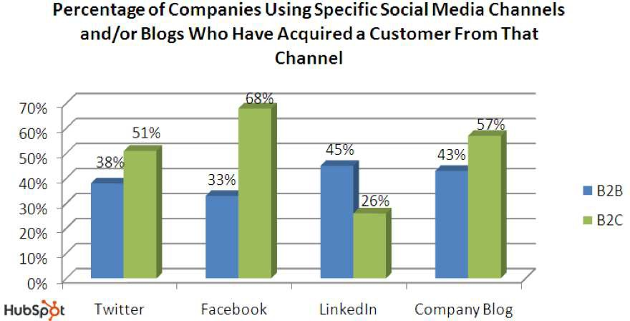

Source: State of Inbound Marketing Report - http://bit.ly/aewfHr

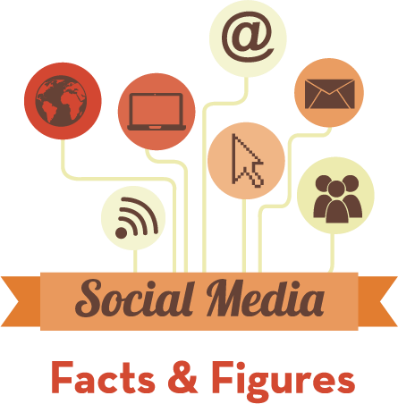

68% of all US Internet users are on Facebook.

74% of marketers believe it’s important for lead generation strategy.
Users share 2.5 Billion pieces of content every day.

1.15 Billion + users

96% of Facebook users access it on mobile.

The best time to post on Facebook is weekdays between 10am and 3pm.

81% of businesses prefer video marketing on Facebook.

Facebook gives your business an image.
You can have live conversations with people who matter, making it a more personal experience.

All the links and posts on your Facebook page are indexed by search engines.

Through comments or posts, you can have direct feedback and conversations with your target audience.

#2 Search engine on the web making it a great resource for traffic and leads.

500 Years of YouTube videos are watched on Facebook everyday.

More video is uploaded to YouTube in one month than the major U.S. TV networks created in 60 years.
1 Billion + users


YouTube reaches more adults aged 18 to 49 during prime time than any cable network does in an average week.

96% of all teens in the United States use YouTube.

“How To…” Videos are a great way to help people solve problems.

Social Media Networks, websites and blogs integrate YouTube embeds into their platform framework, allowing users to watch videos directly from their feeds.

60 % of Twitter users access it via mobile device.

Fastest growing age demographic is 55 to 64 years old, registering a 79% increase in active users.

On average, over 400 million tweets sent daily.

500 Million + users

Businesses Use Twitter to Converse with Prospects, Provide Customer Service and Drive Website Traffic.

83% of the people who sent a Tweet to a company and received a response, felt better about the company and were more likely to do business with them.


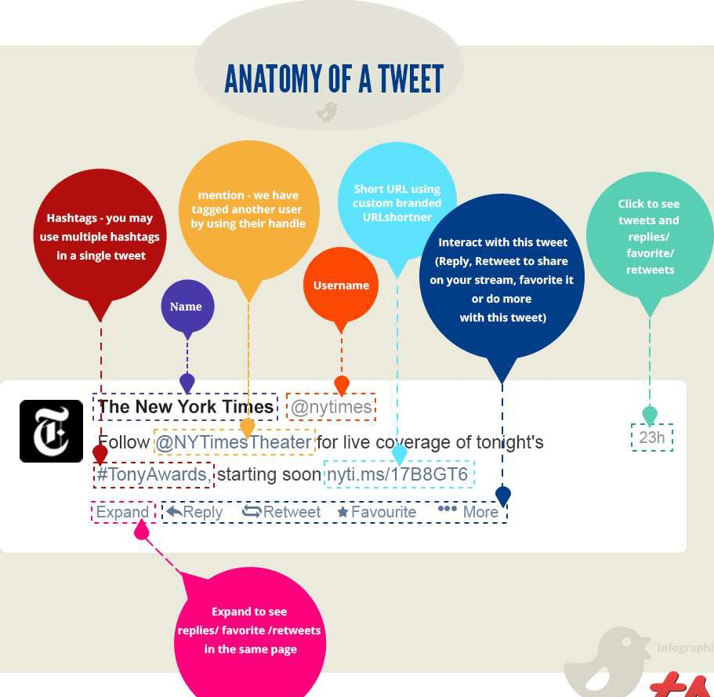

43% of US marketers have found a customer through LinkedIn.

3 Million companies have company pages.

50% of users have a Bachelor’s or Graduate degree.

690 Million + users

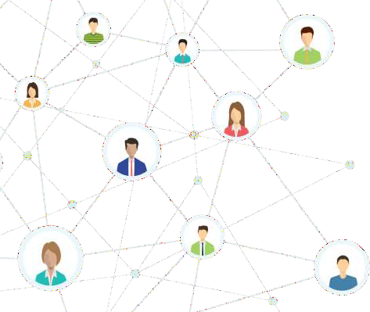
People typically visit LinkedIn with a purpose to make connections, gain insights about their industry,
It is a great way to quickly find content that is relevant to your target market.

More than 16 billion photos uploaded to site.

71% of US businesses use Instagram. It surpassed Twitter in business users in 2017.

Receives 1,000 comments per second.
51MiBllioinllpihoontosaucptloiavdeed uevsereyrdasy.

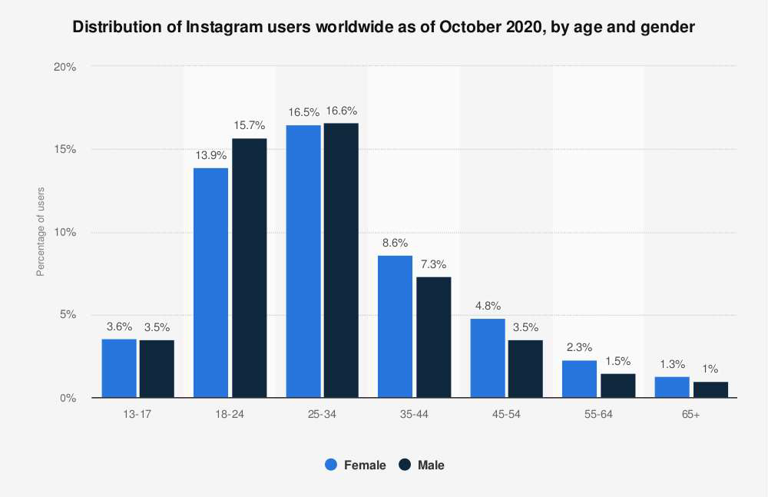

More than 69% of users are female.

80% of total pins are repins of existing content.

29.5% of the most popular pins come from the food and drink category.

DIY Crafts receives the next-highest amount of pins at 13.4%.
70 Million + users



Downloaded over 2 billion times on the App Store and Google Play.
Ranked as the top-most downloaded app in the App Store for Q1 2019, with more than 33 million downloads.

800 Million + users

Roughly 50% of TikTok's global audience is under the age of 34 with 26% between 18
and 24.

One in eight adults have joined TikTok.



Nextdoor is the neighborhood hub for trusted connections and the exchange of helpful information, goods, and services.

The Nextdoor app is now used in more than 260,000 neighborhoods in 11 countries worldwide, including the United States, where one in five households are active on the app.

The strength of the Nextdoor social network relies on the power of proximity. Nextdoor is local, right down to the postal code.

For businesses, that means local targeting is already organically built-in to the experience.

Businesses use Nextdoor to:
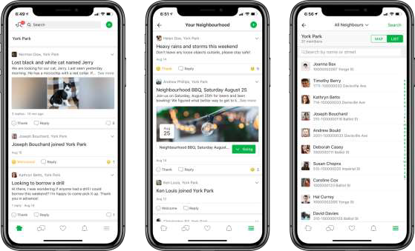
- Run Local Deal ads
- Engage with the community
- Share special offers
- Gauge their local reputation

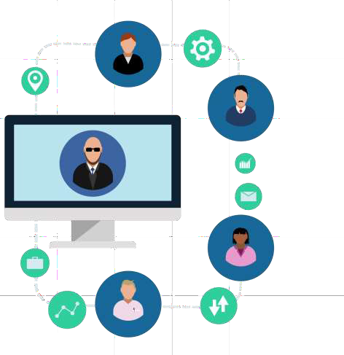


Alignable is the free network where small business owners build trusted relationships and generate referrals.




Alignable has over 25,000+ communities all across North America.

3 Million + users


A hyper-local version of LinkedIn.

A great place for small and local business owners to connect.

Unlike LinkedIn, Alignable is 100% for small business owners to connect and exchange referrals with the business owners in your Local Community.

Social Media

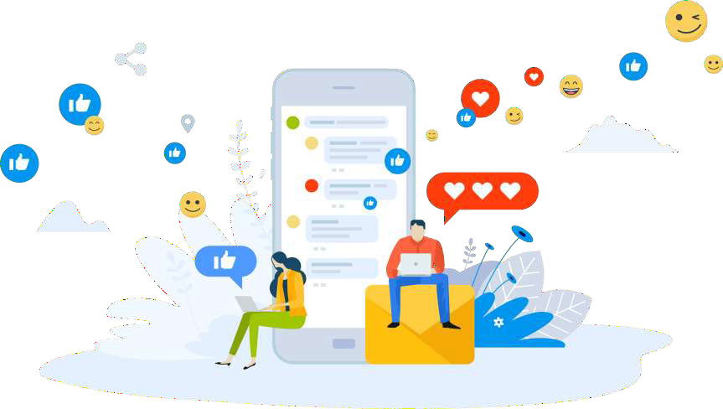

Increase Brand Awareness

Avoid promotional messages.

Focus on meaningful content and a strong brand personality through your social channels.

Through more efficient social media targeting, you reach your core audience much faster.

Social Media ROI
The sum of all social media actions that create value (brand awareness, revenue, customer satisfaction).

Engagement
When people perform actions on your Page. They may like a post, click on a link or comment on an image.

Tips for businesses using Social Media to
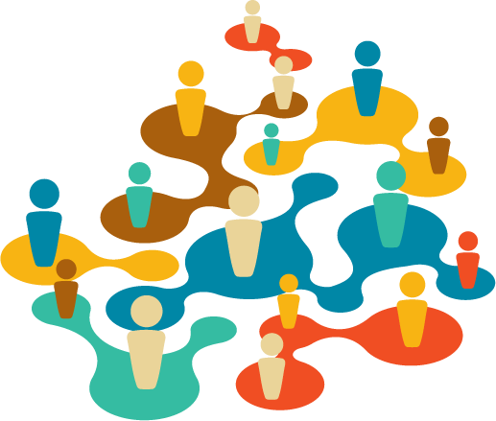
connect with customers

- Listen relentlessly.
- Reply immediately.
- Have a human voice.

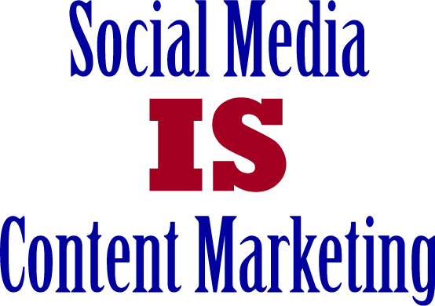

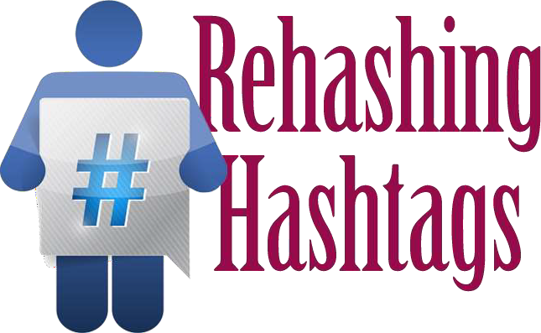

#Hashtags

Hashtags help identify a common topic or theme.

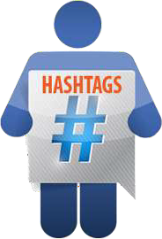
Hashtags have become a critical way to communicate and link information
on Social Networks.

Why are Hashtags Important?

Hashtags make your information searchable by anyone.

Your post appears in the stream of the hashtag you used.
Build an audience & community.

How to Use Hashtags
Identify where your posts or subject fits in.
Chances are there is already a hashtag being used for your area of communication.
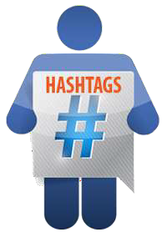
Find someone who is already active in your field, and then see what hashtags they are using.
If you see one you like, click on it,
all posts with that given hashtag will appear.

Social Media Tools

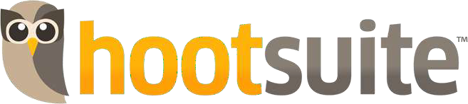



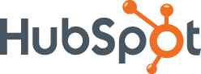

HootSuite offers a comprehensive solution for all aspects of a business’ online promotion activities. You can enter blog posts with ease, handle social media interaction across multiple networks, monitor website metrics, and incorporate SEO features via one easy to use platform.

Buffer allows you to share content (yours and content from the Internet) across multiple social networks.

You can set a pre-set schedule to share posts, and when you share these articles into your "buffer app" it puts the post into a queue to be published at your set time.

HubSpot is an all-in-one Inbound marketing platform that helps you outline your marketing goals, and track your progress. It offers access to the necessary SEO and keyword strategies to help you develop an online marketing campaign, but also offers ongoing feedback to justify your advertising efforts.

Search Engines Focus on 2 Factors

On-Page Content
Content on pages of your website or blog

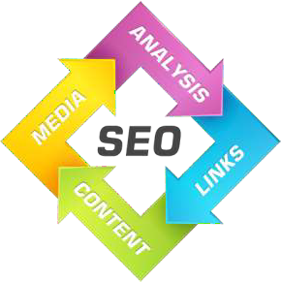
Off-Page Content
Trust/Authority via Social Media & Link Building

Types of Content

Branded Content
Specific to your business

Non-Branded Content
Specific to your industry or field

SMART Goals
Specific Set real numbers with real deadlines.
Measurable Make sure that you can track your goal.
Attainable Work toward a goal that is challenging but possible.
Realistic Be honest with yourself.
Timebound Give yourself a deadline.

SMART Goal Example

I will acquire three new clients for my consulting business within two months by asking for referrals, launching a social media marketing campaign and networking with local businesses.

This will allow me to grow my business and increase my revenue.

Quantify Your Efforts

Number of engaged users.
How often is your post shared?
How many submitted an online form. How many clicked on link to your site.

Social Authority/Influence

Influence is the ability to drive action.

When you share something on social media or in real life and people respond, that's influence.

AND
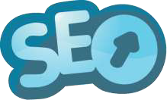

Social Authority
- Individuals or Organizations are recognized as experts in a given field or topic.
- Participate in online conversations and contribute valuable information.

AND

Content Curation Tools
Content Curation is about showing thought leadership.

Good content creation tools help you save time and increase productivity.

They streamline the process of:
- Develop content ideas on a consistent basis
- Organizing and executing content promotion
- Identifying link prospects
- Tracking your results


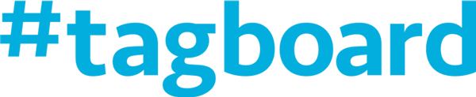

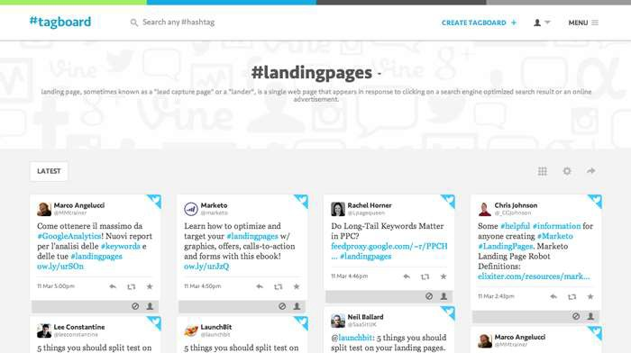
Tagboards automatically aggregate social media hashtags from Twitter, Facebook, Instagram and others in a single view.

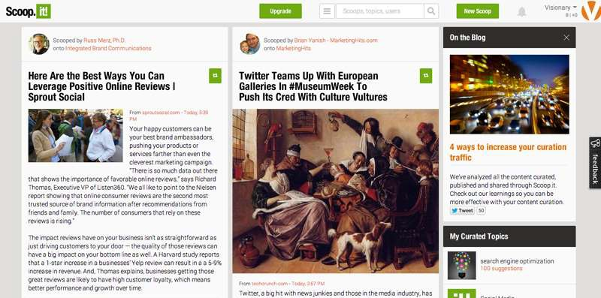
Scoop.It! helps you find content from your favorite topics and allows you to share it via your favorite social networks or blogs.

In Conclusion

Start by Defining Your Goals

Improving your customer service so customers can reach out with complaints, questions, and concerns. Identifying new leads and prospects who are similar to your best customers.

Identify Your Audience

Reaching out to new audiences and new demographics who might be receptive to your products or services Increasing brand awareness and exposing your business to new people.

Learning about the needs, wants, and habits of your audience and customers to increase traffic to your site and boost sales.

Plan Your Content

Consider the type of content you like to create and that works best with your brand

Pair Your Goals, Audience, and Content with the Right Platform


VGL.COM

Presentation available:

www.slideshare.net/hbram

