



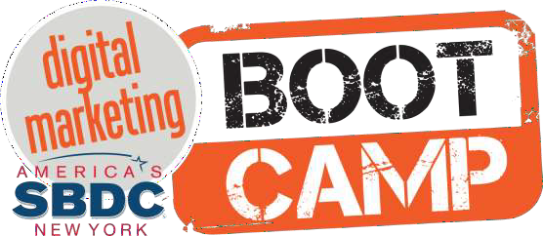
#sbdcbootcamp




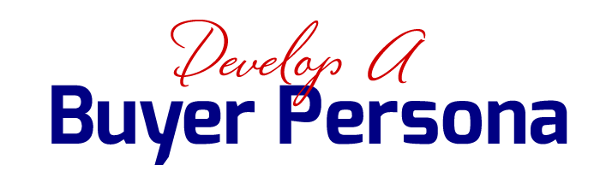

Understanding who our target audience is and where they spend their time, you can build an organic presence by focusing on content that speaks to their needs and wants.

What Is SEO?
Search engine optimization (SEO)
is the process of affecting the visibility of a website or a web page in a search engine's unpaid results—often referred to as "natural," "organic," or "earned" results.



SEO Approach

BLACK HAT WHITE HAT

Black Hat SEO
- Exploits weaknesses in search engine algorithms to obtain high rankings for a website.
- Keyword Stuffing, Cloaking, Hidden Text and links and Link Spam.
- Quick, unpredictable and short-lasting growth in rankings.

White Hat SEO
- Utilize techniques and methods to improve search rankings in accordance with the Search Engine’s Guidelines.
- High quality content, website HTML optimization, relevant inbound links, social authority.
- Steady, gradual, last growth in rankings.

Meta Tags
Meta Tags explain to search engines and (sometimes) searchers themselves what your page is about. Meta Tags are inserted into every page of your website code.

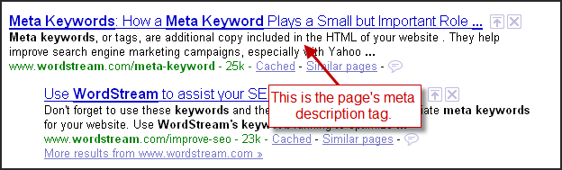

How SEO Has Changed

OLD SEO NEW SEO

Focus on singular keyword
Focus on long tail keywords, keyword intent and
searcher’s needs

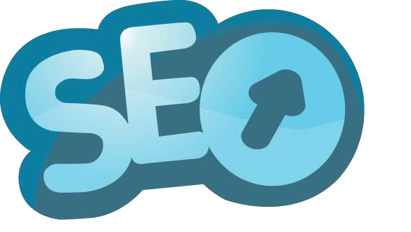

How SEO Has Changed
- When search engines were first created, early search marketers were able to easily find ways to make the search engine think that their client's site was the one that should rank well.
- In some cases it was as simple as putting in some code on the website called a meta keywords tag. The meta keywords tag would tell search engines what the page was about.
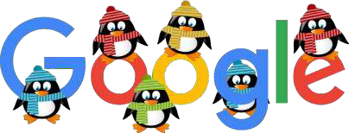

How SEO Has Changed
- Google updated their search algorithm to decrease search engine rankings of websites that violate Google’s Webmaster Guidelines by using now declared Black Hat SEO techniques involved in increasing artificially the ranking of a webpage through manipulation.
- High-quality sites rank higher in search results and demote sites that may be of lower quality.

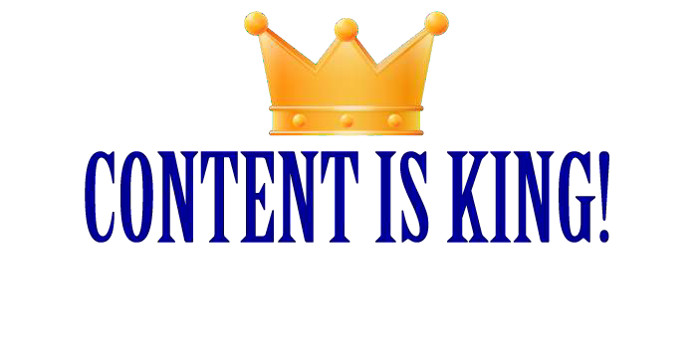

The days of keyword stuffing, or writing meaningless content that would only impress search engines, are thankfully a distant memory.


Violations are generally tactics meant to deceive or manipulate a search engine’s understanding of a site’s true relevancy and authority.

Common Violations

LAYOUT
  - Poor Navigation
  - Below the Fold
  - Not user-friendly

CONTENT
  - Low-quality
  - Spelling Mistakes
  - Duplicate
  - Short, unsubstantial

LINK
  - Non relevant links
  - Link Exchanges

OVER-OPTIMIZED
  - Keyword Stuffing
  - Anything that helps you rank higher without improving the user’s experience.

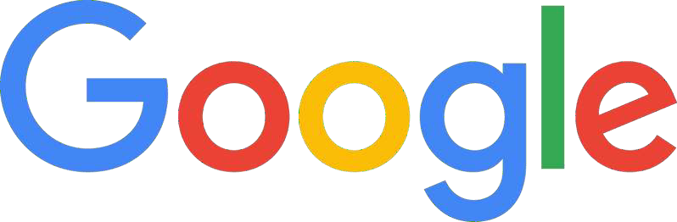

Handles 64.4% of all Searches
Google works for the individual performing a search. Their job is to deliver the most relevant websites (best answer) to a searcher’s query.

comScore Explicit Core Search Share Report April 15, 2015

Combination of Factors
- No single SEO factor will guarantee search engine rankings.
- Having a great Meta Tags won’t help if a page has low quality content.
- Having many links won’t help if they are all low in quality.
- Having several positive factors can increase the odds of success while the presence of negative factors can worsen those odds.

On Page SEO
- On-The-Page search ranking factors are those that are almost entirely within your control.
- What type of content do you publish? Are you providing important clues that help search engines (and users) determine relevancy?

- Does your site architecture help or hinder search engines?

OFF Page SEO
- Activities outside the boundaries of the webpage.
- Gives Search Engines a very good indication on how the world (other websites and users) perceive your website.

- Link Building
- Social Media
- Social bookmarking

Long Tail Keywords
  - Very targeted search phrase containing 3 or more words.
  - Comprise over 70% of all search traffic.

  - Generate better quality traffic because they are more specific.
  - Less competitive.

Example
Keyword: Insurance

Long Tail Keywords:
Group Health Insurance for Small Business

Long Tail Keywords
  - Each page of your website should focus on one set of long tail keywords.
  - Try to use long tail keywords in your page headers.

Keyword Planner Tool
Research keyword performance, historical statistics and create keyword lists. www.adwords.google.com/KeywordPlanner

Schema Markup
Code placed in website pages to help Search Engines return more informative results.

TYPES


Creative work Event Organization Person
Place Product


AND

Social Authority
- Individuals or Organizations are recognized as experts in a given field or topic.
- Participate in online conversations and contribute valuable information.

AND

Social Shares
- Is your content being shared on social networks?
- Post to Online Communities

AND

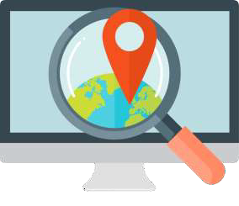
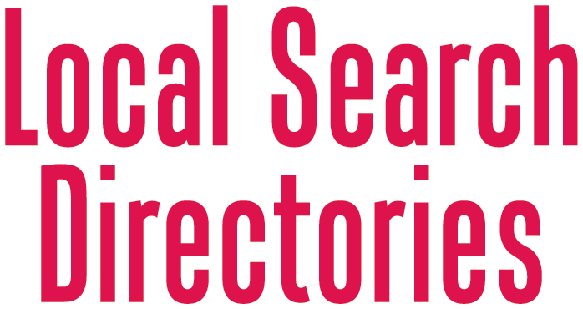

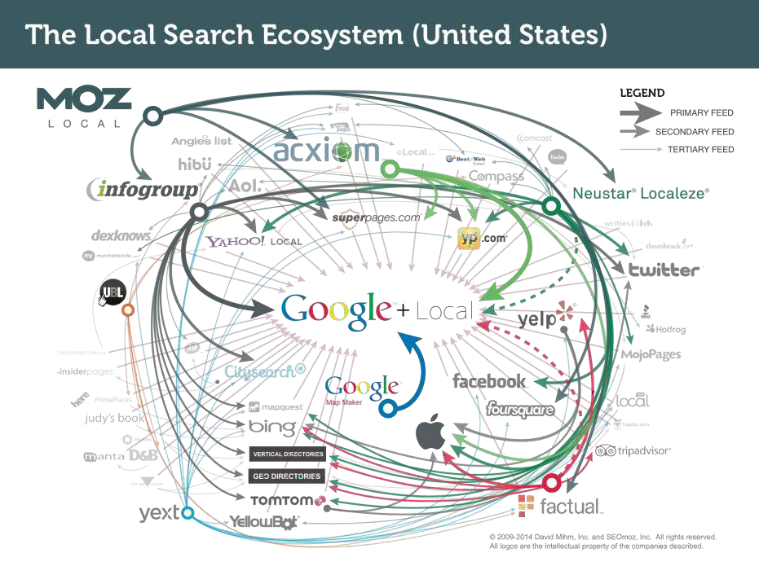

Local Search Directories
Local Search Directories find out about your business in two ways:
They visit links that point to your website and track sites where those links appear. Track Citations of your business and which
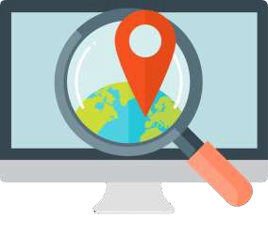
sites these citations appear.

Local Search Directories
Businesses with the most links from
QUALITY WEBSITES IN YOUR AREA,
and the most citations from high-quality websites will rank the highest.

What Are Citations?
Citations are “mentions” of your business name on webpages other than your own.
Business Name Address & Phone Link to Website
Information in your Citations MUST be consistent!

What Are Citations?
Citations are “mentions” of your business name on webpages other than your own.
Business Name Address & Phone Link to Website
Information in your Citations MUST be consistent!

Manage Local Listings

MOZ LOCAL



Moz Local ensures that your business listing is correct, consistent, and visible across the web.

Enter your location data.

Moz pushes your listings to all the major data aggregators
Search engines can find your location and new customers can find you!

Cost: $84/year per location

The line between writing good
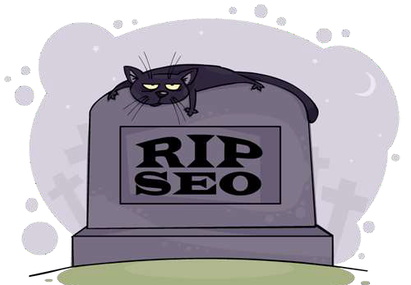
SEO copy for search engines and engaging copy for humans has all but disappeared.


- A free service offered by Google that generates detailed statistics about the visitors to your web site.
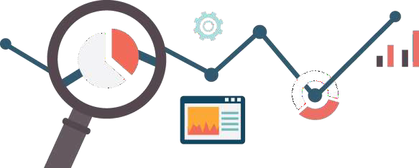
- Shows you how people found your site, how they explored it, and how you can enhance their visitor experience.

SEO Resources
  - Moz.com/local
  - Moz.com/blog
  - SearchEngineLand.com
  - Rand Fishkin - Moz
  - Matt Cutts - Google
  - Hubspot.com



Presentation available:

www.slideshare.net/hbram/seo-presentation-56144538

