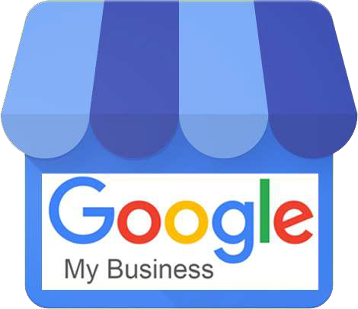
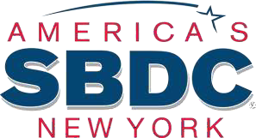

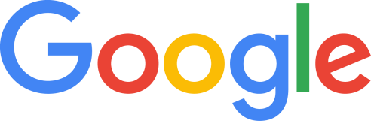
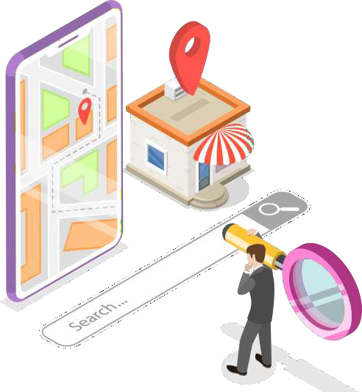

3.5 billion Google
searches are conducted every single


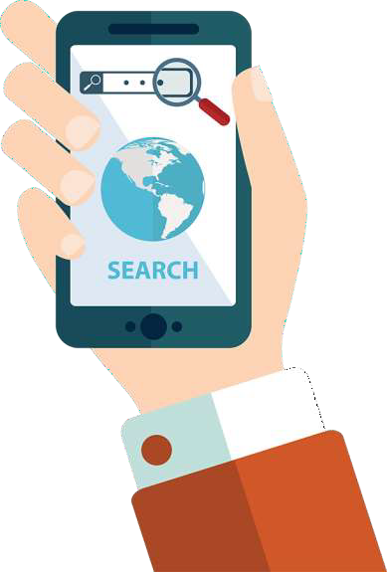
82% of searchers will use their smartphone to help them make a decision about an in-store purchase.

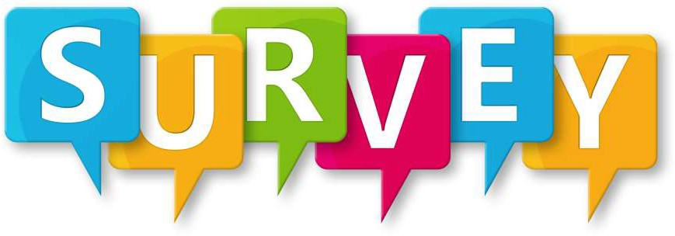

82% of the local marketing experts say that Google My Business optimization is “very effective” in improving local pack rankings.

68% of local marketing experts believe Google My Business is more important than it was a year ago.

100% of local marketing experts use Google posts, photos, and business descriptions for their local business clients.

Most important tasks:
Growing and Responding to Google reviews Keeping information up-to-date
Writing Google posts


A free and easy-to-use tool for businesses to manage their online presence across Google, including Search and Maps.

By verifying and editing your business information, you can help customers find you and tell them the story of your business.


Google My Business can increase your chances of showing up in Google’s Local
Pack, Local Finder, Google Maps, and organic rankings in general.

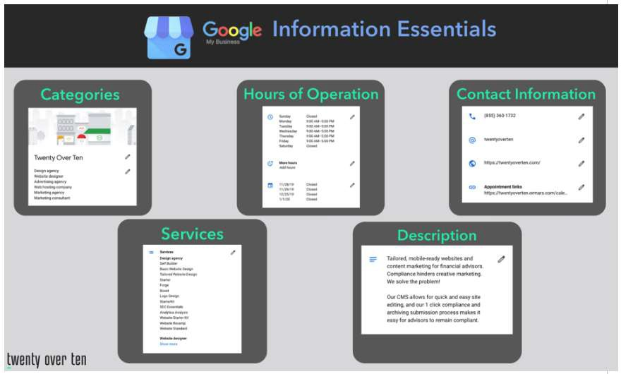

Manage information that Google users see when they search for your business, or the products and services.
Interact with customers - Read and respond to reviews and post photos that show off what you do.
View insights on how customers searched for your business, and where those customers are coming from.

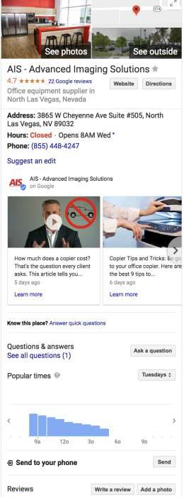
Knowledge Panels

Panels appear on the right in the desktop search results. It contains information about a company.
Panels also contains hours, questions & answers, posts, reviews and photos.

How Google Determines Local Ranking
Local results are based primarily on relevance, distance, and prominence.
These factors are combined to help find the best match for your search.

Relevance
How well a local listing matches what someone is searching for.

Distance
How far is the search result from the location used in the search?

Prominence
How well-known a business is. Links, articles and reviews.

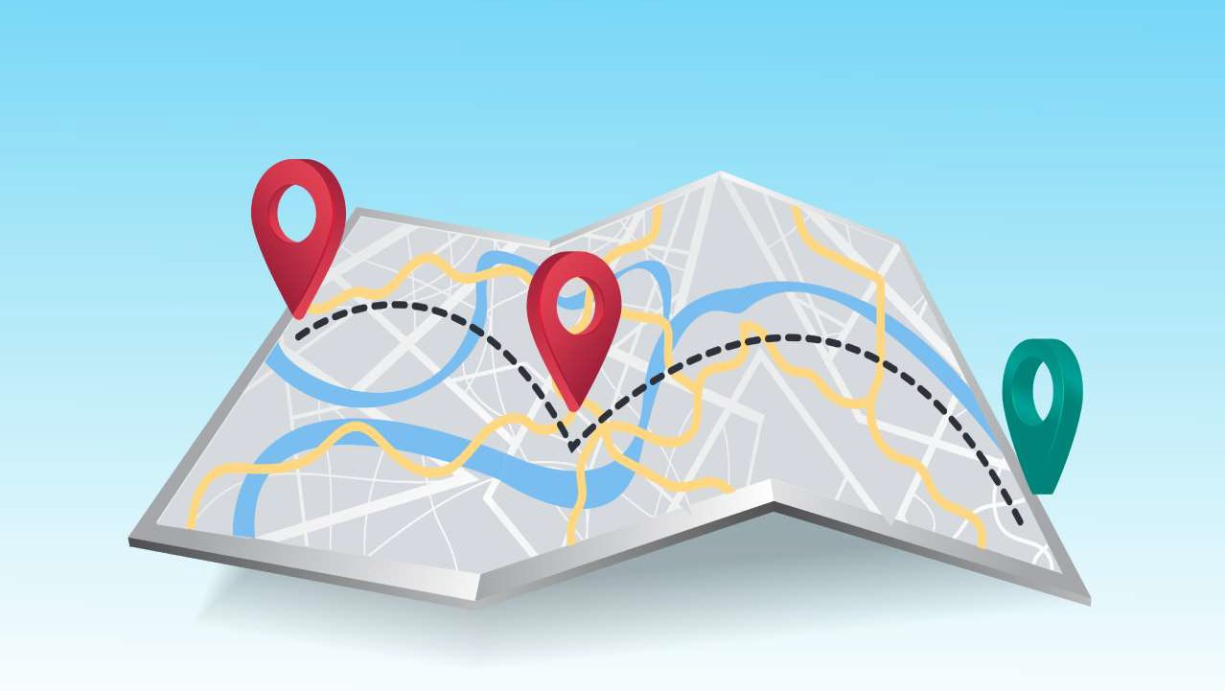
“Near Me” Searches

“Near Me” Searches
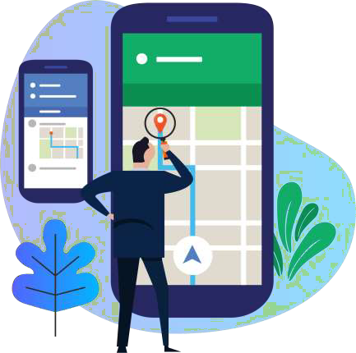
"Near me" searches are critical for businesses, since it allows you to reach your intended customers during micro-moments when they most desire your service or product.

“Near Me” Searches

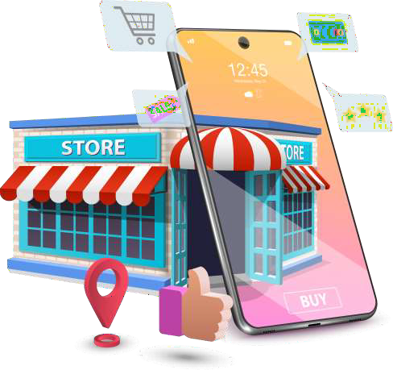
Google has reported a 900%+ increase
in “near me tonight/today” searches
in the past two years.

Semantic Search
Semantic search seeks to improve search accuracy by understanding searcher intent and the contextual meaning of terms as they appear in a search to generate more relevant results.

Google had changed its famous algorithm to focus on the understanding phase of the searches.

Schema Markup
Code placed in website pages to help Search Engines return more informative results.
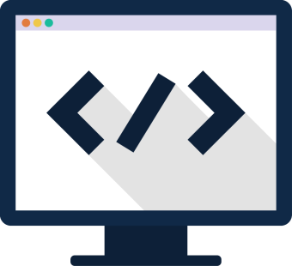

TYPES
Creative work Event Organization Person
Place Product

Google is getting greedy with its own search traffic.
They don’t want to send people to your website if they don’t have to.

Zero-Click Searches
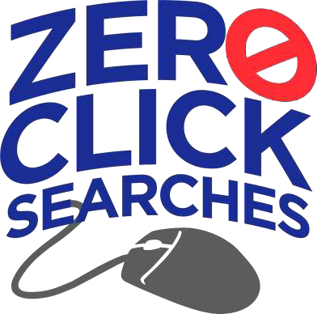
Zero-click searches refer to a search result that answers the query right on the search engine results page (SERP) so the user doesn't need to click to a website to complete the search



New Updating Feature
Instead of having to go into your Google My Business console, you can search for your business in Maps or Search and directly edit your profile from there. You must be logged into the Google account for that business, of course.

Google Guarantee Badge
Google is offering a paid verification service that identifies local businesses who offer quality work and promises to refund unhappy customers. It costs $50/month to upgrade your listing to add the Google Guaranteed Badge.
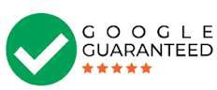

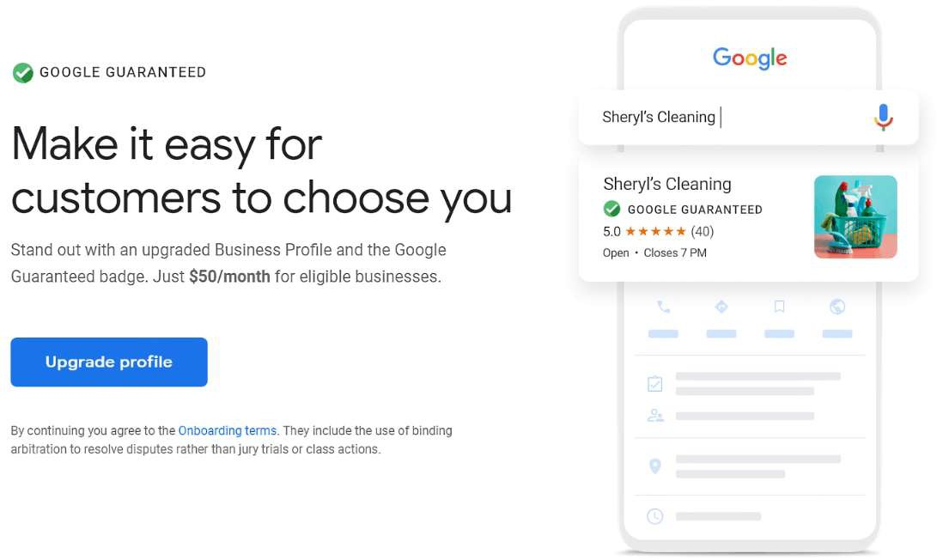



COVID-19 Updates
Use the new COVID-19 post type to share more detailed and timely updates about what’s going on at your business. You can add information about.

COVID-19 Updates
You can use messaging to provide your customers with the support they need when you’re not reachable by phone or after your business hours

Google My Business & COVID-19
Post COVID-19 updates
Adjusted Hours of operation
Added “More Hours” for delivery, takeout Online ordering
Extra services provided to the community COVID-19 testing facilities
Purchase Gift Cards & make Donations

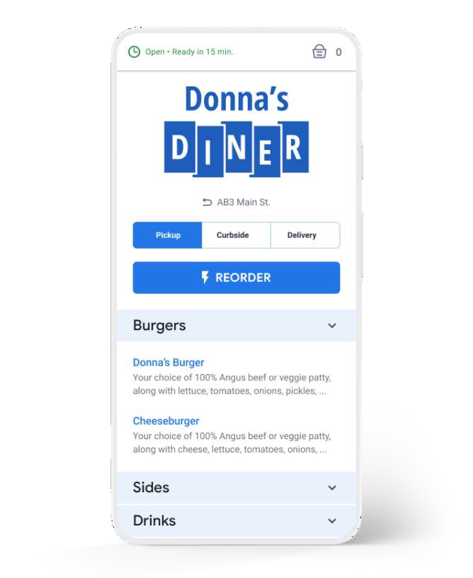
Google My Business Add-Ons

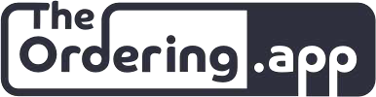
The Ordering.app will allow customers to order right from your website, Google Search, Google Maps and more.

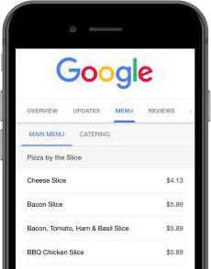
Google My Business Add-Ons

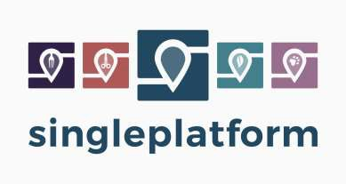
Publish and manage your menus where consumers are searching for you - your website, Google, Facebook, TripAdvisor, Yelp, OpenTable and many more.


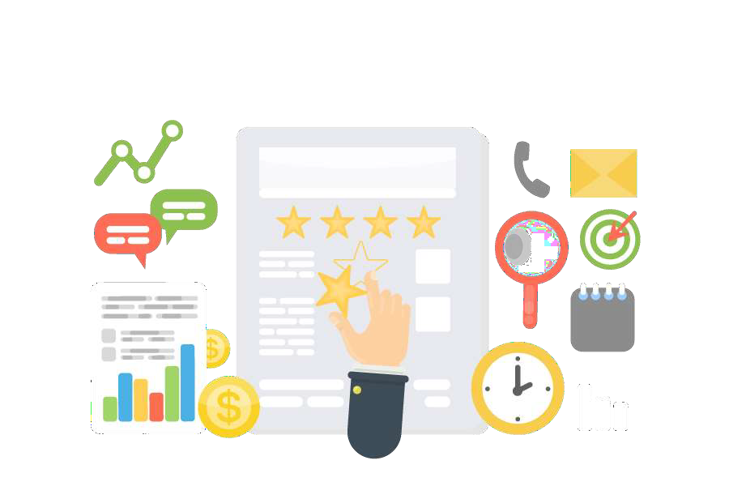
Google Reviews

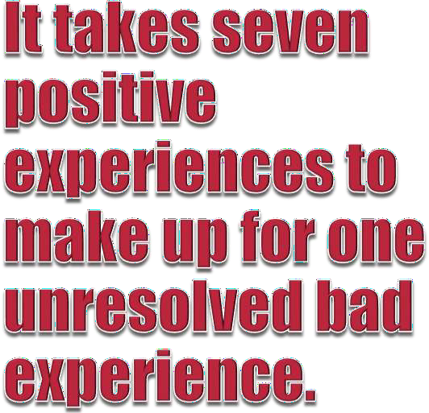


Positive reviews send signals to Google

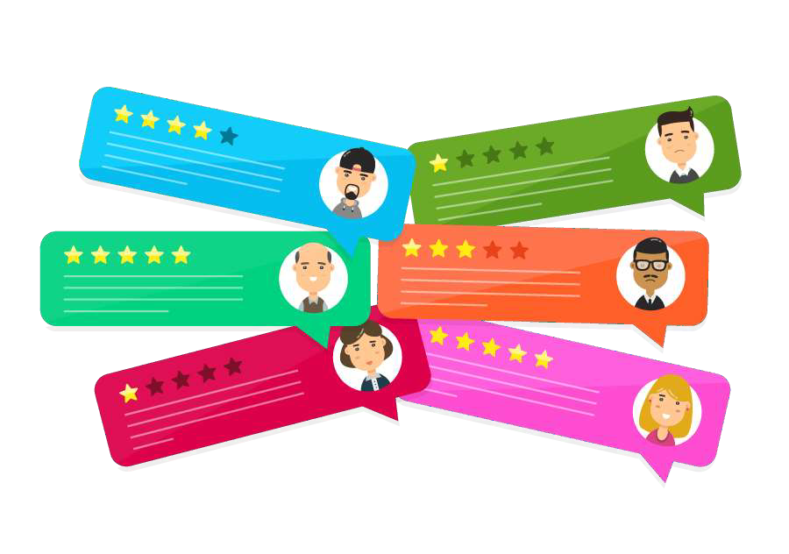


that the business is trustworthy and provides a good experience for customers.

Google uses an algorithmic solution
designed to de-rank sites that offer
poor customer experience.

The Reviews Are In!
- 74% of businesses have at least one review.
- 88% of buyers research products online before making a purchase.


- 86% will hesitate to purchase from a business that has negative reviews.

Complete Transparency
Transparency is a continuous process of learning and improving, turning negative feedback into constructive conversations that build trust and win loyal customers.



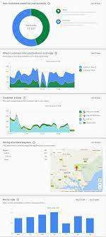
Google My Business Insights
Tracks on how customers find your listing on Search and Maps, and what they do after they find it.
The Insights dashboard provides customer engagement data derived from your GMB listing.



Responding to Negative Reviews
- Respond quickly.
- Offer to make it right.
- Be authentic - conversational and honest.
- Take the high road.
- Be sympathetic.
- Think of future customers.
- Contact the customer offline.



Google My Business
Having a consistent Name/Address/Phone Number (NAP) is very important, because Google places a lot of weight on having that information accurate and correct.
Check your listings at Moz Local.

Google My Business
Enter complete data for your listing Include important keywords
Business operating hours are accurate Manage and respond to reviews Monitor insights
Add photos

Google My Business


Businesses that add photos to their listings receive 42% more requests for driving directions on Google Maps and 35% more clicks through to their websites than
businesses that don’t.

Final Thoughts
Your free My Business listing gives potential clients easy access to your hours of operation, phone number, website and directions with a click of a button.
Your profile also gives customers an inside look at your business by providing insight into your busiest hours as well as review ratings.


Henry Bramwell • 631-475-2959 • hb@vgl.com

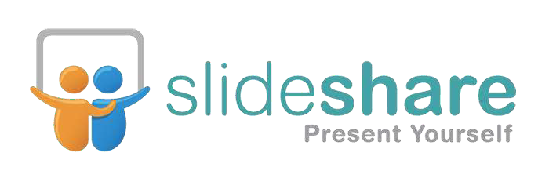
Presentation available:

slideshare.net/hbram/hiali-digital-marketing-presentation

