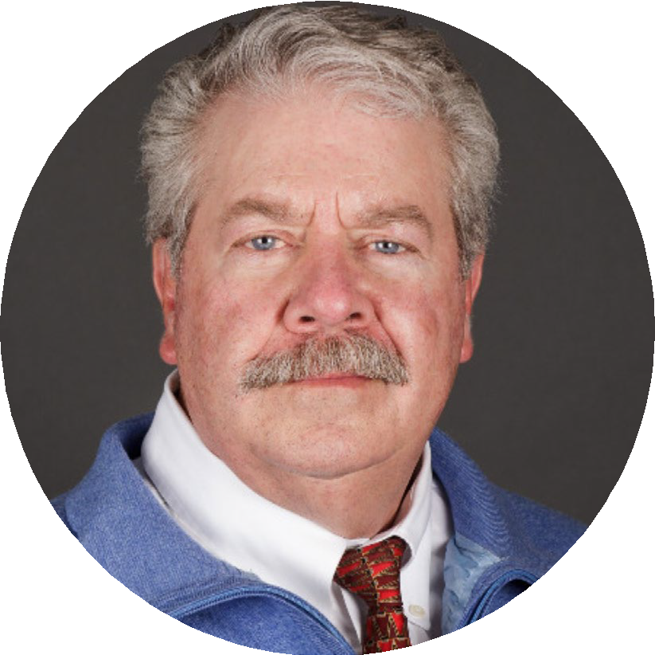
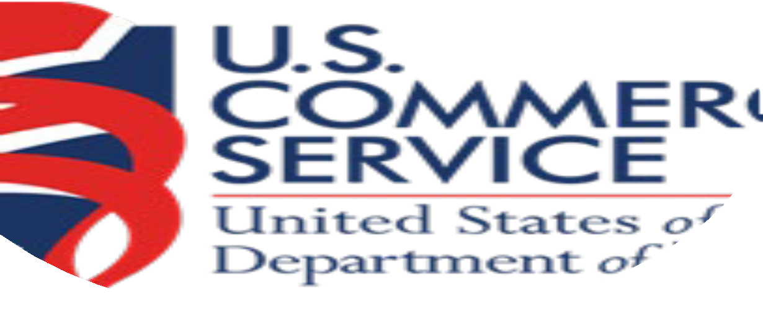
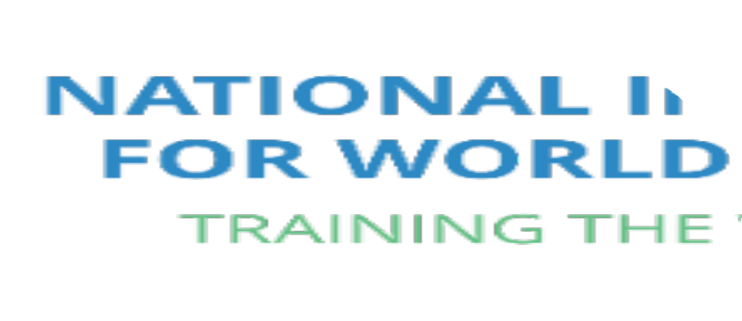


Navigating public procurements: Resources and opportunities for American companies - Webinar

- Thomas Cook, Managing Director
- Blue Tiger International

- “30+ Years engaged in Global Trade and Foreign Business Development including Overseas Government Procurement”

1

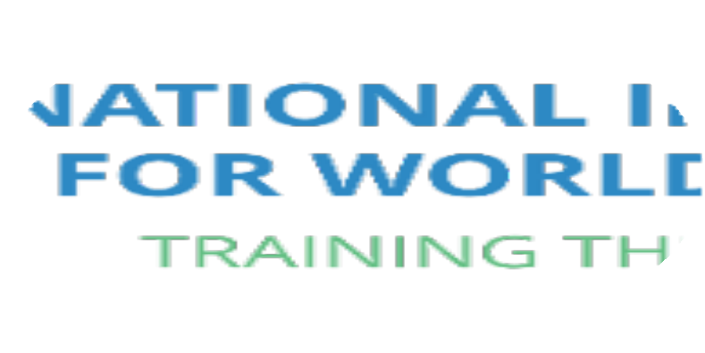





Service Sector

Opportunity

Products

2



Services
- Education, Financial,
Business Training, Entertainment
Products
- Technology, Defense,
Security, Food, Industrial & Consumer Goods
3



Opportunities

Challenges

4



“Opportunities have been created for USA based companies to fulfill foreign contracts not completed by traditional sources impacted by the Covid-19 Pandemic Disruptions to Global Supply Chains”
5



Challenges:



Local Suppliers
Geopolitical, cultural, language, regulatory
Understanding the “process”
“Politics of the sale”
Being competitive

6



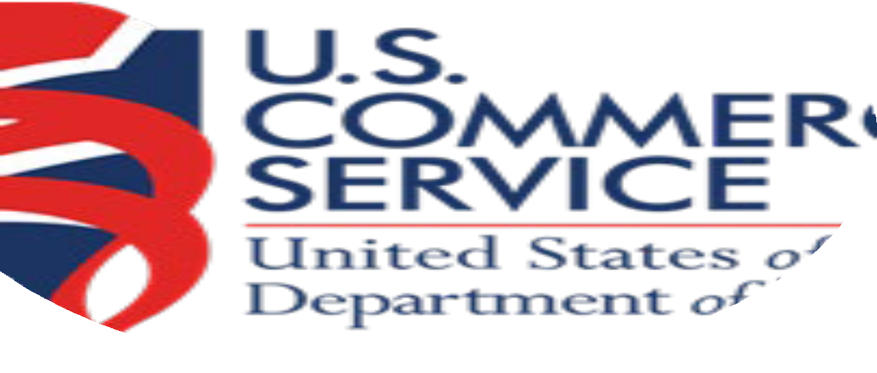
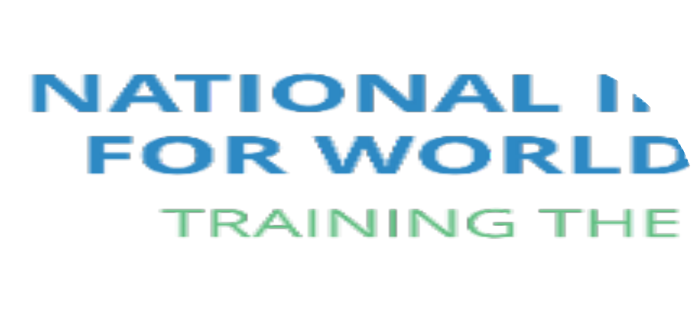
Ten Steps

Develop |           Develop Robust Relationships
Do | Do Your Homework
Develop | Develop “Leverage Points”
Qualify | Qualify the Opportunity
Create | Create a “Local Presence”

Blue Tiger International October 2021 7

Ten Steps

Follow

Follow the RFP Instructions

Learn
Learn the Competition

Adapt
Adapt the Sale to the Local Environment

Respect
Respect the Local Business Acumen

Exercise
Exercise Patience




Blue Tiger International October 2021 8

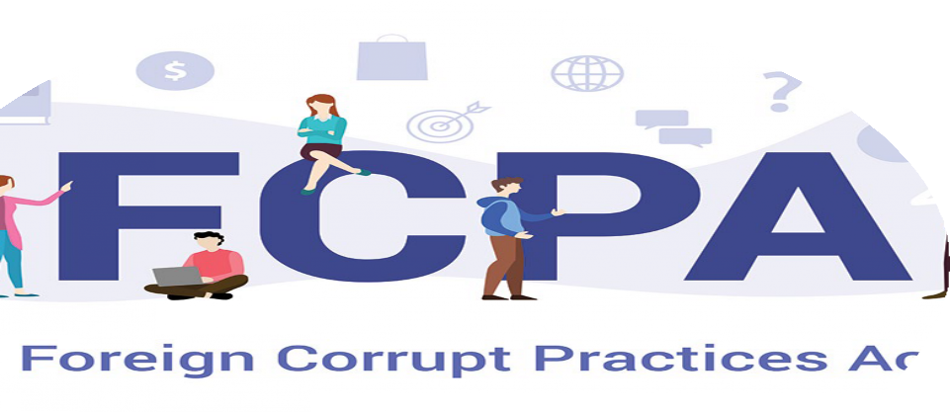

Be Cautious:

Don’t Overcommit

Be Prepared to Compromise

Understand USA Laws on FCPA
9


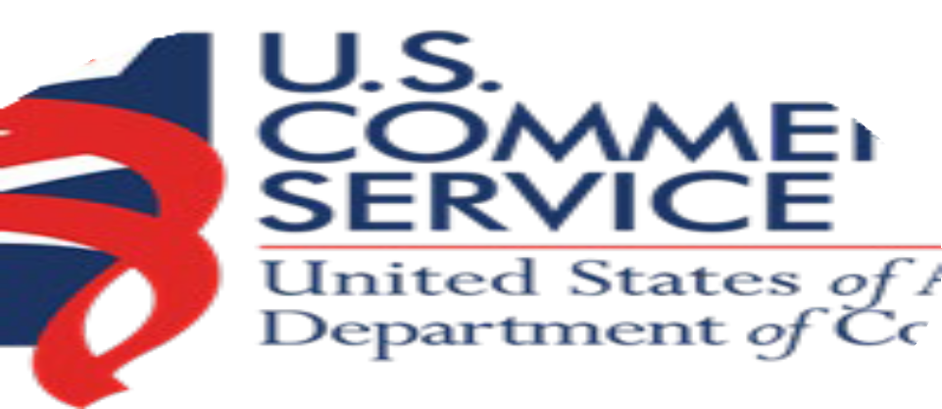

Logistics
Payment
Customer Service
Mitigation Strategies
Legal Consideration’s
10

11

Reach out to Professional Resources
DOC



Blue Tiger International


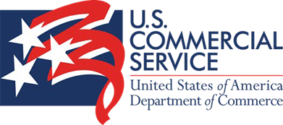
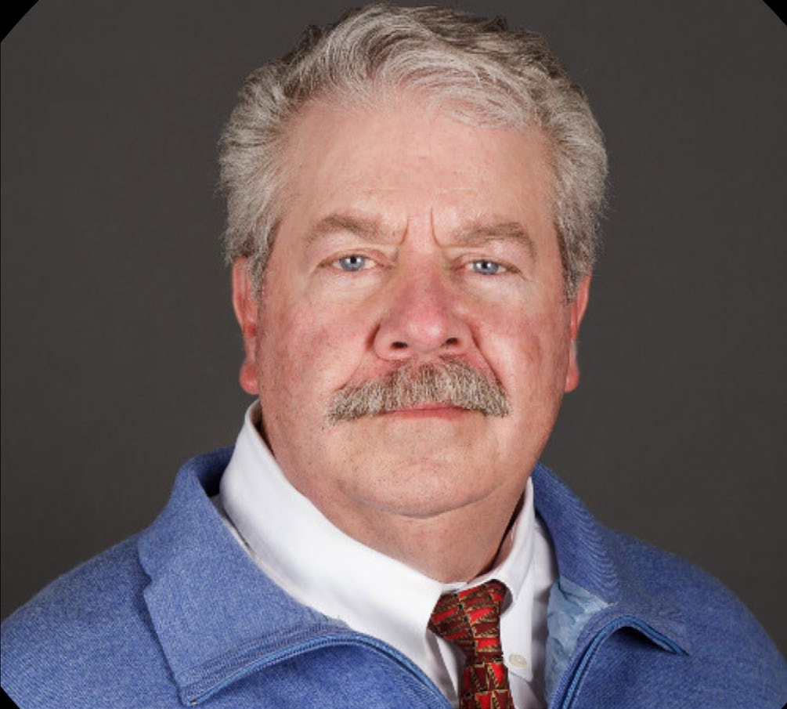


Thomas Cook

Tom is Managing Director of Blue Tiger International, (bluetigerintl.com) a premier international business consulting company on supply chain management, trade compliance, purchasing, global trade and logistics.

Tom has been involved as a consultant for numerous trade associations since 1997, where he and his team has been an integral resource to the various Association Members.

Tom was former CEO of American River International in NY and Apex Global Logistics Supply Chain Operation in LA. Tom has over 30 years’ experience in assisting companies all over the world manage their import and export operations. He is a member of the NY District Export Council, sits on the board of numerous corporations and is considered a leader in the business verticals he works in.

He has now authored over 19 books on Global Trade and is in the middle of an 8 Book Series, titled … The Global Warrior … Advancing on the Necessary Skill Sets to Compete Effectively in Global Trade.

Tom is also the Director of the National Institute of world trade (niwt.org) a 30-year-old educational and training organization, based on Long Island.

Tom is a Veteran and has set up a foundation on LI … soldieronathome.org to support Veterans in need as well as support for training specialized Dogs to treat PTSD.

Tom can be reached at tomcook@bluetigerintl.com or 516-359-6232
Blue Tiger International October 2021 12

