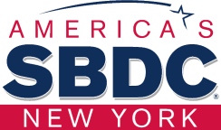

STONY BROOK SMALL BUSINESS DEVELOPMENT CENTER
Presents:

Hispanic Business Strategies Initiative
---------------------------------------------------
M/WBE Certification Bootcamp

Jacqueline R. Franco

NYS Certified Business Advisor

WELCOME

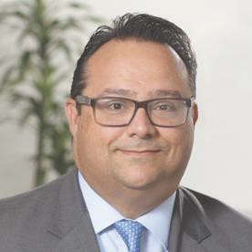
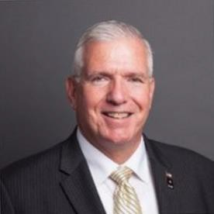
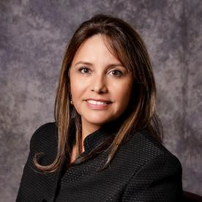
Bernie Ryba
MBA, CPA
SBDC Regional Director
Marc Perez
Long Island President Bank of America
Robert Piechota
Long Island Branch Office Manager SBA NY District Office
U.S. Small Business Administration
Jacqueline R Franco
NYS Certified Business Advisor Specializing in Marketing & Hispanic Market

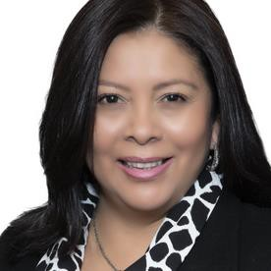
KATHERINE CORTAVARRIA
- President of Manantial Cleaning Service Inc.
- Member of HISPANIC ADVISORY BOARD IN SUFFOLK COUNTY
- DIRECTOR OF MEMBERSHIP AT SCWBEC
(Suffolk County Women Business Enterprise and Coalition)
- Member of a Smithtown Chamber of Commerce
- Member of HIA (Hauppauge Industrial Association).

Katherine Cortavarria
Manantial Cleaning Service Inc.
President
The company has the following certifications:
MINORITY AND WOMEN BUSINESS ENTERPRISE (MWBE) in
Suffolk County, Nassau County, New York State and New York City.
PORT AUTHORITY for New York State and New Jersey State.

3




Hispanic Business Strategies Initiative

M/WBE CERTIFICATION BOOTCAMP
“Latino-owned

businesses play an important role in the
U.S. economy. As the fastest growing segment of the U.S. small business ecosystem.”
LOB has grown 34% over the last 10 years compared
to just 1% for all other small businesses

BUT

This presentation is based on different researches such as: Stanford Latino Entrepreneurship Initiative, INC, Hello Alice, Intuit QuickBooks
4

Hispanic Business Strategies Initiative
M/WBE CERTIFICATION BOOTCAMP

- What does the SBDC do?
- What is the program about?

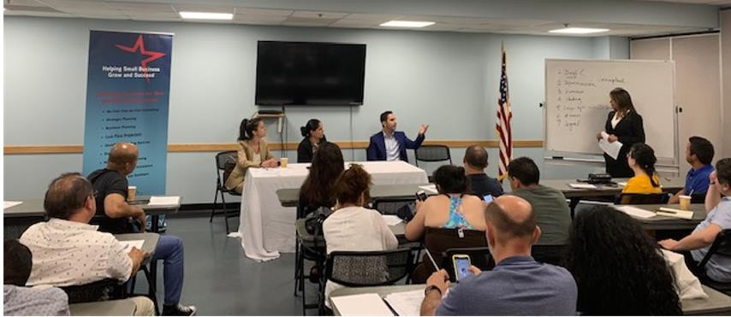
STONY BROOK SMALL BUSINESS DEVELOPMENT CENTER
By assisting new and existing business firms, the SBDC at Stony Brook contributes to the stability and growth of the small business sector and the economy of Long Island.

- Confidential & No Cost One-on-One Counseling
- Training Programs (English and Spanish)

STONY BROOK SBDC
1 Year Pandemic Overview

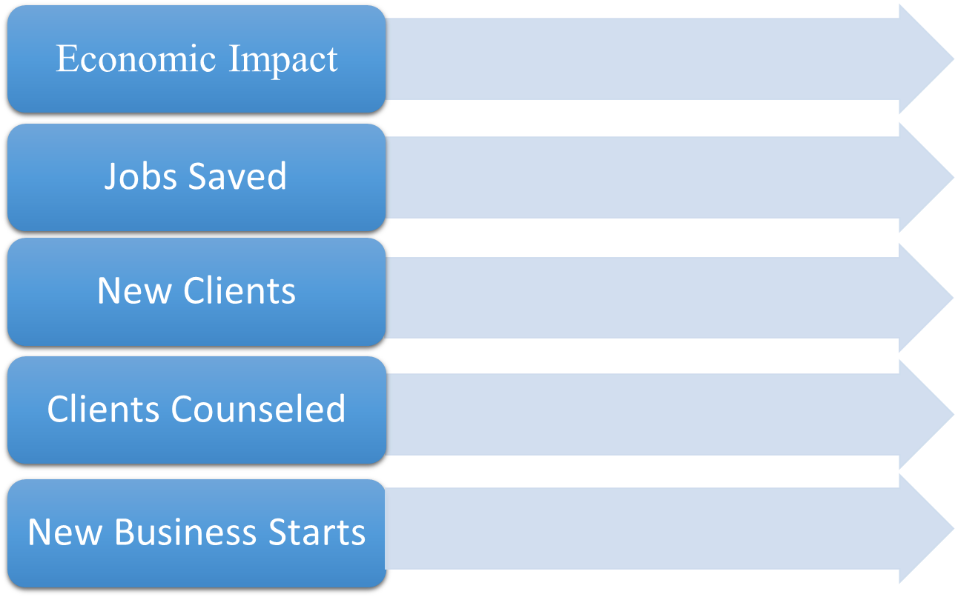
$28+ Million in Disaster Relief

1,208

785

1,676

123

M/WBE CERTIFICATION BOOTCAMP

To provide Hispanic business owners with information, guidance, network, ideas and training to help them to understand, utilize and grow their business by accessing government procurement.

What M/WBE is?
MWBE stands for Minority and Women Owned Business Enterprise.
The M/WBE Program helps minority-and women-owned businesses to grow and thrive.

Article 15-A of the Executive Law, signed into law on July 19, 1988, authorized the creation of an Office (now Division) of a Minority and Women's Business Development to promote employment and business opportunities on state contracts for minorities and women.
Under this statute, state agencies are charged with establishing employment and business participation goals for minorities and women.

MWBE Business in Nassau County, New York

According to the Nassau County Office of Minority Affairs2020 Year-End Report


- As of August 2020, Nassau County registered approximately 600 new MWBEs and SDVOBs, representing approximately 42% of newly registered companies, and 28% of companies registered and qualified to do business with the county.

- There were less than a dozen MWBE and SDVOB registered to do business with the County in 2018.
- In late 2020, OMA certified 175 companies as Nassau County MWBE.

M/WBE Businesses in New York
According to the New York State Division of Minority and Women's Business Development 2020 - 2021 Annual Report:


- At 30.51% by 2021, New York State officially surpassed the nation's top goal, 30% MWBE utilization, in economic empowerment and hiring opportunities for MWBE.
- Total number of MWBE certified companies: 9,243 companies
- Number of companies certified / renewed in 2020-21: 1395 companies

NYS MWBE Certifications in Long Island:
- MBE: 484
- WBE: 548
- MWBE: 187
- Total: 1219

NYS MWBE expenditures in Long Island: $ 460,388,513 NYC MWBE expenditures: $ 958,860,809
NYS MWBE total expenditures: $ 3,055,606,831 11

MWBE Businesses in New York

NYS MWBE Certified Businesses by
Ethnicity:
- Asian - 1501
- Black - 2298
- Native American -85
- Non-minority women – 4034
- Hispanic - 1325 Total: 9,243

Hispanic people: 62.1 million about 19% of total population
According to the New York State Division of Minority
and Women's Business Development 2020 - 2021 Annual Report:

Get certified and contracted as a M/WBE
Bootcamp

Get Certified as an M/WBE

Program Launch January 11, 2022 |  | M/WBE Certifications at Federal, State and Local Level  January 18, 2022 |  | Prepare to Apply and Certify as M / WBE January 25, 2022  - Generality of the required documents, according to each case.  - What it is, how to define and how to write the capability statement. |  | Long Island Contract Opportunities with SBDC Strategic Partners February 1, 2022  - Come and find out about current hiring opportunities on Long Island, through three of our strategic partners: Stony Brook University, Brookhaven National Laboratory, and Eversource - LI Offshore Wind Project.
- What is this program about.  - What are the topics that will be developed.  - What can you expect from it, and what are the main benefits you will get from attending. |  | - Brief description of M/WBE certifications at the federal, state, and local levels.  - Who can apply.  - What are the requirements to be eligible as an M / WBE.  - How to apply to  each certification.

Get Contracts as an M/WBE Business

How to Write a WINNING Bid Proposal April 5, 2022  - How to write a bid proposal step by step. |  | Financing for Companies with M / WBE Certification  April 12, 2022  - By La Fuerza Unida CDC, and SBA.  - Financial management techniques. |  | Bid Opportunity Day April 19, 2022  - Come and learn about current bidding opportunities directly from agencies and contractors. |  | Closure of the Program April 26, 2022  - Closing remarks and conclusion of the program




Let’s do it!

- VISION
- WILLINGNESS
- DETERMINATION
- PERSERVERANCE



Request an Appointment
Stonybrook.edu/SBDC Phone : (631) 631-9837
Email: sbdc@stonybrook.edu


Jacqueline R Franco Jacqueline.franco@stonybrook.edu 631 632 32 52

