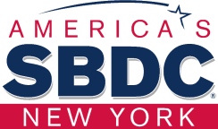

STONY BROOK SMALL BUSINESS DEVELOPMENT CENTER
Presents:

Hispanic Business Strategies Initiative
---------------------------------------------------
M/WBE Certification Bootcamp

Jacqueline R. Franco
NYS Certified Business Advisor Jacqueline.franco@stonybrook.edu

Oportunidades de contratos en Long Island con socios estratégicos del SBDC



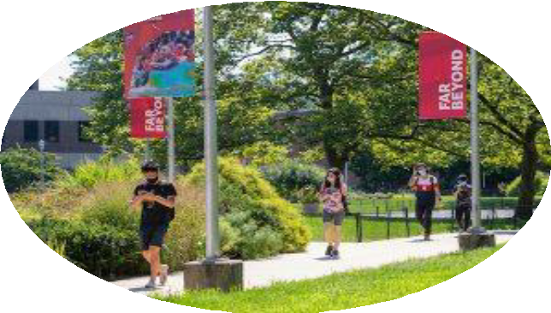

Brookhaven National Laboratory Offshore Wind US - SCD Stony Brook University

2

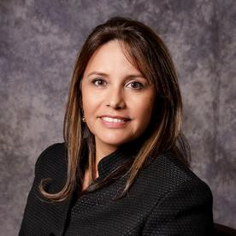


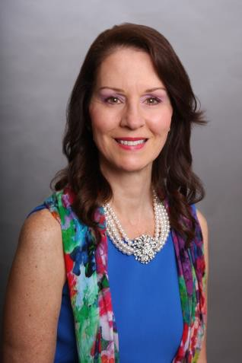
Jacqueline R Franco
NYS Certified Business Advisor Specializing in Marketing
& Hispanic Market
Mary T. Rogers
Small Business Liaison Procurement and Property Management
Division Brookhaven National Laboratory.
Ross Gould
Ross Gould
Vice President for Supply Chain
Development
The Business Network for Offshore Wind New York Office.
Maria Bracco
MWBE & SDVOB Program
Coordinator Stony Brook University
Procurement Dept.

WELCOME





SBU’s MWBE–SDVOB Program

SBU’s MWBE–SDVOB Program

For SBDC’s Hispanic Business Strategies Initiative
Presented by Maria Bracco MacArthur

MWBE Program Coordinator SBU Procurement Department

5

Contents
- Small Business Development Center Questions
- NYS Advice to MWBE Companies
- SBU Advice to MWBE Companies
- SBU’s Procurement System Overview
- Contact Information

Small Business Development Center Questions
What types of contracts does SBU offer?
Is MWBE certification required to do business at SBU?
Who is eligible to obtain that SBU certification? (If it is needed) What are the requirements?

Small Business Development Center Answers
What types of contracts does SBU offer?
SBU is a small city so we need a wide ranges of services and products.
Is MWBE certification required to do business at SBU? No, but it is very helpful. We have the discretionary authority to set aside opportunities for MWBEs.
Who is eligible to obtain that SBU certification? (If it is needed) Your company has to be at least 51% minority owned or women owned, and needs to meet the requirements of Empire State Development (including visiting your company) in order to obtain NYS certification.
What are the requirements? Please see https://esd.ny.gov/doing-business-ny/mwbe/mwbe-certification-eligibility-requirements for the details.

SBDC Questions – Continued
How long does the process to obtain certification take? How business owners can find out about available bids? What are the requirements to get contracts in SBU?
Recommendations to be successful with contracts.

SBDC Answers – Continued
How long does the process to obtain certification take? At least one year from the
time you submit all of the documents.
How business owners can find out about available bids? We will look at both SBU’s
Procurement System and New York State Contract System (NYSCS) in a short while.
What are the requirements to get contracts in SBU? The requirements are outlined in each bid, because bid is unique. There is a lot of paperwork to go through.
Recommendations to be successful with contracts. Be sure you thoroughly
understand all of the requirements before you submit a bid.

Overall NYS Advice to MWBE companies
Obtain ESD Certification if not already NYS Certified – there are
other similar certifications that can be confusing
Register with NYS Contract System - https://ny.newnycontracts.com
Get familiar with NYSCS
- Easy to use with training classes and videos
- Central Repository for all MWBE – SDVOB payments
*Be sure your email address in your account is correct!*

Overall SBU Advice to MWBE companies
https://www.stonybrook.edu/procurement

- Visit our website to register with the NYS Contract Reporter (NYSCR) and be sure to check for updates on our Procurements
- Visit our website often for updates about our bids
- Come to our Bidder’s Conferences – meet the Primes
- Send me your Capabilities Statement
- More websites: https://www.stonybrook.edu/site-directory - Contact the departments directly
- Contact SBU’s sisters on LI – Stony Brook Medicine, FSC, Old Westbury and SUNY Downstate

SBU’s Procurement System

Jaggaer Supplier Registration:
https://solutions.sciquest.com/apps/Router/SupplierLogin

Tutorial Video on registration process
https://www.youtube.com/watch?v=EPwSanSotkw

Important Links
Jaggaer Supplier Registration:
https://solutions.sciquest.com/apps/Router/SupplierLogin

Tutorial Video on registration process
https://www.youtube.com/watch?v=EPwSanSotkw

Current Bid Opportunities/Vendor Database Portal
https://www.asa.stonybrook.edu/Procurement/CurrentBidOpportunities/Vendors/Account/LogIn

New York State Contract Reporter
https://www.nyscr.ny.gov/

Questions?
Maria Bracco MacArthur - Maria.Bracco@stonybrook.edu

GRACIAS
Jacqueline R. Franco
NYS Certified Business Advisor Specializing in Marketing and Hispanic Market Jacqueline.franco@stonybrook.edu
631 632 3252

