

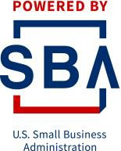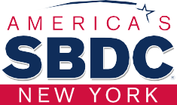
M/WBE Certification Bootcamp

Closing event

By: Jacqueline R. Franco
NYS Certified Business Advisor - SBDC Stony Brook
1

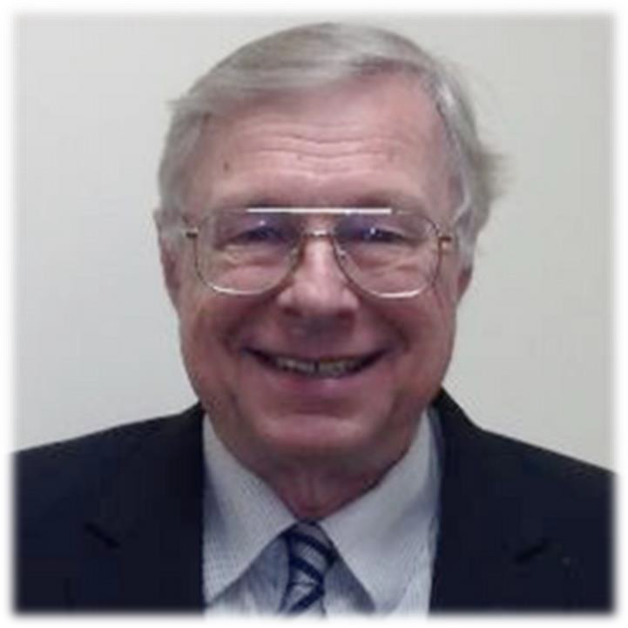

Bernie Ryba
MBA, CPA
SBDC Stony Brook Regional Director

M/WBE Certification Bootcamp 2022
2

Thank you!

To our sponsor Bank of America for your generous contribution.
With your help we have achieved our goal of providing Hispanic small business owners with information, guidance, network, ideas, and training to learn how to grow their business through M/WBE contracts

3

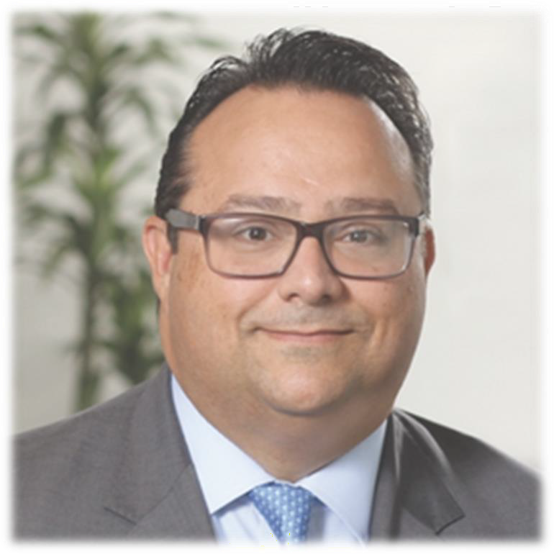

Marc Perez
Long Island President
Bank of America

M/WBE Certification Bootcamp 2022
4

VIDEOS HERE: https://www.stonybrook.edu/commcms/sbdc/en-espanol/Entrenamientos

HOW TO GET M/WBE CERTIFICATIONS

HOW TO GET CONTRACTS AS M/WBE

Long Island – Business Opportunities
- Brookhaven National Laboratory
- Supply Chain Development
- Stony Brook University
Bid Opportunities Day
- Stony Brook University Bid Opportunities and how to get them
- How to get contracts in Nassau County
Hot bids
- SBTRC: Federal, state, and local bids in transportación.








  - Description of federal, NYS, NYC,
and local certifications
  - How to get each certification
  - How to make a profesional Capability statement
Jacqueline R Franco
Stony Brook University/ SBDC

- Opeining
- Statistics
- WBE Success story
  - Access to capital – La Fuerza CDC
  - SBA’s Programs
  - Financial Management - Tips

- Learning about RFP, RPQ, RFI, IFB, LOI, and OP
- How to bid step by step
5
- How to write an effective and winning proposal

Our outstanding results!
8 singular presentations
11 amazing speakers – Key partners Over 500 registered people
Over 250 attendees
Intense counseling – Average 4 people per day Around 30 started certification process – Getting ready
NYS DBE and MBE received!!!!!

6

Thank you!
To our special guests for your participation and support:

Legislator Samuel Gonzalez
Olga El Sehami, Director Suffolk County HR
Amani Hosein, Legislative Aide-Town of Brookhaven Angel Rivera, Outreach Director – Phil Boyle NYS Senate Jonathan Kornreich, Councilmember Town of Brookhaven Luis Vasquez, President LIHCC
Luis Lino, President PACCLI

7

Thank you!

To all our speakers for the wonderful presentations

8

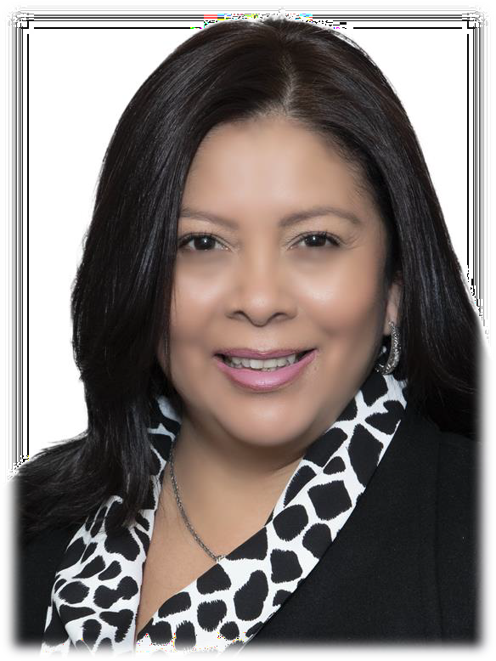

Katherine Cortavarria
President
Manantial Cleaning Services, Inc. Certified M/WBE in NYS, NYC, PANYNJ, Suffolk and Nassau County.

M/WBE Certification Bootcamp 2022
9

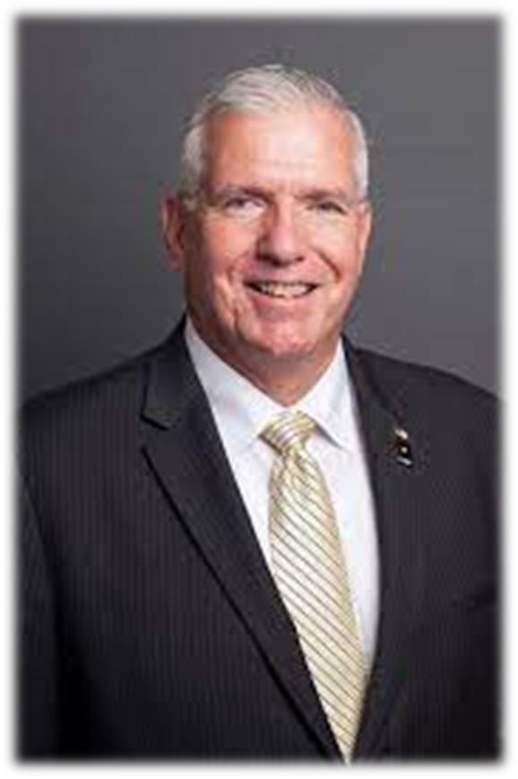

Robert J. Piechota
Long Island Branch Office Manager-SBA NY
District Office
U.S. Small Business Administration

M/WBE Certification Bootcamp 2022
10

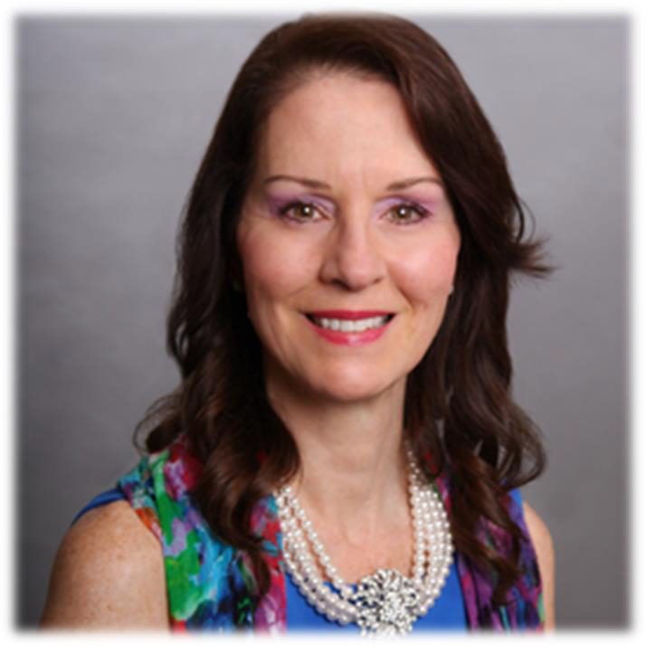

Maria J. Bracco
MWBE & SDVOB Program Coordinator
Stony Brook University Procurement Dept.

M/WBE Certification Bootcamp 2022
11



Mary Rogers
Small Business Liaison Procurement and Property Management Division Brookhaven National Laboratory

M/WBE Certification Bootcamp 2022
12

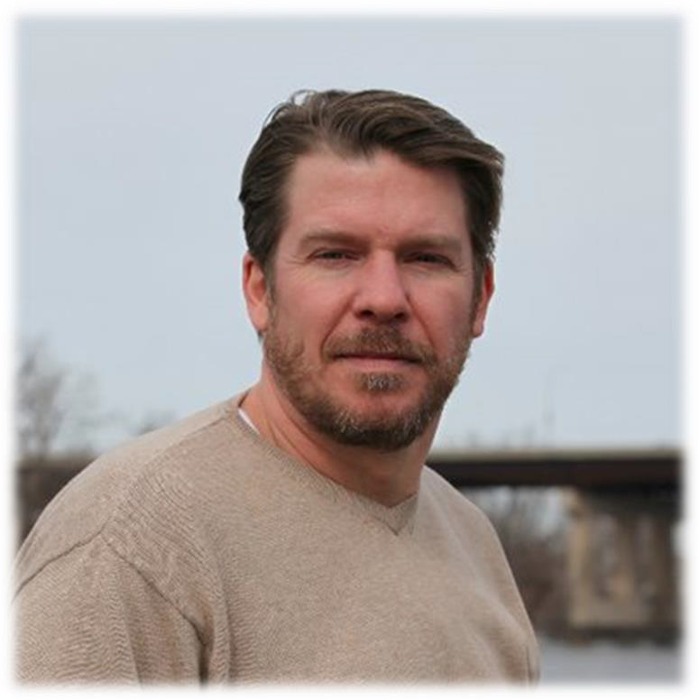

Ross Gould
Vice President for Supply Chain Development The Business Network for Offshore Wind New York Office

M/WBE Certification Bootcamp 2022
13

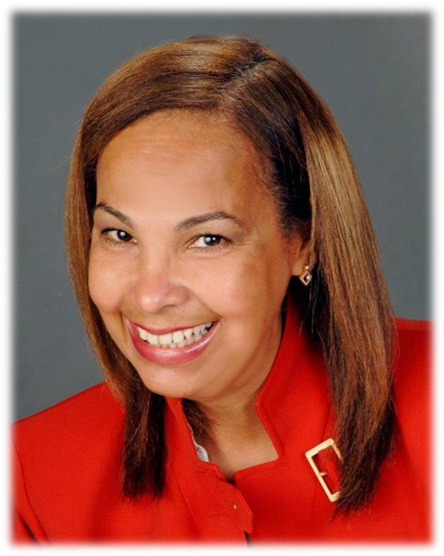

Grace Ioannidis
Director Suffolk County Executive’s Office of Women’s Services
Suffolk County Minority-Women Owned Business Enterprise, Executive Analyst
Suffolk County Wide Language Access Coordinator
Suffolk County Executive’s Task Force to Prevent Family Violence, Co-Chair Human Trafficking Sub-Committee, Chair

M/WBE Certification Bootcamp 2022
14

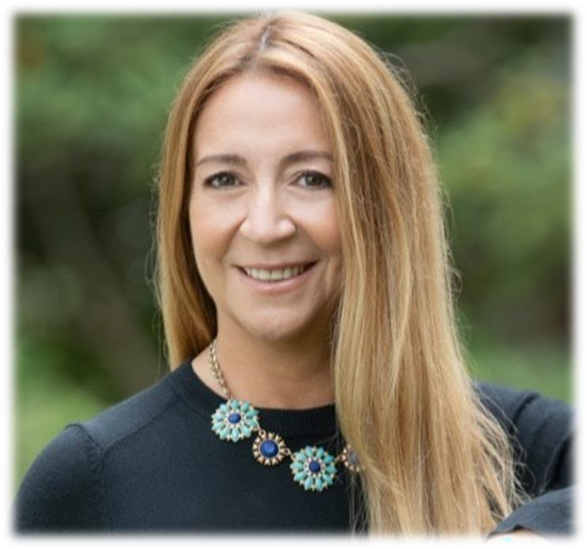

Giovana Bracchi
Executive Director La Fuerza CDC
A Community Development Financial Institution

M/WBE Certification Bootcamp 2022
15

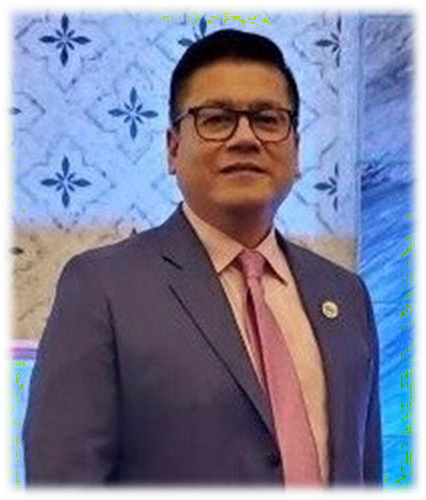

Samuel Ballena, Jr.
Outreach & Marketing Specialist SBA Long Island Branch Office

M/WBE Certification Bootcamp 2022
16

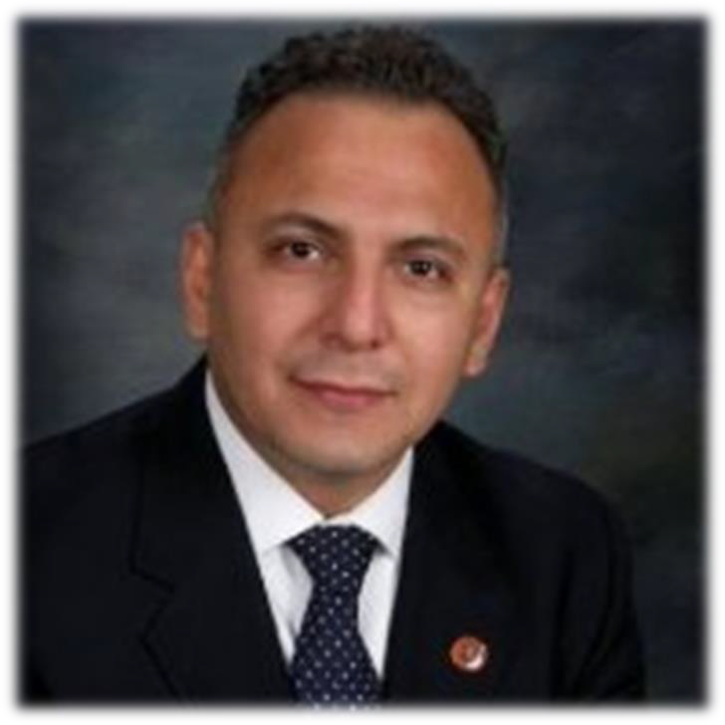

Herb Flores
Director Nassau County Office of Hispanic Affairs

M/WBE Certification Bootcamp 2022
17

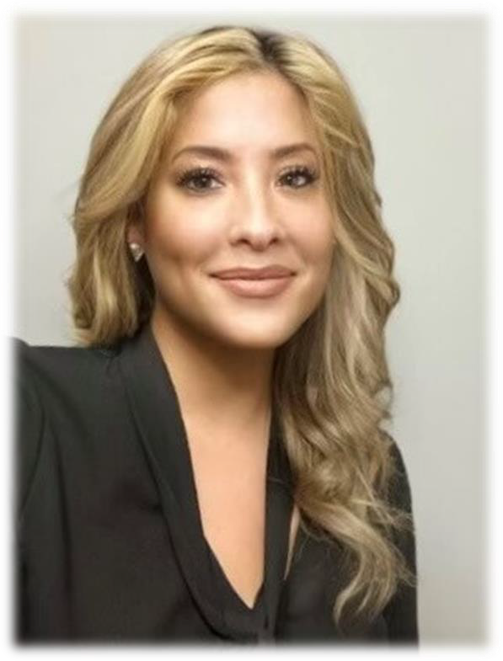

Melissa R. Figueroa
Deputy Director Nassau County
Office of Minority Affairs

M/WBE Certification Bootcamp 2022
18

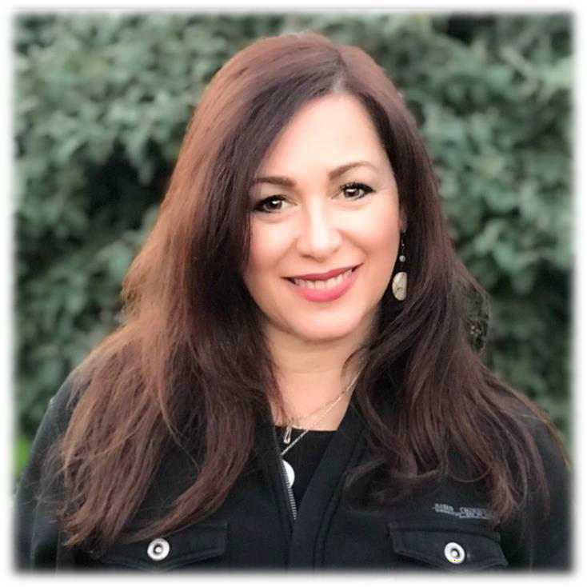

Lizbeth Rodriguez
Northeast Region Director Small Business Transportation Resource Center
Office of Small and Disadvantaged Business Utilization

M/WBE Certification Bootcamp 2022
19

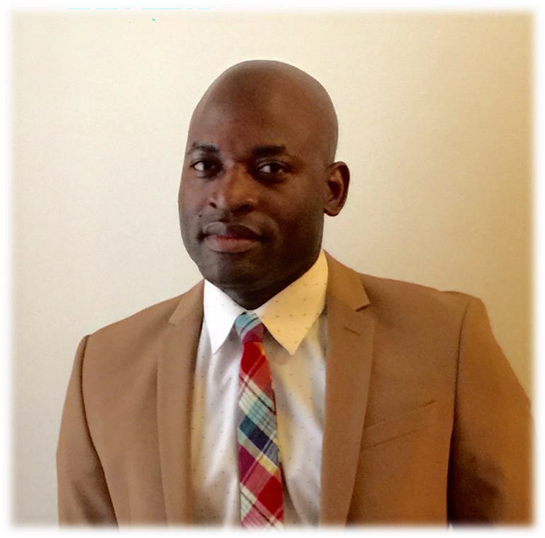

Donignon Soro
Business Development Unit
Division of Minority and Women’s Business Development
Empire State Development
For your guidance and support in getting certified

M/WBE Certification Bootcamp 2022
20

Thank you!

For your help throughout the entire program:
Martha M. Stansbury | Center Administrator, SBDC Stony Brook Clifford Chandler Jr. | Business Assistant, SBDC Stony Brook Marvin Vasquez | Digital Marketing Director, Multimarketing USA

21

THANK YOU ALL
Jacqueline R. Franco
NYS Certified Business Advisor
Specializing in Marketing and Hispanic Market
Jacqueline.franco@stonybrook.edu 631 632 3252

SBDC STONY BROOK

22

