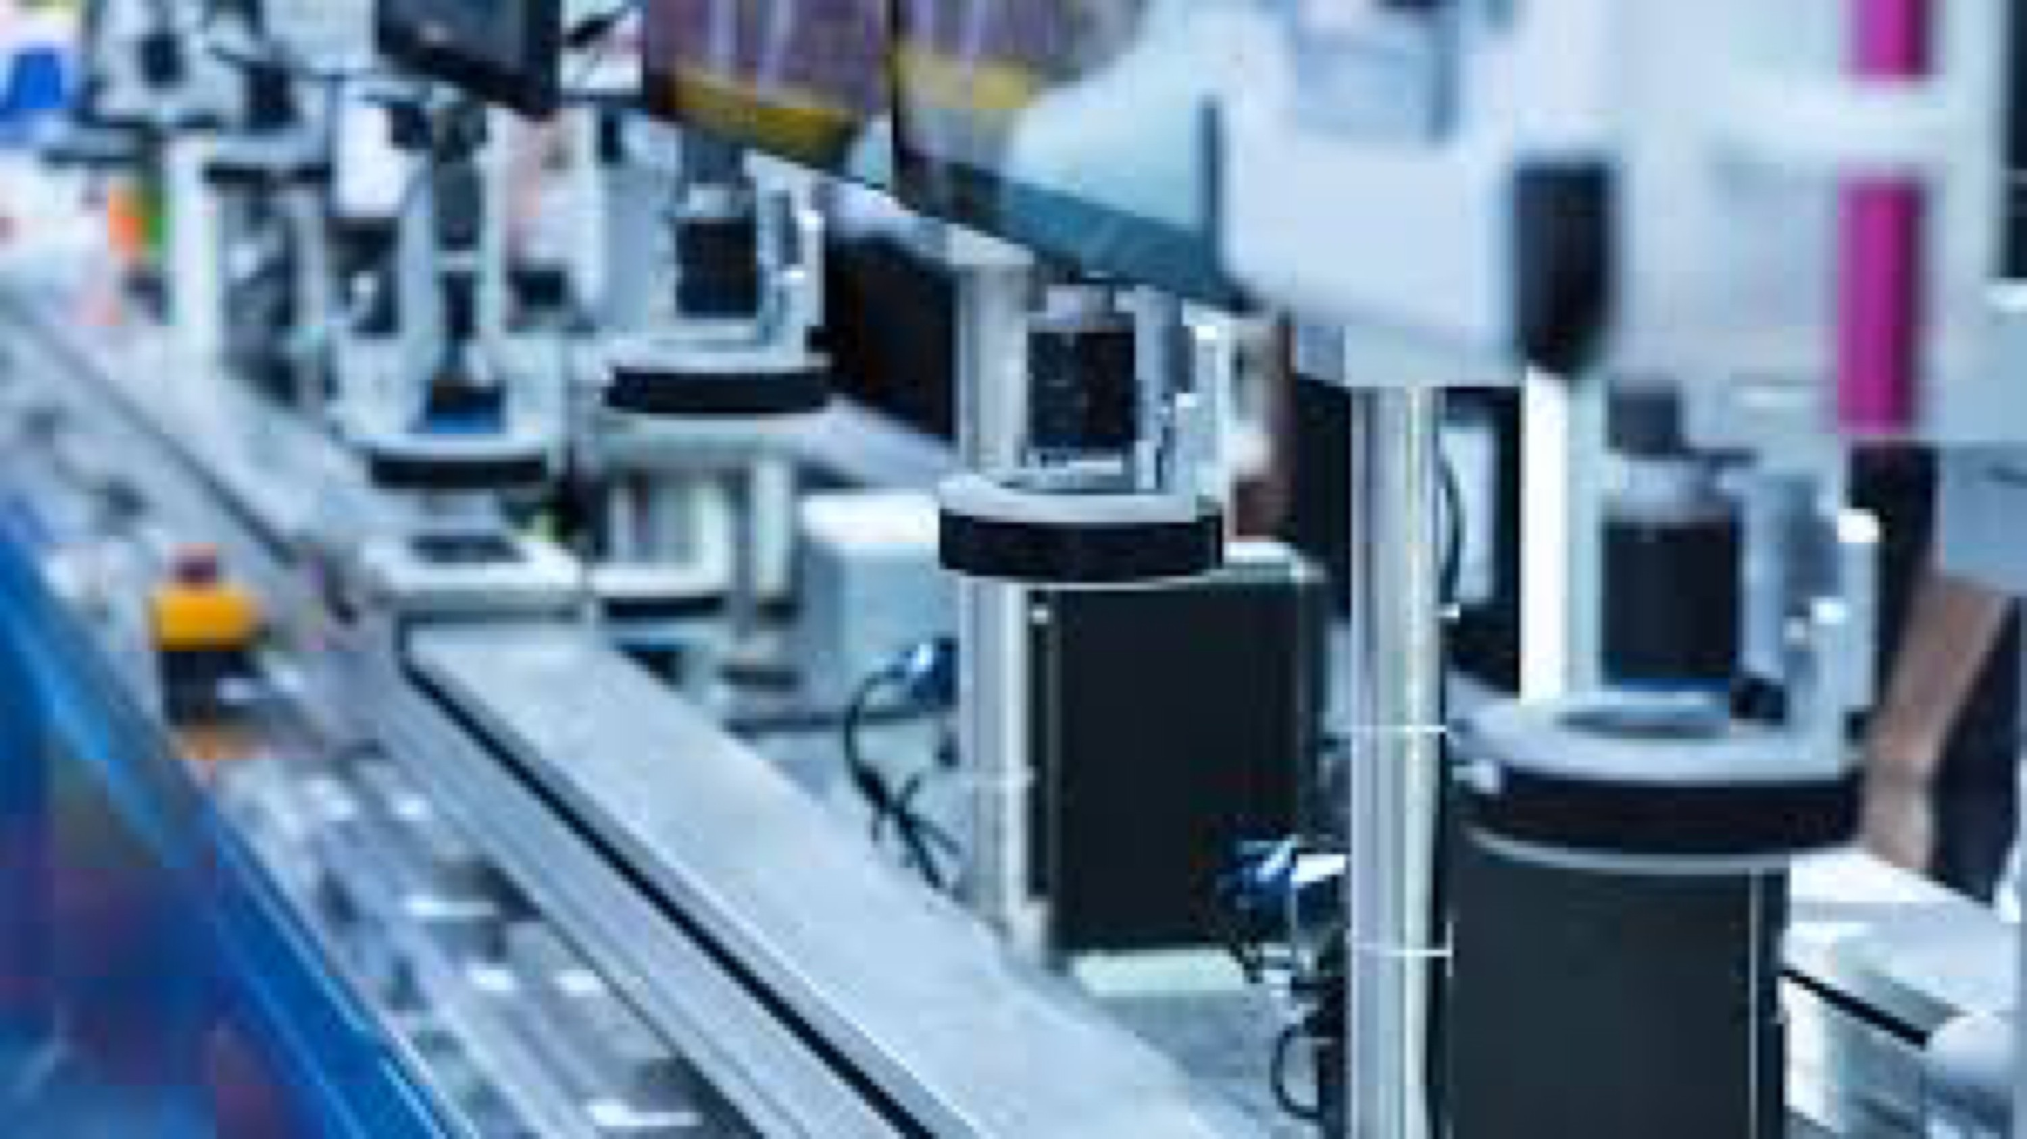


Long Island Manufacturing Day 2020



We Thank Our Sponsors


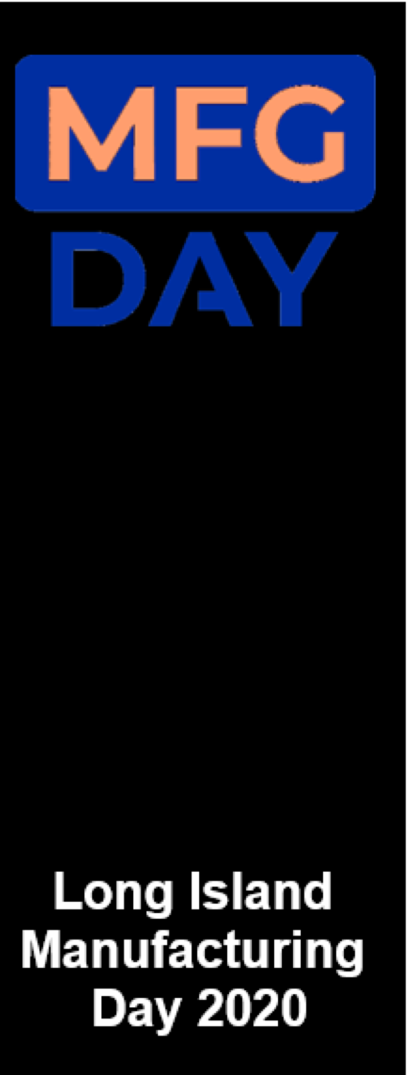
Keynote Speakers

- Ron Loveland, Co-Chair, HIA-LI Manufacturing Committee

- Anne Shybunko Moore, President, GSE Dynamics

- Bob Botticelli, Chairman, ADDAPT

- Terri Alessi-Miceli, President, Hauppauge Industrial Association-Long Island

Panel of Recent Grads working in Manufacturing

Moderator - Patrick Boyle, Director, Ignite LI, Manufacturing Consortium Long Island

- Joseph Valenti-Farmingdale grad, Quality Engineer, Natech Plastics;
- Angela Schuler, Application Engineer, Precipart;
- Kumar Persaud, Process Engineer, Chromalloy;
- Agranya Jampala, SnappyXO
- Megan Dechello, Natach
- Alexis Menke, Production Manager, Broadridge



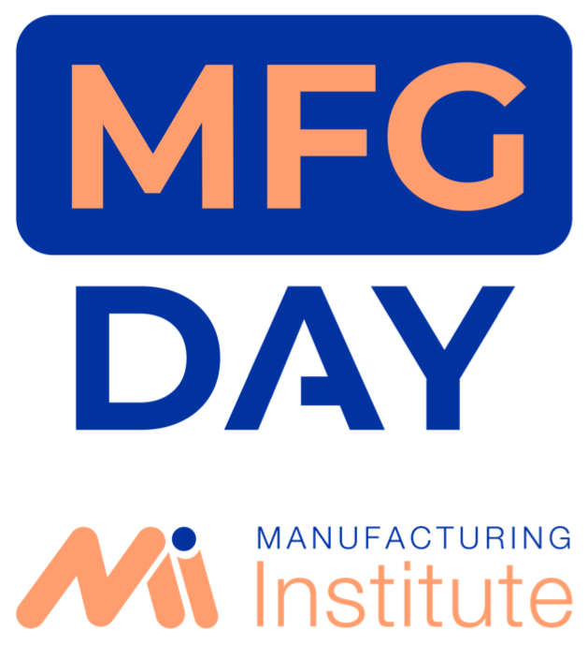
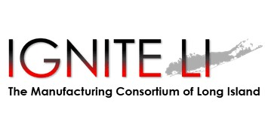
MFGDAY 2020
RECENT GRADS IN MANUFACTURING
Hosted by Patrick Boyle Executive Director

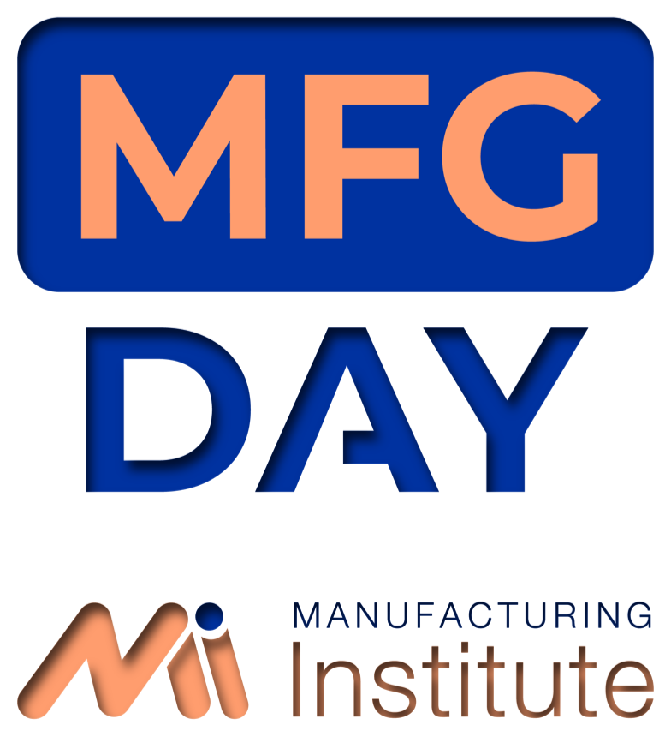
- Meghan DeChello- Natech Plastics
- Agranya Jampala- Mechanismic
- Alexis Menke- Broadridge Financial Solutions
- Kumar Persaud- Chromalloy
- Joeseph Valenti- Natech Plastics
- Angela Schuler, Precipart

PANELISTS

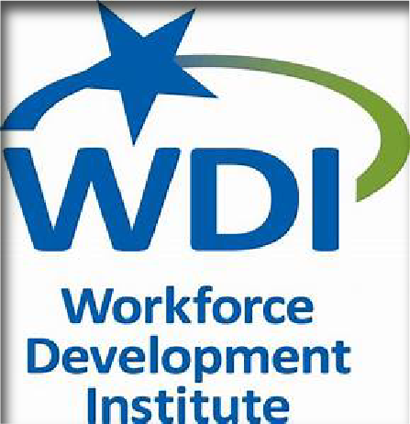
Between 2017 2019, the region’s manufacturers posted between 15,000 and 20,000 job openings online, equivalent to 7.4% of all job openings on Long Island despite representing around 5% of the region’s employment. This data teaches us that we have a complicated mix of retirements, resignations, and separations happening simultaneously with job growth, promotions, relocations, and replacement hires.
A significant percentage of Long Island’s manufacturers are hiring, whether to remain “workforce neutral” or to support growth brought about by their innovations and efficiencies. These manufacturers have reported consistently to WDI and others that, while they are eager to hire graduates from the Island’s technical and production programs, they are hungry for more workers at entry, middle, and upper level positions.

- 7,642 Job Openings (Oct 2018 to Sept 2019) went unanswered

2019 LONG ISLAND MANUFACTURING SNAPSHOT
PREPARED BY THE WORKFORCE DEVELOPMENT INSTITUTE



LONG ISLAND’S MANUFACTURING INDUSTRIES NEED YOU!


  - SBU Bachelor of Arts- Applied Mathematics and Statistics
  - SBU- Bachelor of Engineering- Chemical and Molecular Engineering
  - Research Assistant- Green Polymer & Process Lab
  - Quality Engineering Intern- Natech Plastics
  - Application Engineer- Natech

MEGHAN DECHELLO

APPLICATION ENGINEER
NATECH PLASTICS


  - Pune Vidhyarthi Griha’s College of Engineering & Technology
  - Stony Brook University- Master of Science, Mechanical Engineering
  - Computer Aided Design Innovation Lab- Stony Brook University
  - Research Assistant- Stony Brook University
  - Entreprenuerial Lead- SnappyXO Design
  - Chief Operations Officer- Mechanismic

AGRANYA JAMPALA

CHIEF OPERATIONS OFFICER & ENGINEERING LEAD MECHANISMIC

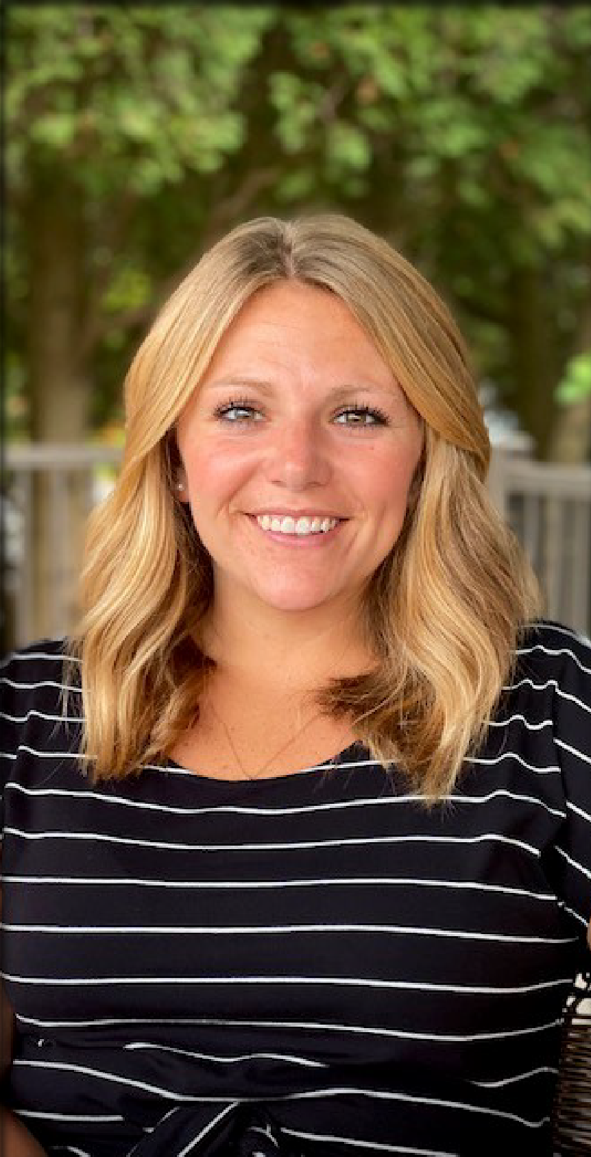

  - Farmingdale State Unicersity- Bachelors Degree, Business Administration and Management
  - National University of Ireland, Galway- J.E. Cairnes School of Business & Economics
  - ViaTech Publishing Solutions, Inc.- Account Manager

ALEXIS MENKE

MANAGER
BROADRIDGE FINANCIAL SOLUTIONS

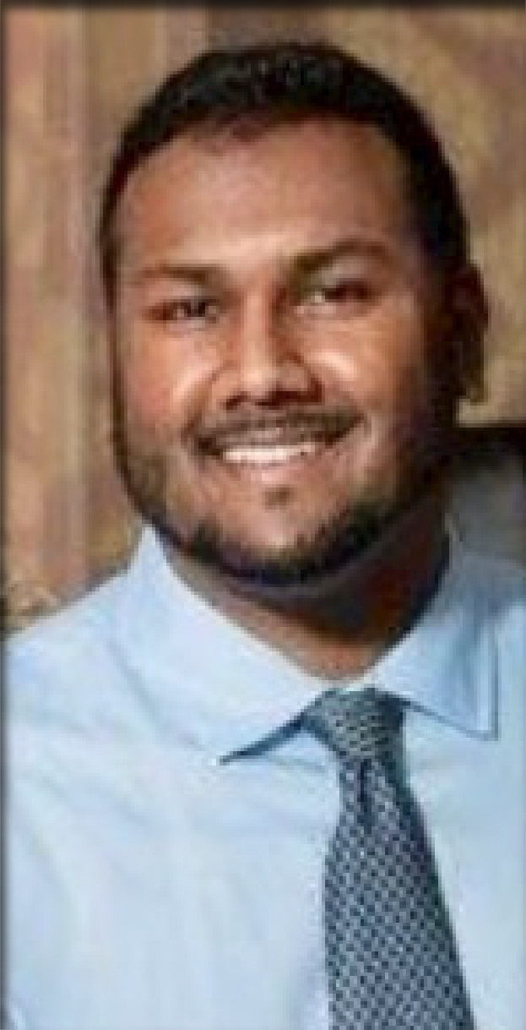
  - SBU- Bachelor of Engineering (B.E.) Engineering Science
  - Process Engineer- Chromalloy
  - Engineering Team Leader- Chromalloy
  - Subject Matter Expert: Precious Metals and Diffusion Coatings- Chromalloy
  - Senior Engineering Leader- Chromalloy

KUMAR PERSAUD

SENIOR ENGINEERING LEADER
CHROMALLOY


  - Bachelor’s Degree, Mechanical Engineering Technology-Farmingdale State College
  - Bachelor’s Degree, Electrical Engineering Technology
  - Mechanical Engineering Intern- Brookhaven National Lab
  - Mechanical Engineer- AMP Design Solutions
  - Research & Development- Farmingdale State College
  - Senior Application Engineer & Additive Manufacturing Manager- JAD Specialty
  - Adjunct Professor- Farmingdale State College
  - Quality Engineer- Natech Plastics

JOSEPH VALENTI

QUALITY ENGINEER
NATECH PLASTICS

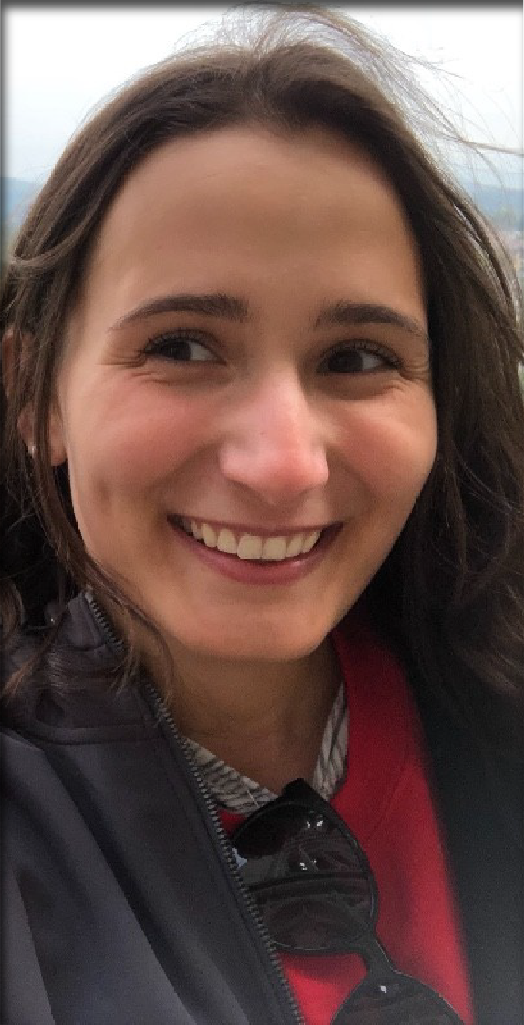
  - SBU- Bachelor of Engineering- BE Mechanical Engineering
  - University at Buffalo- Master of Engineering-Meng, Engineering/Industrial Management
  - Brookhaven National Laboratory- Mechanical Engineering Intern

ANGELA SCHULER

APPLICATION ENGINEER
PRECIPART

“We need to invest in our workforce if we want to maintain our competitive edge. It is increasingly difficult to recruit and retain top talent, particularly among millennials, because of the high cost of living on Long Island. This is one reason why we offer company internships, participate in engineering co-op programs with local universities, and support STEM programs at local schools and organizations.”

-JON COOPER, PRESIDENT, SPECTRONICS CORPORATION

- What advice do you have for students listening in?

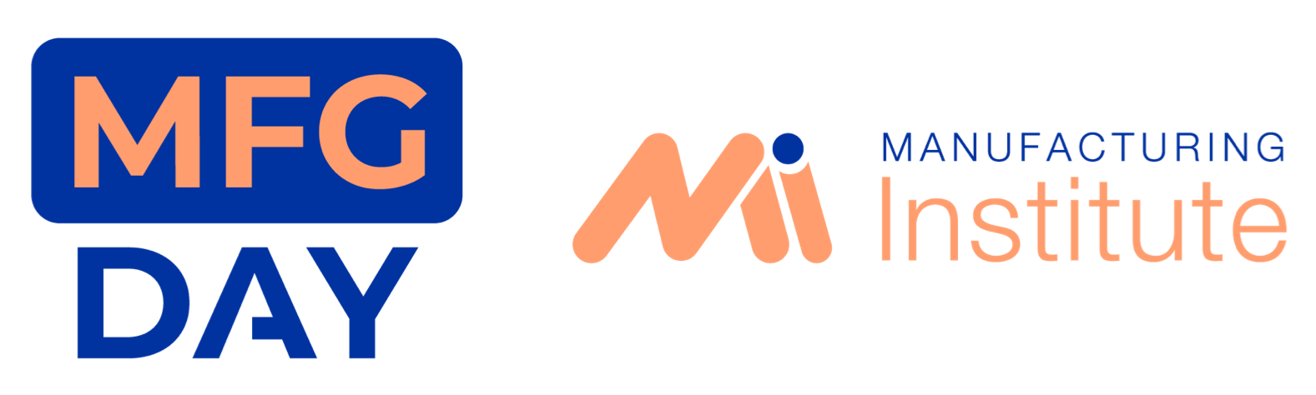
- What topics should we be covering in education to produce the next generation of manufacturers so that Long Island is globally competitive?

- What do Manufacturers have to do to attract young and talented workers like yourselves?

QUESTIONS

Long Island Manufacturers Virtual Tours

Moderator - Bob Harrison, Stony Brook Small Business Development Centre

Audience is asked to take the next 30 minutes to choose virtual tour videos of manufacturers to view at this YouTube channel: https://www.youtube.com/playlist?list=PLzCeJnfSOJ4fUWLv7x9syeK2gA1nF4nV W


Return to the Zoom meeting at 10:00 for a live panel discussion with Long Island Manufacturing Executives https://stonybrook.zoom.us/j/92781958326?pwd=NFNLbXNrYnVoQzRxMDJZZXY zdEp1Zz09
Meeting ID: 927 8195 8326
Passcode: 833581

Q&A Discussion with Long Island Manufacturing Executives

Moderator - John Giordano, Citrin Cooperman CPAs





Q&A Discussion with Long Island Manufacturing Executives

Manufacturing Executives
Moderator:John Giordano, Citrin Cooperman CPAs | Contract Pharmacal Corp, Jeff Reingold
Applied DNA Sciences, Judy Murrah | Designatronics, Robert Kufner
Brookhaven National Lab, Ken White | East/West Industries, Joe Spinoza/Teresa Ferraro
ClearVision Optical, Maddy Moeller | Estee Lauder, Lauren Kleinbaum
Control Electropolishing, Lina DeLaCruz | Exergy, Bob Botticelli
GSE, Anne Shybunko Moore | Mill-Max, Christopher Galasso
Natech Plastics, Jennifer Nagler | Oerlikon Metco, Ed Sottile/Jose Medina
Orics, Ori Cohen | Roman Stone, Tom Montalbine
Thuro Metals, David Thuro | Soter Technologies, Derek Peterson

LI Manufacturers making COVID19 Mitigation Products

Moderator - Ron Loveland, President, Summit Safety & Efficiency

Applied DNA | Judy Murrah | Vaccine, Diagnostic Kits, Testing
Brite Frames | Ian McCarthy | Plastic Barriers/Sneeze Guards
East/West Industries | Joe Spinoza | Masks
Orics | Ori Cohen | Ventilators
Soter Technologies | Derek Peterson | Body Scanners

LI Educational Institutions with Manufacturing Curricula

Moderator - Dr. Subrina Oliver, CEO, O-High Technologies

Suffolk County Community College Laura Galletta
Hofstra University Phil Coniglio

Stony Brook University Stony Brook University
Vinnie Accardi Maria Sicari

Farmingdale University Farmingdale University
Hazem Tawfik Jeff Hung

Vaughn College of Aeronautics and Technology
Manuel Jesus

Robotics Camp & MTRC Resources

Cynthia Colon, Manufacturing Technology Resource Center Ameya Kale, Manufacturing Technology Resource Center




Wrap Up

Rob Grote, Partner, Manufacturing & Distribution, Grassi CPAs Lisa Strahs-Lorenc, President and Owner, Go Career Compass




H"-U,,AUCil INDUIHIAl AUOCIArlOfl I A'IIO
HIA-LI


The Manufacturing CoMortlum of long Island
Manufacturing and Technology Resource Consortium (MTRC)

' AT STONY BROOK UNIVERSITY

New York City - Long Island Chapter
'' UStrou:nvyerBs1:0tyok
��DDAPT

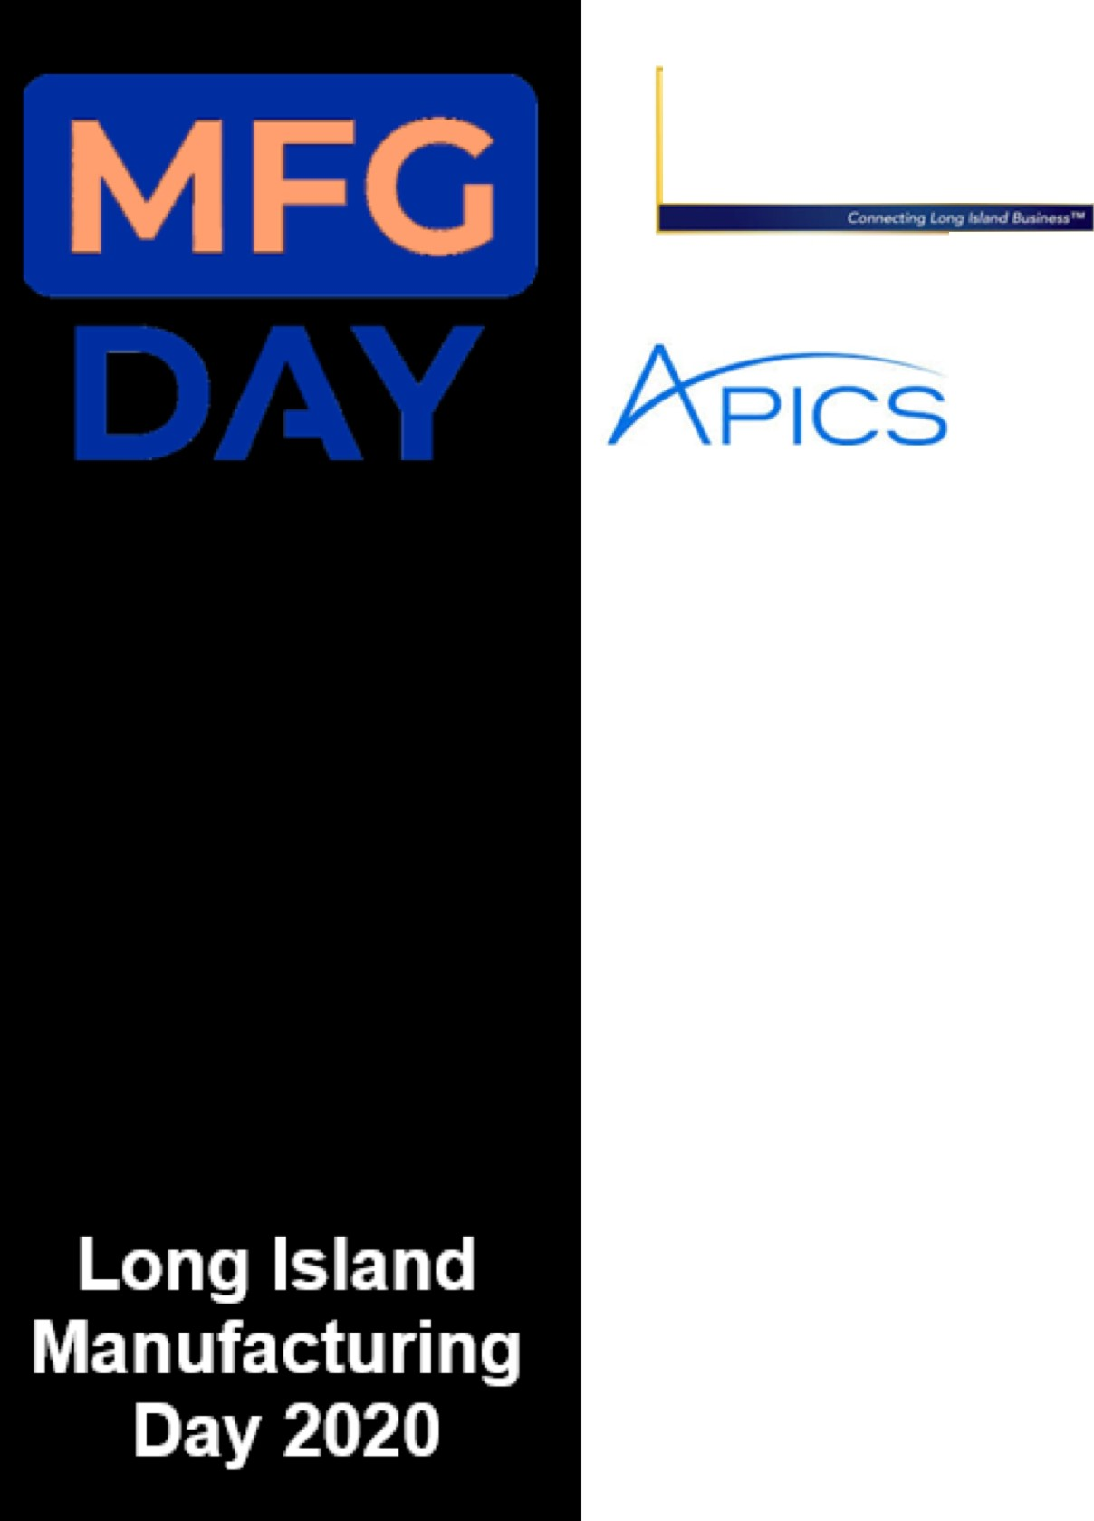


CITRIN COOPERMAN
Accountants and Advisors


�

T E CH NO L O GI E_S gl LC
Hi h

ADVISORS & ACCOUNTANTS

A United Nations Federal Credit Union owned company

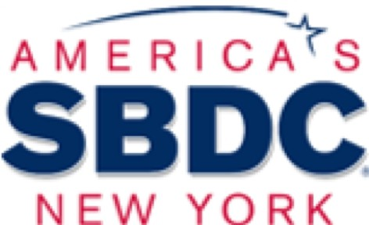
_r� GO CAREER
GRASSI
@:�:.�iii+
� COMPASS

MFG


Long Island
Manufacturing

Day 2020

