Legislative & Regulatory Update

For Small Business Government Contracting Programs

FY22 Wrapup

Legislative Action

National Defense Authorization Act for Fiscal Year 2022
Pub. Law 117-81, signed by the President on 12/27/21
Sect. 861 - Keeps the Miller Act threshold for bonding protection for small-business subcontractors on construction projects at its present level, instead of raising it for inflation.
Sect. 863 - Requires update to SAM.gov for small business status changes and notification to agencies where the firm has a pending offer, if the change would affect eligibility.
Sect. 864 - Gives OHA jurisdiction over HUBZone appeals.
Sect. 866 - Requires DoD report on CMMC effects on small business.

SBIR and STTR Extension Act of 2022
Pub. Law 117-183, signed by the President on 9/30/22
- Extends the SBIR and STTR programs into FY 2025
- Businesses must disclose foreign ties
- Requires each agency to establish a Due Diligence Program on foreign influence
- Requires the Secretary of Defense to establish an Innovation Open Topics Program
- Increases Minimum Performance Standards

The Price Act
Promoting Rigorous and Innovative Cost Efficiencies for Federal Procurement and Acquisitions Act of 2021
Pub. Law 117-88, signed by the President on 2/22/22
- DHS operates a Procurement Innovation Lab aimed at experimenting with
innovative acquisition techniques
- Directs DHS to issue an annual report on innovative procurement techniques, including those used to meet small-business goals.
  - Sunsets after 3 years
- Requires OMB to convene the CAO Council to examine best practices in acquisition innovation, including in contracting with small businesses
  - CAO Council may form a working group to address
  - CAO Council (or the working group) must issue a report on innovative acquisition techniques that lead to meeting or exceeding small-business goals

House version of NDAA FY23 – Passed House
H.R. 7900, passed House on 7/14/22
- Delay SD/VOSB certification transfer to 2024
- Apply HUBZone price preference to unrestricted orders
- Codify SBA scorecard and add set-aside data
- Require more detailed analysis for nonmanufacturer rule waivers
- Would give qualified 8(a) firms an additional program year
- Raise sole-source threshold to $8 mil ($10 mil for manufacturing)
- Interim partial payments on requests for equitable adjustment
- Require Congressional reports on consolidated contracts and
SBA’s WOSB program

Passed the House; Sent to Senate
- H.R. 7670, the Women-Owned Small Business Program Transparency Act, would require SBA to issue an annual report on the WOSB Program.
- H.R. 5879, the Hubzone Price Evaluation Preference Clarification Act of 2021, would extend the HUBZone price evaluation preference to unrestricted task orders.
- H.R. 7694, the Strengthening Subcontracting for Small Businesses Act of 2022, would require agencies to, when awarding a contracting with subcontracting opportunities, use evaluation factors for subcontracting plans and prior small-business subcontracting.

Introduced in the House and Senate
- H.R. 8079/S. 4413 – “Small Business Contracting Fairness Act of 2022” would apply SBA’s existing size standards to the IIJA’s DBE program, thereby eliminating the $26.29mil maximum size standard in DBE.

Introduced in the House
- H.R. 4697, to strike section 8(a)(11), which is the basis of bona-fide-place-of-business rule in the 8(a) program
  - SBA has temporarily waived the requirement through Sept. 30, 2023: SBA Announces
Moratorium on Bona Fide Place of Business Requirements for the 8(a) Business Development Program
- H.R. 6347, Military Spouse Entrepreneurs Act of 2021 – to establish a 5-year pilot procurement program for small businesses owned and controlled by military spouses, with a 5% goal
- H.R. 6504, Native Pacific Islanders of America Equity Act - to define a Native CHamoru Organizations as a nonprofit corporation owned by Guam natives or direct ancestors, define Native Northern Marianas Organizations, and give both such organizations the same treatment as Native Hawaiian Organizations for SDB and HUBZone eligibility.
- H.R. 6923, the Accelerating Small Business Growth Act - create a grant program to help transportation agencies carry out innovative programs to

Introduced in the House
- H.R. 7628, IMPROVE the SBA Act would
  - mandate annual testimony from SBA’s GCBD,
  - require agencies to allocate small-business-contract credit to no more than one socioeconomic category,
  - create a confidential questionnaire for first-tier small business subcontractors, and
  - require that a contractor’s failure to submit timely subcontracting reports result in a
negative effect on past performance
- H.R. 7685, the Truth in Small Business Contracting Credit Act, would restrict small-business goaling credit so a contract would apply only for one socioeconomic category (e.g., SDB but not WOSB)
- H.R. 8273, Small Business Payment for Performance Act, would require agencies to make partial payment on requests for equitable adjustment on a small-business construction contract, upon receipt of the request

Introduced in the House
- H.R. 8942 - To extend the transfer date for the verification of small business concerns owned and controlled by veterans or service-disabled veterans to the Small Business Administration.
- H.R. 8941 – Allows SBA to recommend alternative procurement methods for
agency head, and make agency head’s decision non-delegable.

Introduced in the Senate
  - S. 3928, the Accelerating Small Business Growth Act - create a DOT grant program ($20mil over four years) to fund programs for SDBs to compete for contracts and subcontracts funded by DOT financial assistance.
  - S. 3929, the Disadvantaged Business Enterprise Supportive Services Expansion Act – raise the funding cap for FHWA supportive services program, and provide for supportive services programs at FTA and FAA
  - S.5044, Federal Contracting Fairness Act – covers 8(a) and small business
programs
    - Extend 8(a) participation period, and add ramp-up and transition periods
    - Add SBA to FAR Council
    - Raise sole-source thresholds to $10mil for most contracts (higher for R&D, mentor-
protégé participants, subcontracting in HBCU/MSI, manufacturing)
    - No restriction on number of protégés in mentor-protégé program
    - Streamline 8(a) certification and annual reviews

Passed House and Senate – in conference
  - H.R. 4521, America COMPETES Act of 2022
    - Sect. 50101 – would require one-third small-business purchasing for certain items from frontline operational components (TSA, Secret Service, FEMA, and others)
    - Sect. 50103 – would create a DHS mentor-protégé program for small businesses, HBCUs, and MSIs.
    - Sect. 61007 – would include small-business contracting percentage in
the annual report of the Defense Production Act Fund

Executive Action

OMB Memorandum: Advancing Equity in Procurement
M-22-03, Dec. 2, 2021 – implementing Executive Order 13985
- Raises governmentwide SDB contracting goal to 11% for FY22, on the way to 15% by 2025.
- Implements major changes to Category Management.
  - automatic Tier 2 credit for socioeconomic small businesses (SDB, WOSB, HUBZone,
SDVOSB)
  - reinforced importance of small-business goal achievements
  - making SBA and Dept. of Commerce voting members on the Category Management Leadership Council.
- Seeks to increase new entrants and reverse the decline in the small business supplier base.
- Makes Federal senior managers accountable for small business contracting goals.
- Ensures OSDBUs have access to senior leadership

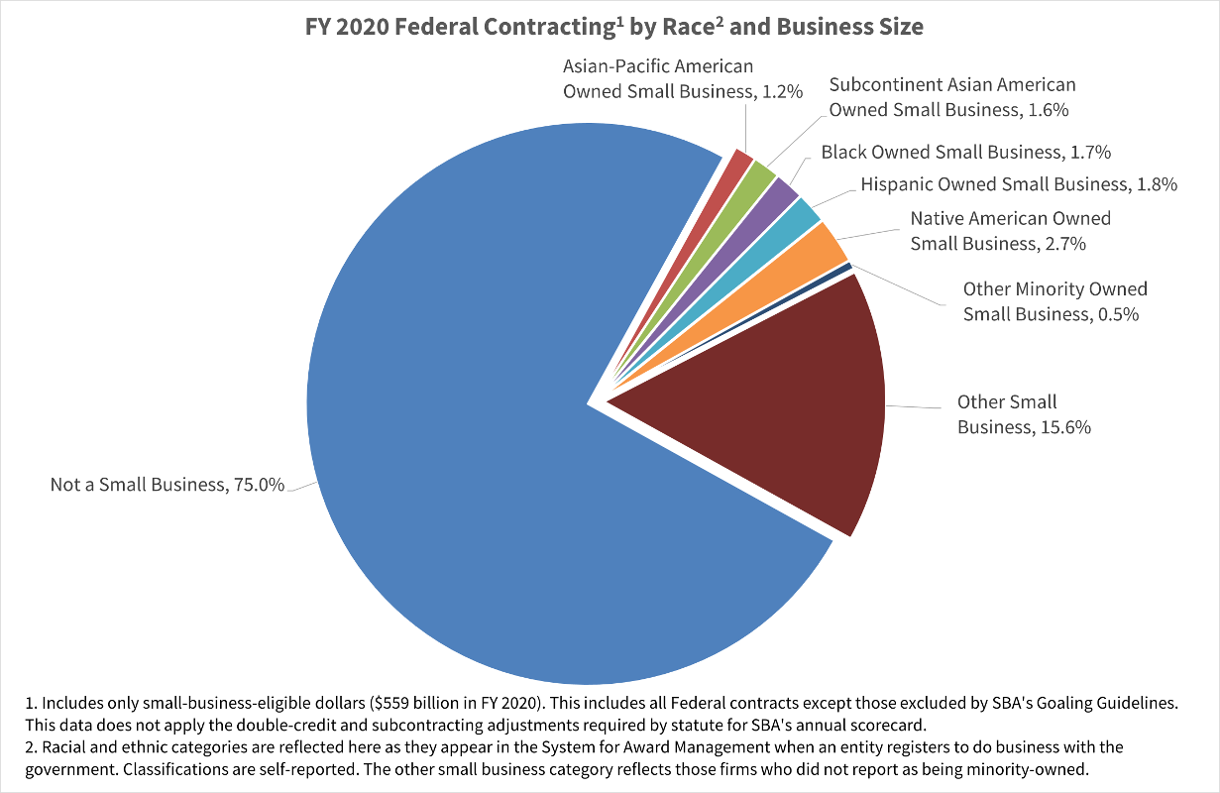
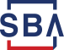
SBA Disaggregated Data Release
SBA.gov – as discussed on whitehouse.gov and analyzed by CEA

OFPP Memo on SDB Strategies
Strategies for Meeting and Exceeding the Small Disadvantaged Business Goal for Fiscal Year 2022, June 2022
- Encourages agencies to maximize use of the 8(a) program
- Suggest that agencies review acquisitions under the SAT, which are required by statute to be set aside for small businesses.
- References the GSA Schedule, SBA’s DSBS.SBA.gov, and SBA PCRs
as other resources to facilitate awards to SDBs.

OMB Memo on Increasing SDB Dollars
M-23-01, Increasing the Share of Contracting Dollars Awarded to Small Disadvantaged Businesses (Oct. 4, 2022)
- Raises the governmentwide goal for Small Disadvantaged Business spending to 12% for FY23
  - SBA negotiates goals with 24 CFO Act agencies
- Build diversity and resilience of the Federal supplier base
- Lower barriers to entry and create opportunities for SDBs, WOSBs, SDVOSBs, and HUBZone businesses

Recent SBA and FAR Regulatory Action

SBA Final Rules (4): Revised Monetary Based Size Standards
87 FR 18607 ; 87 FR 18627; 87 FR 18646; 87 FR 18665 (March 31, 2022)
- SBA issued four final rules to address monetary-based size standards, including all used in government procurement
- Reviewed 468 size standards
  - 229 increases
  - No decreases because of COVID-19
  - Adds about 59,000 small businesses
- Notable changes
  - Engineering Services, 541330 to $22.5 million
  - Administrative Management and Consulting Services, 541611 to $21.5 million
  - Architectural Services, 541310 to $11 million

SBA Final Rule: Calculation of Employee-Based Size Standards
87 FR 34094
- Adopts a 24-month average to calculate a business’s number of
employees for size purposes
- Permits businesses in SBA’s loan, SBIC, and surety programs to use
5-year average receipts, in addition to 3-year average receipts

SBA Final Rule: Adoption of 2022 NAICS for Size Standards
87 FR 59240 (Sept. 29, 2022)
- Reorganized SBA’s size standard table for OMB’s new NAICS
revision.
- New NAICS codes were effective in January.
- The NAICS 2022 revision creates 111 new industries.
- Effective October 1, 2022.

SBA Proposed Rule: Manufacturing and Employee-Based Size Standards
87 FR 24752 (April 26, 2022)
- Reviewed 432 employee-based size standards
  - Proposed to increase 150 size standards
    - 120 of the increases are in manufacturing industries
  - Proposed to retain 282 size standards
- Proposes to retain the 500-employee size standard for the nonmanufacturer rule
- If finalized, would add 250 small businesses

SBA Final Rule: Past Performance Ratings for JV members and Subcontractors
87 FR 43731
- Small business can use past performance from a joint venture,
provided it worked on the joint venture’s contracts
- Small business can use past performance from a first-tier subcontract to go after a prime contract
  - Subcontracting plans will direct primes to provide a rating to the small
business within 15 days
  - The small business must make the request to the prime contractors no later than 30 days after the end of the period of performance of the contract with the government.

Direct Final Rule: Small Businesses in U.S. Territories
87 FR 50925
- Adds Guam, U.S. Virgin Islands, American Samoa, and Northern Marianas to:
  - Definition of a “covered territory business”
  - Exception from limit of three protégés in SBA’s Mentor-Protégé Program
  - Eligibility for state-run surplus property programs
- Effective October 18, 2022 unless adverse comments are received by Sept. 19.

Proposed Rule: Ownership/Control and Contract Assistance for 8(a)
87 FR 55642
- Comments due Nov. 8, 2022
- Size and socioeconomic status determinations from SBA
  - Business shall update its status in SAM.gov no later than 2 days after final determination
  - SBA shall update if the business does not do so
  - Business must notify agencies with which it has a pending offer
- NMR waiver requests must identify each item
  - Individual waivers limited to five years, including options
- Prohibits competitions that require multiple certifications
- 8(a)/WOSB/HZ/SDVOSB cannot be JV partner for more than 1 JV per contract

PR: Ownership/Control and Contract Assistance for 8(a) (cont.)
87 FR 55642
- 8(a) on unrestricted multiple-award contracts or FSS
  - Must be offered and accepted by SBA, SBA will verify firm
  - Can use FSS ordering procedures
- SDB reviews and protests
- Include BPAs in list of vehicles subject to consolidation and bundling
- Overhead costs and bank fees in subcontracting calculations
- LOS – CO cannot give satisfactory/positive past performance to a business that fails to comply with LOS

PR: Ownership/Control and Contract Assistance for 8(a) (cont. pt. 2)
87 FR 55642
- For Business Activity Targets – SBA will consider extenuating circumstances, offers on non-8(a) procurements
- Only need to document IRA exception for economic disadvantage if requested by SBA
- Threshold application issues: for-profit, citizen, one-time eligibility, some revenues for individually-owned applicants
- Bona fide place of business (moratorium through FY23) – can use existing contract locations
- Offer and acceptance not required under SAT, but still need eligibility
- Only active 8(a) firms can receive sole-source orders

Proposed Rule: Veteran-Owned, Service-Disabled Veteran-Owned Certification
87 FR 43731
- Would establish an SBA certification program for VOSBs and SDVOSBs
- Generally, SBA adopts existing application requirements from the VA
  - SBA considering eliminating incarceration from the "good character" requirement for certification
- Certification is required for set-aside or sole source SDVO or VOSB contracts – one-year grace period for self-certified
- Eligible for a term of three years from certification
  - Currently VA verified-firms maintain eligibility through transfer date
  - Self-certified firms must apply within one-year grace period

Nonmanufacturer Rule Class Waiver: Dental Equipment
87 FR 31292
- SBA issued a class waiver under NAICS code 339114 for:
  - dental chairs,
  - dental delivery systems,
  - dental lights,
  - dental cabinets,
  - dental stools,
  - dental handpieces,
  - dental infection control apparatus,
  - dental air management systems, and
  - mechanical room equipment
- Allows otherwise qualified regular dealers to supply the waived items on certain small business contracts, regardless of the business size of the manufacturer.

Nonmanufacturer Rule Class Waivers: Terminations
87 FR 29424 (radiology equipment); 87 FR 34921 (furniture)
- SBA terminated the class waivers of the nonmanufacturer rule for;
  - radiology equipment, NAICS code 334517; and
  - furniture under NAICS codes 337215, 337127, and 337113.

- Small businesses will need to provide the product of a small-business manufacturer for set-aside contracts, unless the agency obtains an individual waiver.

Notice of new WOSB Program NAICS Codes
87 FR 15468 (March 18, 2022)
- SBA identified new NAICS codes for the WOSB program
- Underrepresented industries are qualified for EDWOSB set-asides/sole-source procurements
  - 113 underrepresented NAICS codes
- Substantially underrepresented industries are qualified for WOSB set-asides/sole-source procurements
  - 646 substantially underrepresented NAICS codes
- SBA will issue a notice to update for 2022 NAICS codes

FAR Final Rule: WOSB Certification
87 FR 58237 (Sept. 23, 2022)

- Require EDWOSB and WOSB concerns to apply for certification through SBA or an SBA-approved third-party certifier and to be certified in order to be eligible for WOSB or EDWOSB set-aside or sole-source contracts under the Program.
- Requires agencies to check SAM or SBA’s DSBS for WOSB/EDWOSB
set-asides and sole-source awards
  - SAM designation not yet effective
- Firms may submit offers on WOSB/EDWOSB set-asides if certification is pending

FAR Final Rule: Policy on Joint Ventures
87 FR 58219 (Sept. 23, 2022)

- Permits joint ventures between mentor and protégé to qualify as small or for a socioeconomic program
- Agencies must consider the past performance of each party to a joint venture if the joint venture is not able to demonstrate its own
- SBA does not perform joint venture approval for competitive 8(a) awards (but still determines 8(a) participant eligibility)

FAR Final Rule: Update of HUBZone Program
87 FR 58232 (Sept. 23, 2022)

- HUBZone firms are certified annually for the entire year, instead of being required to represent for each offer
- Removes requirement for firm to be HUBZone qualified at both offer and award for HUBZone set-asides—instead just offer
- Authorizes HUBZone set-aside and sole source awards under SAT
- HUBZone offerors must attempt to maintain HUBZone residency percentage if performing a HUBZone contract

FAR Final Rule: Construction Contract Administration
87 FR 58227 (Sept. 23, 2022)

- For construction contracts for small businesses, agency must publish information about definitization of equitable adjustments
  - Policies or procedures that apply to definitization of equitable adjustments for change orders under construction contracts
  - 3-year data on time required to definitize equitable adjustments
    - Use table showing number of change orders definitized within 30 days, 60 days, 90
days, 180 days, 365 days, or more
    - If have less than 3 years, provide for available FYs
- Agency must collect data on time required to definitize change orders for construction contracts

FAR Final Rule: Small Business Programs Overseas
87 FR 24836
- Amends FAR 19.000 to specify that agencies “may apply” Part 19 (Small Business Programs) outside the United states and its outlying areas.
  - If applied, participants must meet definition of small business concern
  - And must submit representations
  - Note: SBA definition of “Small business concern” at 13 CFR 121.105:
“place of business located in the United States, and which operates primarily within the United States or which makes a significant contribution to the U.S. economy through payment of taxes or use of American products, materials or labor.”
- Applies bundling definition to contracts performed entirely outside the U.S. (they previously were exempted)

FAR Final Rule: Consolidation and Bundling
86 FR 61038
- Requires the publication on SAM.gov of a notice, no later than 7 days before the solicitation, for
  - Substantial bundling, and for
  - Consolidation
- Requires the publication on SAM.gov of a determination, with the publication of the solicitation of
  - The rationale for substantial bundling, or that
  - Consolidation of contract requirements is necessary and justified

FAR Proposed Rule: Exemption from Inflation Adjustments
87 FR 58300
- Exempts two thresholds from automatic inflation increases:
  - The dollar level at which payment and performance bonds are required on a construction contract (currently $150,000); and
  - The dollar level at which payment protections are required as an alternative to payment bonds (currently $35,000).
- Comments due November 25.

FAR Proposed Rule: Small Business Program Amendments
87 FR 10327
- Size changes
  - Size determined at offer on a multiple-award contract, even if price not
evaluated (e.g., two-step eval)
  - IT value-added reseller size standard of 150 employees
  - Allow status protests based on ostensible subcontractor
- Allow set-asides for socioeconomic programs where multiple-award contract was set aside for small business
- Cannot exercise an option past 5th year on an 8(a) contract if firm is no longer an 8(a) participant

Upcoming SBA proposed rules
- Adjustment of Monetary Based Size Standards for Inflation
- NDAA 2020, Credit for Lower Tier Subcontracting and Other Amendments
- HUBZone Program Updates and Clarifications
- HUBZone Appeal Process

Upcoming SBA final rules
  - Veteran-Owned Small Business and Service-Disabled Veteran-Owned Small Business - Certification

Upcoming FAR proposed rules
    - Proposed 2023-001, Subcontracting to Puerto Rican and Covered Territory Small Businesses
    - Proposed 2022-009, Certification of Service-Disabled Veteran-Owned Small Businesses
    - Proposed 2021-020, Limitations on Subcontracting Revisions
    - Proposed 2021-012, 8(a) program
    - Proposed 2021-011, Past Performance Ratings for Small Business Joint Venture Members and Small Business First-Tier Subcontractor

Upcoming FAR proposed rules (cont.)
    - Proposed 2021-009, Protests of Orders Set Aside for Small Business
    - Proposed 2020-016, Representation of Size and Socioeconomic Status
    - Proposed 2020-010, SBIR/STTR
    - Proposed 2018-003, Credit for Lower-Tier Small Business Subcontracting

Upcoming FAR final rules
- 2020-007, Accelerated Payments Applicable to Contracts with Certain Small Business Concerns

U.S. Small Business Administration

