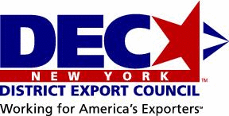
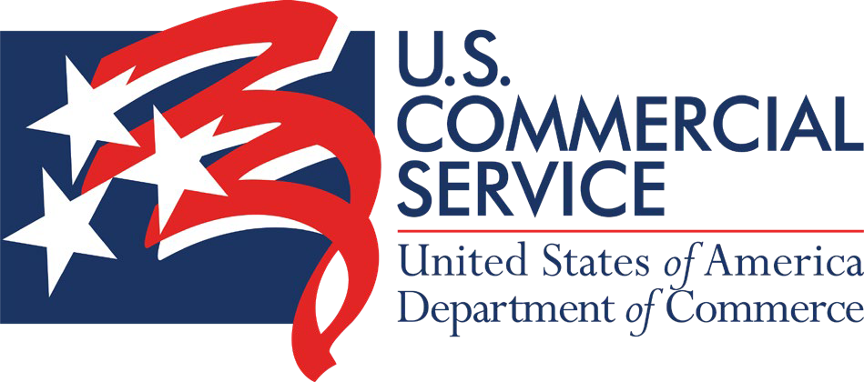


NAVIGATING PUBLIC PROCUREMENT
RESOURCES AND OPPORTUNITIES FOR AMERICAN COMPANIES

October 29, 2021 / 1-2:30 pm ET Marisel Trespalacios

trade.gov

Agenda

Introduction, 5 mins
- Marisel Trespalacios, Director, U.S. Commercial Service Long Island

Managing RFPs, Best Practices, 20-25 mins
- Thomas Cook, Managing Director, Blue Tiger International
Best practices in selling to foreign governments. Presenter, with over 30 years of experience in export sales and business development, will frame some of the concerns and issues in creating sales to foreign public entities. There will then be an outline of 10 steps to avoid the pitfalls and maximize the opportunities for successful export sales and business development into foreign markets destined for public entities.

United Nations, 15-20 mins
- Susan Hettleman, Commercial Officer, U.S. Commercial Service New York City
Will discuss how U.S. companies can successfully navigate the United Nations Procurement System with the assistance of the U.S. Commercial Service New York and the U.S. Mission to the United Nations (U.S. Department of State).

Advocacy Center, 15-20 mins
- Malcolm Burke, Trade Specialist, Advocacy Center, International Trade Administration
Will discuss how the Advocacy Center helps U.S. exporters win foreign government contracts and major projects. Advocacy assistance is provided to businesses of all types and sizes, but they must apply and qualify to receive advocacy services.
Q&A, 15 Mins

Logistics



MICs AND CAMERAS: Please please please make sure your mic is on mute and your camera is turned off.
Q&A: The Q&A session will be held after all speakers are finished.
You are welcome to type in your questions/comments in the Microsoft Teams Chat Box. Please state who you are addressing your question(s) to.
You may also raise your hand if you prefer to ask the question yourself.
PRESENTATIONS: Participants will receive all presentations by email sometime after the event.

Partnerships

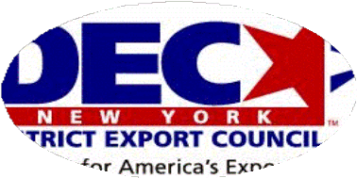
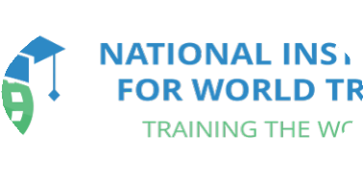
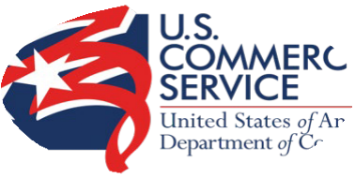
- Non-profit, public-private org
- Members appointed by Secretary of Commerce
- Experienced int’l businesspeople
- Provide support/assistance to NY companies interested in exporting/int’l business
- Grants awards/organizes events (World Trade Week)
- www.newyorkdec.org
NY District
Export Council
- Educates, informs, trains professionals on int’l
trade issues
- Have experienced and trained educators that counsel companies on trade-related matters
- Strategic partner of the Commercial Service for many years
- We co-counsel and organize educational seminars and webinars throughout the year
- www.niwt.org
National
Institute for World Trade
- Export promotion arm of the US government
- Federal agency
- Operate through our US embassies/consulates in +75 countries
- Programs/resources to help US companies find business opportunities overseas
- Assist with finding foreign partners, conducting background checks, promoting your company/product, providing trade leads, advocating for your company
- www.trade.gov
U.S. Commercial
Service

Who we are

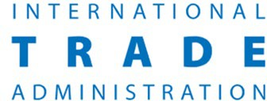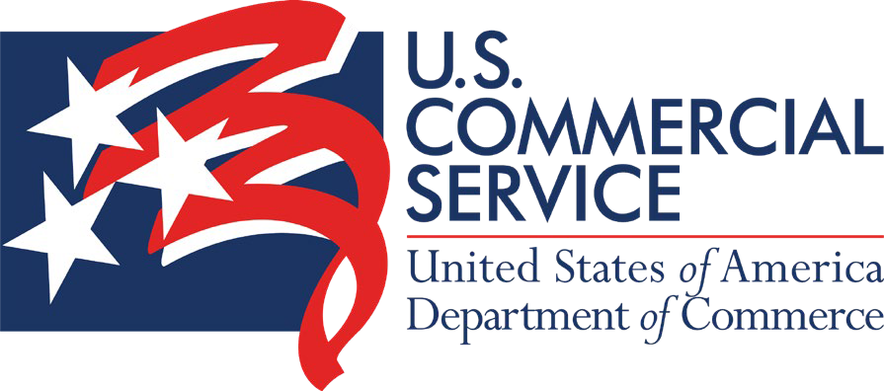

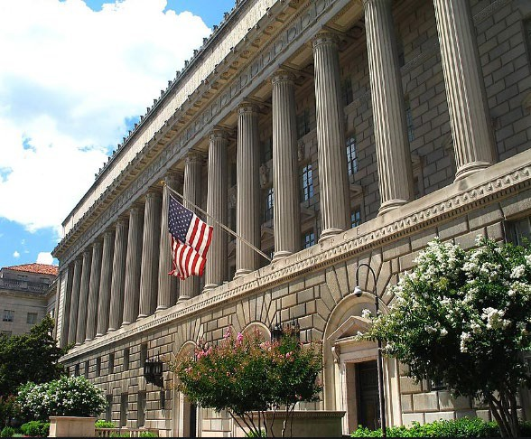
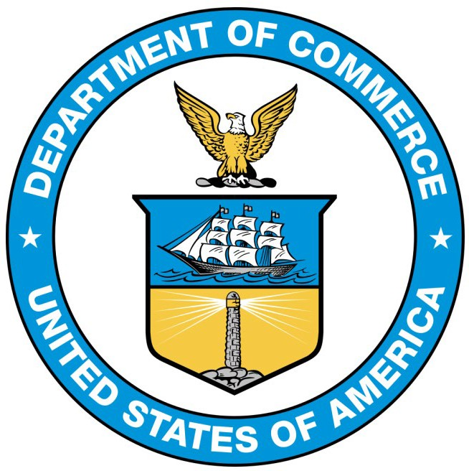
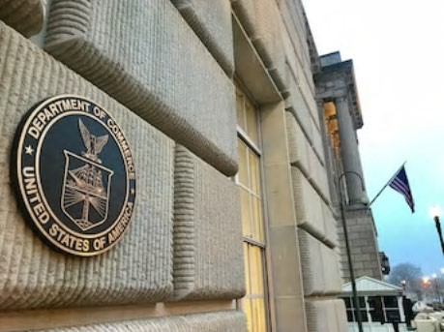
The mission of the Department of Commerce is to create the conditions for economic growth and opportunity.
ITA strengthens the competitiveness of U.S. industry, promotes trade and investment, and ensures fair trade through the rigorous enforcement of our trade laws and agreements. ITA works to improve the global business environment and helps U.S. organizations compete at home and abroad.
The U.S. Commercial Service is the export promotion arm of the U.S. government

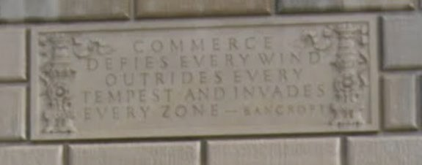

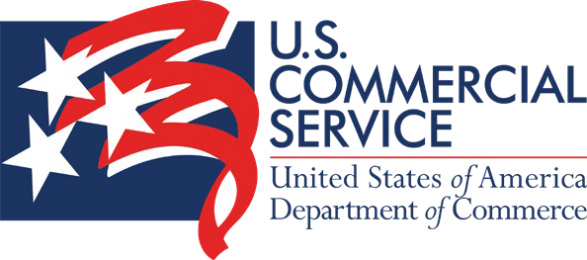
Who we are – Connecting you to global markets

The U.S. Commercial Service is the lead trade promotion agency of the U.S. government. Trade professionals in over 100
U.S. cities and more than 75 countries help U.S. companies get started in exporting or increase sales to new global markets.
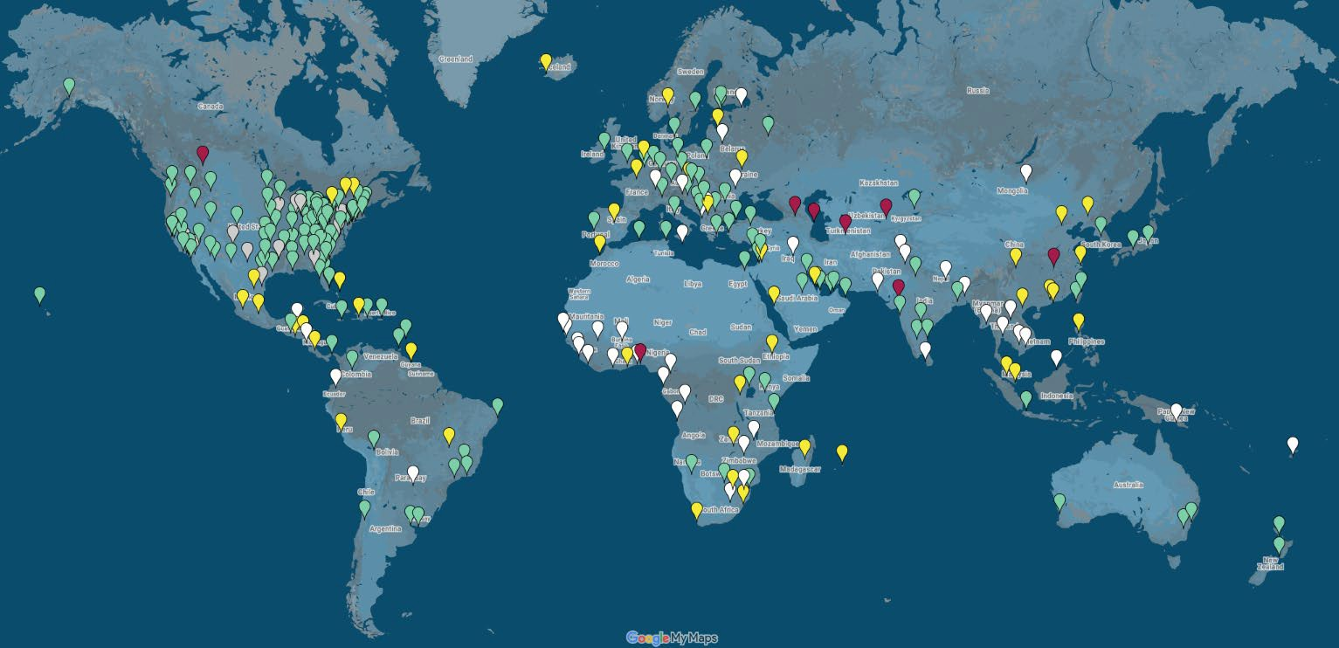
The Commercial Service is the only federal agency with an integrated U.S. and overseas field organization. It has offices both in exporters' backyards and in the foreign markets where they seek to do business.

Who we are
U.S. Commercial Service Long Island – Export Assistant Center in Old Westbury, NY

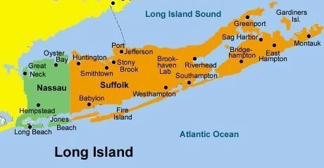

Director: Marisel.Trespalacios@trade.gov
Industries: Aerospace/Defense, Automotive, Building Products, Chemical Production Machinery, Computers/Peripherals, Consumer Electronics, Computer Software and Services, Cosmetics, Electronic Commerce, Electronic Components and Systems, Environmental Technologies and Machinery, Industrial Chemicals, Information Technology and Telecommunications, Mining Industry, Machine Tools/Metalworking, Oil/Gas Industry, Pollution Control, Print Media and Entertainment, Renewable Energy, Robotics, Security/Safety

- CS Long Island works with companies HQ’ed on Nassau and Suffolk counties
- Work with companies of all sizes/industries. SMEs size as defined by SBA
- ≥51% U.S. content rule applies
- Some services are free of charge; others have modest fees and are based on company size
International Trade Specialist: Jamel.Hicks@trade.gov Industries: Agricultural Products, Foods – Processed and Food Processing/Packaging Eq., Apparel, Biotechnology, Drugs/Pharmaceuticals, Education/Training Services, Financial Services, General Consumer Goods, General Services, Health Care Services, Insurance and Investment Services, Marine Fisheries Products, Medical Eq., Sporting Goods/Recreational Eq.,
Textile Eq. and Products, Travel and Tourism
trade.gov/commercial-services-offices-us


Let our global network work for you.

Worldwide Recognition
As the U.S. government, we can open doors that no one else can in markets around the world.

Global Network
Our unmatched global network with trade experts in more than 80 countries can provide you with on-the-ground knowledge and connections.

Results Driven
Our expert, in-person counseling is unparalleled and designed to help you succeed in global markets.
The world is open for your business.
Our global network of experienced trade professionals is located throughout the United States and in
U.S. Embassies and Consulates worldwide. Whether you’re looking to make your ﬁrst export sale or expand to additional markets, we offer the expertise you need to connect with lucrative opportunities and increase your bottom line.

Our Services


Export Counseling
- Develop eﬀective market entry and sales strategies.
- Understand export documentation requirements and import regulations of foreign markets.
- Navigate U.S. government export controls, compliance and trade ﬁnancing options.


Market Intelligence
- Analyze market potential and foreign competitors.
- Obtain useful information on best prospects, ﬁnancing, laws, and cultural issues.
- Conduct background checks on potential buyers and distributors.


Business Matchmaking
- Connect with pre-screened potential partners.
- Promote your product or service to prospective buyers at trade events worldwide.
- Meet with international industry and government decision makers in your target markets.


Commercial Diplomacy
- Overcome trade obstacles to successfully enter international markets.
- Beneﬁt from coordinated U.S. government engagement with foreign governments to
protect U.S. business interests.


 Export Counseling
Common exporting questions

  - How can I be sure Brazil will accept the testing that has been done on my product?
  - How can I protect my intellectual property abroad?
  - Does my product qualify for preferential tariff treatment under a FTA?
  - Can you help me find an in-country attorney to review my contract?
  - I want to open a sales office in Vietnam, what’s required?
  - Can I export to Cuba, Syria, Sudan, Somalia, etc.?
  - My buyer never paid me. Help!
  - My company is bidding on a port development project in Morocco. What support can the USG provide?

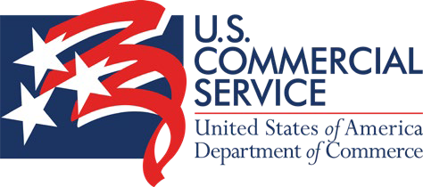
Market research – tools & resources
- Research by Country: Country Commercial Guides on market conditions, opportunities, regulations, and customs from U.S. Embassies worldwide.
- Free Trade Agreements: FTAs between the United States and select trading partners provide low or duty-free access, strong intellectual property protection, and greater U.S. exporter input into FTA country product standards. Take advantage of FTAs today to increase your competitiveness in markets representing almost 40 percent of U.S. exports. FTA list: Australia, Bahrain, Chile, CAFTA-DR (Costa Rica, Dominican Republic, El Salvador, Guatemala, Honduras & Nicaragua), Colombia, Israel, Jordan, Korea, Morocco, USMCA (formerly NAFTA: Canada & Mexico), Oman, Panama, Peru, & Singapore.
- Industry Research: Find the latest market intelligence, trade events, and trade leads for your industry.
- Market Diversification Tool: Get market recommendations based on your HS Code! Learn about potential new export markets using your current trade patterns. Bookmark this great tool of ours.
- Global Market Finder (Census): An interactive tool for U.S. exporters that tells you the biggest export markets by product and destination. Great for new exporters or those already exporting but looking to find new export market.
- Top Markets Reports: Understand the competitive landscape within a sector, including opportunities and challenges in key markets. Our Top Market Reports help exporters determine their next export market by comparing opportunities across borders.
- Market Destination Videos: Short videos on export opportunities and interviews with in-country trade experts for multiple markets.
- Commercial Service Newsletters: Industry-specific newsletters and/or our local Long Island newsletter highlighting trade leads, events, webinars, seminars, trainings, trade shows, and any other relevant export resources. Let us know if you’d like to be added!
For more, check out our trade.gov market research website!!
U.S. Department of Commerce | International Trade Administration | U.S. Commercial Service


Next event
NY DEC / NIWT / CS Long Island

“Overview of the Current State of Supply Chains in the U.S.” Wed. November 17, 2021 / 1-2:30 PM EDT
$25/person
Come hear a representative from the U.S. Department of Commerce speak about supply chain congestion and resiliency from the government perspective and what is Commerce’s role on this issue. Session will then be followed by an in-depth presentation on how U.S. companies can mitigate supply chain risk and current challenges.

RSVP to: Marisel.Trespalacios@trade.gov


Thank you!


Marisel Trespalacios
Director
516-493-8150
Marisel.Trespalacios@trade.gov

