How To Start A Startup 

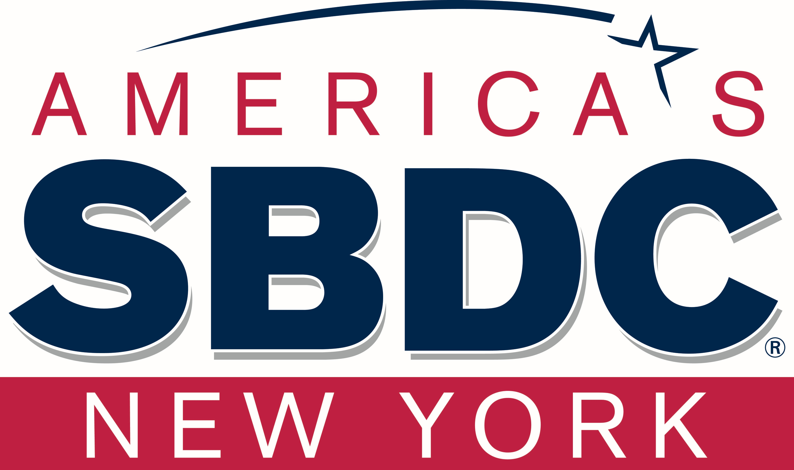
Tech Entrepreneur-In-Residence
at the Stony Brook SBDC


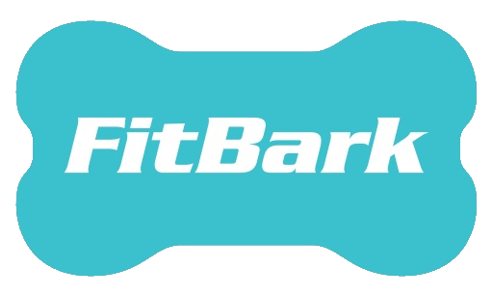


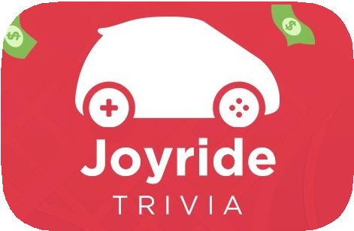




HARDWARE MOBILE APPS WEB APPS
FOUNDER
OF THE FOLLOWING

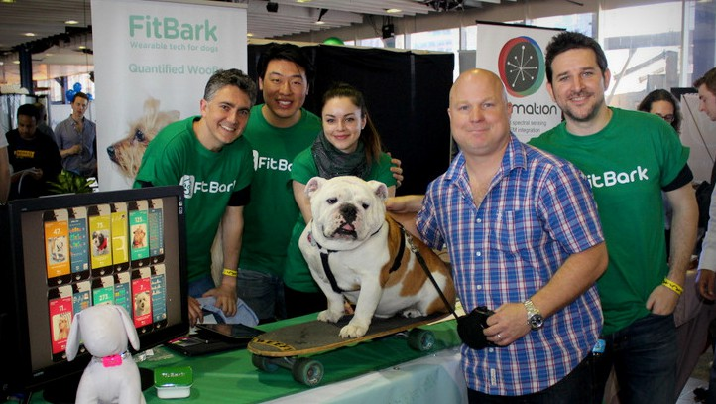

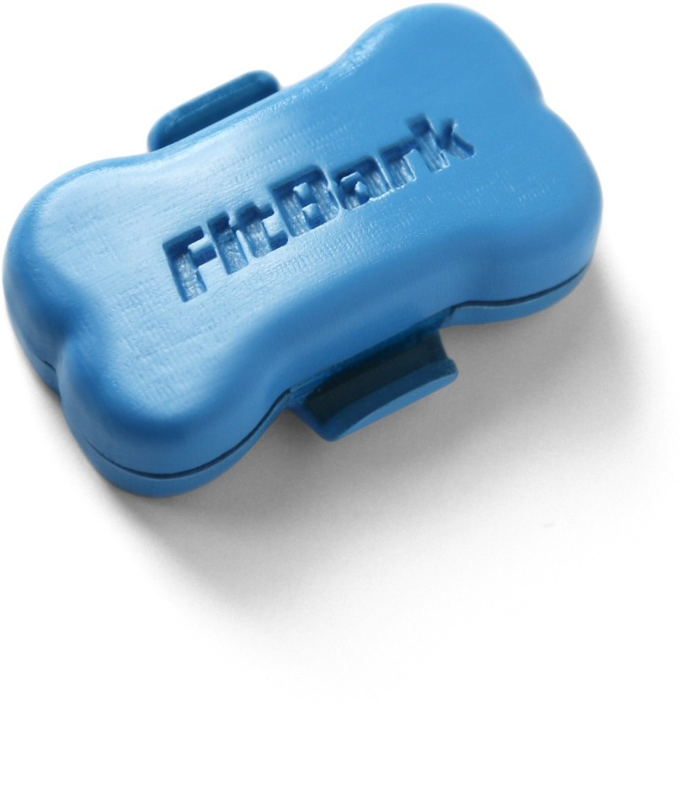


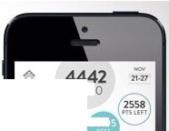
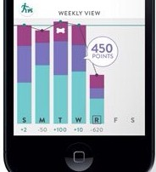


/700
--··


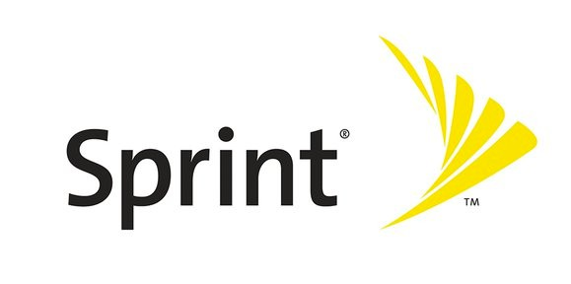



RAISED MONEY THROUGH:

3,000+ MEMBERS
Ran NYC Mobile Apps Meetup (largest mobile app meetup in NYC)

STEP

01
STEP

02
STEP

03
STEP

04
STEP

05
STEP
06

INITIAL PRODUCT MARKET FIT
SEARCH

IDEA PROTOTYPE LAUNCH
 TRACTION MONETIZE GROWTH

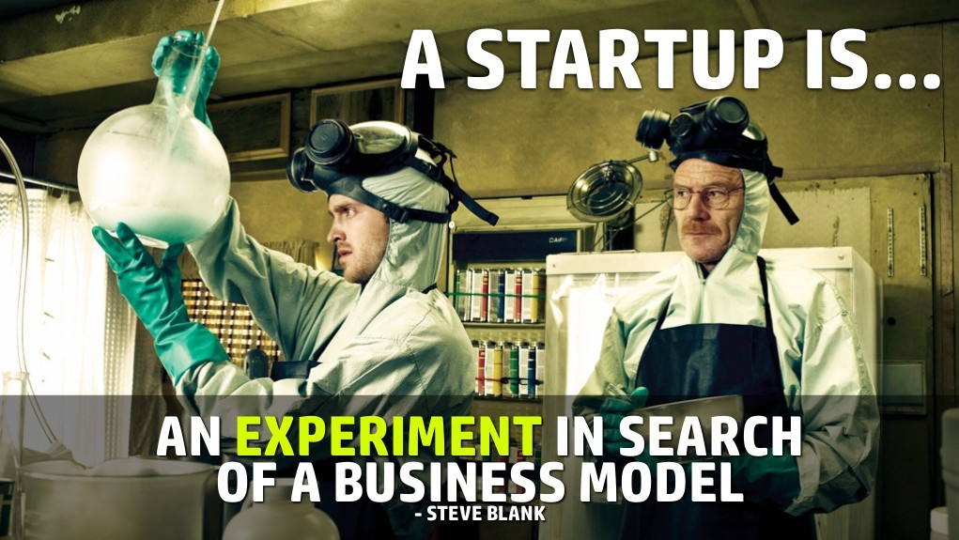

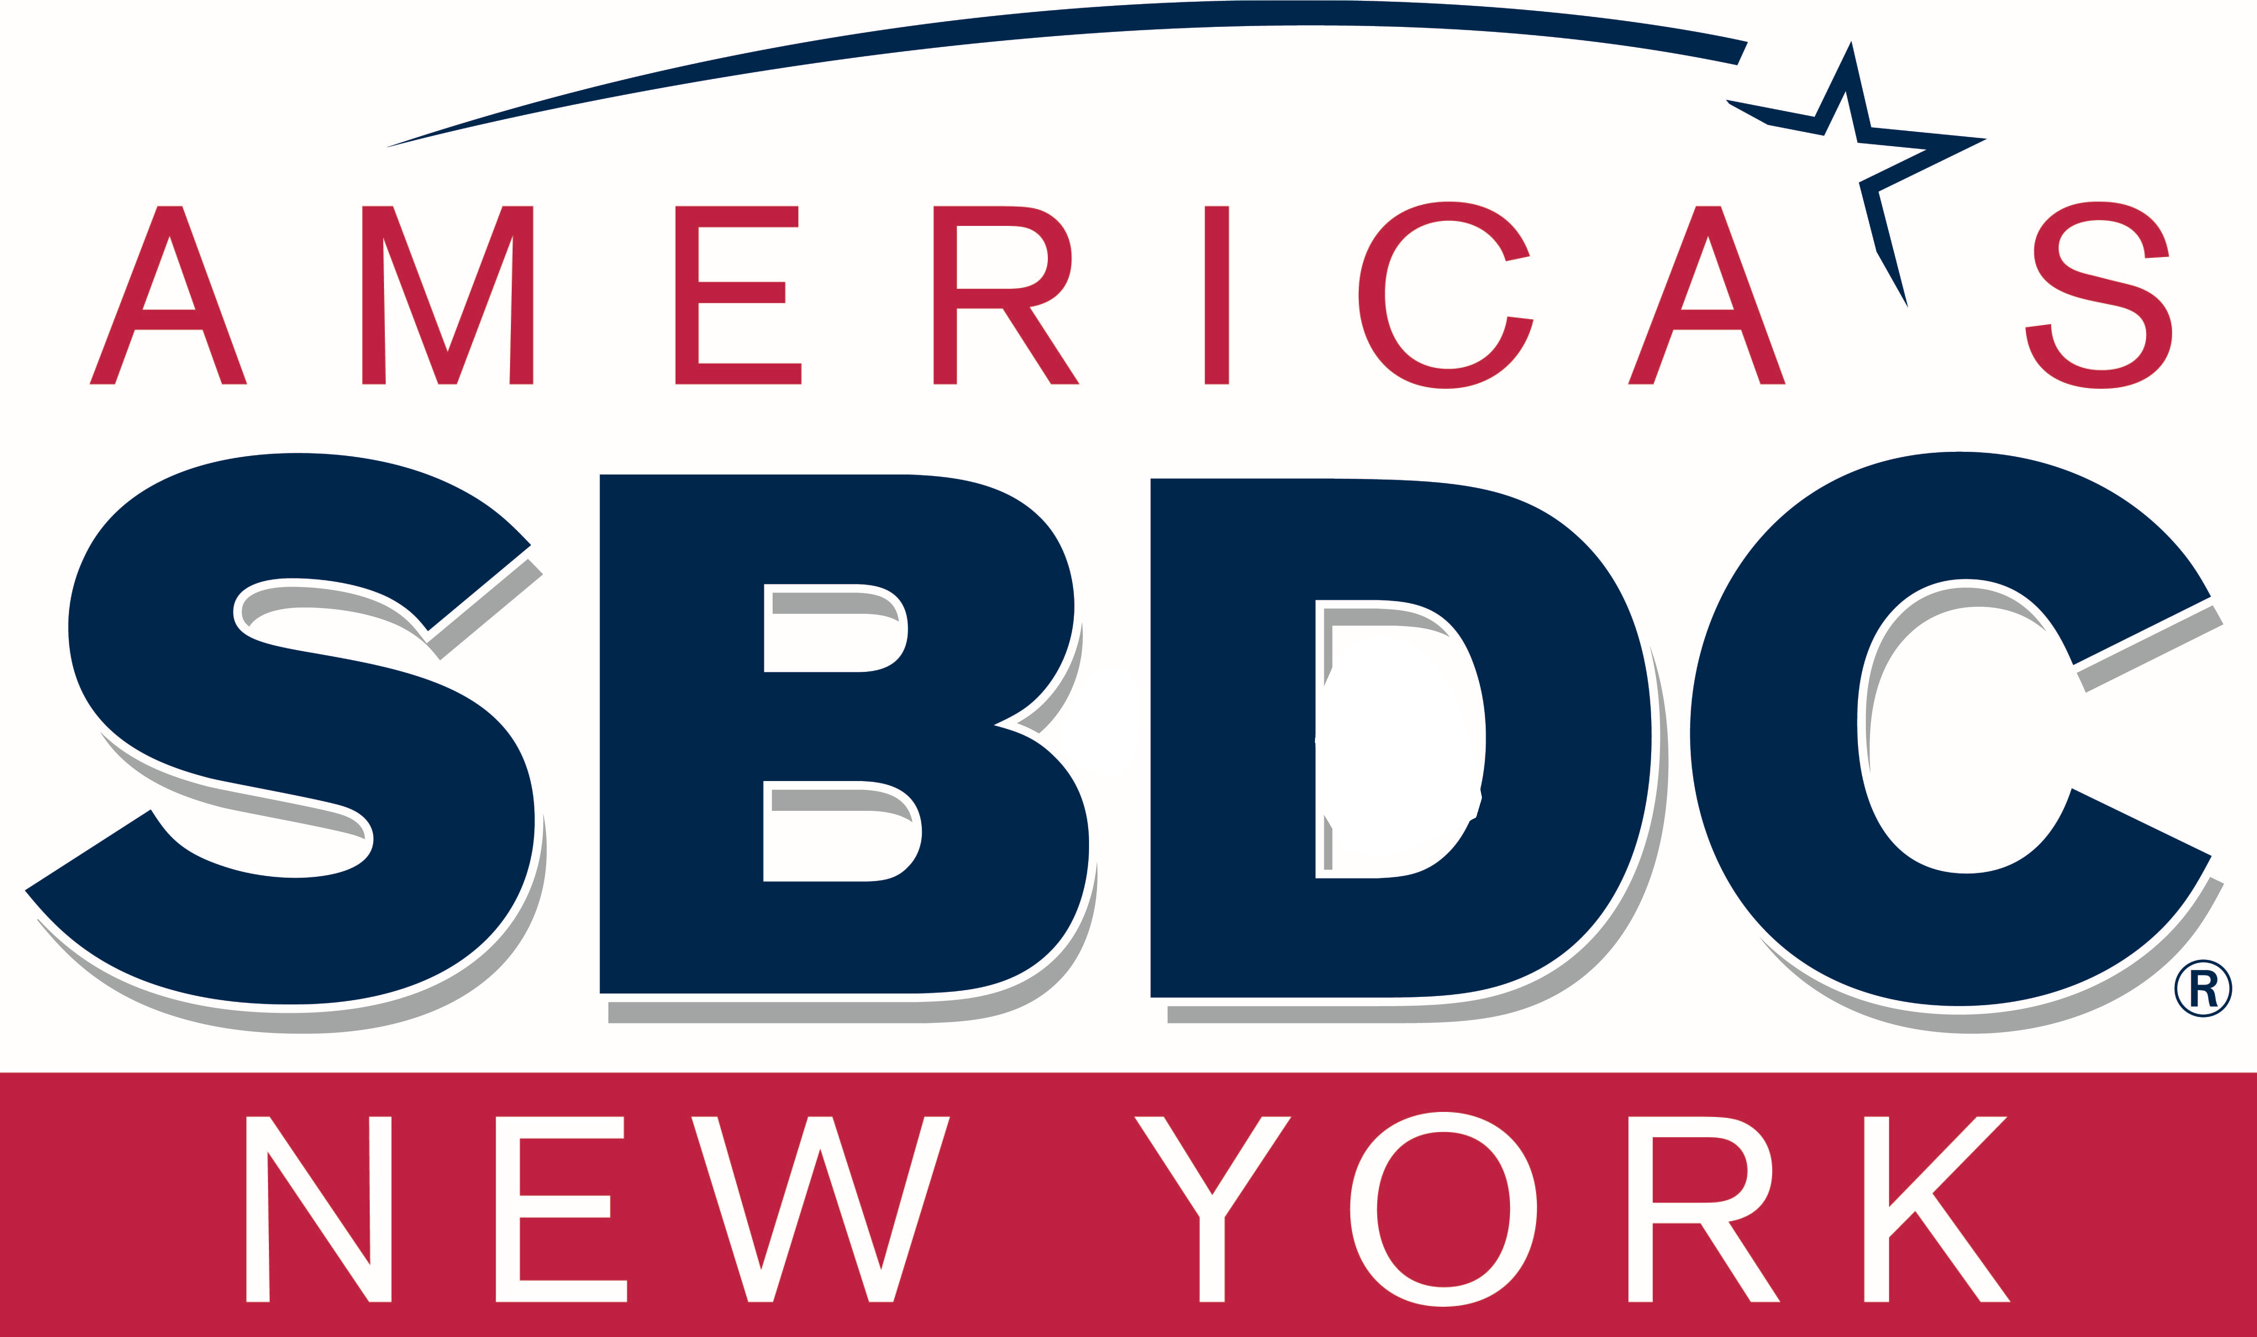

Good Idea
+ Strong Team
+ Beloved Product
+ Great Execution

SUCCESS


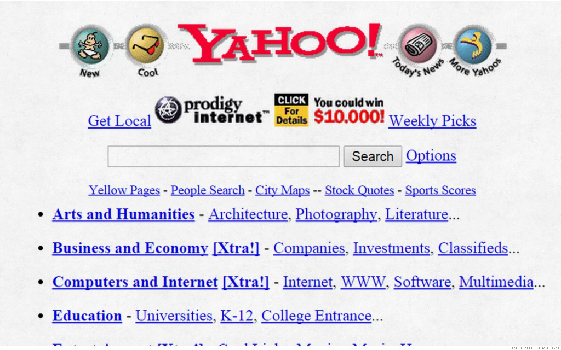
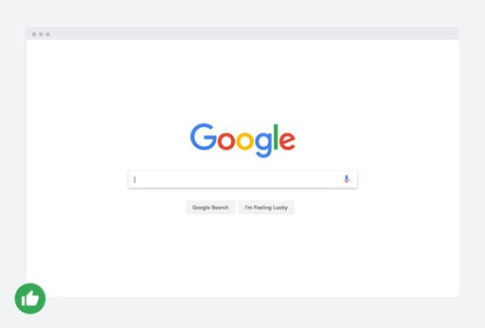

PROBLEM. SOLUTION. INSIGHT.

HISTORY DOES NOT REPEAT ITSELF, BUT IT RHYMES.

Netflix is like TV but when you want to watch it. Twitter is like blogging but only 140 characters.
Instagram is like your camera but with filters.
Whatsapp is like SMS but free.
Uber is like other taxi companies but with an app.
Airbnb is like a hotel but from other people.

THE MOST VALUABLE THINGS ARE OFTEN THE SIMPLEST.
THEY ADDRESS THE FRUSTRATIONS OF EVERYDAY LIFE.

I want to watch X but it’s not on TV.
I want to blog but it’s too much effort.
I want to share pictures but they’re not beautiful. I want to contact my family but it costs too much.
I want a taxi but I can’t wait for it.
I want a hotel but there are no free rooms.

AM�7'"s
■SBDC

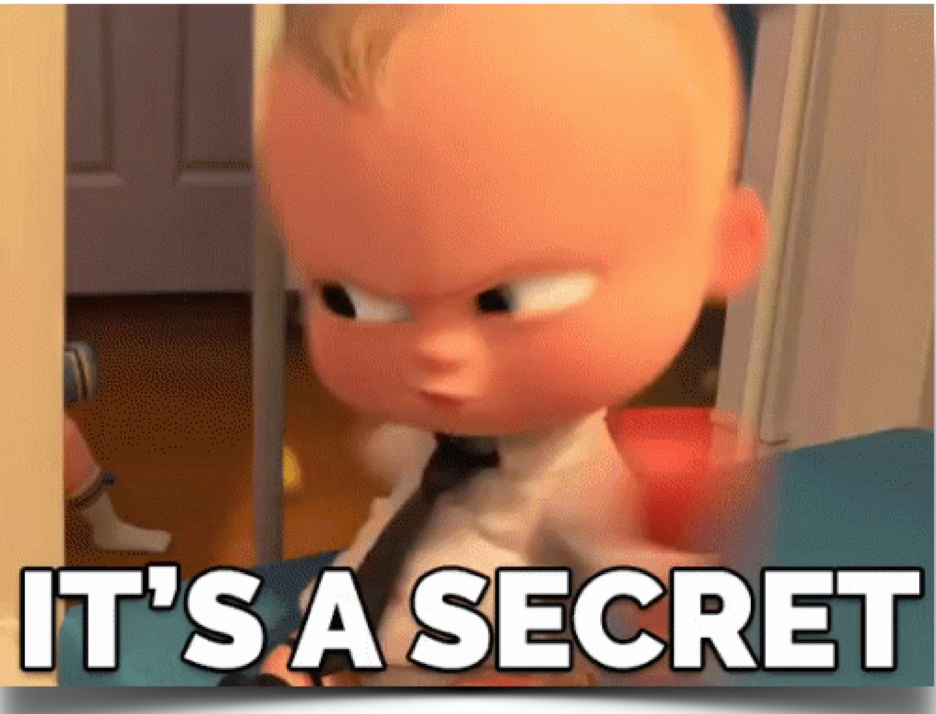
l■:aflWIH9a

WHAT CUSTOMERS WANT
A GREAT PRODUCT.

Most startups fail because they “ran out of funding” but real problem was that customers didn’t want the product.

OBSERVE
Talk To Users / Watch Them Use Your Product

FIND WEAKNESS
Figure out which parts are
bad.

IMPROVE
Make them better.

If you improve your product 5% every week, it will really compound.
Sam Altman
President of Y-Combinator

DO THINGS THAT DON’T SCALE.

QUESTIONS TO ASK ABOUT PRODUCT
- Are users using your product more than once?
- Are your users fanatical about your product?
- Would your users be truly bummed if your company went away?
- Are your users recommending you to other people without you asking them to do it?
- If you’re a B2B company, do you have at least 10 paying customers?

Have The Cheapest Easiest Product

FINDING THE RIGHT TEAM





*Ask everyone about their previous IP history
ANIMAL TEST
IDEALLY 2-4 FOUNDERS
1 SALES
(acquire users)
1 TECHNICAL
(build the company’s product/services)

If things are not working out, part ways quickly 

RAISING MONEY



BOOTSTRAPPING
VENTURE CAPITAL
ACCELERATORS

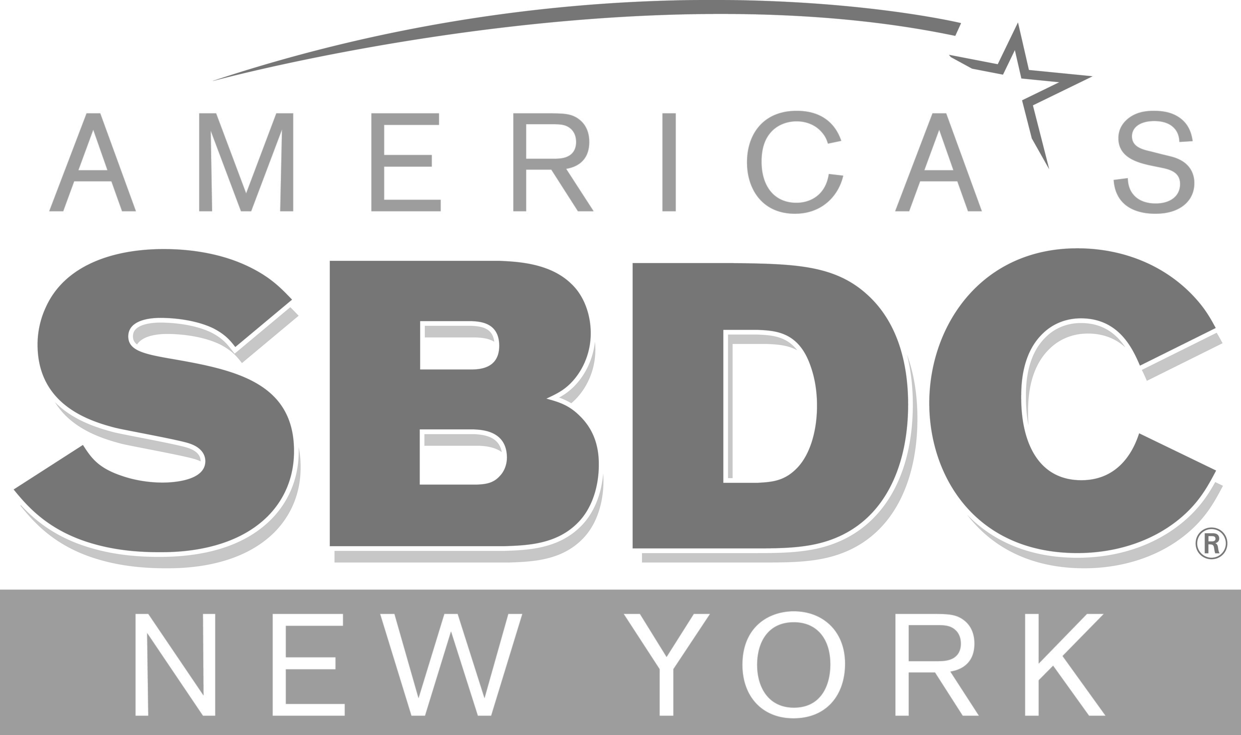

ANGELS & GROUPS
CROWDFUNDING
GOVERNMENT GRANTS

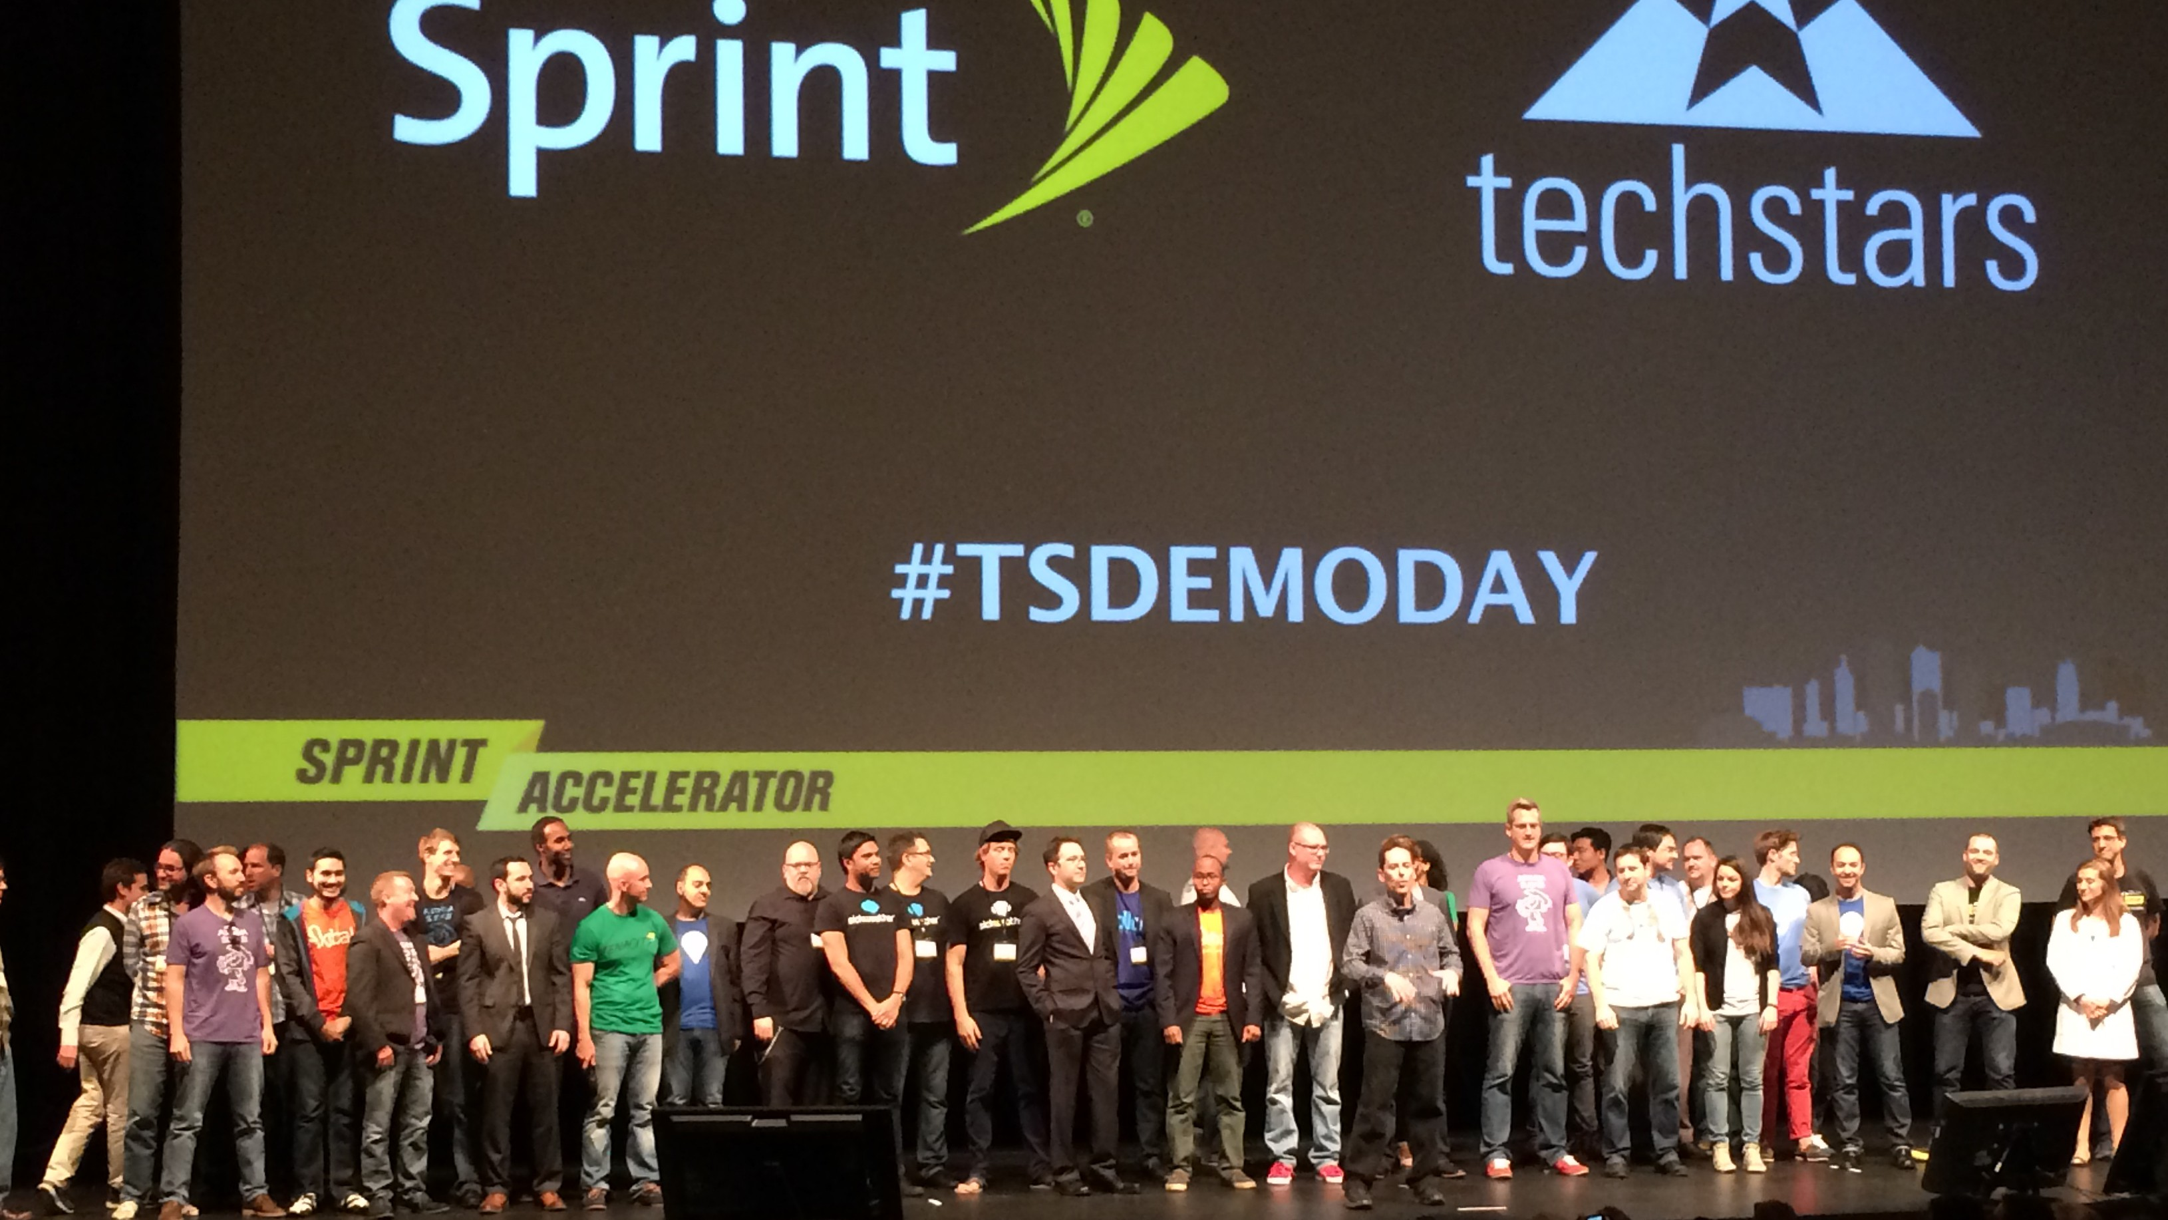

TYPES OF INVESTOR DOCS
- CONVERTIBLE NOTES
- SAFE NOTES
- TERM SHEETS

GROWTH



FOR CONSUMER STARTUP
Retention + New User Acquisition

FOR B2B
Revenue Growth Per Month

For consumer apps, you are aiming for 30% MoM growth

AM�i-"s
■SBDC

l■:afl#IH;l:W





"Product/market fit
means being in a
prod\JCT
fl\°'(
1
ftt
good market with a product that can satisfy that market."

RETURNING USAGE
3 OUT OF EVERY 7 DAYS

NPS
SHOULD BE > 50

PAYING CUSTOMER RENEWAL RATES
> 80%

pre P/M fit post Product/Market fit


traction.

Retentiam Curve

100%
PiroduciA
Prod�ct B,
Prod'uct,A Ha_s
ProduetJMaiket Flt
Prcduc, B Does
, 01T Have P/MI!Fil

1S%

A.c1ive 50%

2-

0%
0 !5 10
TI'

15 20

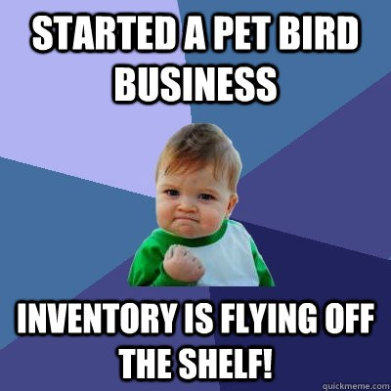

when people who know they want your product are happy with what you’re offering
…then you’re ready to shift your focus from
product to distribution and “win the market.”

Rich Company  millions of dollars from investors

Rich Company millions of dollars in revenue

COMPETITORS





99% of the time, ignore your competitors
Don’t worry about a competitor until they are beating you with a real, shipped product
There’s always a counter-move

KEYS TO SUCCESS
Understand your business Understand your users
1
2

Build something they love & spend less than you make
3

HELPFUL TOOLS

customer interviews
(5-10 NEEDED)

UX TESTING SESSIONS
(3-5 NEEDED)

METRIC
YOU’LL NEVER HAVE AS LARGE A SAMPLE SIZE AS YOU’D LIKE - BEWARE OF TELLING TOO MANY STORIES WITH TOO LITTLE DATA).

HOW TO PITCH YOUR IDEA
“Revolutionizing the world of food discovery via the social web.”

”A mobile application showing you nearby restaurants your friends recommend”

WRITE IN PLAIN SPEAK!
Eliminate jargon, acronyms, marketing speak, and any ambiguous terms such as “platform”

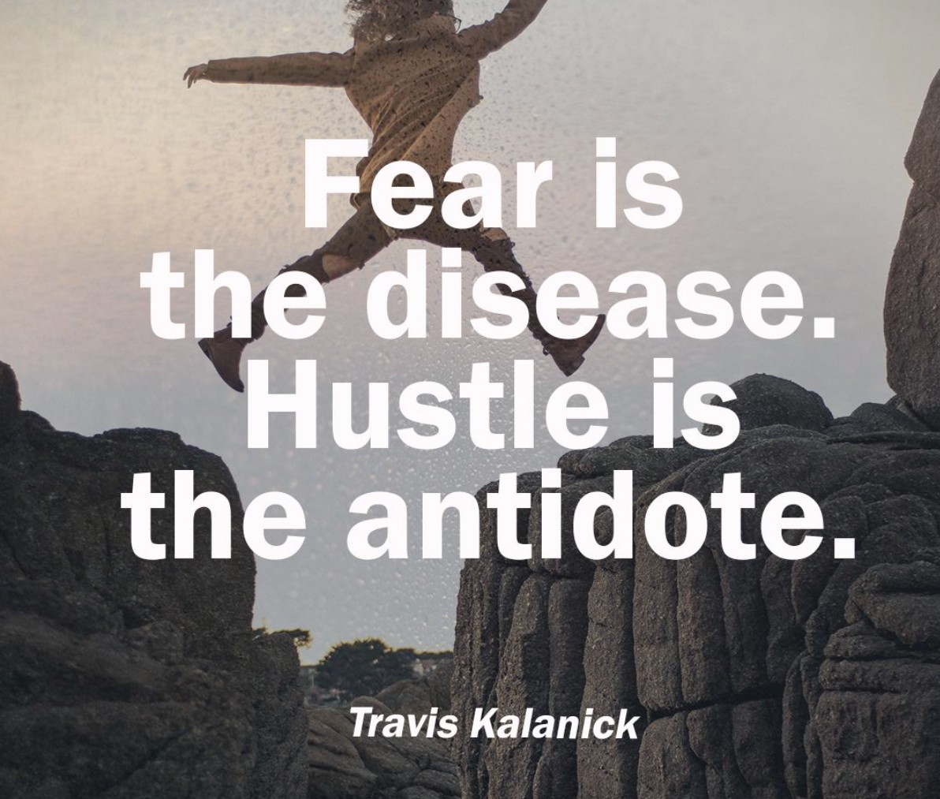

START BUILDING




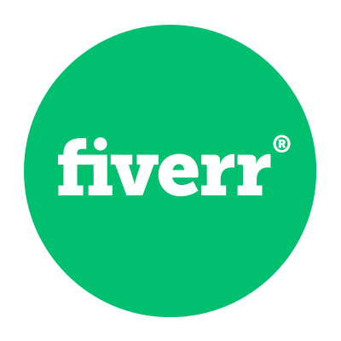


Prototype your idea with Moqups
Get a logo cheap on Fiverr
Hire early team on Upwork

HELPFUL LINKS

STONYBROOK SBDC (regional Small Business Development Center funded by the Small Business Administration)
PRODUCT HUNT (website that let's users share and discover the newest products in tech)
ANDREW CHEN (thought leader on startups, mobile growth and metrics)
ANGELIST (a platform for startups to raise money through angel investors and recruit talent)
REPUBLIC (an equity crowdfunding platform for startups)
CRUNCHBASE (platform for finding business information about private and public companies) MIXPANEL (a top service that tracks data on user interactions with web and mobile apps) APPRADAR (tool for App Store optimization)
STARTUP WEEKEND (think startup camp but a weekend event where you can form a team and build a working prototype and demo in 54 hours)
Y-COMBINATOR (the top US accelerator for tech startups, the guys behind Airbnb and Dropbox) PAUL GRAHAM'S ESSAYS(founder of Y-Combinator and his deep thoughts on startups and tech) TECHSTARS ENTREPRENEUR'S TOOLKIT (online resource to help you learn entrepreneurship) They also have more startup resources HERE

RECOMMENDED READS

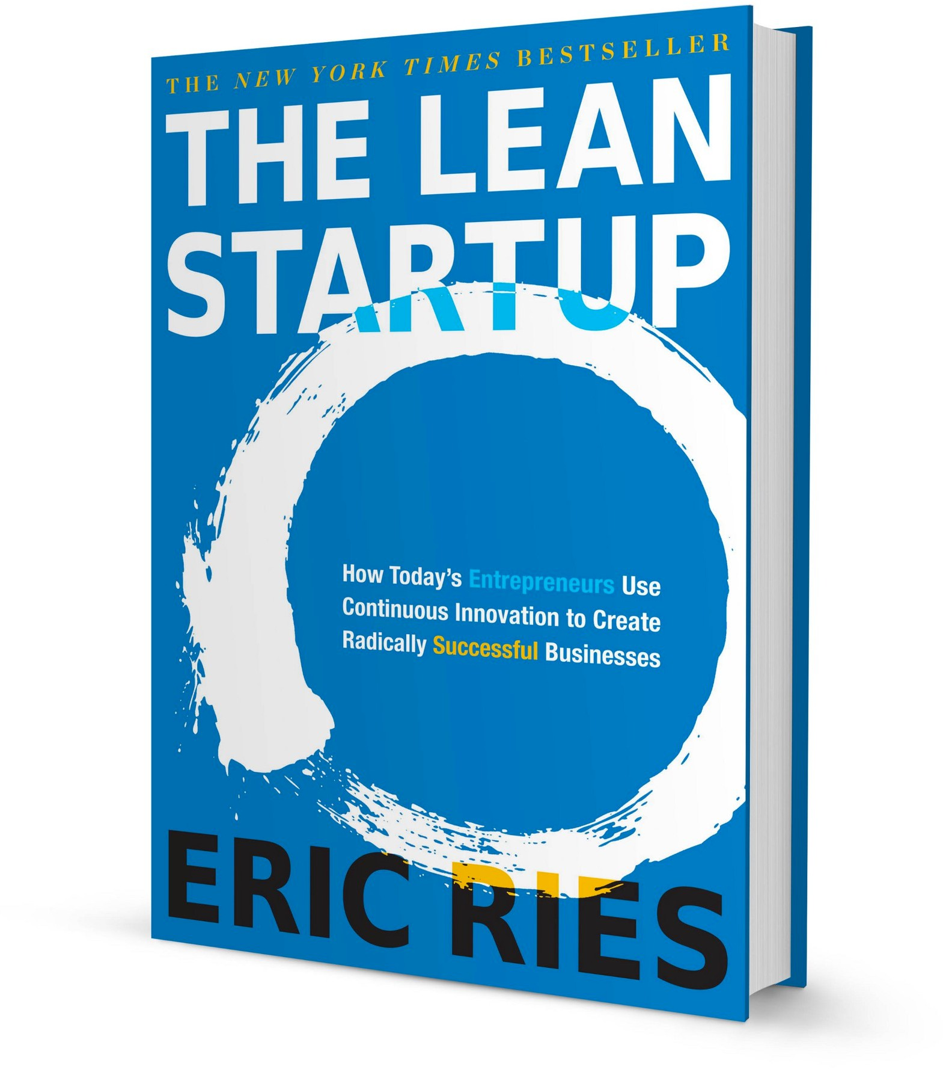
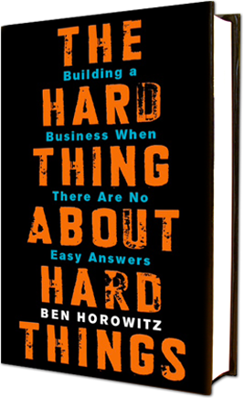

The Lean Startup The Hard Thing
About Hard Things

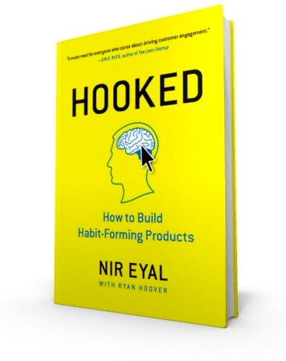
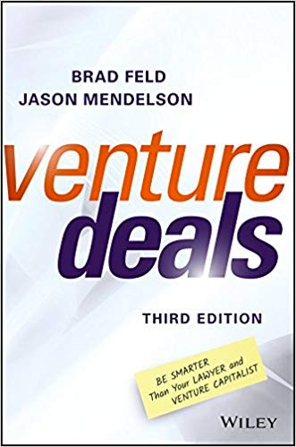
Hooked Venture Deals

MORE FROM ME


EPISODE:
Ninja Steps To Building An App


EPISODE:
Serial Entrepreneurship and Mobile Apps

Thank you.
Questions?

michael.chiang.1@stonybrook.edu (631) 632-9118

@iammikechiang

