
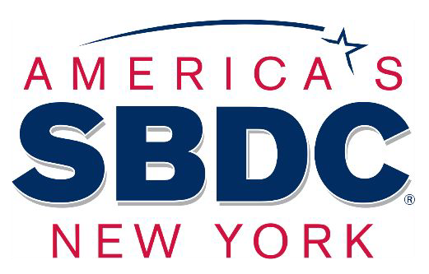
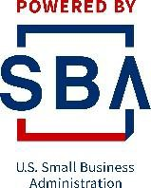



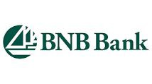
BNB Resiliency and Recovery Program
Sponsored by BNB Bank

Seasonal Business Management

Presenter: Brenda Zhang, CPA / NYS Certified Business Advisor SBU College of Business student researchers: Simranjit Kandola
Shiyi Zhu

BNB Resiliency and Recovery Program - Sponsored by BNB Bank

Center For Entrepreneurial Finance Program Advisors

Richard Chan, Ph.D.
Director, Center of Entrepreneurial Finance
Associate Professor, College of Business, Stony Brook University
Danling Jiang, Ph.D.
Associate Director, Center of Entrepreneurial Finance Associate Dean for Research and Faculty Development Professor of Finance, College of Business
Margot Palermo - Business Honors Program
Stony Brook SBDC Program Business Advisors

Ann Garbarino - Senior Business Advisor

Robert B. Harrison - MBA/CPIM, Business Advisor Gifty Oduro-Ostrander - MBA, Business Advisor Brenda Zhang - CPA, Business Advisor

AMER1c;�s

SBDC
NEW YORK

STONY BROOK SBDC
6 Month Pandemic Overview

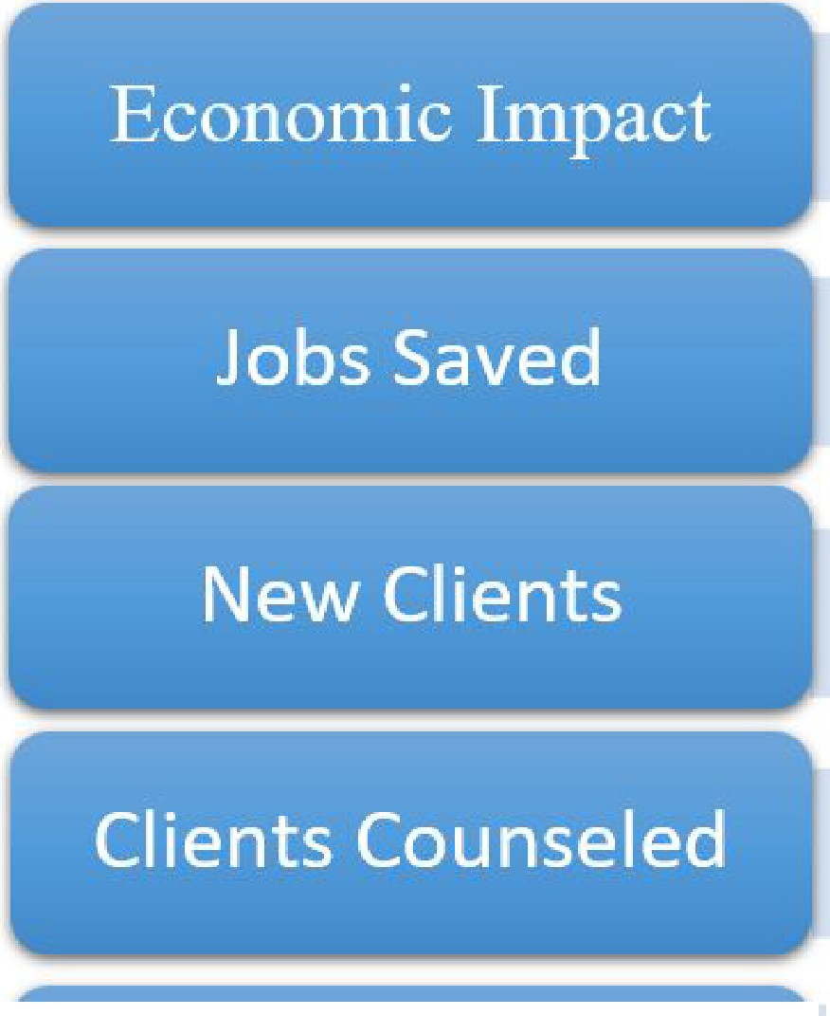
llion
$35 Mi
1,420
500
913 +
in EIDL & PPP

�ew':..•• � Tr..B_ ,'ur s• im• es� 's- " S••t• a� • �t�s 43


@)8NB Bank ,� Stony Brook University
College of Business
POWERED BY
I I
SBA
I I
US. Small Business Administratio11

The State University

of New York

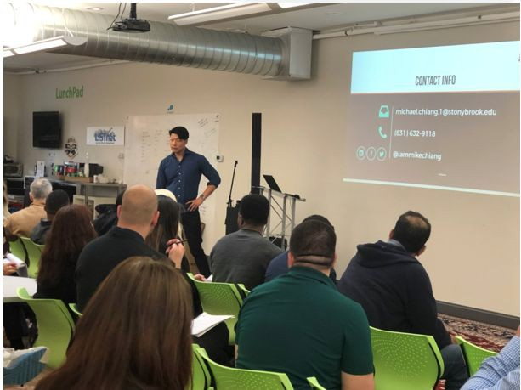

Stony Brook Small Business Development Center:
Helping You Start Up or Grow Your Established Business

The mission of the Small Business Development Center is to strengthen the small and medium size business community by providing customized business solutions through free and conﬁdential one-on-one business advisement, education, research and advocacy for entrepreneurs and innovators.

https://www.stonybrook.edu/commcms/sbdc/

What are seasonal businesses?

- A business dependent on weather
- A business that is linked to tourism or holiday seasons
- Agencies who get paid depending on client budget cycles
- A business that is busy because of a speciﬁc event or occasion
- Writers writing for magazines that get shorter during summer

Example...

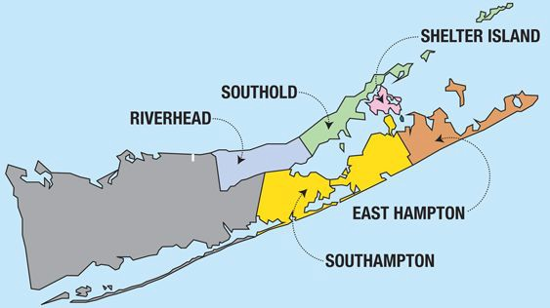

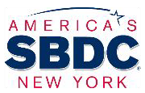


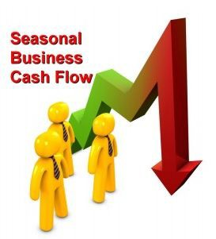
Common Problems of Seasonal Businesses

  - Poor cash flow
  - Difficulty on expense control
  - Inability to predict fluctuating cycles
  - Lack of staff during high season
  - Excess inventory at the end of the peak season
  - Lack of activity during low season
  - Not knowing what to do with free time during the offseason
  - Not knowing how to keep customers interested all year

Problem Solving

Cash Flow Management
  - Inventory Management
  - Off-Season Management
  - Reopening Guidelines

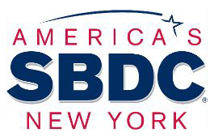
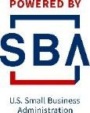

Accounting Basics

Balance Sheet:
What you own… What you owe… What you are worth…

Income Statement (Profit & Loss):
Reflecting ongoing operations

Cash Flow Statement:
Operation / Finance / Investment activities

CASH FLOW VS. NET PROFIT
Definition
r
!Financial performance of a company

Money co1ming in (Inflows)
vs..
Going out (Outflows)

Operational concept, look at your bank account!
Income from services or products
vs.
Cost to deliver them

Accounting concept, call your accountant!

What does it measure?

r
Sollvency, or the ability to pay a
company's bills

What are we aiming for?

Having posltlve cash flow
Being profitable

Income> Expenses

Inflows > 0 utflows


Cash Flow Management

- Do Cash Flow Forecast

- Manage Account Receivables

- Get help with financing for slow seasons

Cash Flow Management - Projection

Cash flow is the net amount of cash and cash-equivalents being transferred into and out of a business. It comes in three forms: operating, investing, and financing.

Cash flow can be quite fluctuating for seasonal business. It’s crucial to prepare the projection to gain additional insight about your business’s finance.

- Create a baseline for expenses
- Plan a year in advance
- Track as much as you can

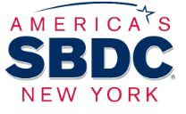
Cash Flow Management - Projection
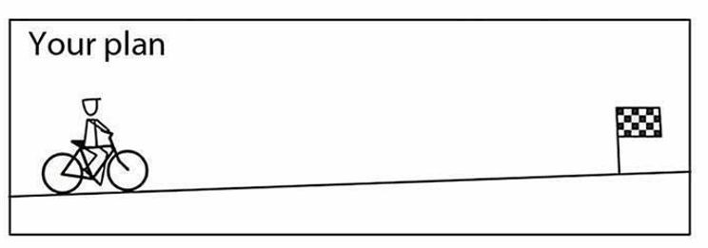
❏ Cash flow forecasting for all expenses requirements in the following season, anticipate future needs
❏ Guide and template
https://bench.co/blog/operations/cash
-flow-forecasting/

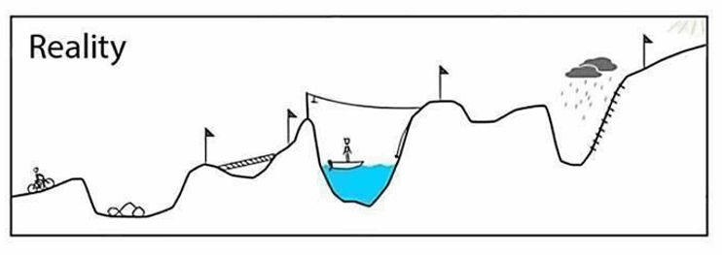
❏ Small business cash flow projection https://templates.office.com/en-us/s mall-business-cash-flow-projection
-tm16410107

Cash Flow Management





Stony Brook SBDC's Resiliency and Recovery Program Webinar
Cash Flow and Inventory Management Thursday Sept 24th

Cash Flow Management - A/R
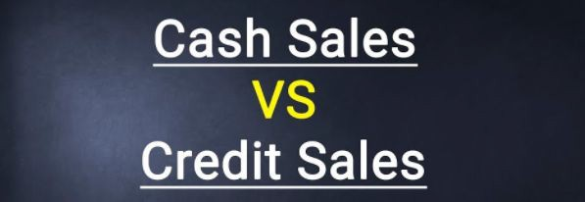
Accounts receivable (A/R) is the balance of money due to a firm for goods or services delivered or used but not yet paid for by customers.
- Send invoice soon after you make each sale
- Shorten the payment terms (net 10 )
- Offer incentive for early payment ( 2/10, net 30)
- For large sales, collect deposit in advance
- Follow up with late-paying customers

Cash Flow Management - Finance Options
The seasonality nature causes some months to be lower in sales, which, in turn, may causes cash flow issue.
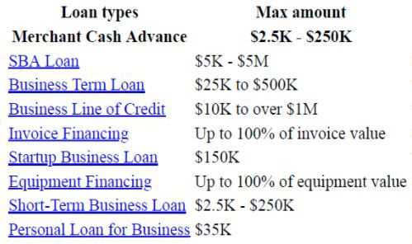

Problem Solving

  - Cash Flow Management

Inventory Management
  - Off-Season Management
  - Reopening Guidelines

Inventory Management
Inventory management refers to the process of ordering, storing and using a company's inventory.

Benefit:
- Avoiding lost sales
- Gaining quantity discounts
- Reducing COGS (cost of goods sold)
- Achieving efficient production runs

Inventory Management

- Track historical data and stay up to date on industry trends to develop plan on inventory level on peak season and the reordering point
- Keep good vendor relationship for low cost, and better payment terms
- Pay close attention to your top selling items
- Bundle items together and sell as a package deal
- Calculate your inventory storage expenses
- Know the lead-time from your various suppliers and make sure you have everything set up and ready for your peak season

Inventory Management
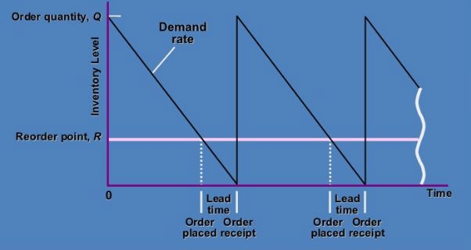
Reordering Point System:

Problem Solving

  - Cash Flow
  - Inventory Management

Off-Season Management
  - Reopening Guidelines

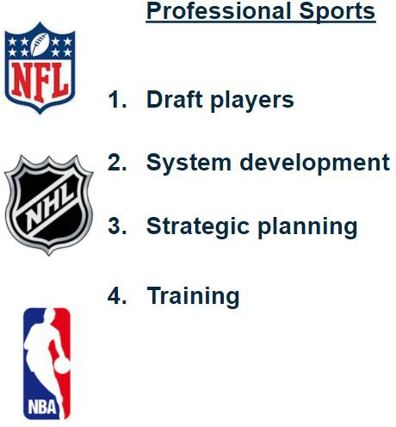
Off-Season Management

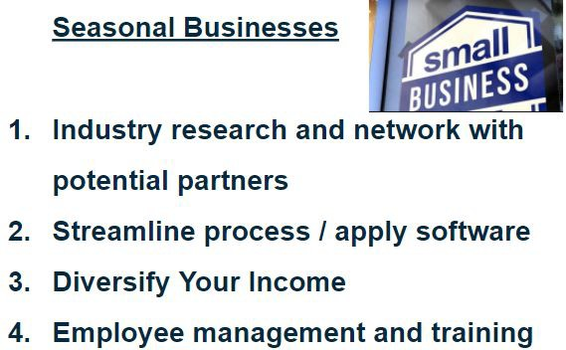

NYS Shared Work Program
https://dol.ny.gov/shared-work-program-0

Online Platforms to Create a Website





SquareSpace
Pros
-Easy To Set Up
-Great For Simple Stores
-Template Designs Provided
Cons
-Limited Ecommerce Integrations
-Limited Payment Gateways
-No Phone Support

GoDaddy
Pros
-Fastest and easiest to build
-Cheapest option
Cons
-Limited creative control
-Some features lack quality

BigCommerce
Pros
-Flexible and scalable
-Excels with multi-channel selling
-Strong SEO Performance Cons
-Inconsistent loading speed
-High volume stores pay more
-No one-Click Selling

Shopify
Pros
-Fastest Load Time
-Easy Set Up
-1-Click Selling Apps Available
Cons
-Weak SEO
-Checkout Not Customizable
-Apps Can Become Costly

Social Medias
#Create hashtags!




Stony Brook SBDC's Resiliency and Recovery Program Webinar
Social Media - Attracting and Retaining Customers
Tuesday Sept 29th

SBDC Stony Brook -

Small Business Tech Enhancement Program
The SBDC has partnered with Suffolk County Forward Program and Stony Brook University Colleges of Business and Engineering to assist Suffolk County small business owners enhance online technology capabilities. The Technology Enhancement Program will assess small businesses’ current technology profile, pinpoint needs, and assist in developing solutions

- Setting Up Contactless and Remote Payments
- Ensuring Websites are Mobile Friendly
- Managing Delivery Orders From Multiple Delivery Services

Phone : (631) 632-9837

Email: sbdc@stonybrook.edu

Problem Solving

  - Cash Flow
  - Inventory Management
  - Seasonal Employment
  - Off-Season management

Reopening Guidelines

Reopening

The COVID-19 pandemic has had devastating consequences to all types of businesses.

Federal: Paycheck Protection Program (PPP) Economic Injury Disaster Loans (EIDL)
NYS: NY Forward Loan Fund (NYFLF)

Reopening
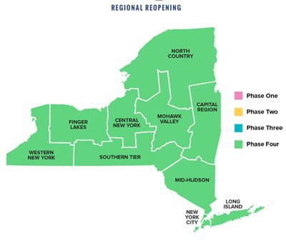
- Maintain a safety environment
- Utilize online platform
- Contactless Payment
- Innovation of products or services that can get customers engaging to increase sales
- Get necessary material only, do not overstock

CDC and NYS DOH Guidelines for Reopening
❏ COVID-19 Employer Health Screen Review Documentation Template ( Require by the NYS)
❏ https://www1.nyc.gov/assets/doh/downloads/pdf/imm/covid-19-health-screen-template.pdf

❏ Reopening Safety Plan (Required)
❏ https://www.governor.ny.gov/sites/governor.ny.gov/files/atoms/files/NYS_BusinessReopeningSafetyPlanTempla te.pdf
❏ COVID-19 Symptom Screening Tool Sample (required)
❏ https://www1.nyc.gov/assets/doh/downloads/pdf/imm/covid-19-symptom-screening-businesses.pdf
❏ CDC preparing for workplace guideline
❏ https://www.cdc.gov/coronavirus/2019-ncov/community/guidance-small-business.html
❏ New York Forward Business Reopening Lookup Wizard: A guided tool to help businesses determine if they are eligible to reopen

❏ https://www.businessexpress.ny.gov/app/nyforward

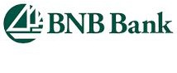
College of Business, Stony Brook University
Center of Entrepreneurial Finance
- College of Business COVD-19 Economic Recovery Assistance https://www.stonybrook.edu/commcms/business/about/_COV19-for-Business/
  - Virtual Expert Network Oﬃce Hours
  - Small Business Tech Enhancement Program
  - Pandemic Shift Business Survival Workshops
  - Videos, articles, and more
- Center of Entrepreneurial Finance COVID-19 Resources https://www.stonybrook.edu/commcms/cef/covid19resources/index.php
- COVID-19 Long Island Small Business Survival Guide https://tinyurl.com/coronavirusﬁnance

SBDC Stony Brook
Request an Appointment
Phone
(631) 632-9837
Email sbdc@stonybrook.edu



