
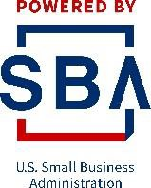

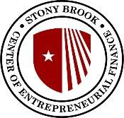



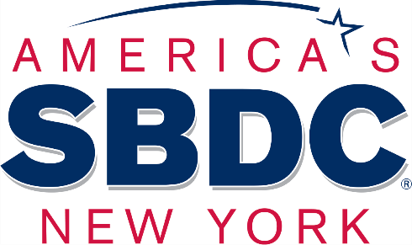
BNB Resiliency & Recovery Program

Sponsored by BNB Bank
Construction, Home Improvement, & Manufacturing

Presented by Robert B. Harrison, Business Advisor, MBA, CPIM
College of Business and Center For Entrepreneurial Finance
Research Assistants: Jacob Rueb & Jiawei Gao

BNB Resiliency and Recovery Program
Sponsored by BNB Bank
Center For Entrepreneurial Finance Program Advisors

Richard Chan, Ph.D.
Director, Center of Entrepreneurial Finance
Associate Professor, College of Business, Stony Brook University
Danling Jiang, Ph.D.
Associate Director, Center of Entrepreneurial Finance
Associate Dean for Research and Faculty Development
Professor of Finance, College of Business, Stony Brook University
Stony Brook SBDC Program Business Advisors

Ann Garbarino, Senior Business Advisor

Robert B. Harrison, MBA/CPIM Business Advisor Gifty Oduro-Ostrander, MBA, Business Advisor Brenda Zhang, MBA/CPA, Business Advisor Ronni Rosen, Senior Business Advisor
College of Business Program Advisor

Margot Palermo – Director, Business Honors Program


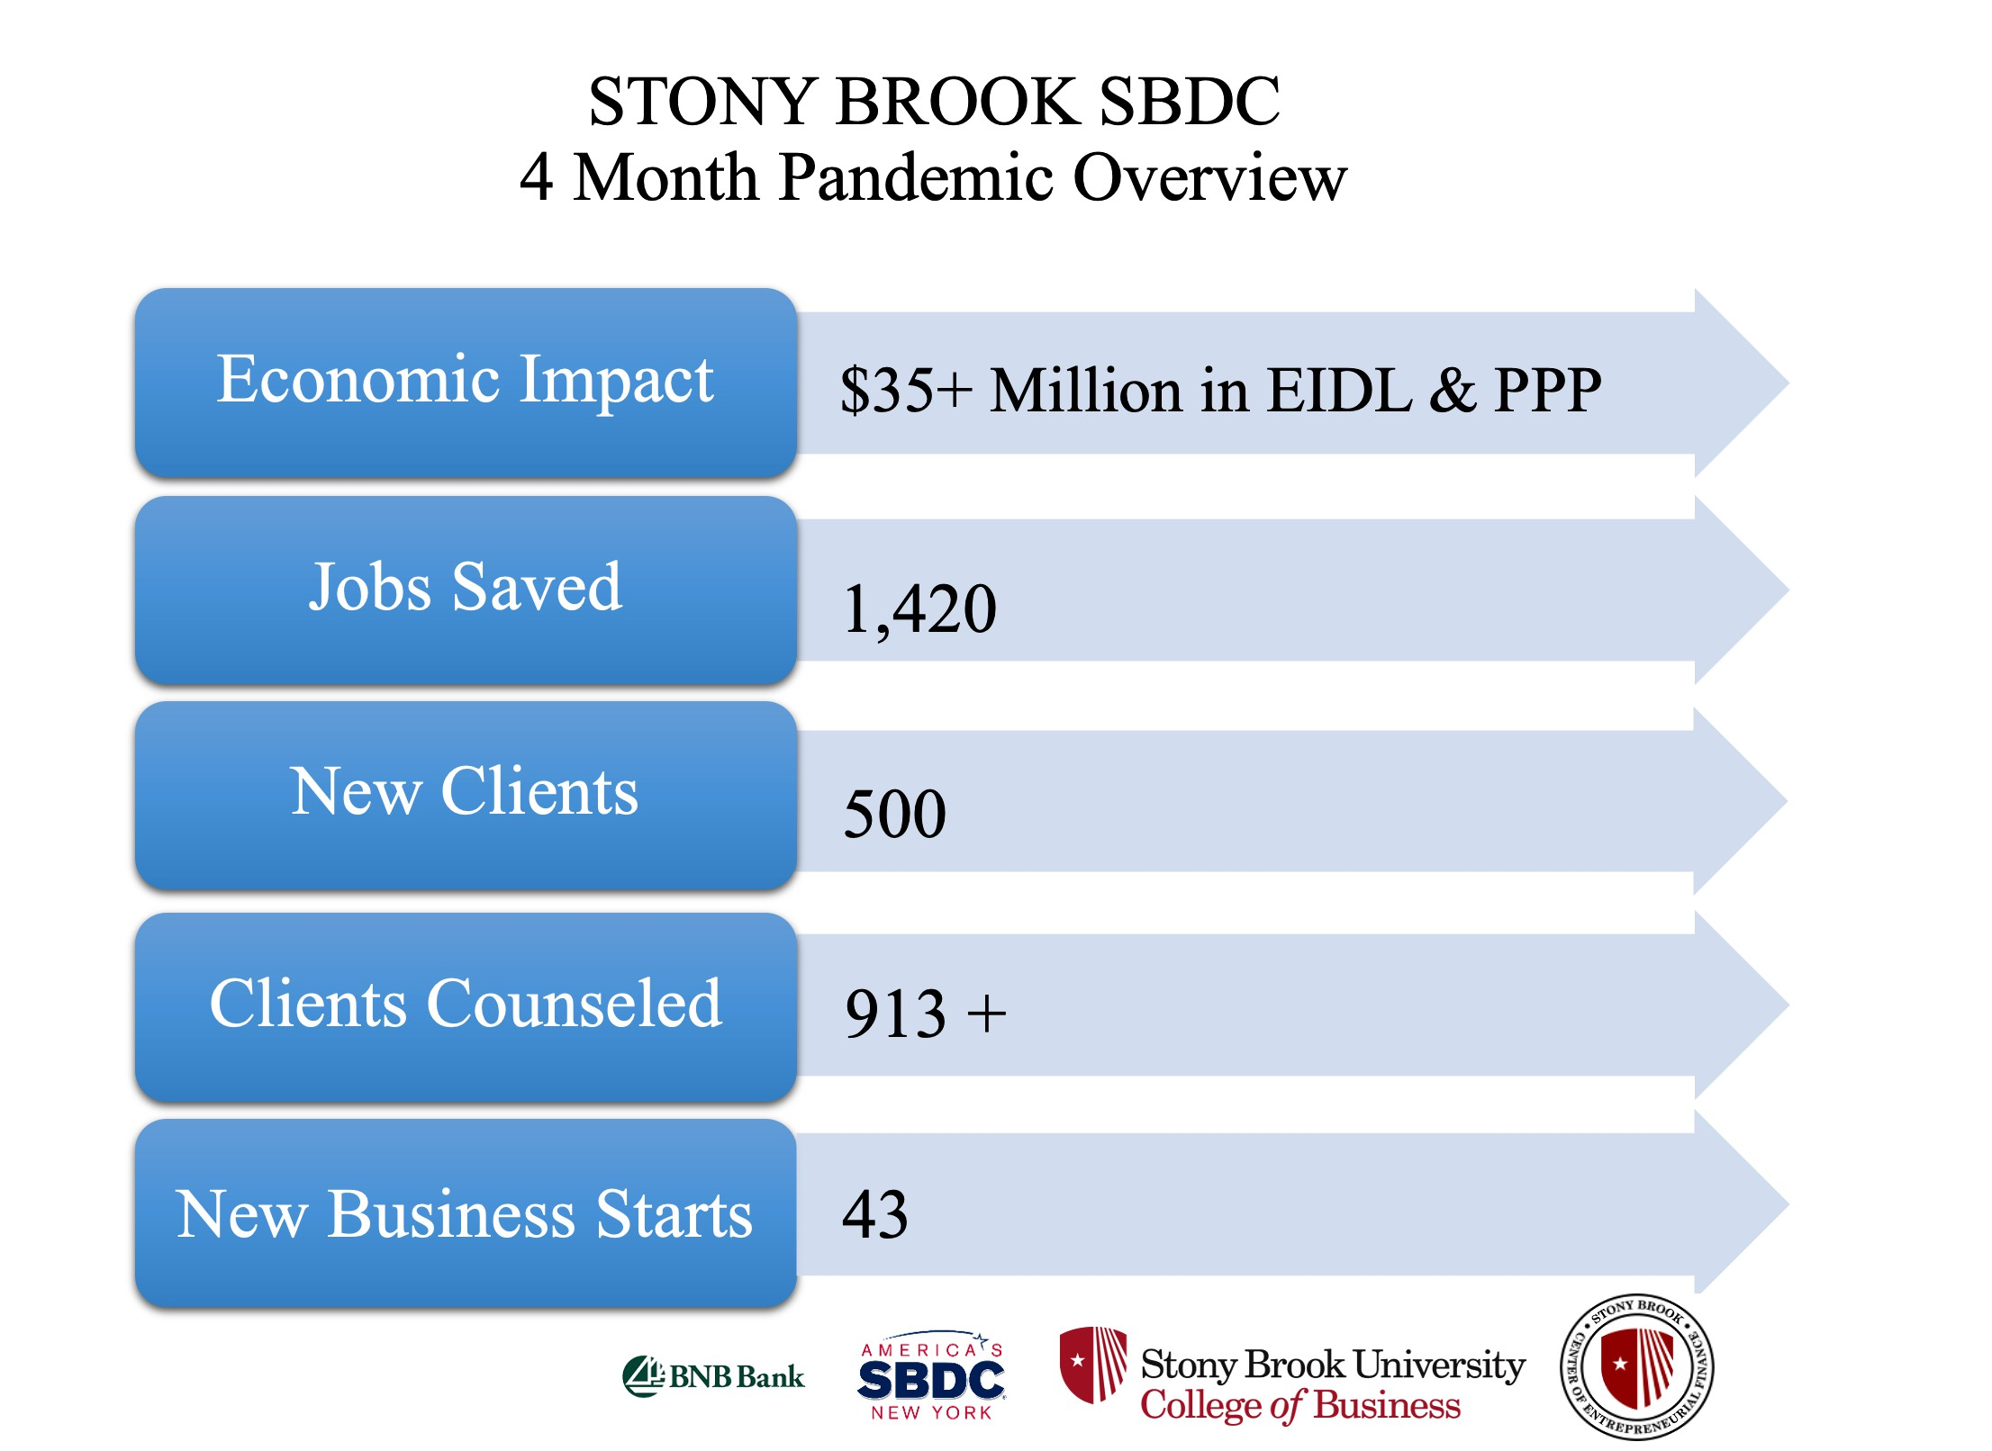

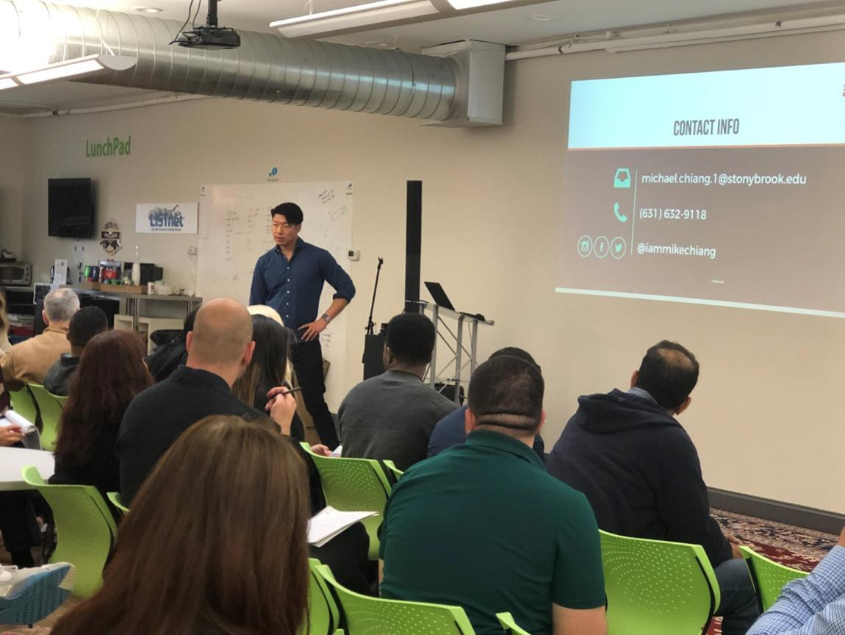

Stony Brook Small Business Development Center: Helping You Start Up or Grow Your Established Business

The mission of the Small Business Development Center is to strengthen the small and medium size business community by providing customized business solutions through free and confidential one-on-one business advisement, education, research and advocacy for entrepreneurs and innovators.

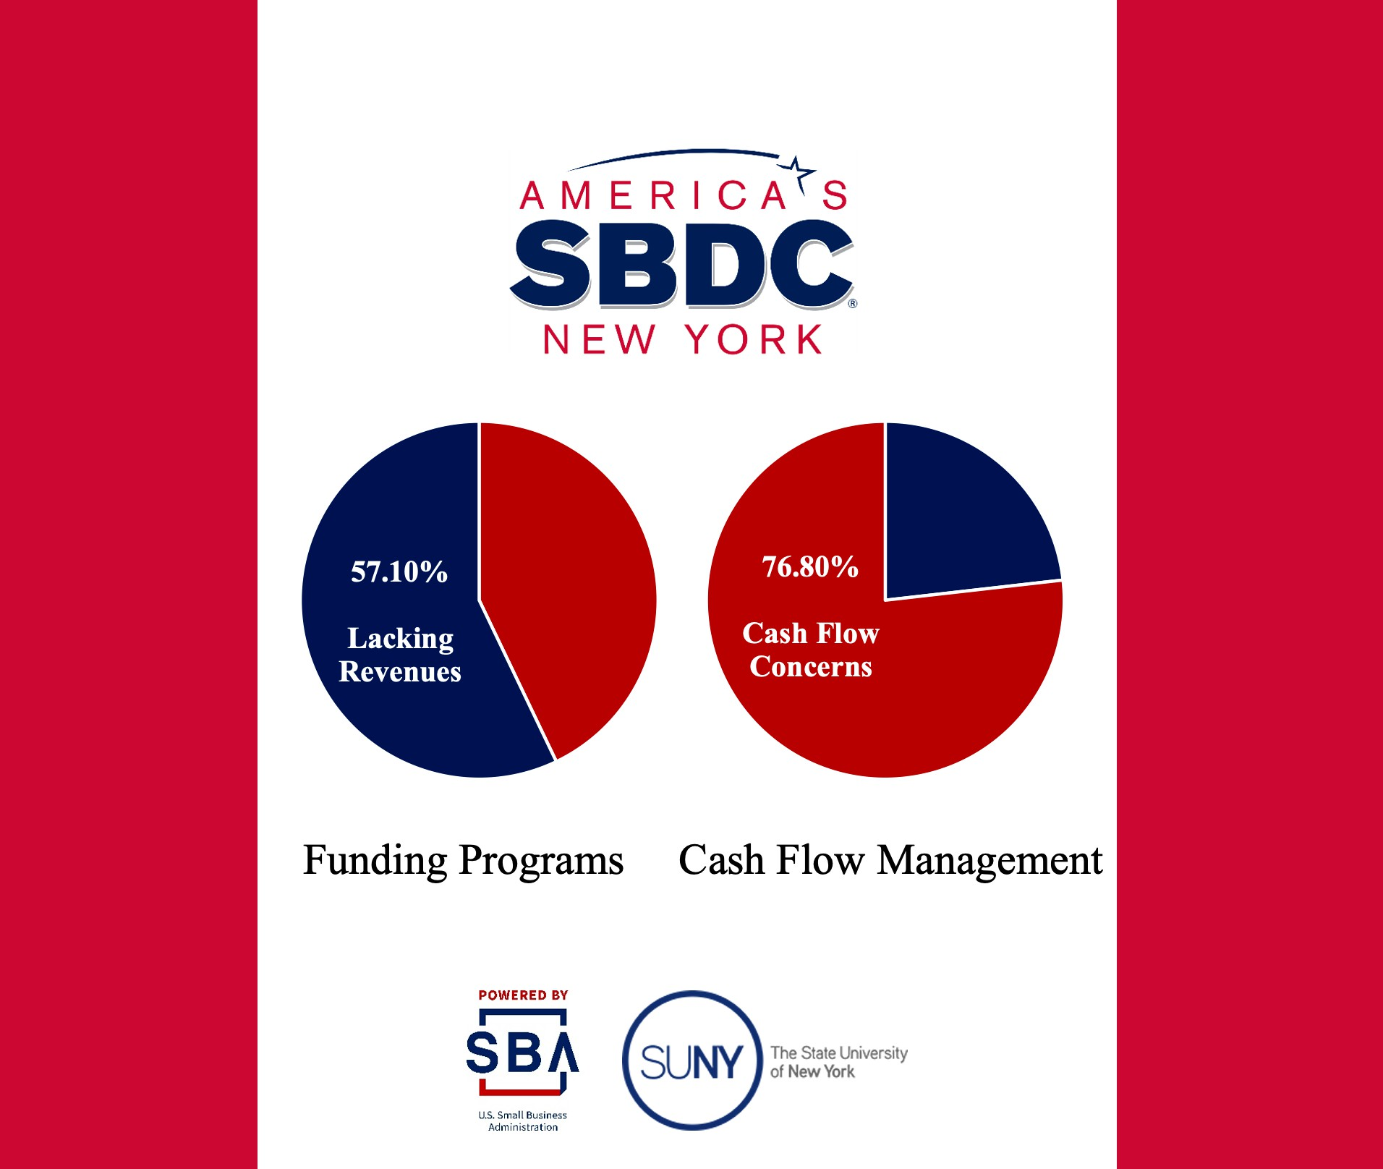

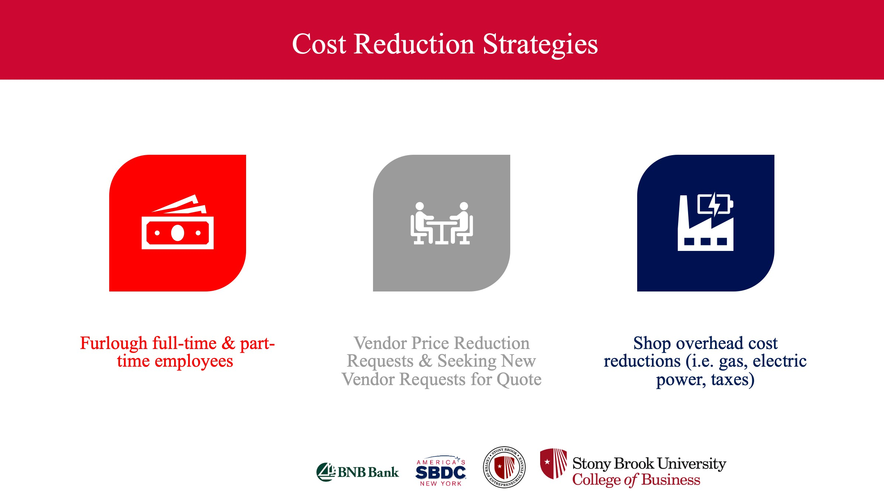

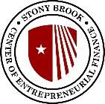

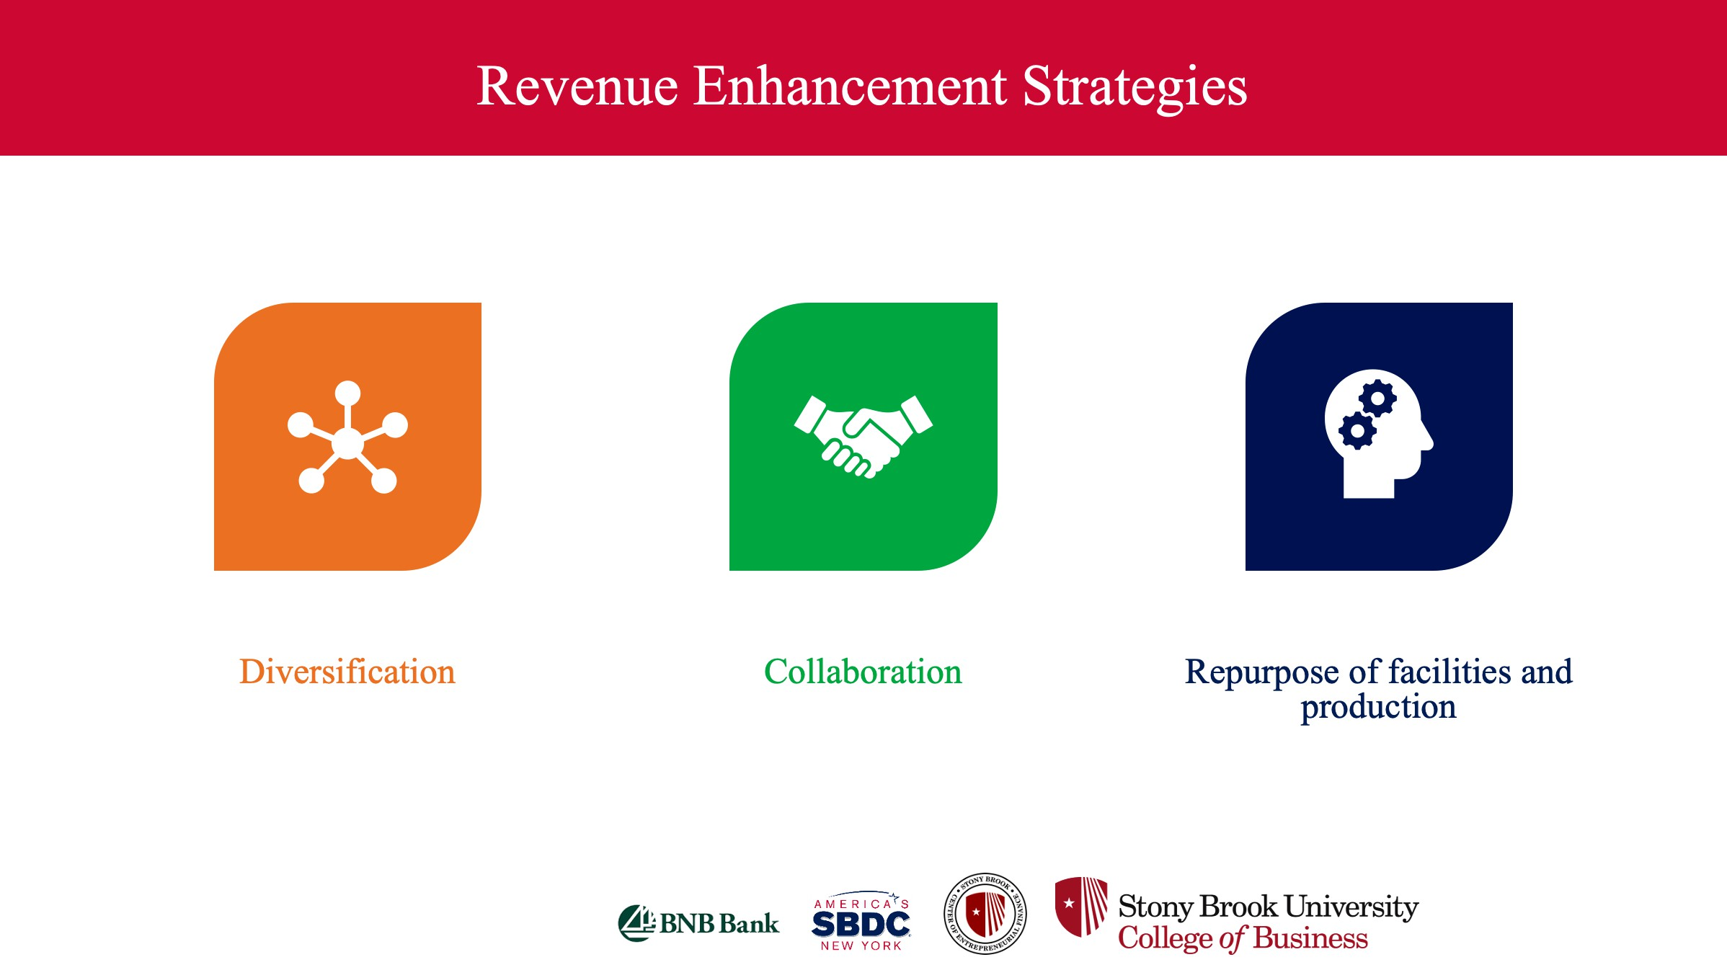
Revenue Enhancement Strategies



Diversification Collaboration Repurpose of facilities and production

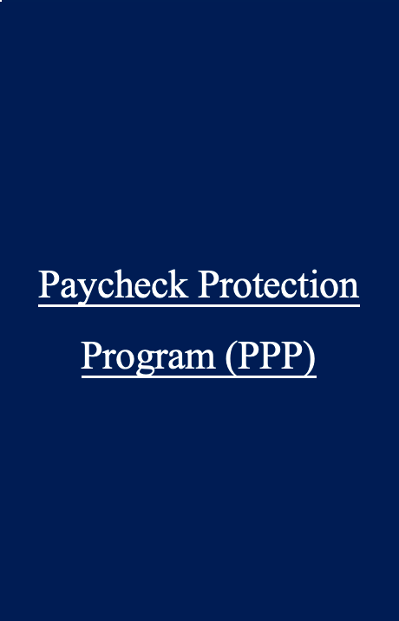

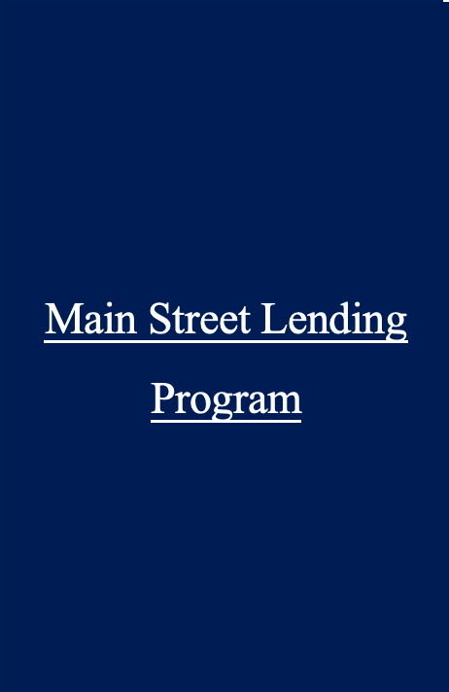
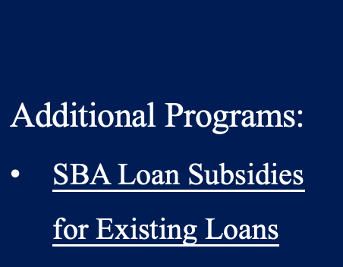

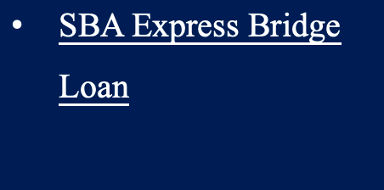
Federal Funding Programs
Click to edit Master
title style
Click to edit Master
title style
Click to edit Master
title style
Click to edit Master
title style

Economic Injury Disaster Loan Program (EIDL)

Paycheck Protection
Program (PPP)

Main Street Lending Program

Additional Programs:
- SBA Loan Subsidies for Existing Loans
- IRS Employee Retention Credit
- SBA Express Bridge
Loan

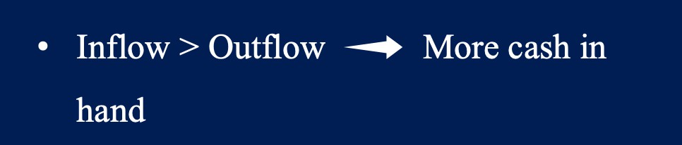
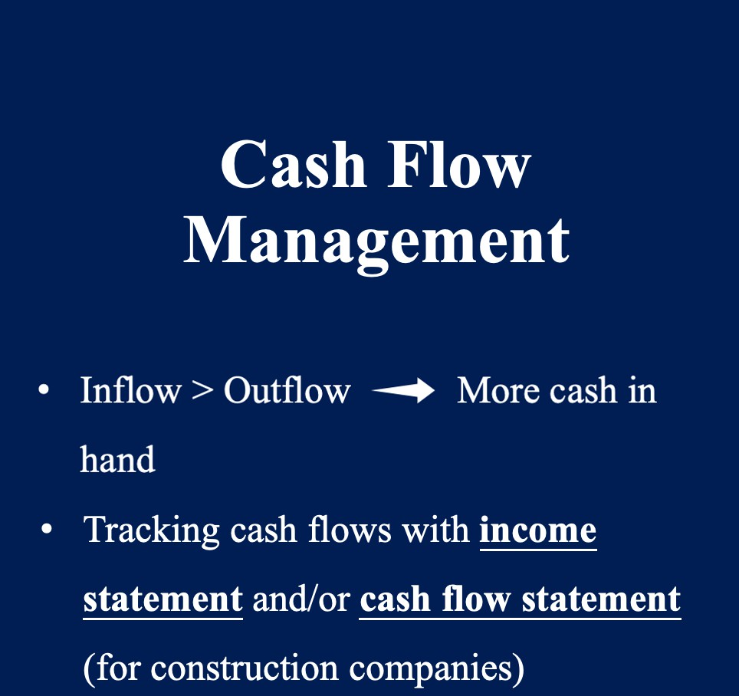
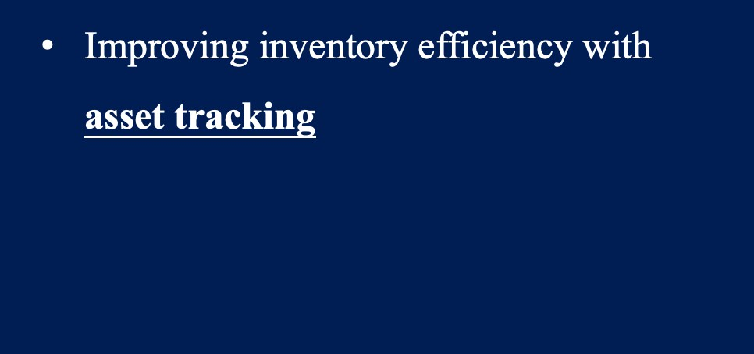

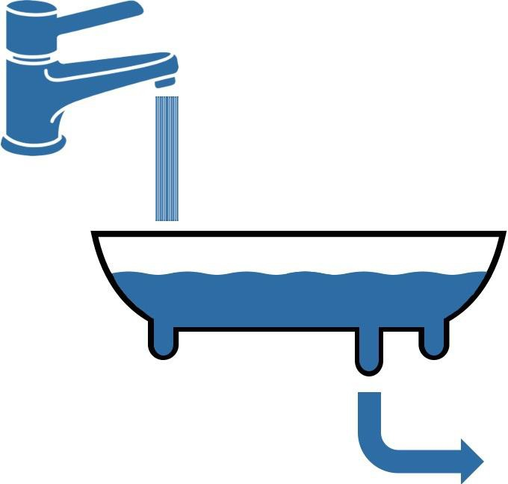
Cash Flow Management
Cash inflow
(Revenue from sales)
(Loans from funding programs)
Cash in hand
Cash outflow
(Costs of materials)
Target: manage
outflows wisely

- Inflow > Outflow More cash in hand
- Tracking cash flows with income statement and/or cash flow statement (for construction companies)
- Improving inventory efficiency with
asset tracking

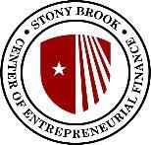

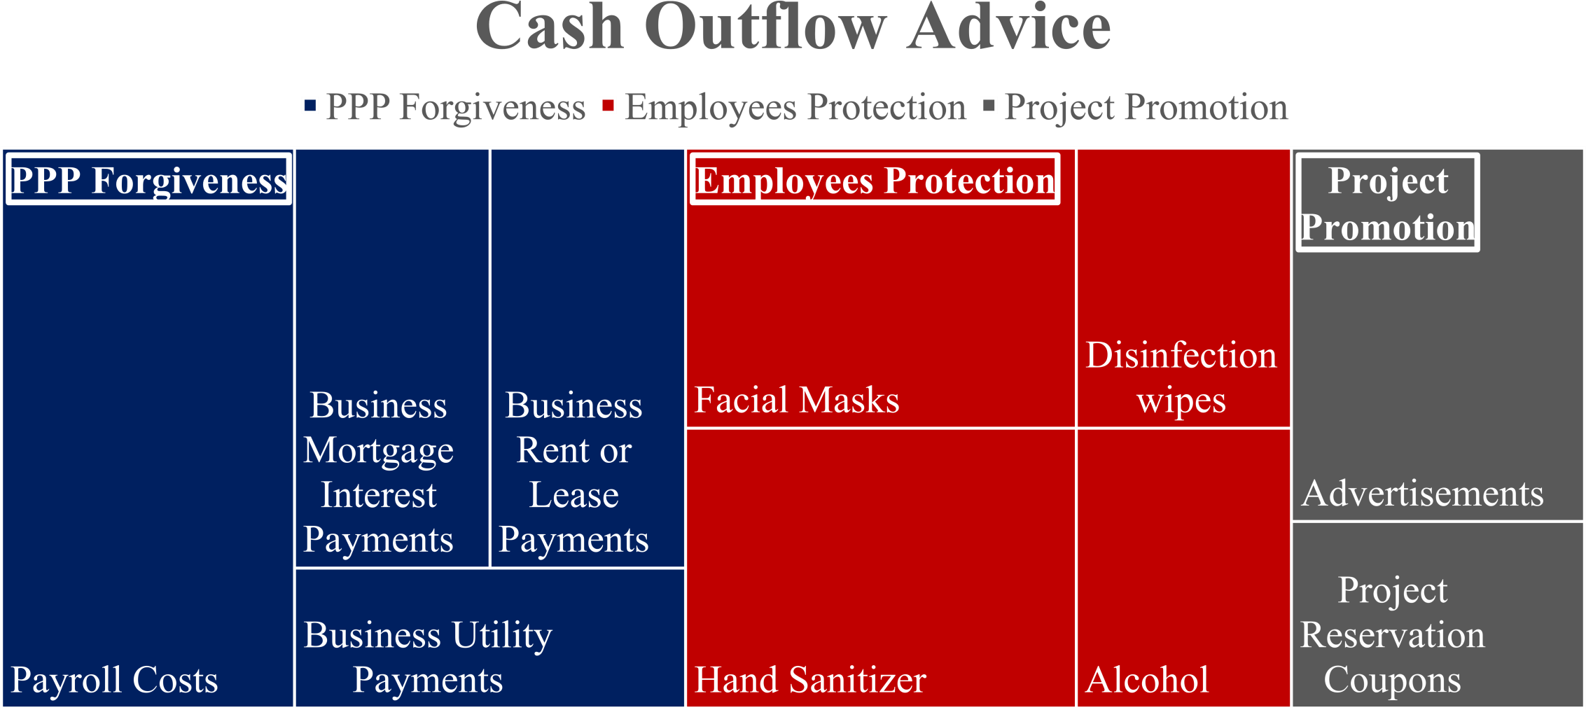
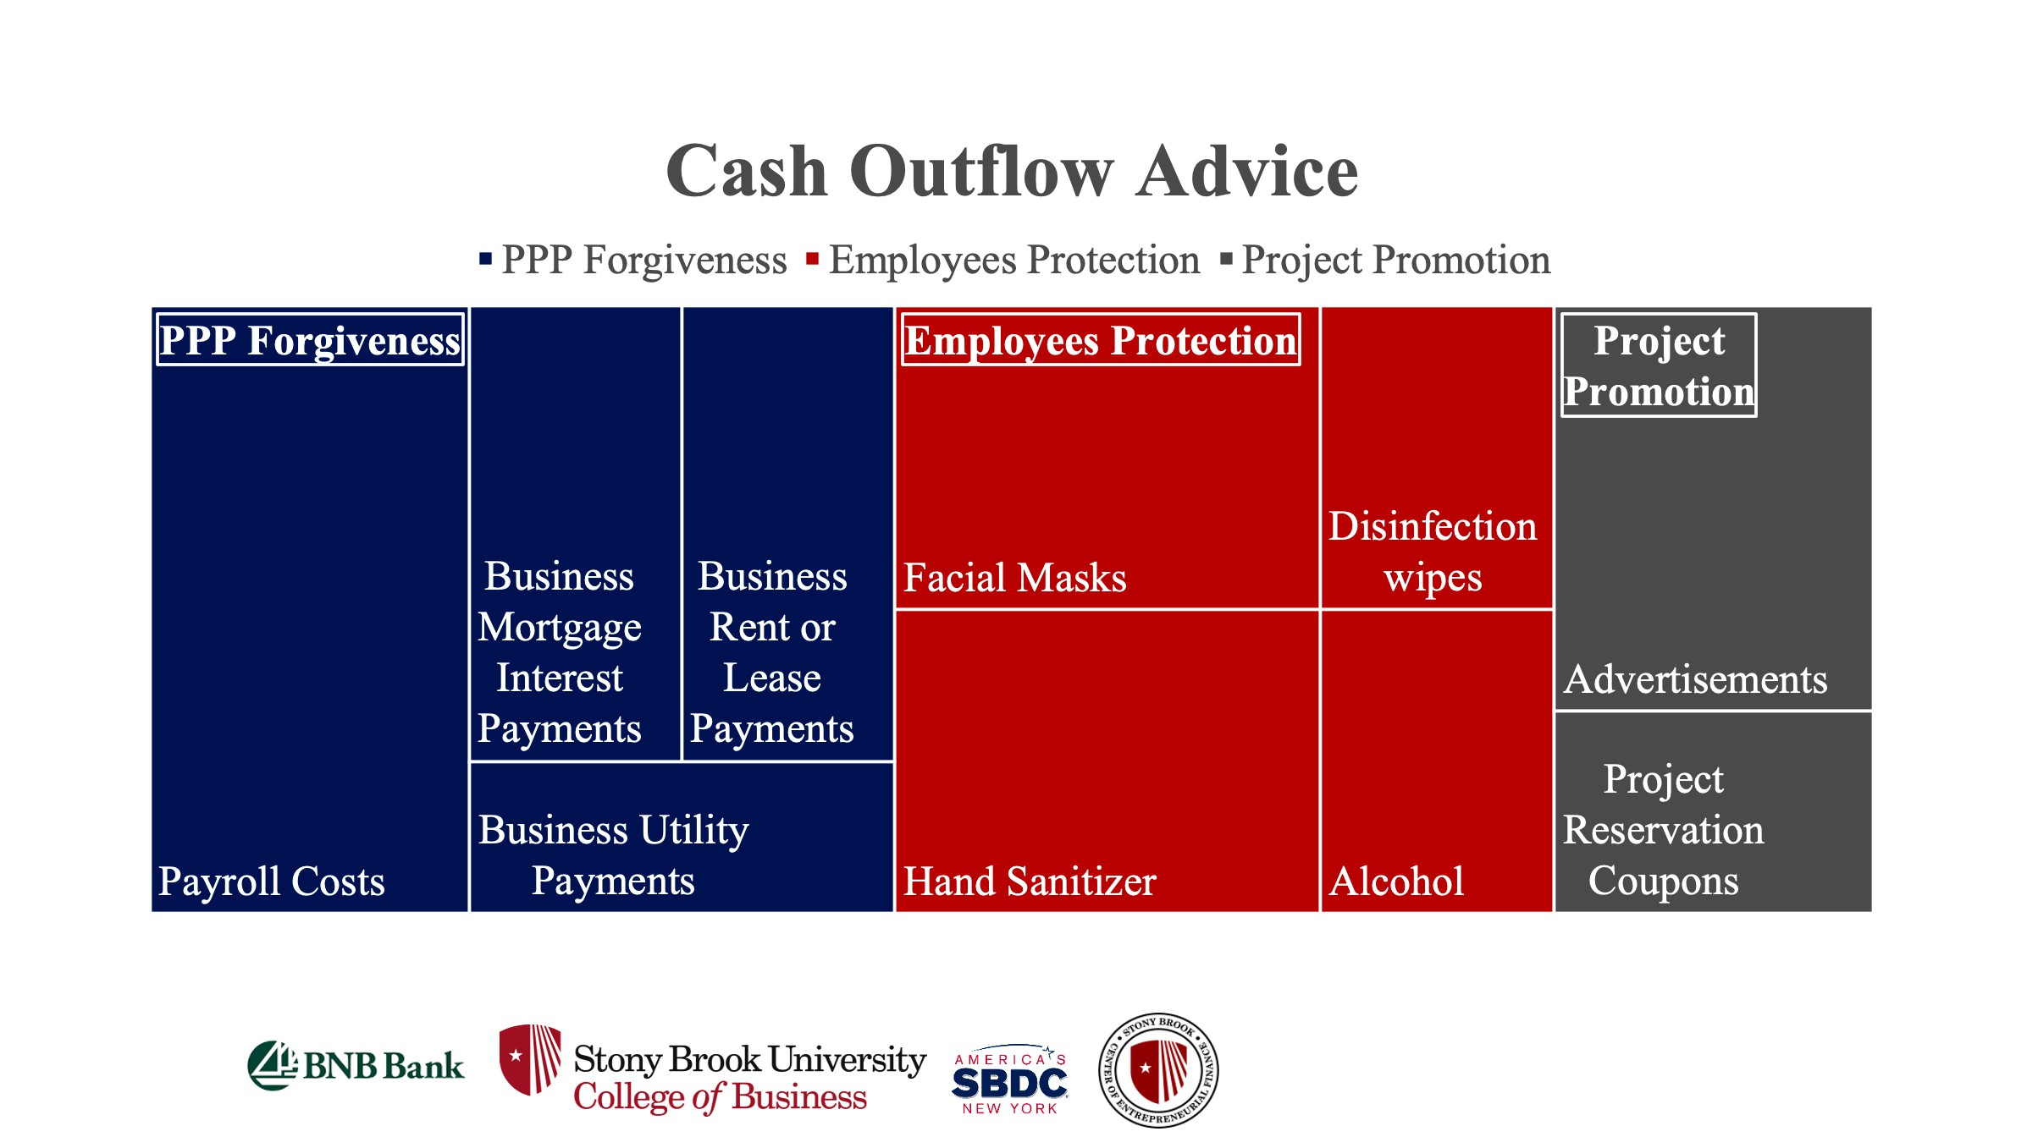

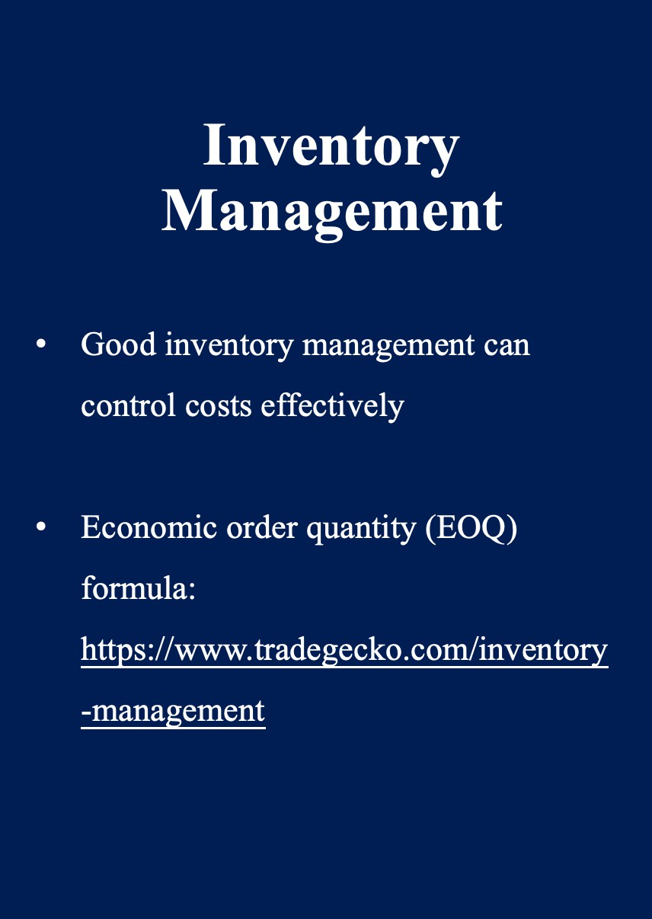
Inventory Management
- Good inventory management can
control costs effectively
- Economic order quantity (EOQ)
formula:
https://www.tradegecko.com/inventory
-management

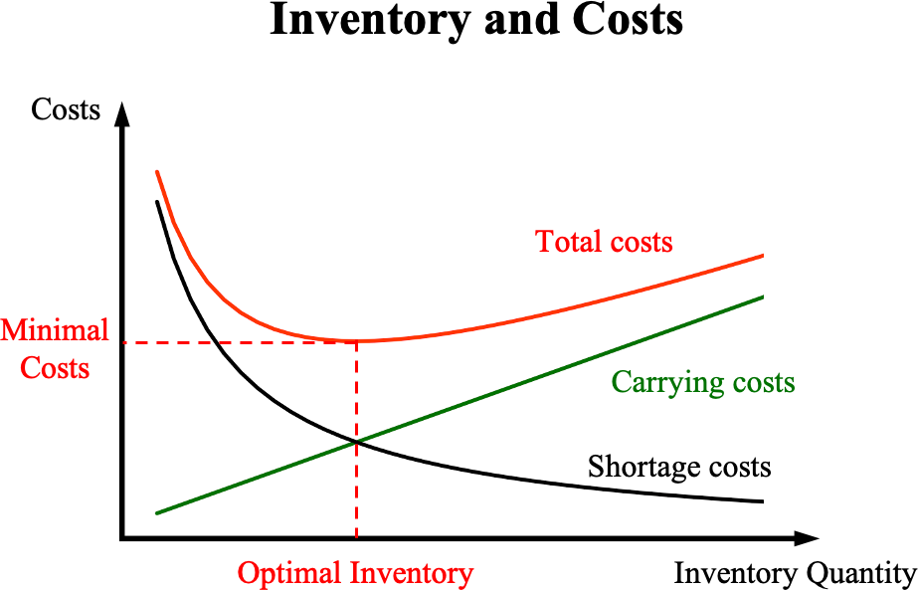

Re-opening Guidance
Click to edit Master
title style
Click to edit Master
title style
Click to edit Master
title style
Click to edit Master
title style







Rules and Regulations

Re-hiring

Re-engaging and Re-deploying

Plan for future

Re-opening Rules and Regulations

- Essential business are not subject to the in-person restriction Are you essential? The guidance of eligibility and compliance: https://esd.ny.gov/guidance-executive-order-2026

- Reopening in 4 phases - Construction industry is in the 1st phase: https://forward.ny.gov/phase-one-industries



Re-Hiring: Check List

- I-9 and/or E-Verify: https://www.uscis.gov/i-9-central

- W-4 (Employee’s Withholding Certificate for federal taxes):
https://www.irs.gov/forms-pubs/about-form-w-4

- IT-2104 (Employee’s Withholding Certificate for NYS taxes):
https://www.tax.ny.gov/forms/withholding_cur_forms.htm

Re-Hiring: Check List

- Wage notifications: https://labor.ny.gov/workerprotection/laborstandards/work prot/lshmpg.shtm
- Employee rights notifications: https://www.dol.gov/sites/dolgov/files/WHD/posters/FFC RA_Poster_WH1422_Non-Federal.pdf
- Report all new AND re-hires to NYS within 20 days of the
hiring date via https://www.nynewhire.com/#/login



Re-engaging and Re-deploying

  - Prioritize planning, well-being and
communication
  - Focus on employee experience, engagement
and motivation
  - Balance short-term cost concerns with medium-term resilience and rebound
  - Ensure responsible work redesign

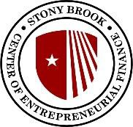

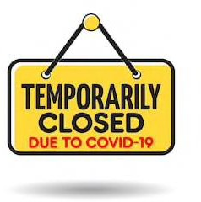
Plan for the Future

Website updates

Refining employee policies

Upgrading systems or facilities

Adjusting Your Digital Marketing Strategy Post-COVID-19

Improve website user experience

Transition from traditional to digital
advertising platforms
Interact with customers – Read and respond to reviews from your customers, and post photos that show off what you do

Manage the information that Google users see when they search for your business, or the products and services that you offer

Optimize online business – add services and products, enable online transactions
Understand and expand your presence – How customers searched for you and where they are coming from

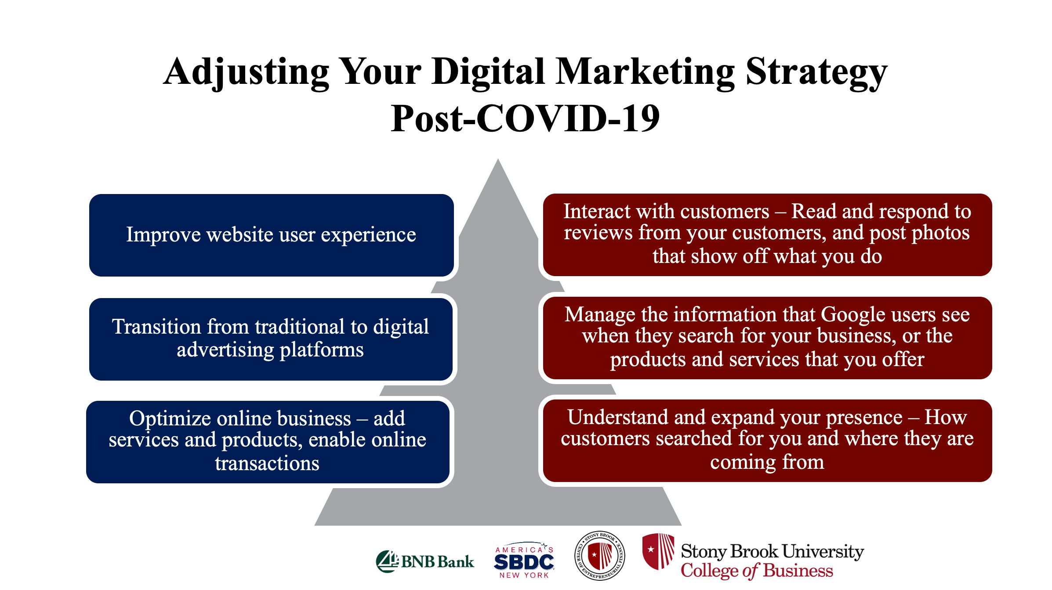

Pay-Per-Click Advertising Options
- Advertisers are only charged when a search participant clicks on an ad
- Online advertising that allows advertisers to target specific sets of keywords or audiences in order to drive
traffic to a website

Search Ads- appear at top and bottom of search results pages
Display Ads – appear on 2 million display network websites

Social Ads – appear in social media feeds
Remarketing Ads – serve ads to people who have visited your website


Google Shopping – ads appear in a carousel on a Google search result page
Google Sponsor Promotions – ads appear at the top of a user’s mailbox

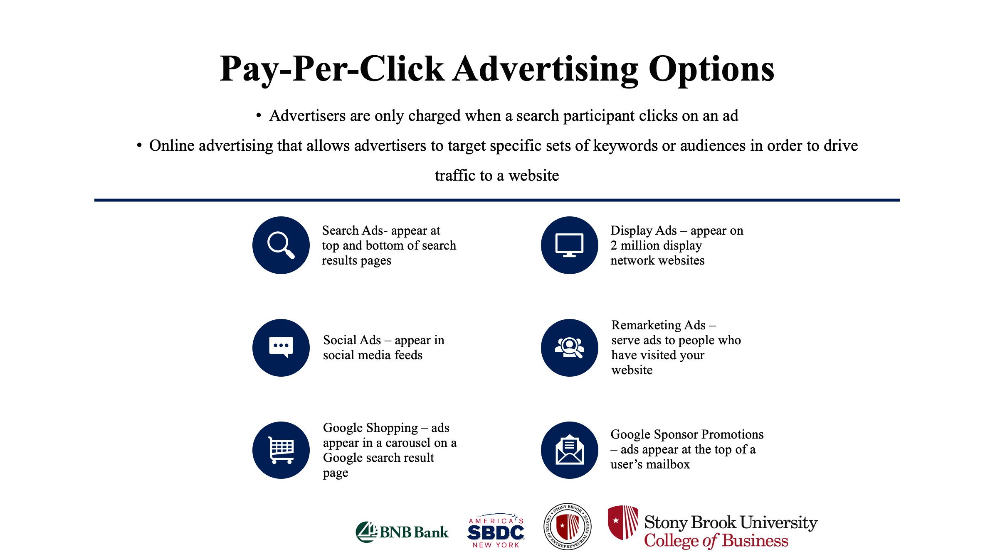

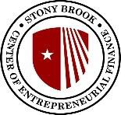




Request an Appointment
Stonybrook.edu/sbdc
Phone : (631) 632-9837
Email: sbdc@stonybrook.edu

