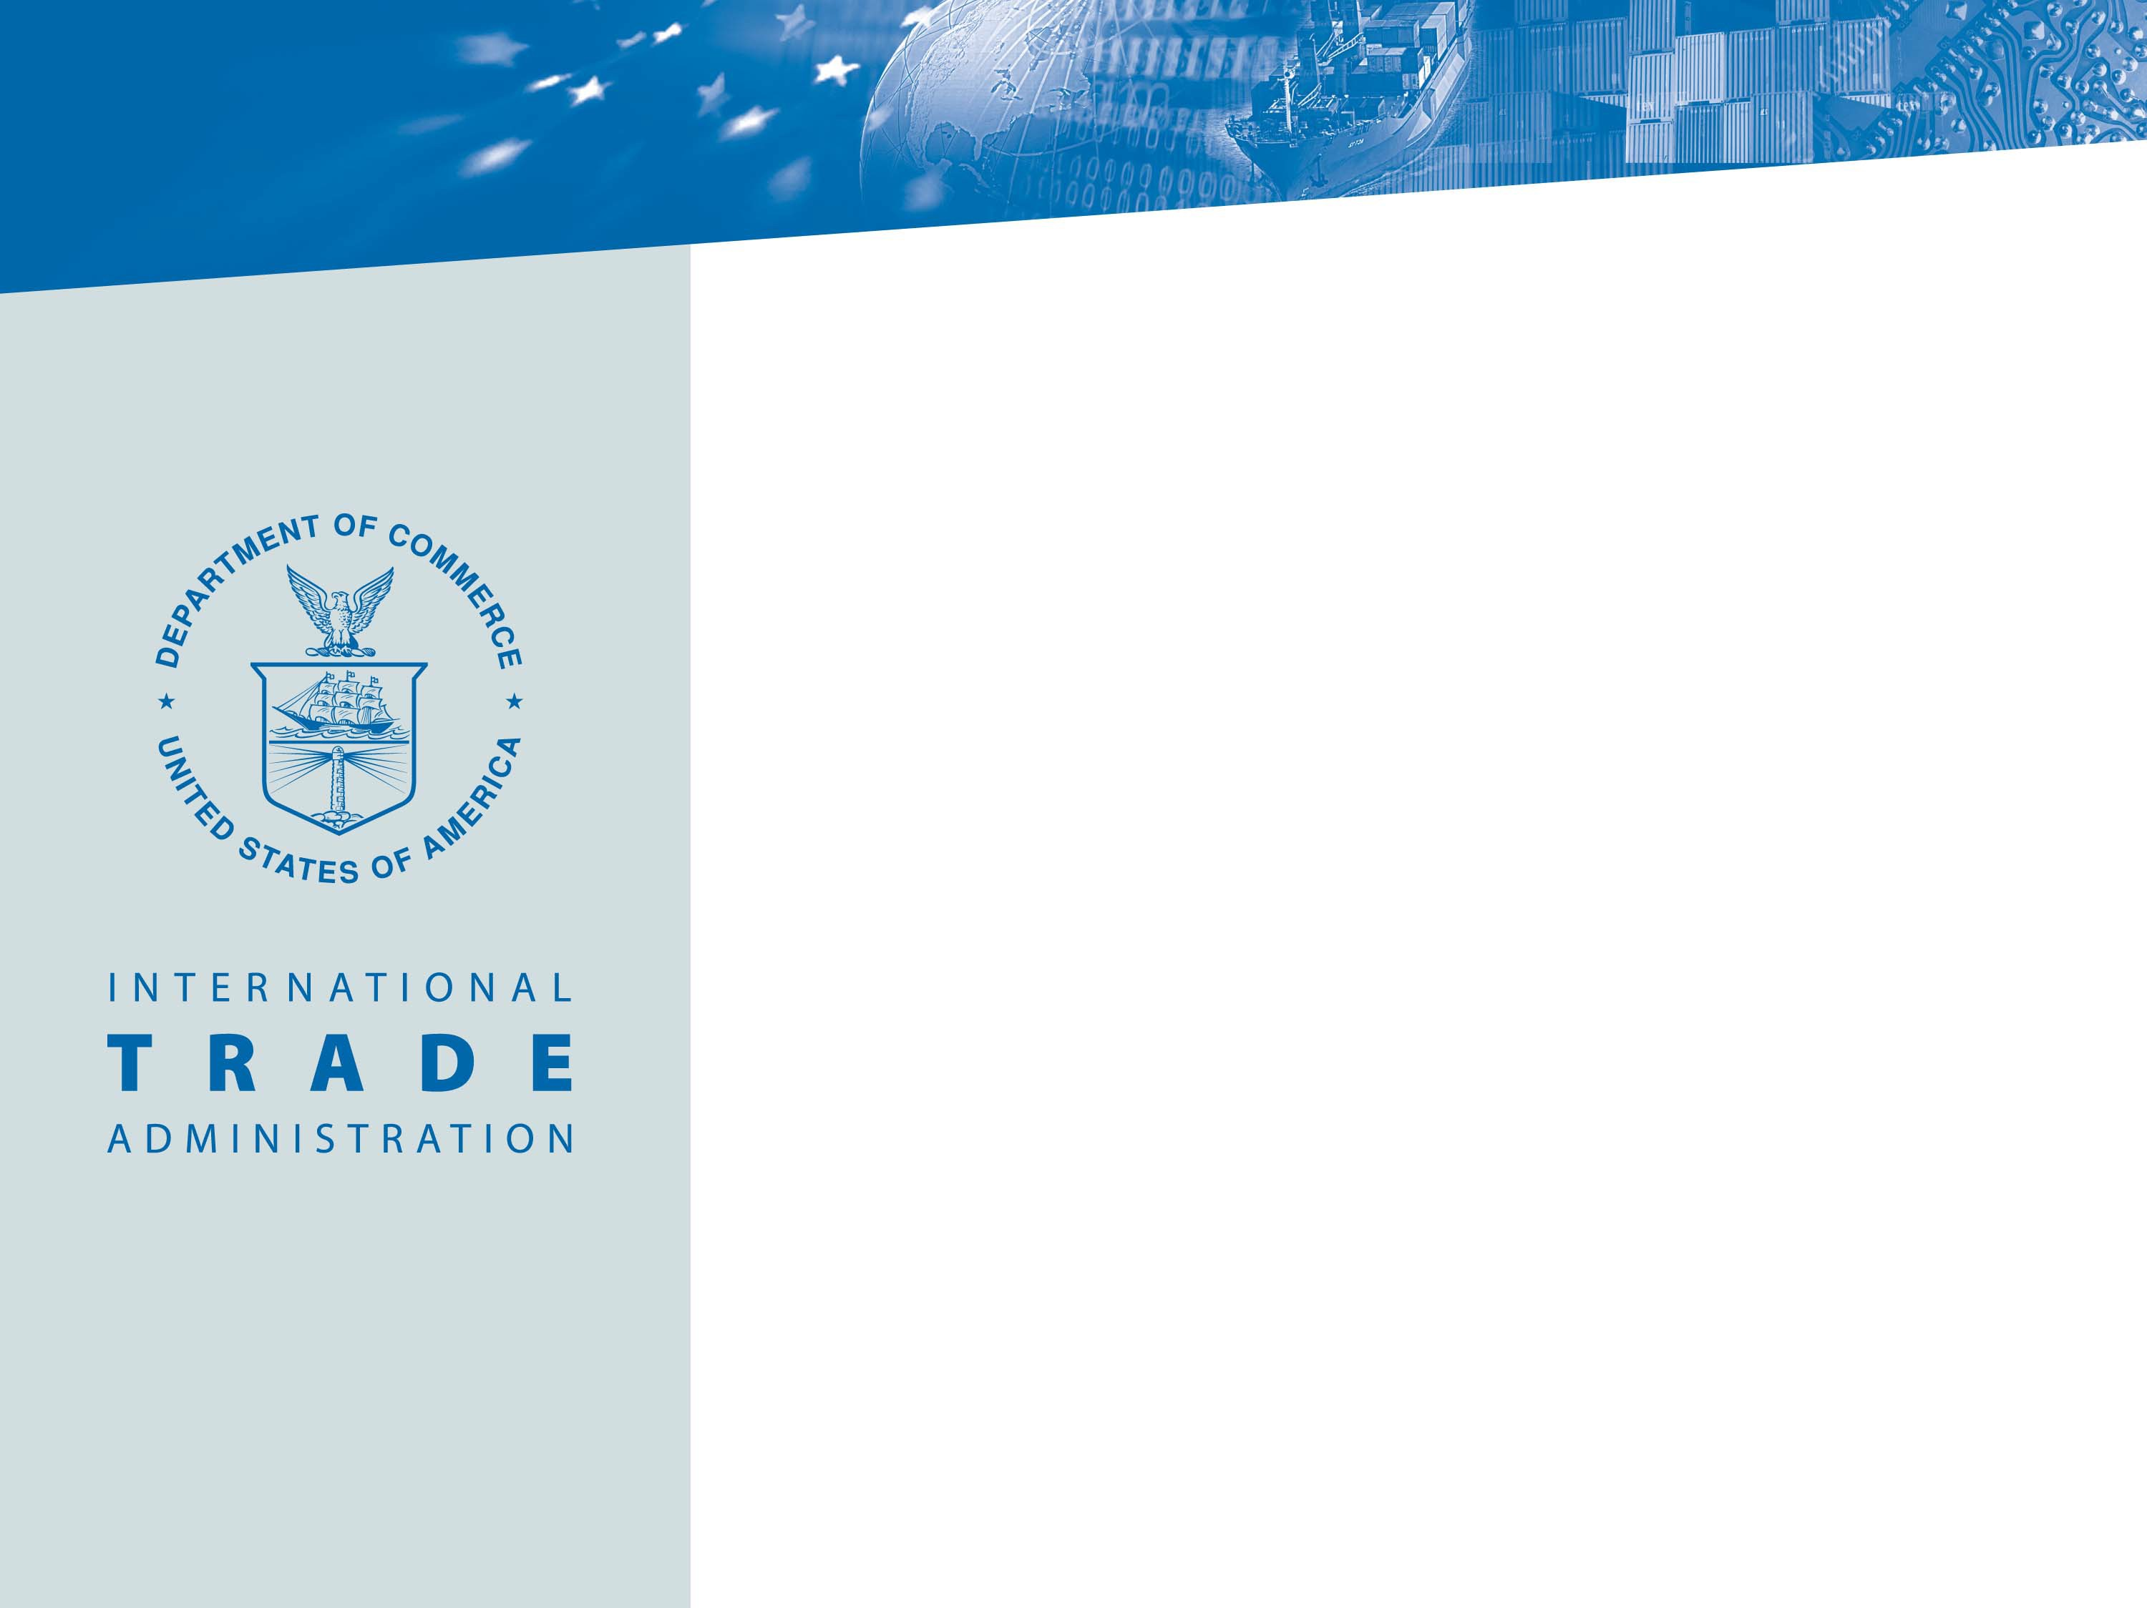

The Advocacy Center
Presented by:

Malcolm Burke, Regional Manager, Advocacy Center

October 2021


Official Advocacy

The Advocacy Center exists at the intersection between business and foreign policy, where commercial diplomacy efforts are required to let U.S. business compete fairly.

Our mission is to coordinate U.S. Government resources and authority in order to level the playing field on behalf of U.S. business interests as they compete against foreign firms for specific international public contracts, both civilian and defense sales.

The Advocacy Center also has Commercial Service liaisons to five Multilateral Development Banks to assist U.S. firms and advocate on their behalf when they compete for Bank tenders.

2

Advocacy is:

- Government-to-Government (G2G)

- A counter-weight to foreign government political pressure

- Intended to promote fairness in the tender processes

The Advocacy Center and Advocacy Policy were developed for project-focused, company specific issues.

.

Advocacy Questionnaire

  - Project Description
    - Type of Project / Transaction
    - Estimated Total Value
    - Estimated U.S. Content
    - Project Partners and/or Bidder of Record
    - Overall Effect on U.S. Economy
  - Type of Assistance Requested
  - Foreign Government Decision Maker
  - Timeline

Anti-Bribery Agreement

- Attached to the Advocacy Questionnaire
- Signed by the Bidder of Record
- Attesting that the company and its affiliates:
  - Have not and will not engage in the bribery of foreign public officials in connection with the matter for which advocacy assistance is being sought; and
  - Maintain and enforce a policy that prohibits the bribery of foreign public officials
- Advocacy Questionnaire and Anti-Bribery Agreement can be
accessed at http://www.trade.gov/advocacy/ under the “How to Apply” section

National Interest Determination

- Based on Material Benefit to the U.S. Economy
- When the U.S. content is less than 50% of total value, other considerations include:
  - U.S. Materials and Equipment Content;
  - U.S. Labor Content;
  - Contribution to the U.S. Technology Base (including R&D); and
  - Potential for Follow-On Business Benefiting U.S. Economy.
- All companies that apply for advocacy and whose bids are deemed to be in the U.S. National Interest shall be advocated for equally.

Applicant Responsibilities

- Apply in a timely manner to allow sufficient time for the Advocacy Center to conduct its review in coordination with other agencies

- Inform the Advocacy Center of new developments, including the conclusion of the competition or the applicant’s withdrawal from the competition

- Respond promptly to requests for additional information from the Advocacy Center

Advocacy Strategies

The Advocacy Center is the gateway to U.S. government advocacy at various levels. Advocacy is always government-to-government and typically addressed to the advocating official’s direct counterpart.




Ambassador, DCM
- Staff-level decision-makers
- Ministers, Cabinet-level officials, Heads of State
- Chief executives at the sub-national-level
Cabinet Secretary
- Ministers, Cabinet-level officials, Heads of State
President
- Heads of State
Senior Commercial and Economic Officers
- Staff-level decision-makers
- Sub-cabinet officials

Advocacy Center Contact Info

Website: www.trade.gov/advocacy

  - List of Regional Managers
  - Advocacy Questionnaire
  - Advocacy Guidelines & Policy

