



College of Business

1

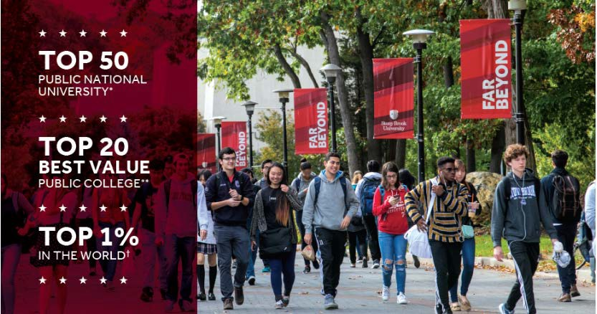

College of Business Programs
- 36 Credit MBA for students with Bachelors in Business
- 48 Credit MBA
- MBAs in Accounting Finance, Marketing, Health Care Management plus “general” MBA
- MBA concentrations in Innovation and Operations Management
- 30 Credit MS programs in Accounting and Finance
- MS in Human Resources Management in SPD
- AGC in Finance
- CPA Track Accounting Program: Minor, MBA & MS in Accounting

3

Stony Brook MBA Program
- 36-48 credit program completed at student set pace
- Students with undergraduate degree in business may qualify for 36 credit program
- Start in Fall, Spring or Summer
- Program and concentration options in Management, Finance, Marketing, Accounting, Healthcare Management, Operations Management and Innovation.
- Classes meet once or twice a week.
- Saturday, weeknight and online class options.
- Students are from large and small organizations from across Long Island.
- Taking applications for Fall until July 1.

Faculty Profile

  - 40 Full-Time Faculty Members

    - 15 Adjunct Faculty Members

      - 11 Staff Members
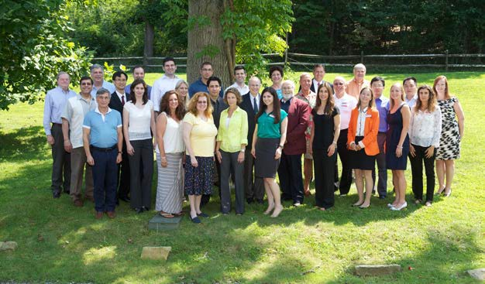

Enrollments

Undergraduate
Business Majors | 1338
Business Minors | 171
Accounting Minors | 87
Entrepreneurship Minors | 6

Graduate
MBAs | 305
Full-time | 173
Part-time | 132
MS in Accounting | 29
MS in Finance | 7
AGC in Finance | 11

6

Hallmarks of SBU Business Degree

- Active/experiential learning for career preparation
- Innovation and Entrepreneurship
- Strong faculty support/involvement

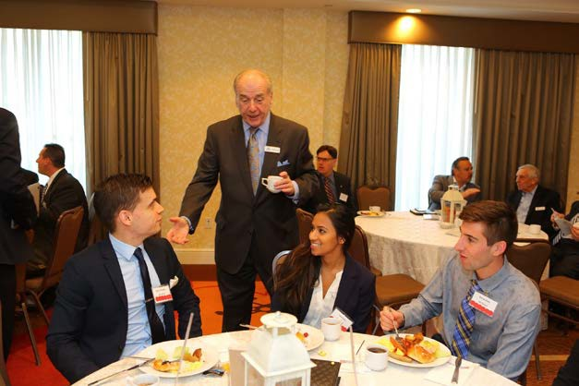
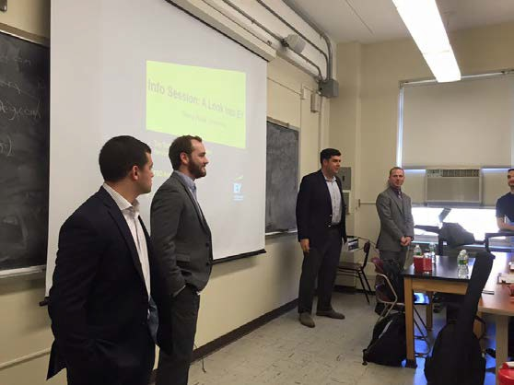

7

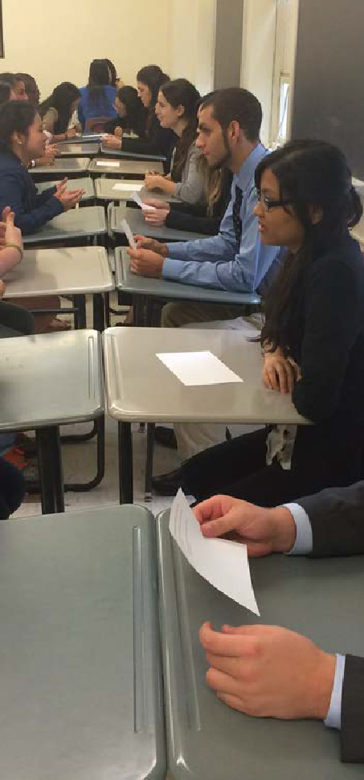
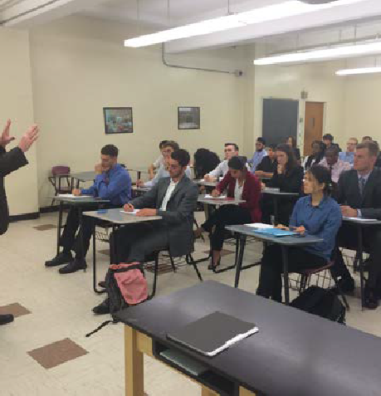
Classroom learning goes beyond textbook teaching
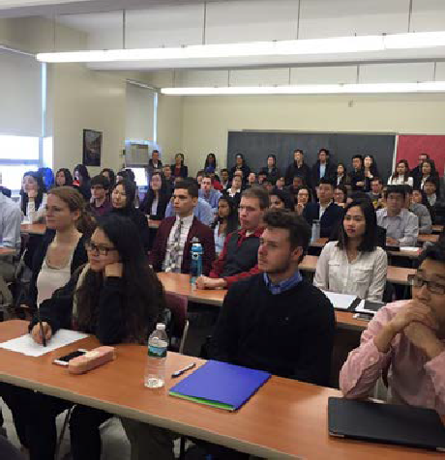
The College of Business has a strong focus on preparing students for internships, working closely with the Career Center, faculty and academic student clubs. Students receive career counseling and attend workshops on topics such as Intro to Internships, Networking, and Mock Interviewing.
Student Groups like the Accounting Society work with the Career Center to bring guest speaker to campus on a weekly basis.
Guest speakers often visit classes as well.

COB students practice their 30-second elevator pitch on each other; hear from Professor Shane Higuera on internship skills, and hear from E&Y in a stand room only presentation on careers

8

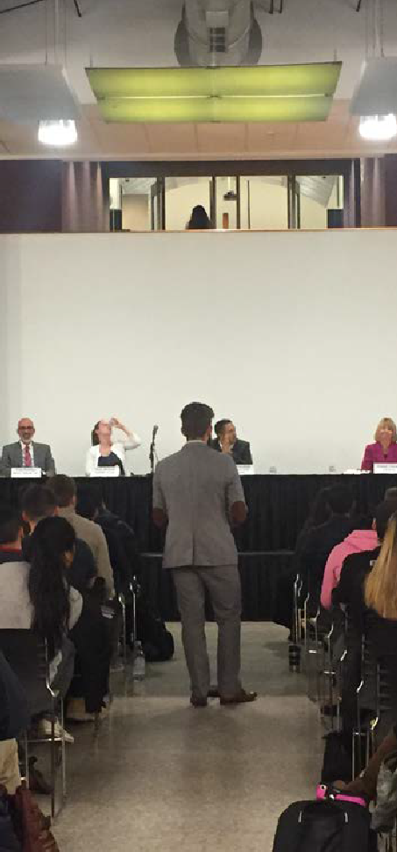
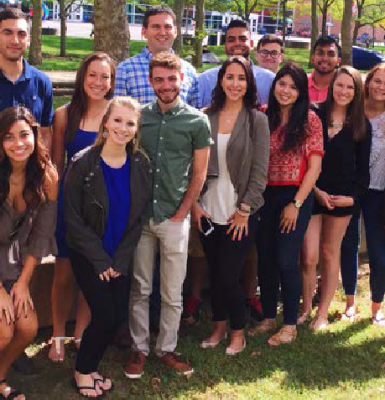
Faculty reach beyond the classroom to enhance student learning
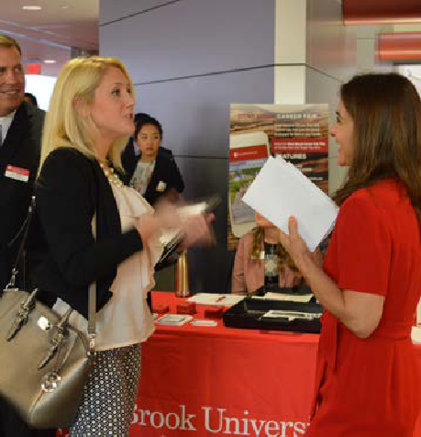
Faculty work with students in research labs, career related clubs & workshops, and in experiential projects to provide students with education that goes far beyond the walls of a classroom.

COB students attend Employer Internship Panel organized by Faculty Internship Coordinators, Shane Higeura and Colleen McKean (left); Professor Peter Caprariello and students from Consumer Affiliative Process Lab (upper right); Professor Christie Comunale welcomes Accounting Networking Breakfast employers and students to annual Fall event (lower right).

9

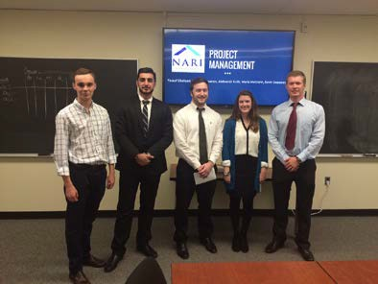

Under the guidance of faculty,
COB students – both graduate and undergraduate – can assist organizations while they get valuable experience working in teams on a real life project.
MBA Project Consulting Program
- Completed over the course of a semester, students work with you as your team of consultants
- Students work on a specific challenge in your organization
- Can be marketing, finance, operations related…we will work with you to create and define the project
Executive in Residence Program
- Semester-long initiative in Business Strategy class that students must qualify and apply for
- Broadridge Financial

Undergraduate and Graduate Marketing Classes
- Marketing Strategy and Brand Management

Case Competition Projects in Marketing and Operations Classes
- Target and GEICO

Experiential Projects

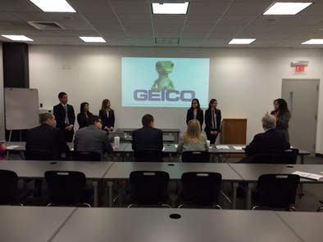
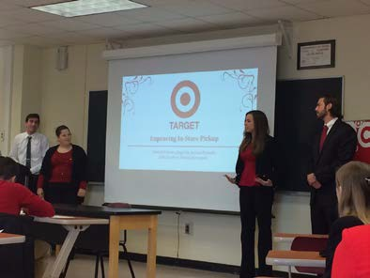

COB Classes Provide Students with Real-World Experience
The Hamptons’ Golden Pear Restaurant group worked with a team of students from Camille Abbruscato’s MBA 522 Industry Project class on a product launch for an all natural, premium margarita mix. The students conducted market testing for branding, packaging and labeling, and pricing thresholds prior to product launch. The business went into full scale production with a revised label and package due to the information provided by the team of students.

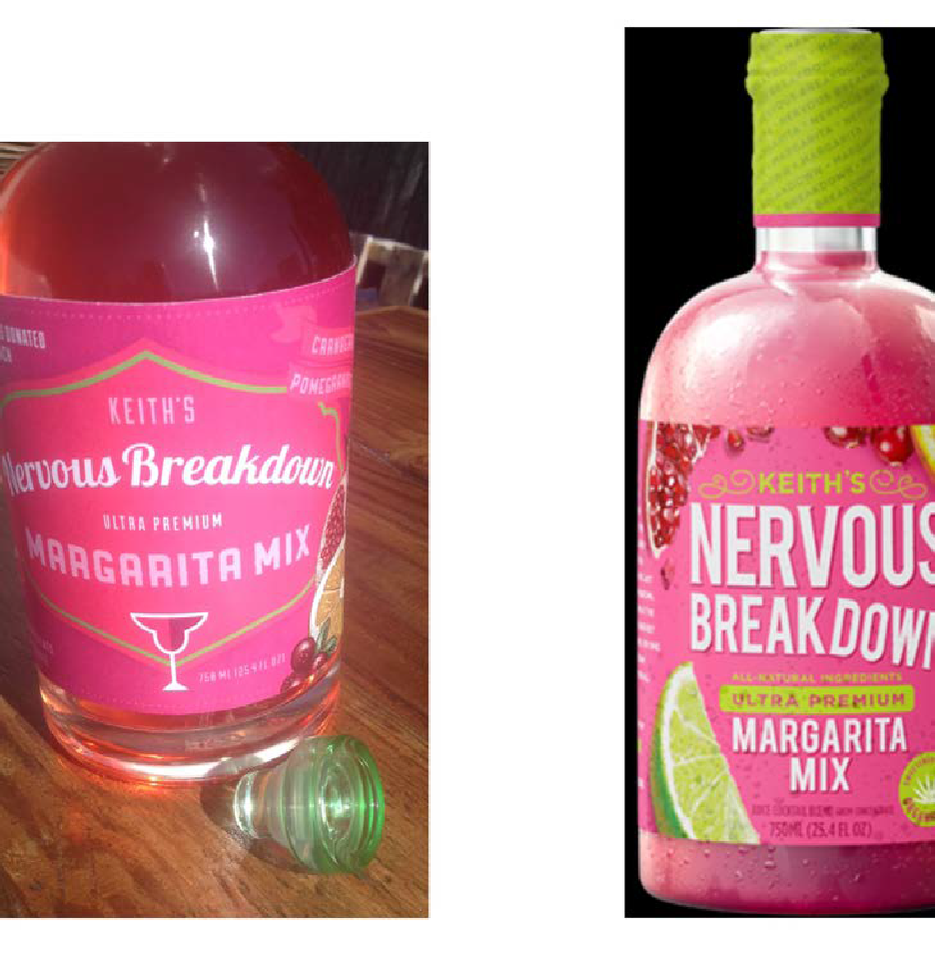

original product (on the left) and the revised product (on the right)

11

Sponsored & Related Events
Ken Langone, Mario Mignone

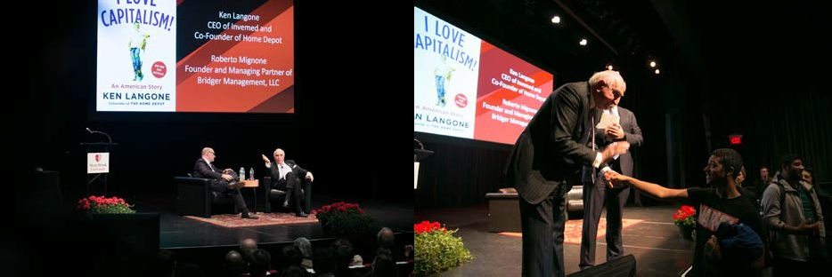
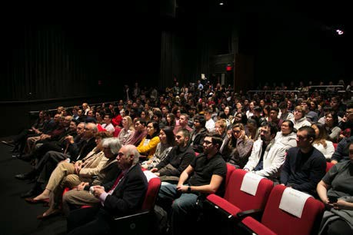
Student Quote On the Ken Langone Lecture
“I thought Ken Langone was one of the most unique successful men I have ever encountered. Although he emphasized the importance of receiving an education, it seemed as if most of his success came from his determination and persistence rather than intelligence, which I didn’t expect to hear. Much of what he said was powerful and motivated me personally.”

Entrepreneurs Edge Welcomes Dawn Zier ’86, CEO
NutriSystem

Annual event brings together 250 students, alumni, faculty and business community members.
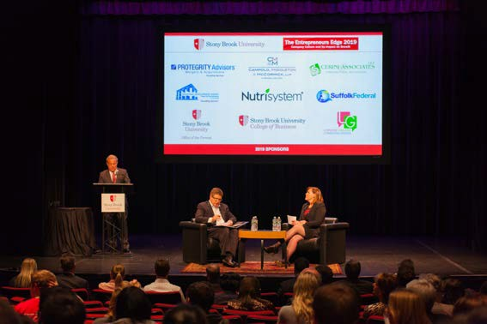
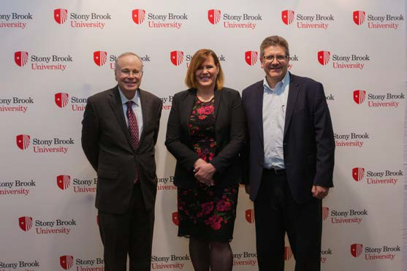
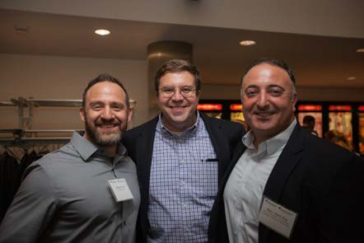
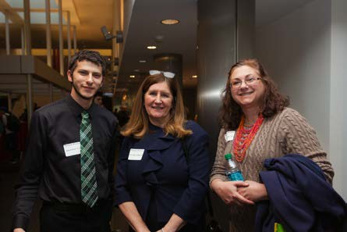

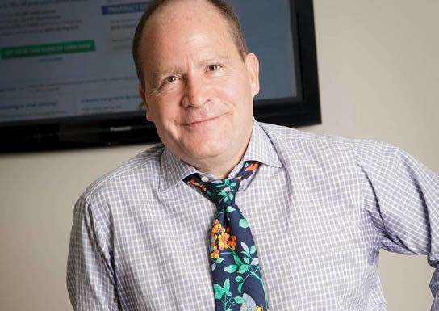
Ted Karkus, Serial Entrepreneur: Cold-EEZE
- Michael Loeb: Founder of Priceline with Bonin Bough Lecture (in conjunction with Journalism)

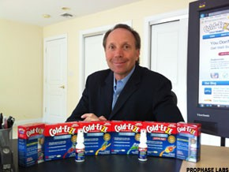

14

Some examples:

Numerous Guest Speakers and Events

  - Guest Speaker: Do-Yeong Kim, Professor of Organizational Behavior-HR, Ajou University (son in SBU Medical School).
  - COB Professor Panel: Featuring Robert Ettl, Julie Huang, Danling Jiang and Michael Nugent telling stories of their journeys, sponsored by student clubs: American Marketing Association and Finance Society.
  - Real Estate Institute John Kominicki Symposium: “Moving Forward: New Infrastructure and Business Development Projects on the Island” Real Estate Industry event free to students.
  - Real Estate Institute Student Workshop: How To Put Your Degree To Work In The Real Estate Industry.
  - 9th Annual Student and Alumni Networking Mixer

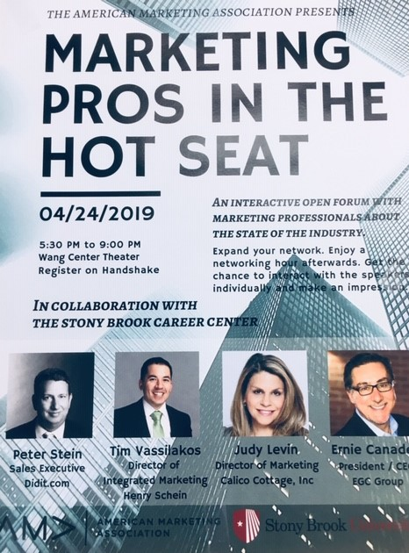
Career Events

16

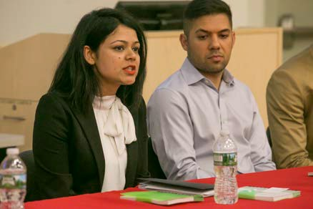
Active Student/Alumni Clubs
- Accounting Society
- American Marketing Association
- Guerilla Marketing (client projects)
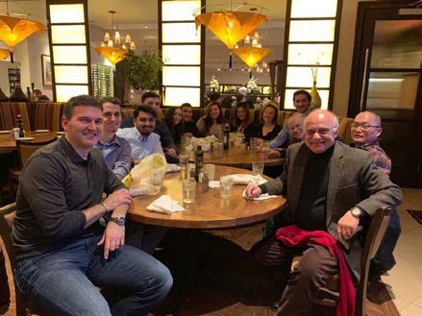
- Alpha Kappa Psi
- Delta Sigma Pi
- Investment Club
- Finance Society
- Entrepreneurship Club
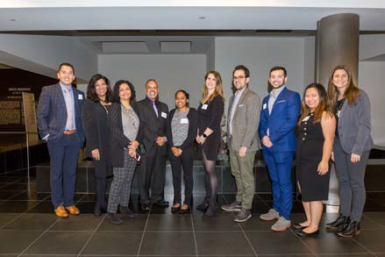
- Dean’s Advisory Councils
- MBA Alumni Network

COB Team Wins Certified Financial Analyst Institute Research Competition

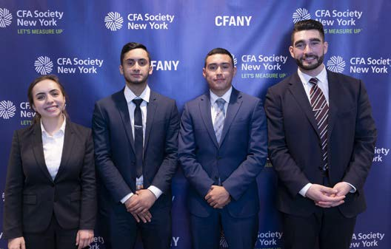
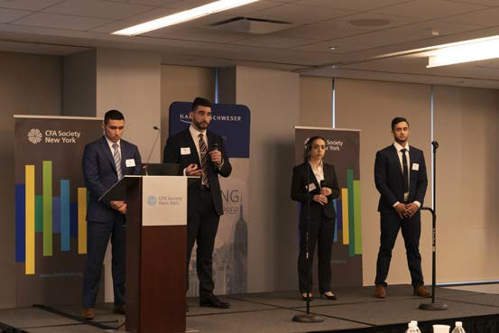
  - Under the direction of Professor Michael Nugent, a COB team of students won the regional CFA research competition, beating out 27 teams, including Cornell, Baruch and Fordham.

Experiential Learning for Problem Solving

Broadridge Executive-in-Residence Program
Special section of BUS 441 Business Strategy

    - Semester-long, team-based project where students work directly with Broadridge executives (many of them SBU alumni) on actual company challenges.
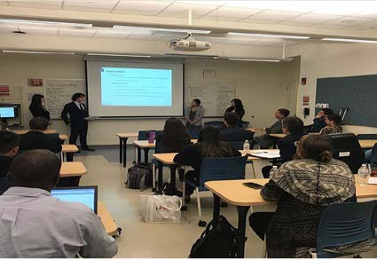
    - Sponsored by Robert Kalenka, Chief Operating Officer, Broadridge

More Experiential Learning

Guerrilla Marketing Agency
Students of the American Marketing Association, Stony Brook Chapter

    - Provide an array of marketing services including social media marketing, graphic design, copywriting, website creation and maintenance, market research, and more.
    - Nominal fees go towards funding events for AMA to
benefit student members
    - Clients include Lucky Lou’s Rice Pudding, Copia Granola, Men’s Room Collection, Aspen Insurance, Josephine Amplo’s Shopping Service, and Energy Fitness.
    - Contact is guerrillamarketingsbu@gmail.com

Innovation
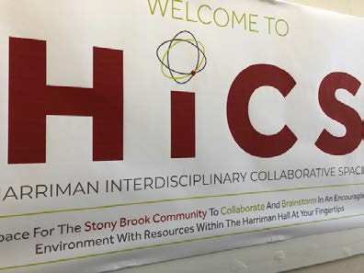
Innovation Center - Gerrit Wolf & Richard Chan
- Courses in tech innovation, entrepreneurship, & social entrepreneurship
- Entrepreneurship game & on-line capstone course
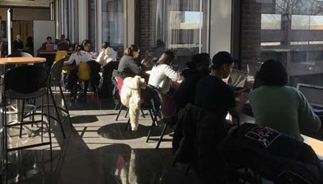
- Start-up consulting

iCREATE - DoIT Partnership, Directed by Dave Ecker
- Innovation Lab in Harriman Hall
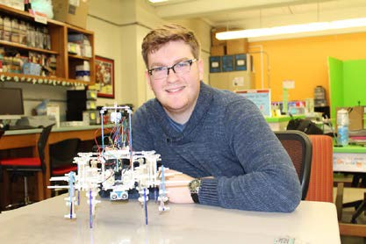
- Newly renovated Harriman Collaborative Space
- InnovateIT: Hackathon Event
- Workshops
- Wolfie Tank Pitch Competition
- Interdisciplinary student initiated start-ups

Hiring Students
Internships & Full Time Positions

  - Undergraduate students can complete an internship for pay or credit (or both)
  - Post your position on Handshake. Employers can search and download resumes
  - Attend Career Fairs in Fall and Spring
  - Conduct On-Campus Interviews
  - Host Information Sessions
  - Participate in Diversity Recruitment Initiatives
  - Contact at sbucareercenter@stonybrook.edu; 631-632-6810; stonybrook.edu/career-center

Thank You!

23

