

Doing Business with Stony Brook University
Useful Information for New Vendors


Introduction

Here at Stony Brook University we want to do business with local vendors and are always looking for more partners to help us!

Interesting facts:
  - We have over 20,000 students on campus; 10,000 live on campus.
  - We have over 10,000 faculty, staff and support personnel working on campus

We need your goods and services to run the University!

Introduce yourself!

- Fill in the Substitute W-9 Form (forms provided)
We need the general W-9 information but are also asking for contact information so we know how you wish to receive a purchase order (fax or email) and to whom it should be sent.

- Send us a Line Card, Capability Statement describing what goods and/or services you could provide
We will forward your information to the appropriate departments.

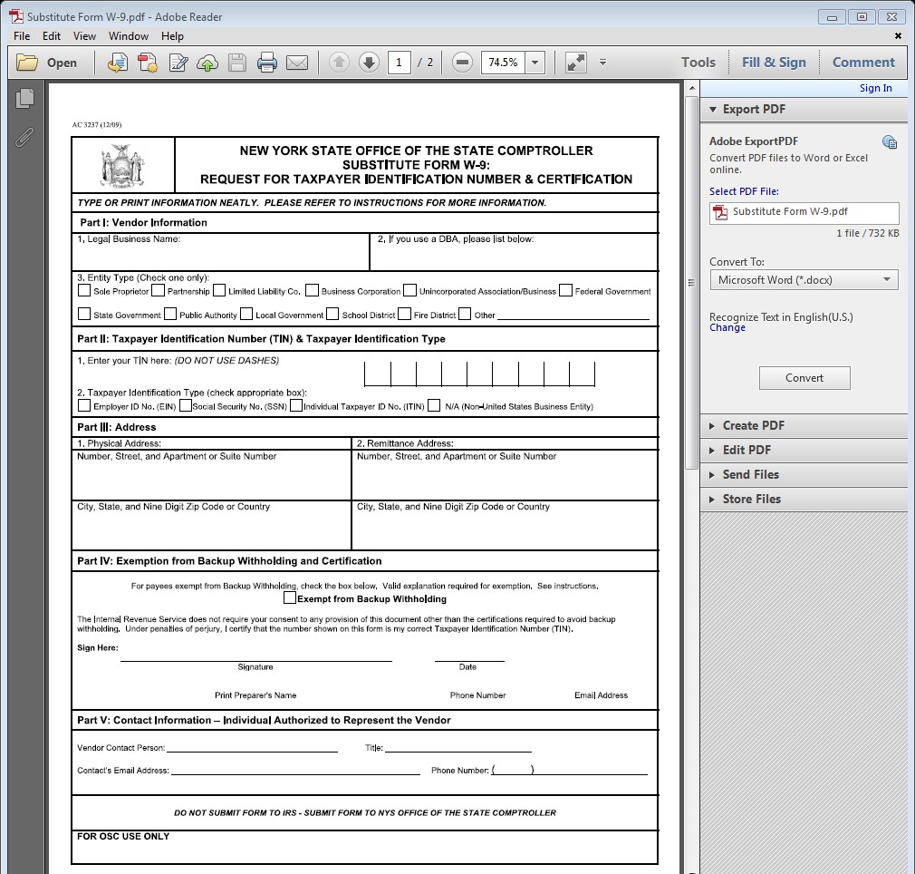
W-9
Form

- Introduce Yourself (cont.)
Tell me if you have any of the following:

- New York State Office of General Services (OGS) contract www.ogs.state.ny.us

- Group Purchasing Organization (GPO) contract – a.k.a. Consortia contract

- NYS Certified Status as a Minority-Owned Business (MBE) https://esd.ny.gov/mwbe/certification.html

- NYS Certified Status as a Woman-Owned Business (WBE) https://esd.ny.gov/mwbe/certification.html

- NYS Certified Status as a Service Disabled Veteran Owned Business (SDVOB) https://ogs.ny.gov/Core/SDVOBA.asp
- NYS Certified Status as a Small Business SBE http://www.nyssbdc.org/centers/centers.aspx?centid=27

Becoming a Vendor at Stony Brook University and New York State

After you have sent us your Substitute W-9 Form, please visit the Stony Brook University procurement department’s website: http://www.stonybrook.edu/procurement/

  - How to register as a vendor in NYS http://www.osc.state.ny.us/vendors/index.htm
  - How to get paid faster by NYS: http://osc.state.ny.us/vendors/epayments.htm

Finding Opportunities at Stony Brook University

- A. Current Bid Opportunities at SBU: https://www.asa.stonybrook.edu/Procurement/CurrentBidOpportuni ties/Vendors/Account/LogIn or call Bid Clerk at (631) 632 9060
- B. Visit the campus – consider who your possible customers are and use our website to find phone #s, email addresses, etc. and set up a meeting
- C. Use the procurement website to find contact information of Buyers and Contract Officers, who might be responsible for your type of goods or services

Important Tips
- Only authorized members of the Procurement Office may make awards of contracts or purchase orders for the University campus.
DO NOT ACCEPT VERBAL ORDERS
ASK FOR WRITTEN PURCHASE ORDER OR CONTRACT!

- Some purchases are permitted with the use of a Procurement Credit Card (P-Card).

- When submitting an invoice for payment, please include:
  - the Purchase Order # or Contract #
  - State your “remit to” address
  - List the commodities or services provided
  - Be sure to comply with the Terms and Pricing on the PO/Contract
  - Any freight charges over $100 required an actual freight bill
  - Mail your invoice as shown on the PO/Contract (do not email!)

5. Important Tips (cont.)
- We generally will need multiple quotes for purchases over $2,500.00. Either our end user or a Procurement department representative will contact you. Please respond quickly, in writing, and provide all necessary information:
  - price
    - description of item with part #
    - availability (lead time)
    - shipping method
    - quote # and when it might expire
    - contact name and number

- Stony Brook Hospital and Long Island State Veterans Home have their own Procurement departments.

SBUH Procurement: (631) 444-0671

LISVH Procurement: (631) 444-8500

Contacts at Stony Brook University Procurement
- Mary La Corte – Asst. Director, Service Contracts (631) 632 9849
- Edith Koelln – Purchasing Manager, Research Commodities (631) 632 6068
- Karin Waslo – Purchasing Manager, State Commodities (631) 632 6057

- Alfred DiVenuto – Accounts Payable Manager, State (631) 632 9838
- Porshia Russell – Accounts Payable Manager, Research (631) 632 6019

Conclusion

Working with our local community vendors benefits us:
- you are our alumni
- you are our student’s families
- you are our neighbors
- doing business with you supports our local economy
- you care about us!

- Thank you!

