
Recruiting Stony Brook Student Talent

Kimberly Joy Dixon
Director of Employer Engagement & Diversity Recruitment SBU Career Center

Employer

Partnership

Career
Services








SUCCESSFUL PARTNERSHIPS
Branding Pipelining Talent
Expanded Partnerships
SBU Career Center

Branding
- Engaging Alumni







- Career Education Events

Diversity
- Connecting w/ faculty & student groups
- Advertising

Pipelining Talent

SUCCESSFUL PARTNERSHIPS
- Job /Internship Fairs
- Online Job Listings
- On-Campus Interviews
- Information Sessions
- Internship/Co-ops

WHY RECRUIT AT SBU?

One Stop Shop for Hiring College Talent

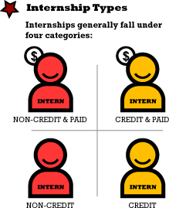
Internship: career related

Co-op: multiple work terms, pay and credit, career related

Part-time: there is no set end date, may or may not be career related

Volunteer: very similar to non-credit internship

Full-Time Hiring: Entry Level & Experienced




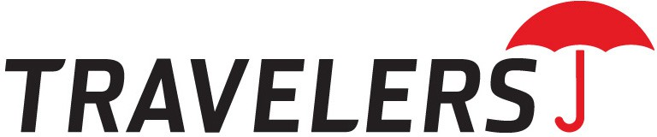



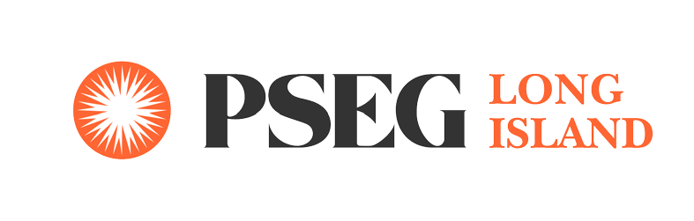
SBU Long Island Employer Partnerships




MAKING THE CONNECTION



To create your own account in Handshake visit http://stonybrook.joinhandshake.com/

MAKING THE CONNECTION

Fall 2019 Job & Internship Fairs

- 9/19/19: IT/Computer Science
- 9/20/19: Engineering
- 9/26/19: Business
- 9/27/19: Healthcare, Research & Human Services
- 10/4/19: Accounting Networking Breakfast
- 11/8/19: Diversity Recruitment Lunch

SBU Career Center

Thank you!
Kimberly Joy Dixon
Director for Employer Engagement & Diversity Recruitment
SBU Career Center 631-632-6805
Kimberly.dixon@stonybrook.edu www.stonybrook.edu/career

