
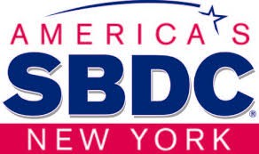
Stony Brook Small Business Development Center

New York State SBDC: Historical Perspective

1984 -
Inception
$6.6
Billion in Economic Impact

Present Day

476,000
Businesses Counseled
200,000+ Jobs
Created/Saved

Stony Brook Small Business Development Center: Historical Perspective

11,000+
Jobs Created/Saved

27,000 Businesses Counseled

$550,000 – Economic Impact

New York State SBDC Fiscal Year 2019

22 – Statewide
150 Advisors
10,793 New Clients
$295.9 Million in Economic Impact
5,500+ Jobs Created/Saved 1,864 – New Businesses Started 642 – Training/Workshops
16,000+ Attendees



Stony Brook SBDC Fiscal Year 2019


600 New Clients
100+ Jobs Created/Saved
$12.7 Million in Economic Impact
80 – Economic Impact Clients 38 – Training/Workshops
353,412 Email Marketing Recipients





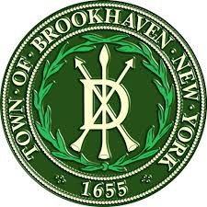


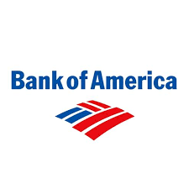
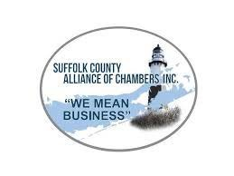

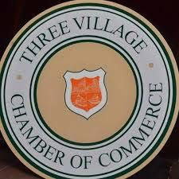


Noteworthy Working Relationships

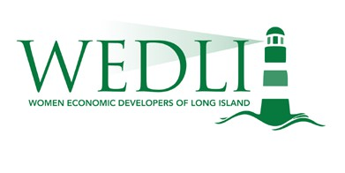


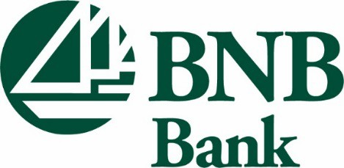
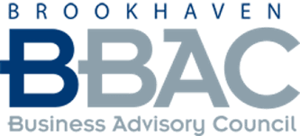


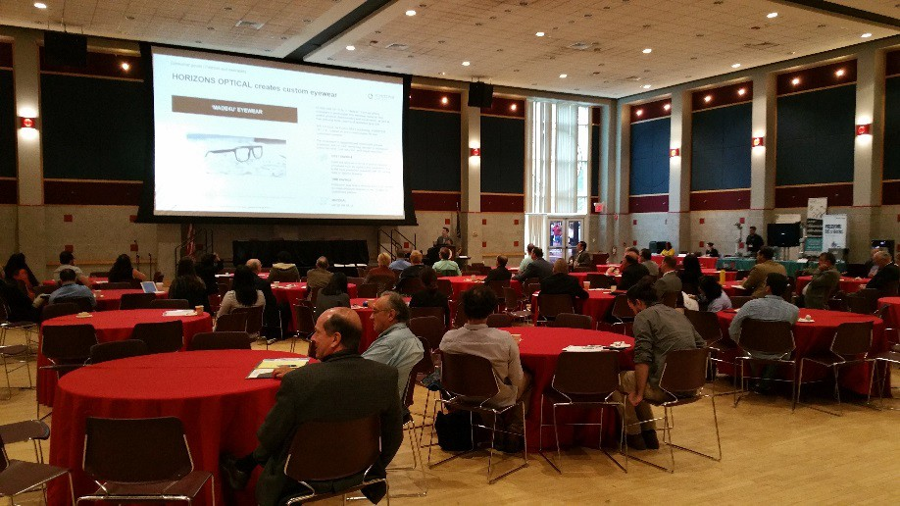
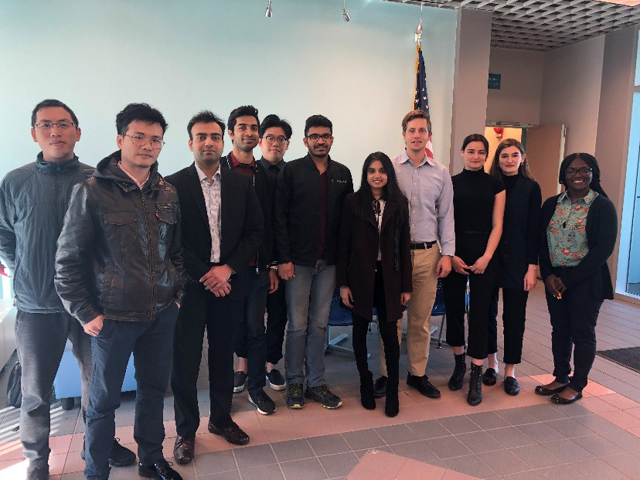
Special Events
Annual Manufacturing Day Conference

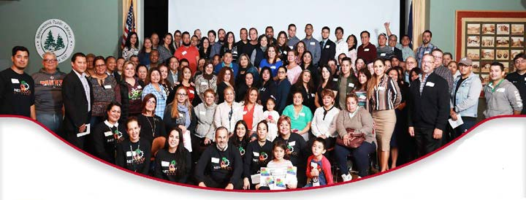
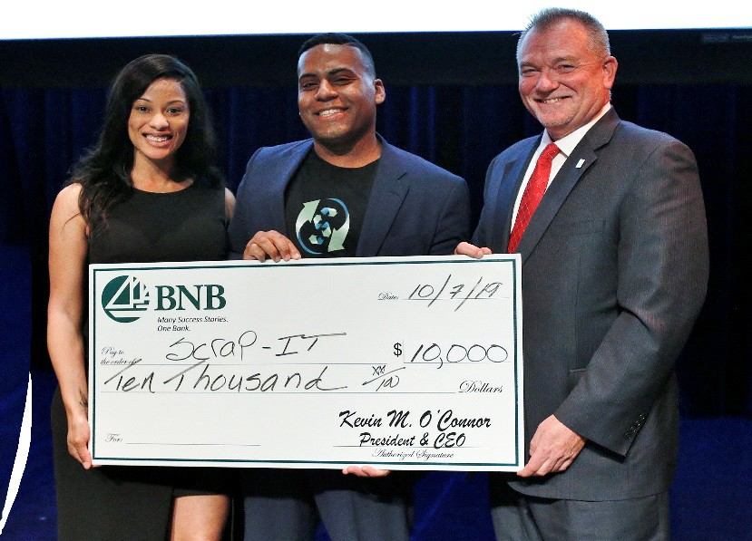
Hispanic Business Strategies Initiative

Stony Brook Student Entrepreneur Challenge


BNB Bank Technology Entrepreneur Pitch Night

SBIR/STTR Grant Proposal Writing Clinic

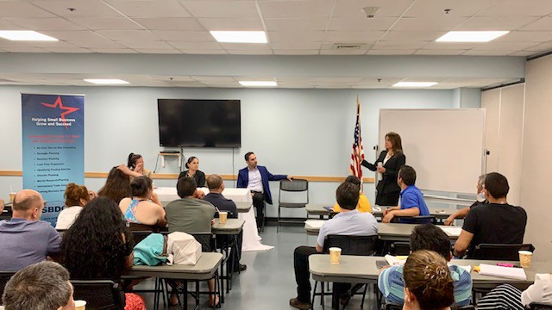
Assists participants in preparing proposals for Phase I or Phase II SBIR/STTR grants.

Staff


Brenda Zhang: Internet Retail
Gifty Oduro-Ostrander: Disaster Recovery
Bernie Ryba: Center Director
Ronni Rosen: Retail, Workshops
Ree Wackett: MWBE, Procurement

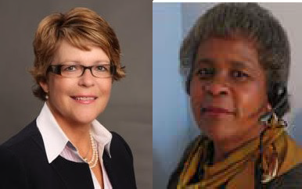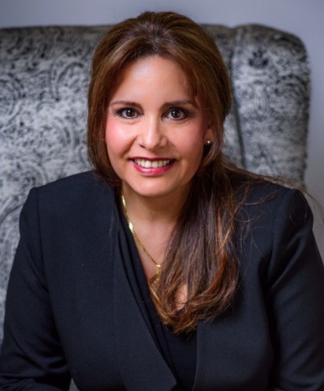

Ann Garbarino: Food, Retail
Bob Harrison: Manufacturing
Martha Stansbury: Center Administrator
Leslie Rurup: Intake Coordinator
Jackie Franco: Hispanic Community
Michael Chiang: Technology EIR


Stony Brook Small Business Development Center

@StonyBrookSBDC
Stony Brook Small Business Development Center

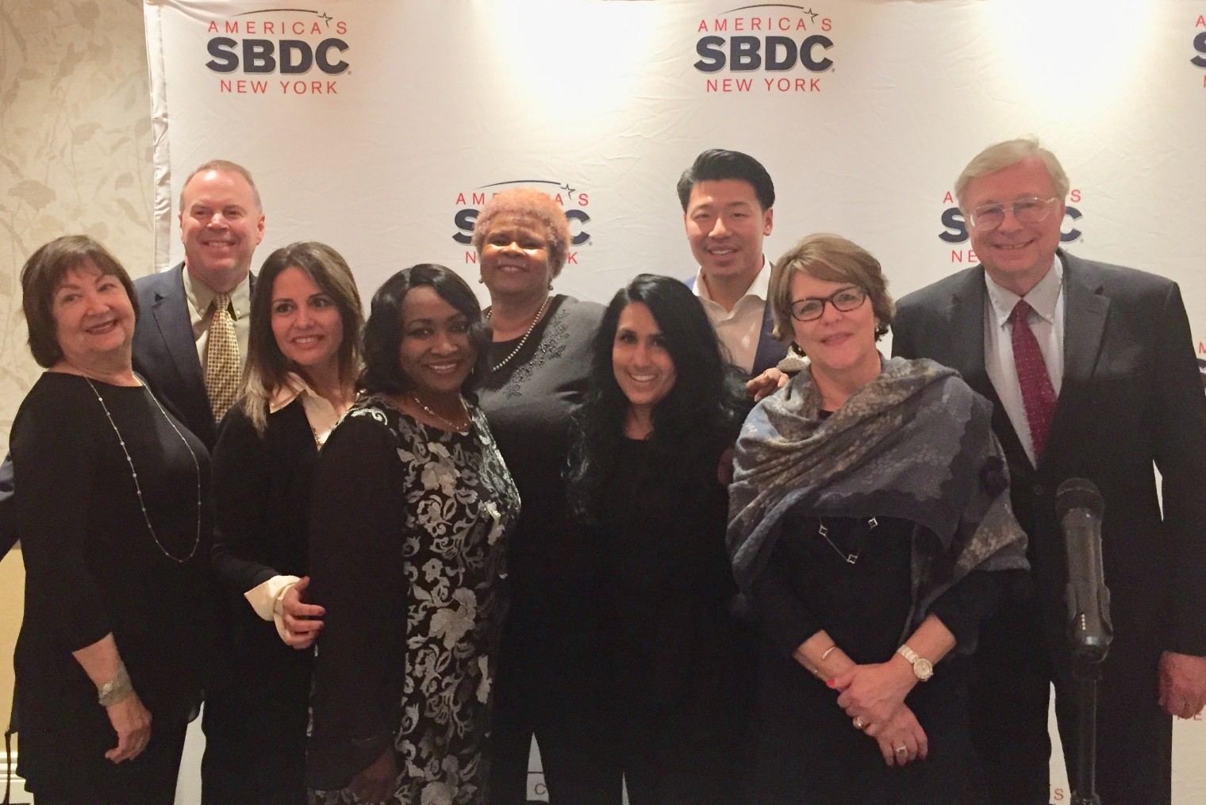
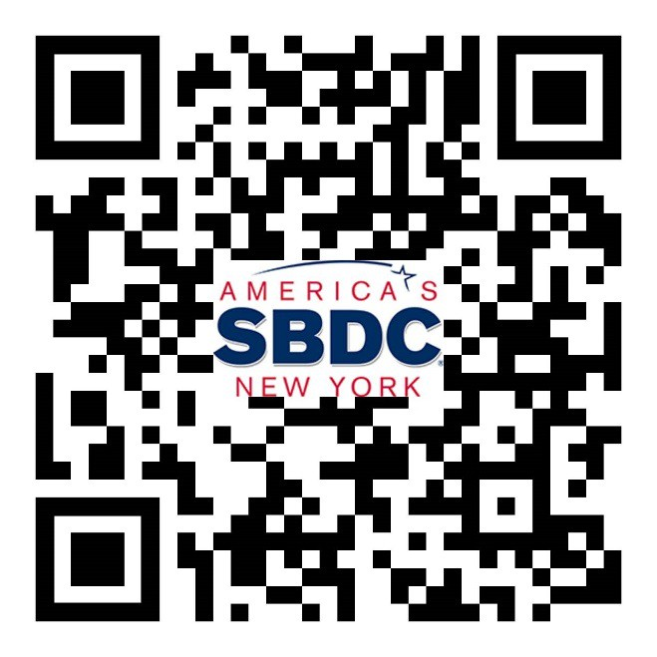

https://www.stonybrook.edu/sbdc/






SBDC.reviews/post

