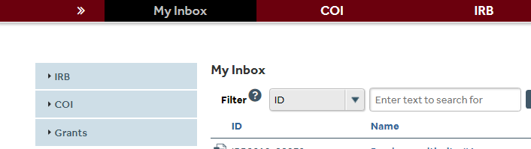
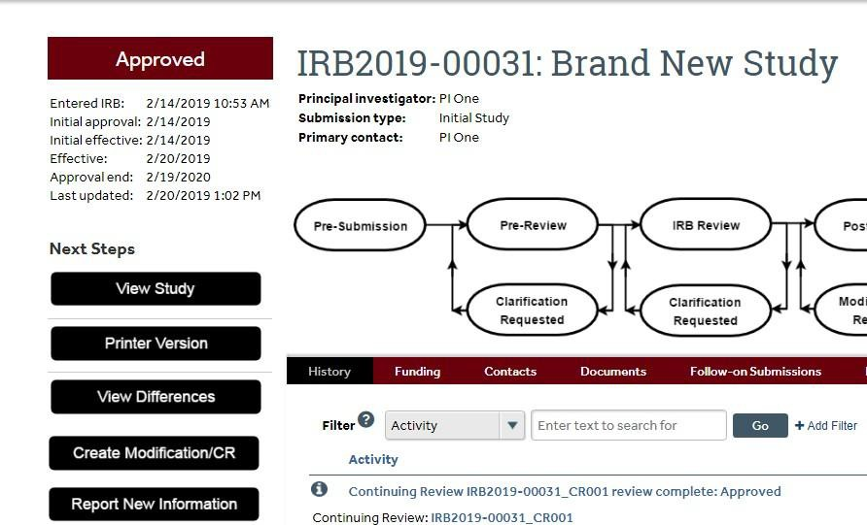
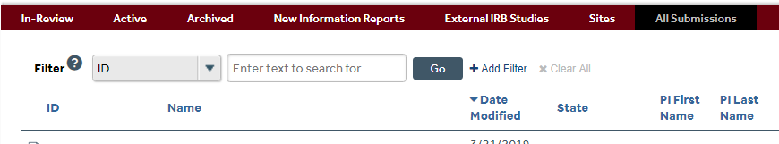
In order to begin the process of submitting a modification/amendment to the Institutional Review Board (IRB) click on the IRB tab.

Use one of the various filters to search for your study using the IRB number. Click on the “All Submissions” tab. NOTE: You can also filter by ID as well as the study title or the PI first/last name.

Once you are in the study’s “main workspace” there will be several actions available to you on the left side of the screen. Select “Create Modification/CR”.

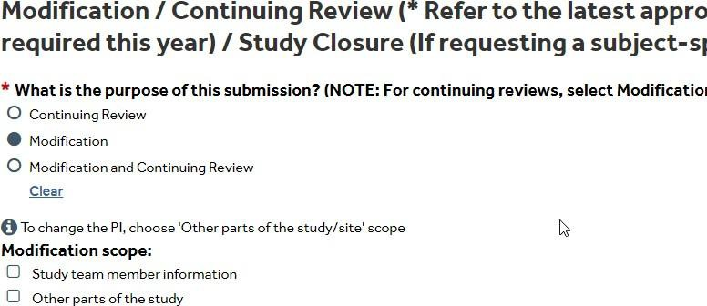

Select “Modification” as the purpose of the submission.
NOTE: If you select any option other than “Modification” and then select “Continue”, the system will not allow you to update this selection. You will need to select Discard (on the left navigation area of the main workspace) and start again.

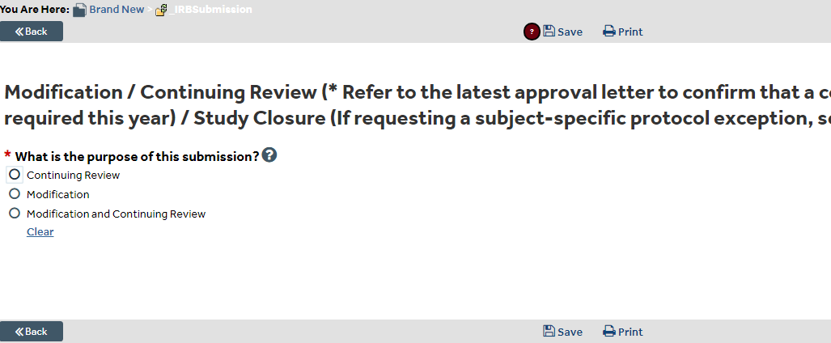
Choose “Study Team Member Information” if you must make a change to the “Study Team Members” page list only. If you choose this only, you will not be able to modify any previously approved documents or update any other sections of the most recently approved application. If your modification is associated with changes to previously approved study documents (e.g. removing a study team member that is also listed in the protocol/data collection sheet/consent form) or other sections of the application, you must choose both “Study Team Member Information” and “Other Parts of the Study”. Review your approved documents and the application prior to making this selection.

Complete the “Modification Information” page. Confirm that the selections for study enrollment status are appropriate. In the “Summarize the Modifications” section, summarize each proposed modification and provide a clear rationale for each modification in the text box.
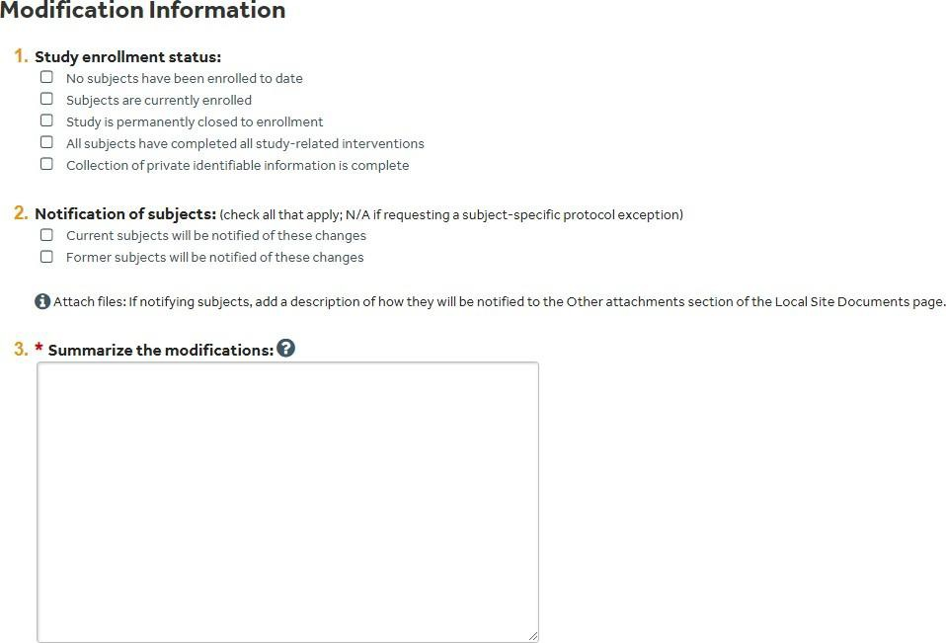

Once the page is complete, select “Continue” to review each page of the applicationfor accuracy and upload/delete documents as needed.
Reminders related to the various pages:
- In cases where the “Other Parts of the Study” scope is selected you must upload a completed Amendment Cover Sheet. The latest version is available in the myResearch library (click Library > click For Investigators > select the correct template). Navigate to the “Local Site Documents” page in your submission and upload the completed form in the “Other Attachments” section.
- Confirm that you have replaced/removed documents that no longer require approval. For example, if you are making changes to a previously approved consent form, you should update the version in the system. Revisions should be indicated with tracked changes. Please do not use highlighting to indicate changes in documents that need to be stamped for use (e.g. advertisements, consent forms, recruitment scripts).
- Be sure to click “Save” on the top/bottom of the page once you complete each pageto ensure that you do not lose your work.

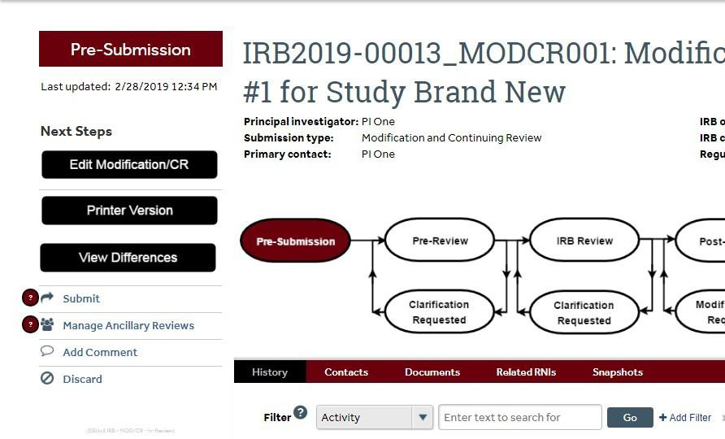
Select  at the top/bottom of the page to see a list of required sections that have not been completed. This will check for completeness, not verify accuracy of responses.
Review each page of the application SmartForm until you reach the Final Page. This page provides you with reminders related to managing ancillary reviews before submission. NOTE: The Department Chair approval via ancillary review must be obtained before submission of a major amendment (see Amendment Cover Sheet for full explanation – e.g. modification associated with increased risk to subjects, inclusion of a vulnerable populations). Any major amendment submission missing documentation will result in a clarification request or submission withdrawal. Minor amendments do not require departmental approval.
Click Finish to exit the page and select Manage Ancillary Reviews to request necessary reviews (if applicable). The PI and study team will receive an email notification when the Department Chair/Designated Signatory has submitted a review and accepted/approved the submission.
This notification will also appear in the History section (see previous image). Once Department Chair/Designated Signatory approval is confirmed (if applicable), the Principal Investigator can click Submit (see previous image) and agree to the Principal Investigator certification by clicking OK.

