Departmental representatives (e.g., Department Chairs/designated signatories, University Hospital administrators, etc.) complete ancillary reviews in myResearch using a brief form certifying approval or disapproval of the proposed submission.
The Principal Investigator, study team member, or IRB Coordinator may send the study to you for an ancillary review. You will receive an automatic email notification with a link to the study in myResearch.

Follow these steps in order to submit an ancillary review:
- Select the name of the study that you would like to review. You can find all studies where you are listed as an ancillary reviewer in your myResearch Inbox. On the Inbox page, you can filter studies (e.g., by type of submission, study state, etc.) by selecting a Filter from the drop-down list typing in the free text box, or sort studies by clicking the respective heading.
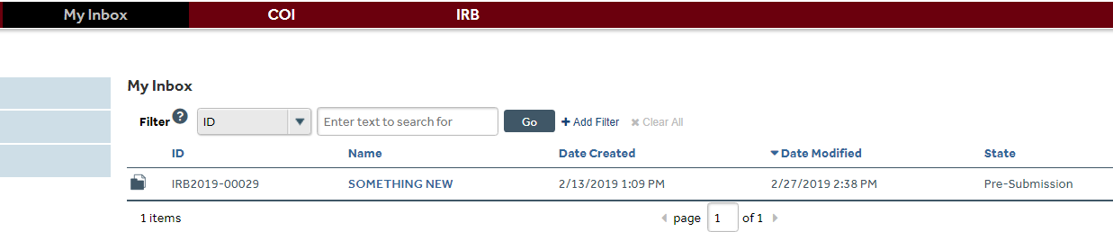

- In the study’s workspace, select View Study to review the study page-by-page or Printer Version to view the entire study (including document links) on one page. Select View Differences to see a log of changes made to the application/documents between modifications. You can also view Funding, Contacts (who has access to the study), and Documents on the tabs in the main study workspace.

Note: As an ancillary reviewer, you have read access only, which means that you will not be able to modify the study.

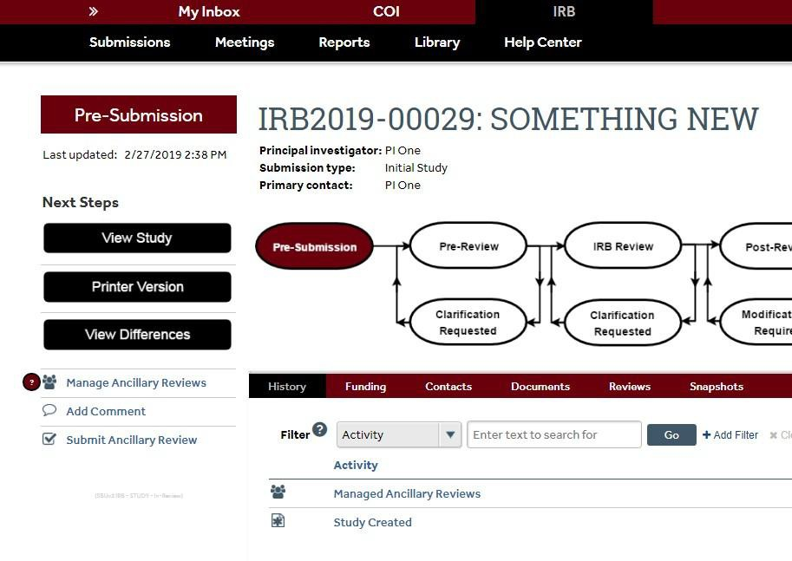
- If you have questions for the study team or IRB coordinator, you can select Add Comment from the functions listed on the left navigation area to add a comment that will appear as part of the study record in the History section. You will also see the option to upload a document and email a notification about the comment to the PI, the study team, and/or the IRB Coordinator.

- Once you are ready to submit your review, select Submit Ancillary Review on the left navigation area. Do not use the Manage Ancillary Review option. Only use Submit Ancillary Review to document your approval.
Troubleshooting tip: If you are assigned as an ancillary reviewer but you do not see Submit Ancillary Review, the most likely reason is that a study team member listed your name
as a Study Team Member. You can delete your name if you have full access to the study. This requires selecting the Edit Study or Edit Modification/CR option, navigating to the Study Team Member page, removing your name, and clicking Save. Alternatively, contact the PI/study coordinator to ask them to remove your name.

Notes:
  - Your name should only be removed from the Study Team Member list if you were erroneously listed as a study team member. If you are the departmental reviewer and a study team member, you cannot provide departmental approval for the study.
  - Send an email with the IRB study number to ORC_OVPR@stonybrook.edu for assistance if the Submit Ancillary Review option is not available and you are not listed as a study team member.

- To complete the Ancillary Review form: select the checkbox next to your name, select the checkbox if approving/accepting the study, add any applicable comments/documents, and

select OK to submit your review. If you do not check the box at #2 to accept/approve the

submission, it will be posted as a “No” for approval.
Note: You can select the Submit Ancillary Review option to complete the page as often as necessary, such as in situations where if you need to correct an incorrectly submitted review or update your ancillary review based on the PI’s response.
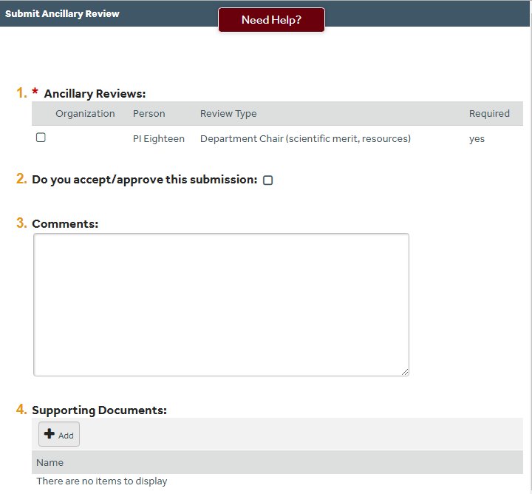

- The PI will receive an email notification after you select OK. Your decision and comments will become part of the study record; they will be available to IRB Coordinators/Reviewers as well as the research team.

