RESEARCH MATCH
Instructions and Template Language IRB Application Recruitment Supplement

What is ResearchMatch?
ResearchMatch.org is a national electronic, web-based recruitment tool that was created through the Clinical & Translational Science Awards Consortium in 2009 and is maintained at Vanderbilt University. It is aimed at expediting the pace of healthcare discoveries through research. There is no cost for researchers at Stony Brook University to use ResearchMatch for the purposes of conducting recruitment feasibility analysis or participant recruitment. This national registry provides a secure, web-based approach to address a key barrier to advancing research: participant recruitment. To use this recruitment tool, Researchers are required to submit individual requests for approval by the Stony Brook IRB.

How Does Research Match Work?

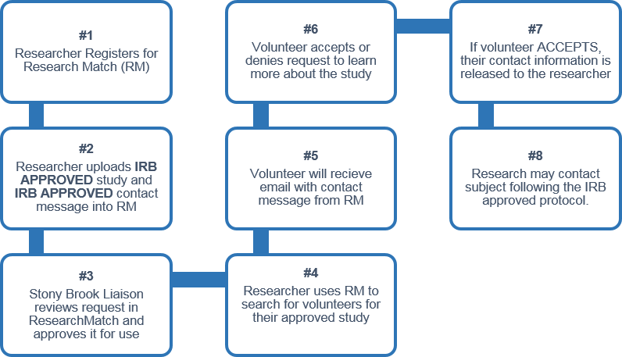

How to Sign Up For ResearchMatch:
Researchers can register at any time with ResearchMatch for feasibility access. This allows a Researcher to explore the database and determine if this tool will be a good fit for a study.
Follow these steps to sign up NOW:
- Go to https://www.researchmatch.org/
- Click “Researchers” at the top of the page
- Select the Green “Register Now” button (If you think you’ll need help registering, click on the tutorial link below the green button)
- Select “Stony Brook University” as the institution
- Type in your Stony Brook email address
- Retrieve verification code from your email, cut and paste it into RM
- Read site instructions
- Read Researcher Acknowledgement form and “ACCEPT”

That’s IT! You will be ready to use this recruitment method for your existing and upcoming studies.

How to Add this Recruitment Method to a Study?
- To add this recruitment method to a NEW application, include use in the recruitment section of the application and protocol, and submit the contact message using the template below for approval.

- To add this recruitment method to an EXISTING study, submit as an amendment. Include the amendment cover sheet and proposed contact message using the template below in a new package for approval.

What Information Should Be Included in a Contact Message?
Please note: To use ResearchMatch for study recruitment, a contact message for subjects MUST follow these guidelines before it will be IRB approved and the liaison staff can approve its use in the RM system:
Contact message must:
✔ Follow the provided template below
✔ Be IRB approved
✔ May not exceed 2000 characters
✔ May not include an embedded survey
✔ Should include a brief overview of the study and inclusion criteria
✔ Must EXCLUDE direct study contact information: NO study title, email, phone #s, or investigator names can be included in the message.

***SEE NEXT PAGE FOR CONTACT MESSAGE TEMPLATE***

=====================================================================================

RESEARCHMATCH
Contact Message Template:

General Description of Request to the IRB:
I am requesting IRB approval to send the following study recruitment message to potential study volunteers through ResearchMatch.org. ResearchMatch asks me to confirm that this language has been IRB approved and that my direct study contact information has been removed (email/phone) before sending my study announcement through ResearchMatch to volunteers that appear to be a good match for my study.

Contact Message Content Description:
Below is the study-specific announcement that I wish to have inserted into the ResearchMatch notification regarding my study:
<INSERT YOUR MESSAGE HERE>

EXAMPLE CONTACT MESSAGE:
Would you like to help researchers learn more about the causes of motor neuron diseases such as ALS and SMA?
Are you interested in helping researchers who are trying to learn more about the causes of motor neuron diseases such as ALS (Lou Gehrig’s disease) and SMA? Researchers at Stony Brook are looking for study volunteers.
You may be eligible if:
You are 18 years or older
You are a healthy volunteer OR if a physician has determined that you have ALS, SMA or another disorder affecting the motor neuron nerve.
You are available for one visit for
approximately 1 hour.
You are willing to have a small biopsy of skin taken from a small spot on your leg. The skin around the spot will be numbed prior to the sample being taken.
The skin biopsy procedure is a standard technique used to look at the nerve fibers in the skin. For this study, the researchers will use the skin cells from the biopsy to grow a lot of skin cells (called a culture) and these will be converted to nerve cells.
If you are interested in hearing more about this study, please click “yes” so that a study team member may contact you.

ResearchMatch provides the following standard notification language (in blue) that will be received by all ResearchMatch volunteers who may be a match for a given study. My specific message for which I am seeking approval will be inserted accordingly:
---------------------------------------------------------------------------------------------------------------------
A research team with Stony Brook University in Stony Brook, NY, believes you might be good match for the following study:

<researcher’s IRB approved study-specific recruitment announcement is inserted here>
If you are interested in this study and having the research team contact you directly, please select the "Yes, I'm interested" link below. By clicking the "Yes, I'm interested" link, your contact information will be released to the research team. If you select the "No, thanks." link or do not respond to this study message, your contact information will not be released to the research team.

QUICK LINK OPTION: YES QUICK LINK OPTION: NO

Thank you for your interest in ResearchMatch.

