Getting lab personnel added to your IACUC protocol

PRIOR TO OBTAINING ACCESS TO ANY DLAR FACILITIES YOU MUST COMPLETE THE FOLLOWING STEPS

Need to complete:
-Occupational Health Clearance
-OLAW training
-CITI training
-have PI add personnel to IACUC protocol
-receipt of email stating you have been added to the protocol

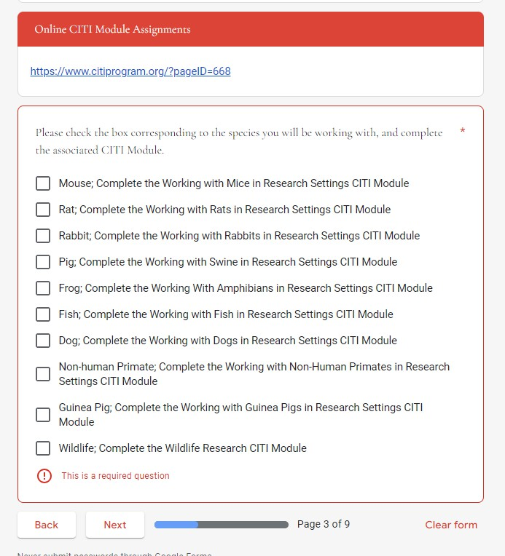
For OLAW training: Link: https://forms.gle/vLgonYTuwZsGXVL99
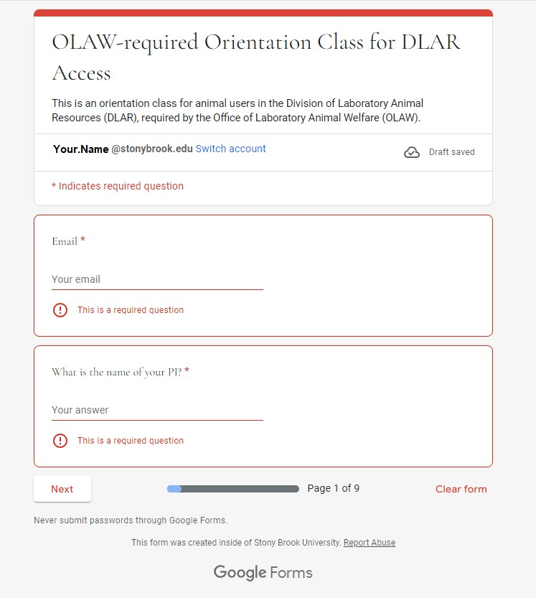

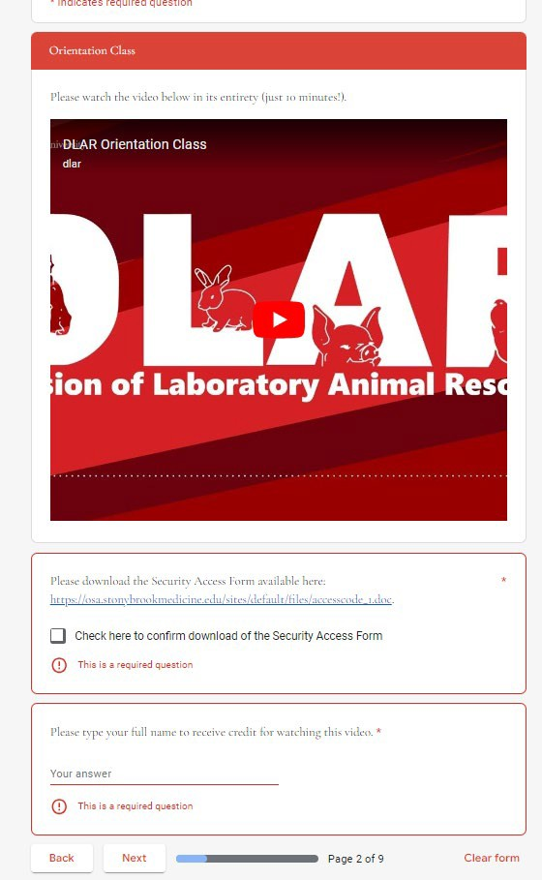
enter required info & click “Next”
Watch video, download & complete facility access form, enter required info & click “Next”

PI & lab personnel choose appropriate courses to take based on research and work being done in the lab & click “Next”

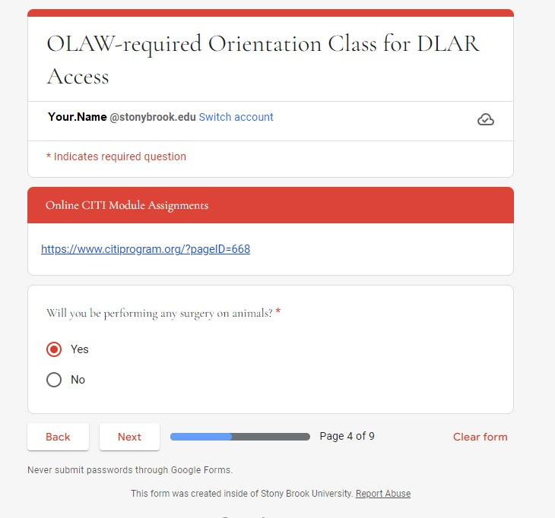
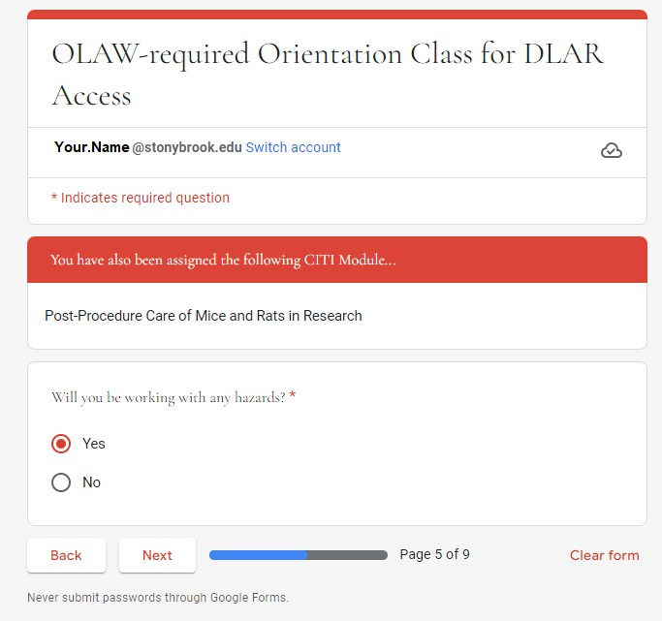
For OLAW training (con’t):

Note another CITI course!
If answered ‘yes’ to previous question!

PI & lab personnel choose appropriate answer based on research and work being done in the lab & click “Next”
PI & lab personnel choose appropriate answer based on research and work being done in the lab & click “Next”

For OLAW training (con’t):
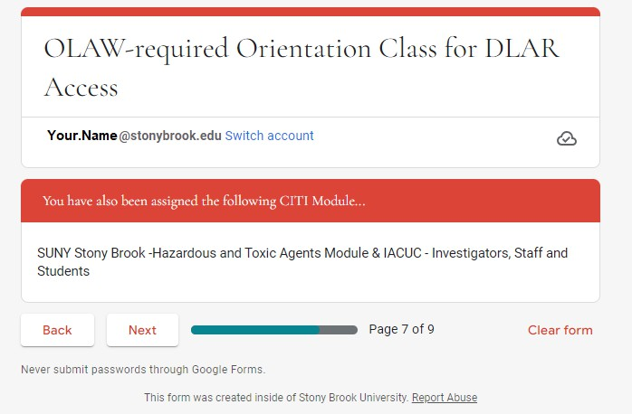

Note another CITI course!
If answered ‘yes’ to previous question!
Remember all CITI modules needed & click “Next”

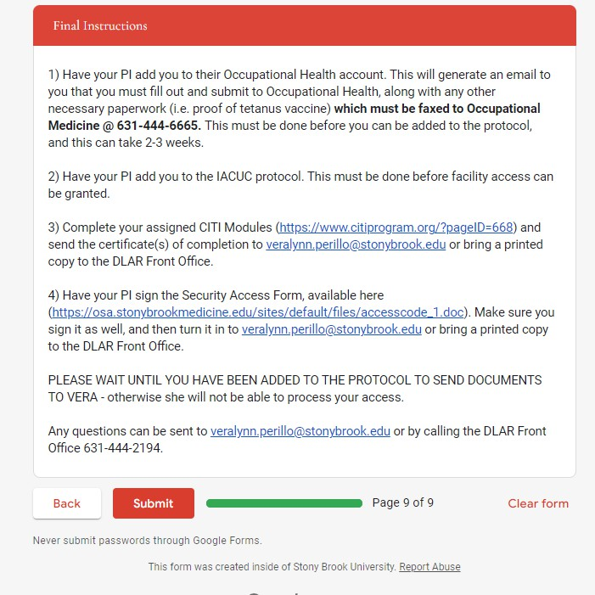
For OLAW training (con’t):

Next steps:
Note the instructions:
-Submit vaccination record
-PI adds lab personnel to IACUC protocol
-Complete CITI modules (see next slides)
*WAIT FOR EMAIL CONFIRMATION THAT YOU WERE ADDED TO PROTOCOL*
-Complete Facility Access Request form & submit it, along with:
-Proof of completion of CITI courses,
-PDF of email confirmation that you’ve been added to the protocol,
-copy of your SBU ID,
to DLAR (either via email or in person)
CLICK “Submit” to complete this Google Form & OLAW training

For CITI modules :
Link:
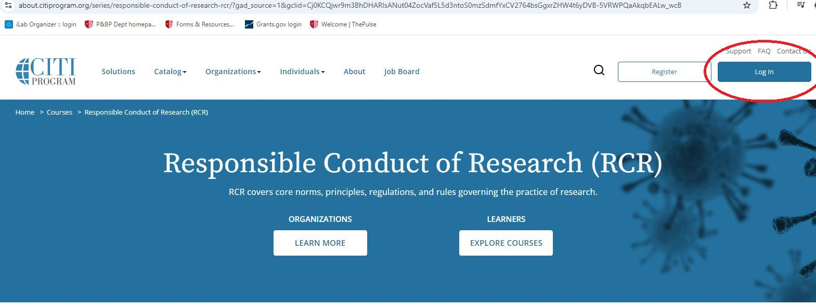

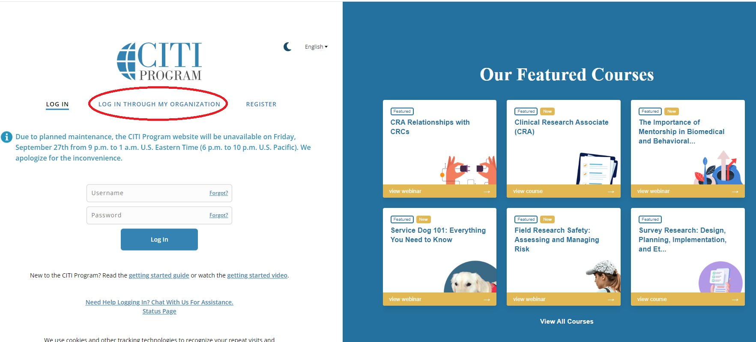
https://about.citiprogram.org/series/responsible-conduct-of-research-rcr/?gad_source=1&gclid=Cj0KCQjwr9m3BhDHARIsANut04ZocVaf5L5d3ntoS0mzSdmfYxCV2764bsGgxrZHW4t6yDVB-5VRWPQaAkqbEALw_wcB

Click “Log In” in
top right corner of webpage

Click “Log In Through My Organization”

For CITI modules (con’t) :

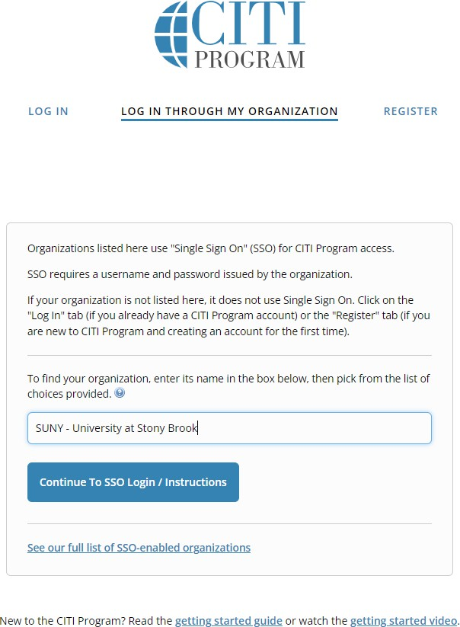
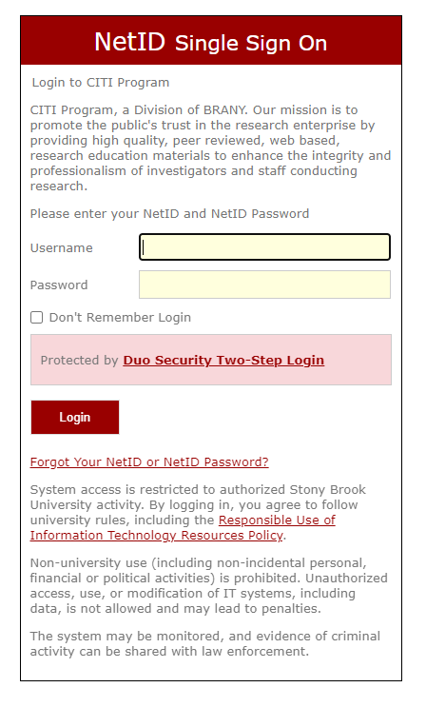
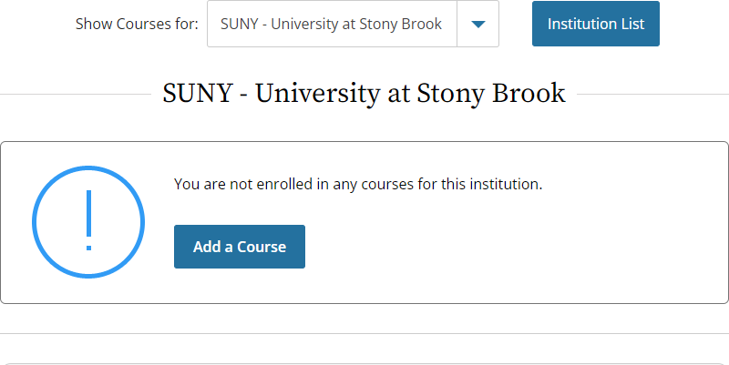
Ensure you are looking at courses for SUNY – Stony Brook & click on
“Add a Course”
Search for SUNY – Stony Brook & click on
“Continue to SSO Login/ Instructions”
Enter your NetID & Password & perform Duo Authentication if required

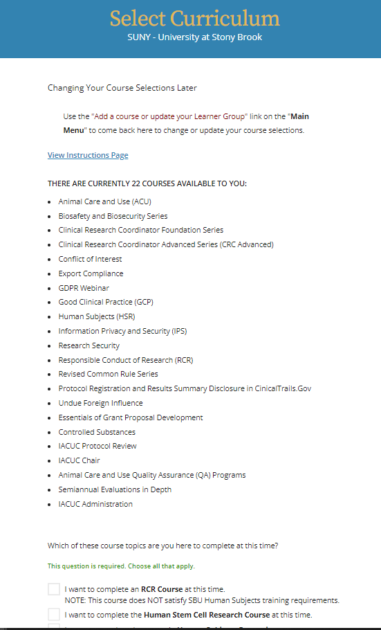
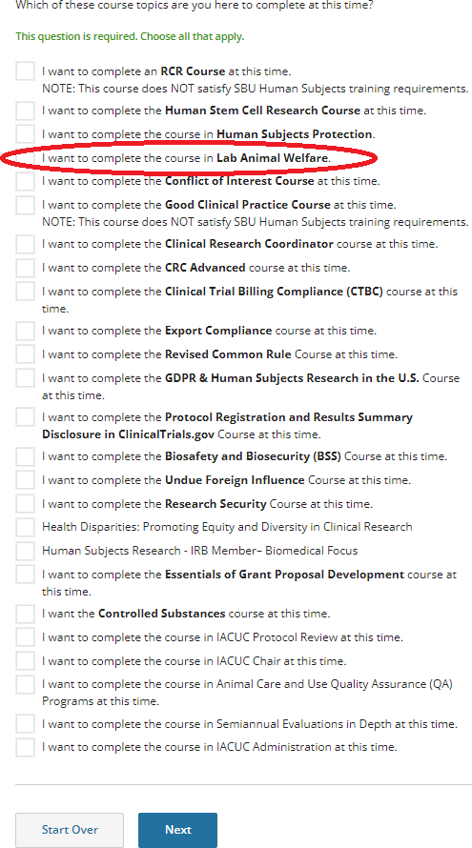
For CITI modules (con’t) :
Scroll to
bottom section

Check the box for the Lab Animal Welfare course & click on “Next”

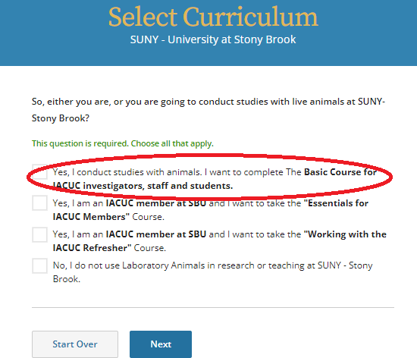
Check the box for the Basic Course for IACUC Investigators, staff and studcents course & click “Next”

For CITI modules (con’t) :

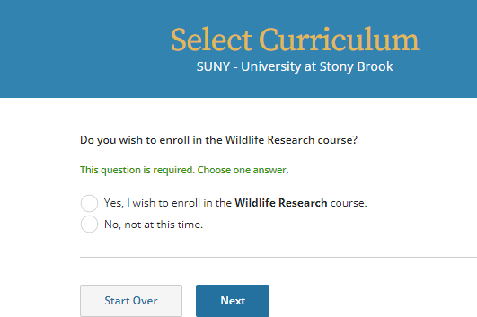

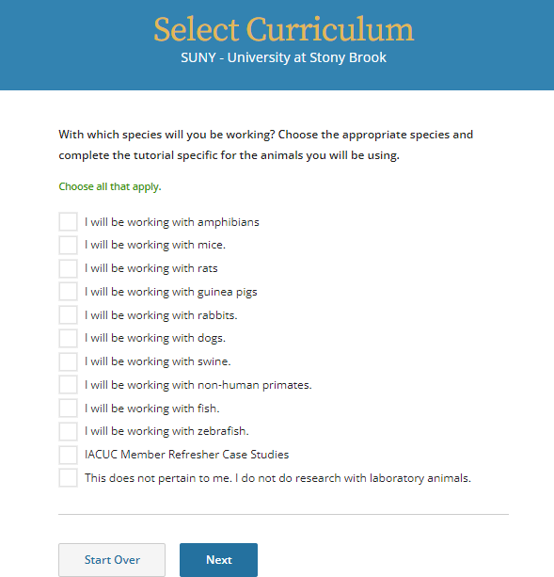
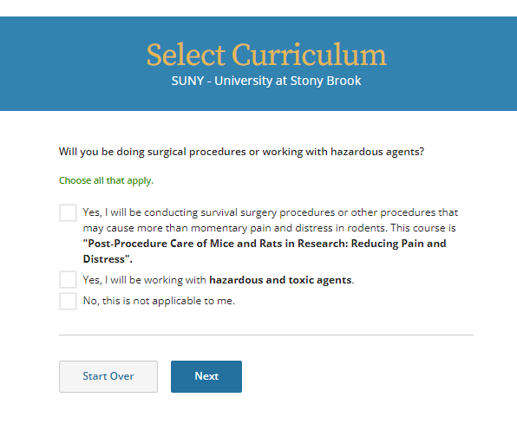
PI & lab personnel determine appropriate answer & click “Next”
PI & lab personnel determine appropriate answer & click “Next”

PI & lab personnel choose appropriate tutorials to take based on animal research being done in the lab & click “Next”

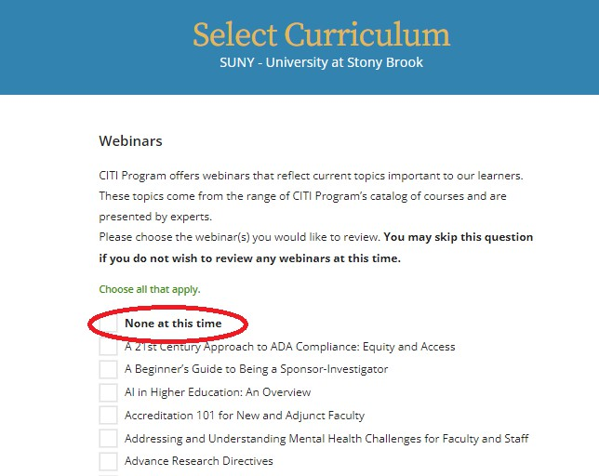
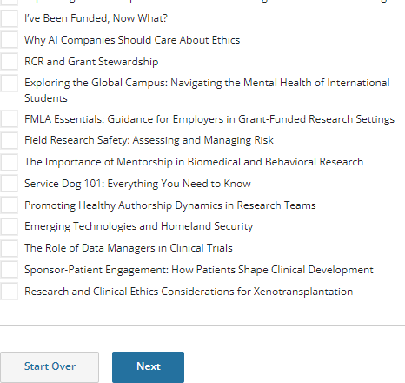
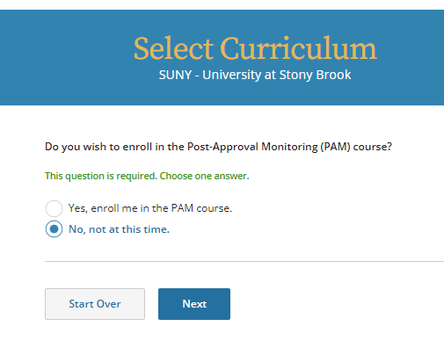
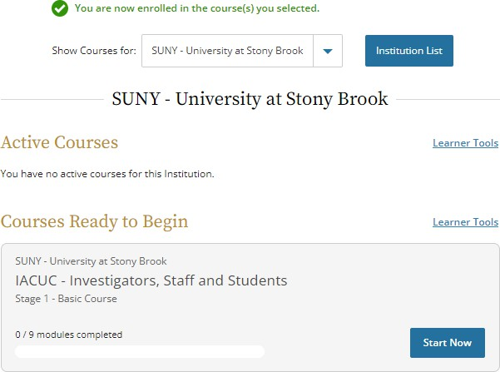
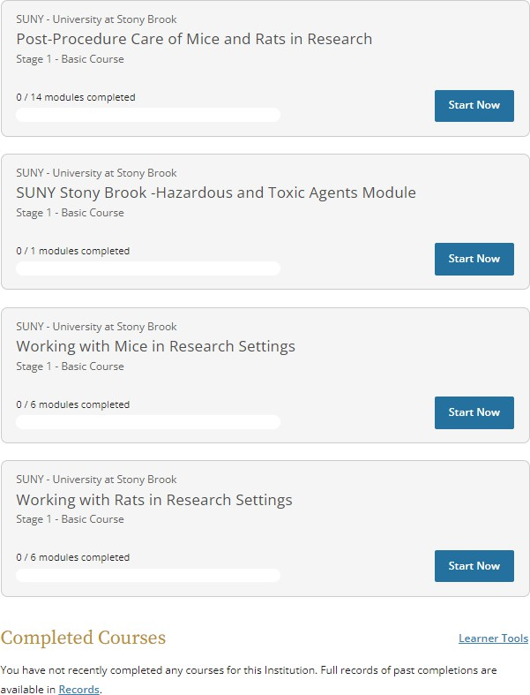
For CITI modules (con’t) :

Scroll to bottom section & click “Next”

PI & lab personnel determine appropriate answer & click “Next”

List of enrolled courses to complete

To wrap it all up:

YOU MUST SUBMIT THE FOLLOWING PAPERWORK EITHER BY EMAIL OR STOPPING IN THE DLAR OFFICE IN ORDER TO REQUEST ACCESS:

- Copies of your completed CITI modules (just the completion page)
- The completed Facilties Access Request form filled out by you and your PI
- The IACUC approval letter that you have been added to the protocol
- Copy of your SBU ID with your picture

