To log onto CITI, go to: htps://www.ci�program.org/?pageID=668
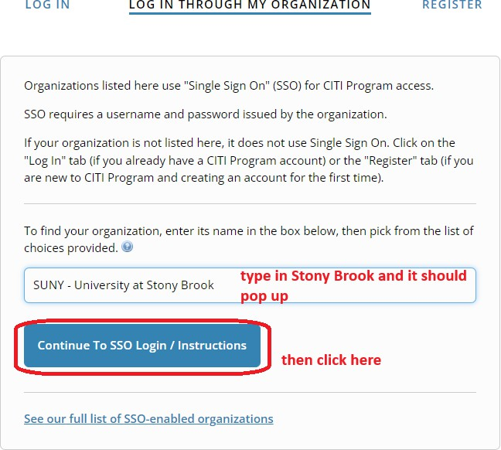

To add an appropriate course:

To add the Human Subjects Protec�on course:

You must select at least one of the 2 courses, either Group 1 SBS or Group 2 Biomedical:

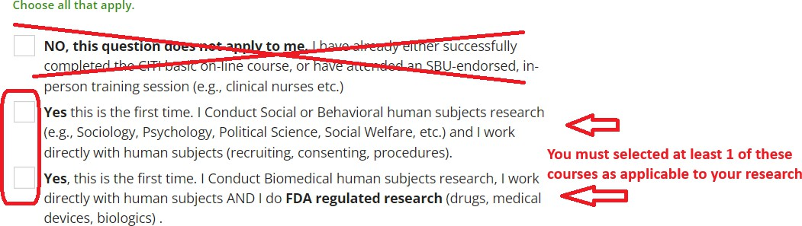

The course should then be added to your Courses Ready to Begin list on CITI.

