To log onto CITI, go to: htps://www.ci�program.org/?pageID=668
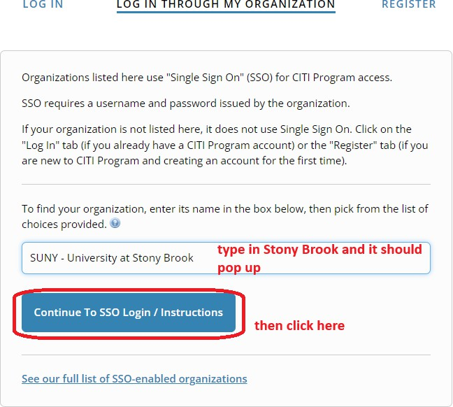

To add an appropriate course:
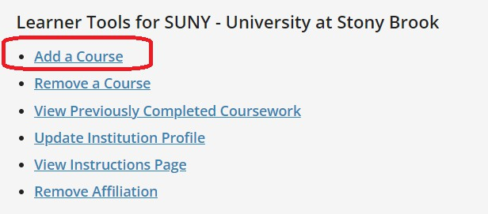
To add the RCR course:


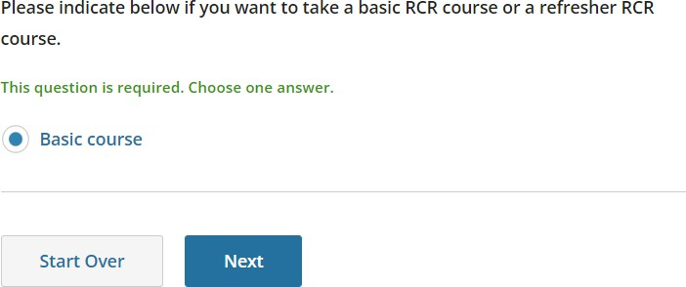

Please select the appropriate RCR course as per your department/discipline/research interest:

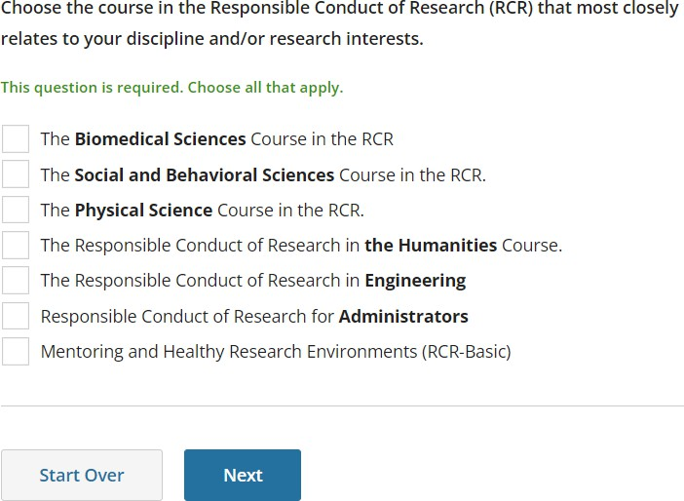

The appropriate course depending on your selec�on should then be added to your course list
on CITI:

SUNY • University at Stony Brook

Responsible Conduct of Research in Engineering
Stage 1

O / 8 modulescompleted

Start Now

SUNY • University at Stony Brook

Responsible Conduct of Research in The Biomedical Sciences
Stage 1

Ot 7 modulescompleted

Start Now

SUNY • University at Stony Brook

Responsible Conduct of Research in the Humanities
Stage 1

Ot 7 modulescompleted Start Now

SUNY • University at Stony Brook

Responsible Conduct of Research in the Physical Sciences
Stage 1

Ot 7 modulescompleted Start Now

SUNY • University at Stony Brook

Responsible Conduct of Research in the Social and Behavioral Sciences
Stage 1

Ot 7 modulescompleted

Start Now

