To log onto CITI, go to: htps://www.ci�program.org/?pageID=668
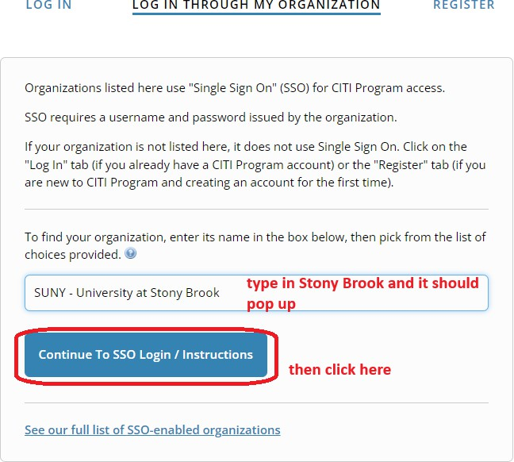

To add an appropriate course:
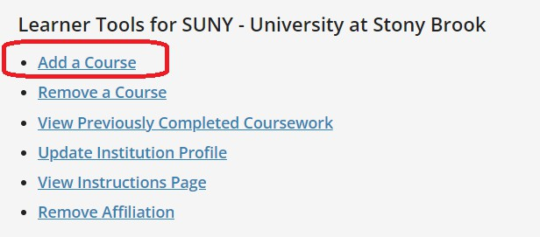

To add the Laboratory Animal Welfare Course:
Inves�gators and Key Personnel do not select the “IACUC Members ONLY” op�on. Please only select this op�on:

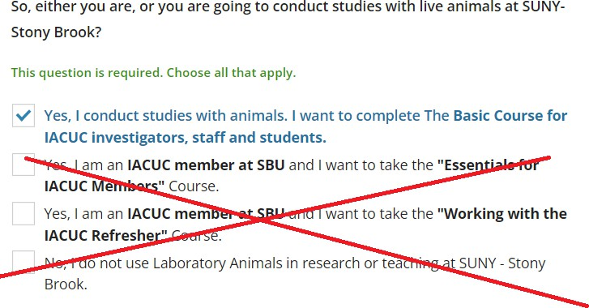

Select the appropriate species below:
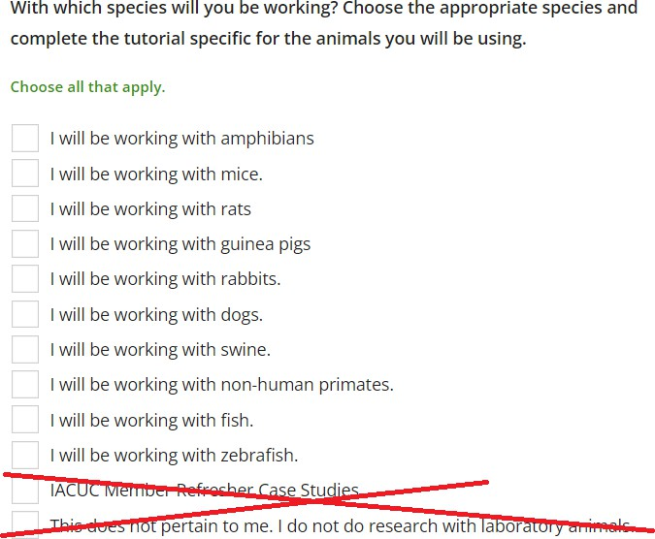

Select whichever is appropriate:
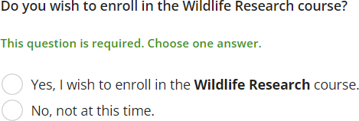

Select whichever is appropriate:

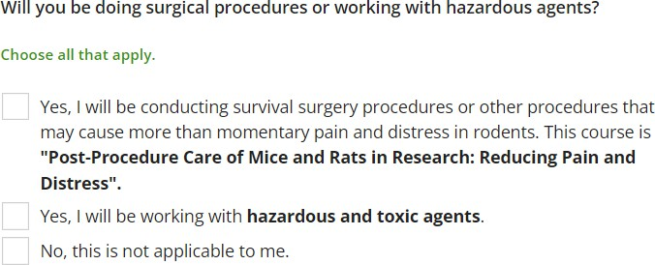

Select whichever is appropriate:
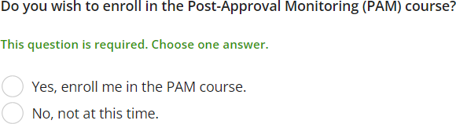

Depending on your selec�ons, the course(s) should then be added to your Courses Ready to Begin list on CITI.

SUNY - University at Stony Brook

IACUC- Investigators, Staff and Students
Stage 1 - Basic Course

O t 9 modulescompleted
Start Now

SUNY - University at Stony Brook

Post-Approval Monitoring (PAM)
Stage 1 - Lab Animal Research

Ot 1 modulescompleted
Start Now

SUNY - University at Stony Brook

Post-Procedure Care of Mice and Rats in Research
Stage 1 - Basic Course

0 / 14 modules completed
Start Now

SUNY - University at Stony Brook

Wildlife Research

Stage 1 - Lab Animal Research

O t 5 modulescompleted
Start Now

SUNY - University at Stony Brook

Working With Amphibians in Research Settings
Stage 1 - Basic Course

O t 5 modulescompleted
Start Now

SUNY - University at Stony Brook

Working with Dogs in Research Settings
Stage 1 - Basic Course

O I 6 modulescompleted
Start Now

SUNY - University at Stony Brook

Working with Fish in Research Settings
Stage 1 - Lab Animal Research

O I 6 modulescompleted
Start Now

SUNY - University at Stony Brook

Working with Guinea Pigs in Research Settings
Stage 1 - Basic Course

O t 5 modulescompleted
Start Now

SUNY - University at Stony Brook

Working with Mice in Research Settings
Stage 1 - Basic Course

O t 6 modulescompleted
Start Now

SUNY - University at Stony Brook

Working with Non-Human Primates in Research Settings
Stage 1 - Basic Course

O t 6 modulescompleted
Start Now

SUNY • University at Stony Brook

Working with Rabbits in Research Settings
Stage 1 - Basic Course

O t 6 modulescompleted
Start Now

SUNY • University at Stony Brook

Working with Rats in Research Settings
Stage 1 - Basic Course

O t 6 modulescompleted
Start Now

SUNY • University at Stony Brook

Working with Swine in Research Settings
Stage 1 - Basic Course

O t 6 modulescompleted
Start Now

SUNY • University at Stony Brook

Working With Zebrafish (Dania rerio) in Research Settings

Stage 1 - Lab Animal Research

O t 5 modulescompleted
Start Now

