To log onto CITI, go to: htps://www.ci�program.org/?pageID=668
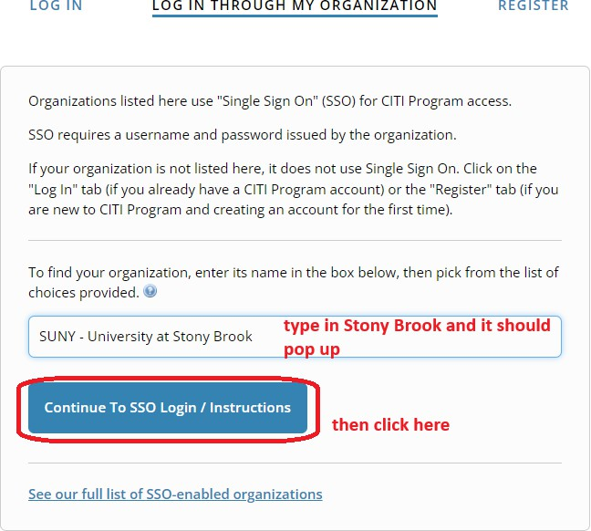

To add an appropriate course:

To add the Good Clinical Prac�ce Course:

Choose the applicable course as per your study:

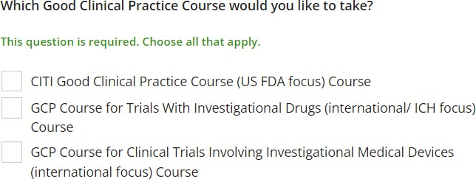
Depending on your selec�on, the course should then be added to your Courses Ready to Begin list on CITI.


