To log onto CITI, go to: htps://www.ci�program.org/?pageID=668
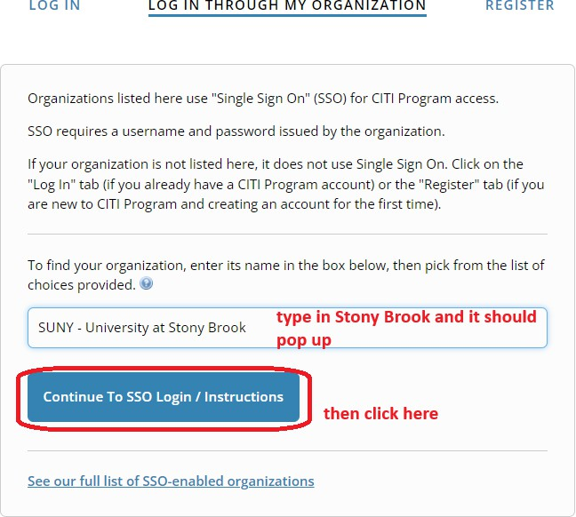

To add an appropriate course:

To add the Clinical Research Coordinator course:
The course should then be added to your Courses Ready to Begin list on CITI.

SUNY - University at Stony Brook

Clinical Research Coordinator (CRC)
Stage 1 - Basic Course

0 I 11 modules completed

Start Now

