How to add your department chair to sign off:
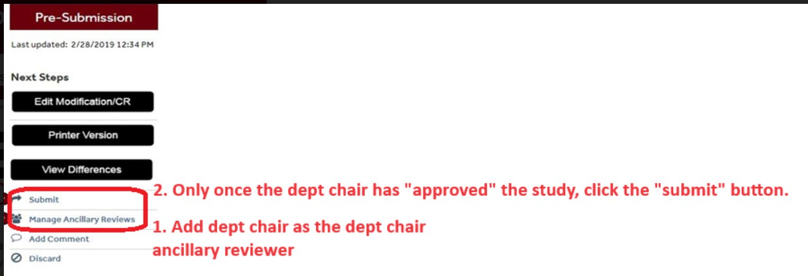
Click the "manage ancillary reviewers" option on the left hand side. A new window should pop up. Here you click "add":
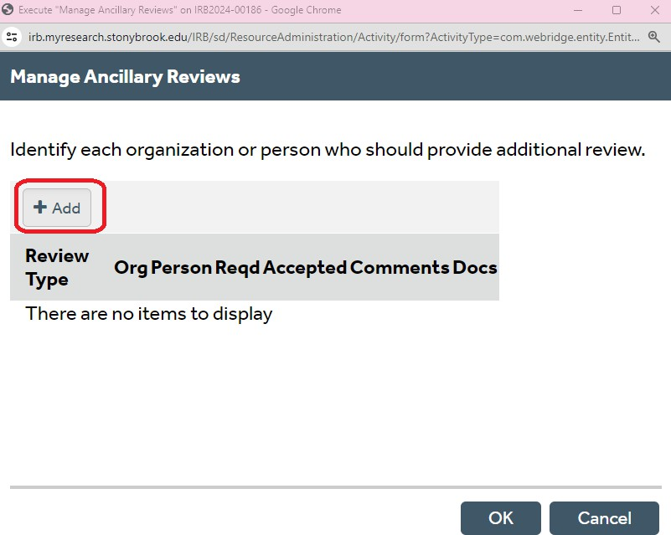

Once you click "add" another window pops up:

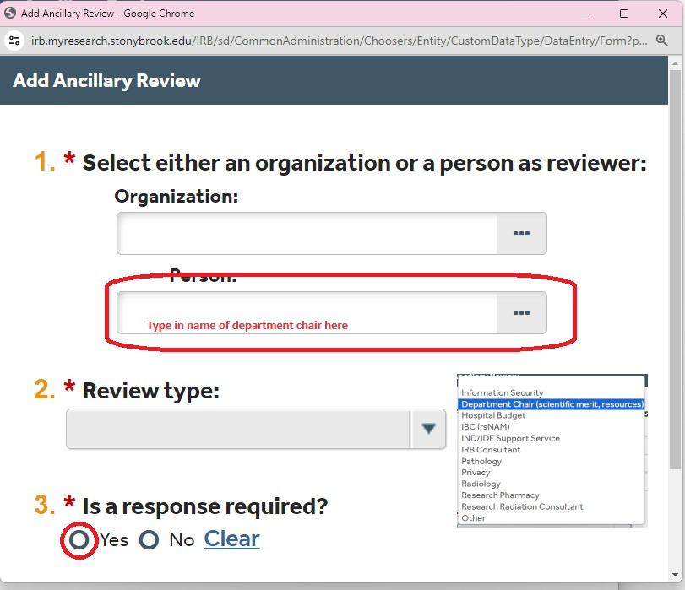
Once you type in the name of the department chair, XXXXX in your case, the name should pop up. Select it. Then choose for review type: department chair, and finally click a response is required. Click ok for both of these windows.


That should add the department chair to the study to be able to sign off. The department chair should get a ping within the system, however, I do advise PI's to reach out to their dean's just in case as they might miss it or the spam filter might catch it.

