




Pivot Snippet
How to Update Your Pivot Profile

What is PIVOT?
The Office of the Vice President for Research subscribes to Pivot, which is a web-based discovery and workflow tool that combines a comprehensive source of global funding opportunities with the largest collection of scholar profiles into one intuitive solution.

With Pivot, faculty, research administrators, postdocs, and graduate students can easily explore new avenues for funding, view funding opportunities uniquely matched to their scholar profile, collaborate with colleagues, and build a funding strategy that supports both immediate and long-term funding needs.

For more information or assistance with building your profile or searches, please contact OPD at OPD_OVPR@stonybrook.edu.

Benefits of Having an Updated Profile

- Automatic - updated profiles allow for automatic results - It’s easier to find funding
- It’s easier for others to find you, and for you to find others
- OPD is better able to assist faculty find funding and collaborators

Step 1: Create your account at https://pivot.proquest.com/
You must use a stonybrook.edu or
stonybrookmedicine.edu email address
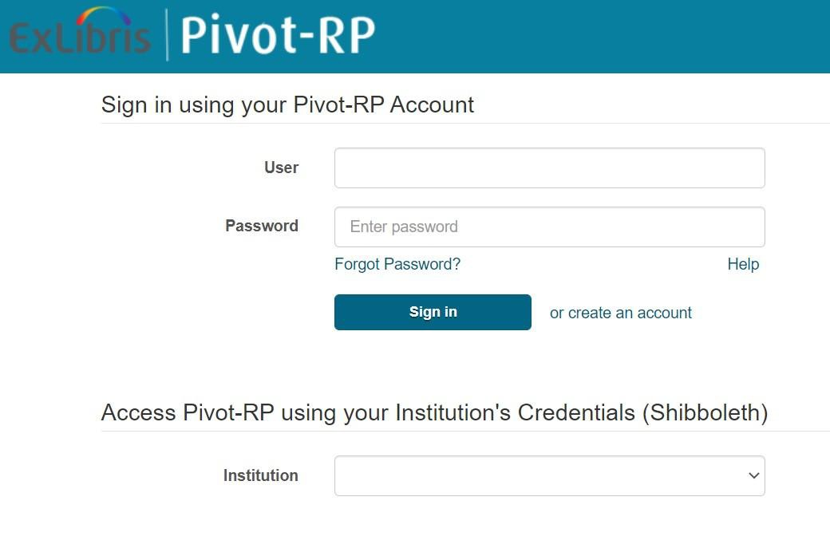

Step 2: Log into PIVOT
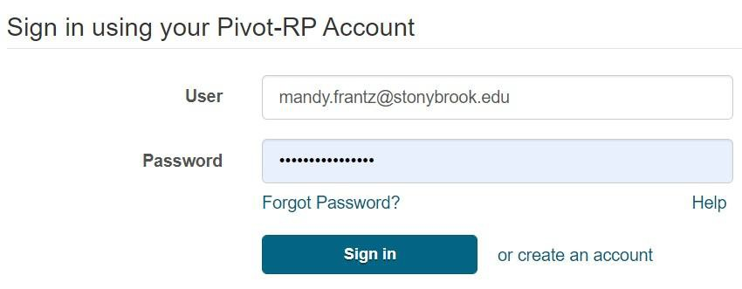
For most faculty members, you will see a profile already set up when you first log in. You may see more than one profile. If there is more than one profile for you, select the ‘THIS IS ME’ option of the profile that is most current and email us at OPD_OVPR@stonybrook.edu and we will ask that the second profile be removed. If you do not see a profile for you, you can create your own by following their prompts or email us and we will add your information.


Step 3: Claim Your Profile
Under your Profile drop down menu in the top right corner, select Claim Profile.
You must ‘Claim’ your profile to begin receiving funding opportunities or editing your profile.

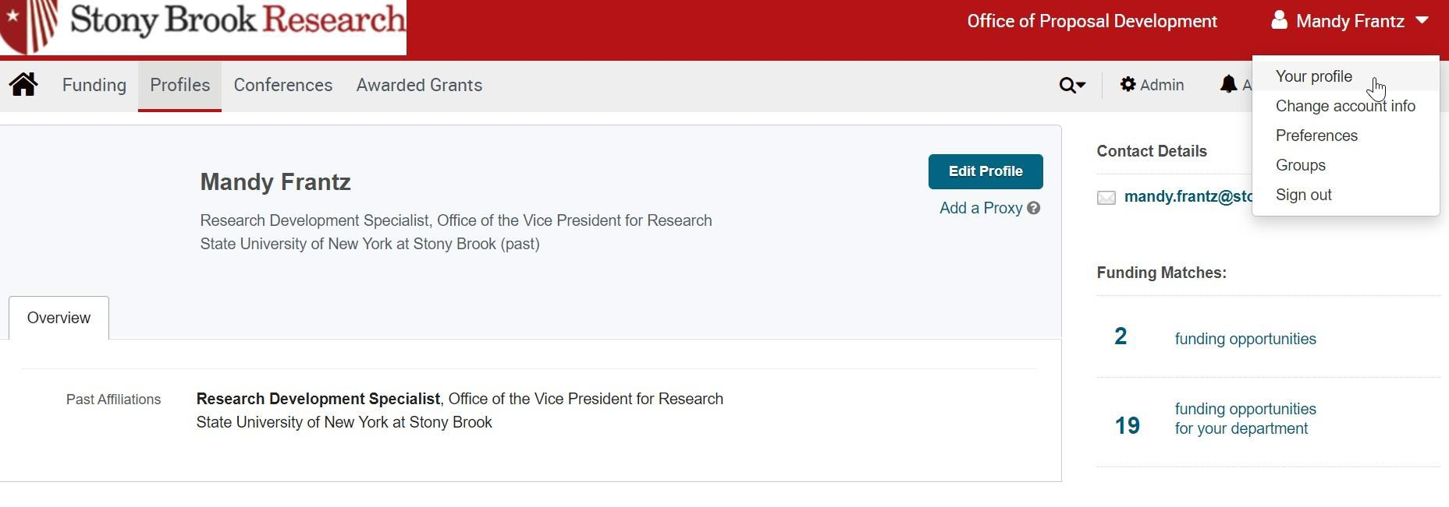

Editing Your Profile

You can edit your profile at any time by going under your profile tab in the upper right-hand corner.

Editing Your Profile - Overview
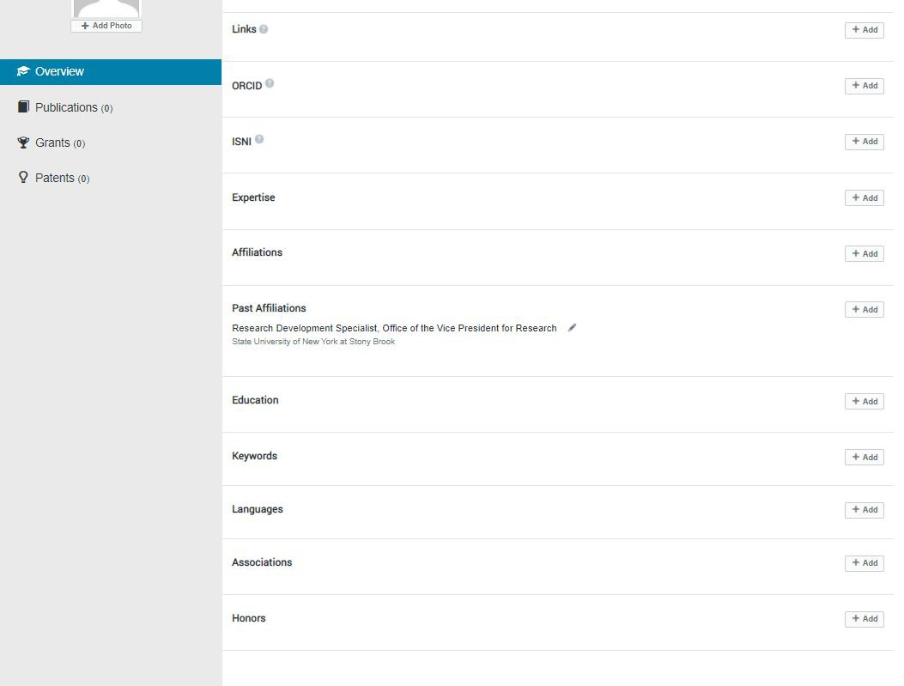
To add more details, click ‘+ Add’ to the right of each subsection

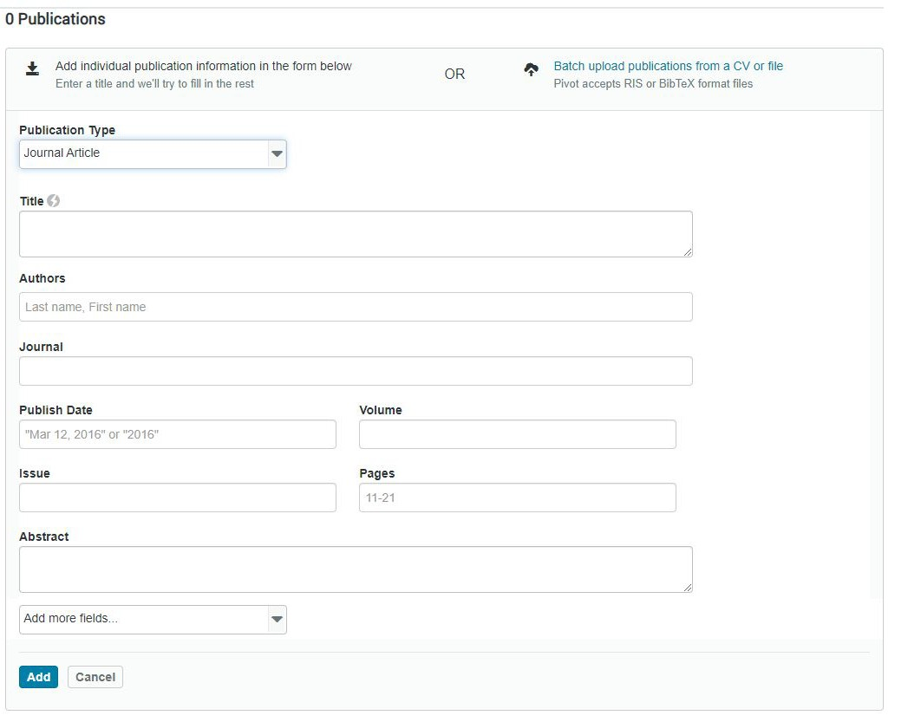

Editing Your Profile - Publications, Grants, and Patents

Once you’re done making your edits, click ‘Done’ in top right corner – and your profile is updated!

Faculty Profiles Search

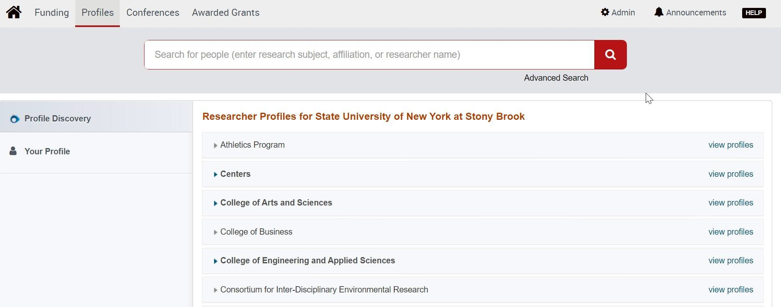

Pivot is primarily used to find funding opportunities, but if profiles are up to date, then it’s a good resource to find collaborators.

Faculty Profiles Advanced Search

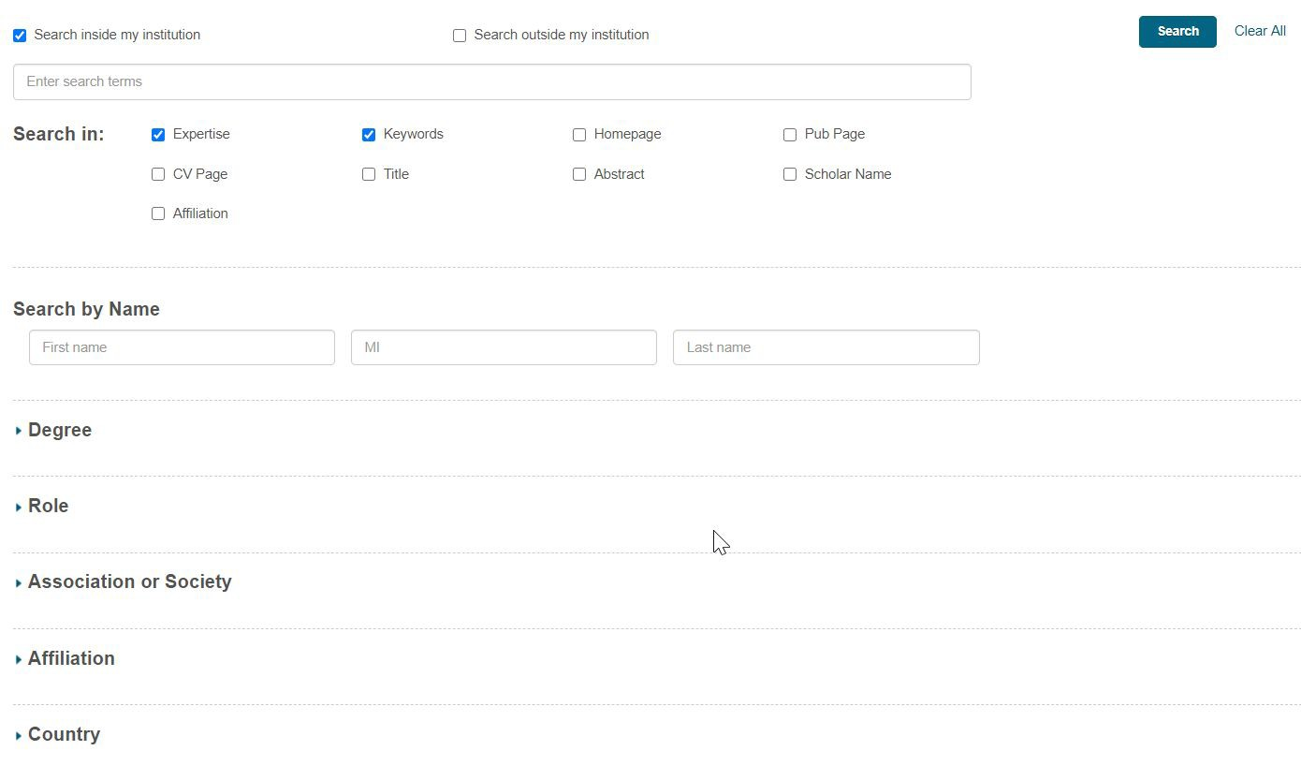
For the most accurate results, we recommend searching in expertise and keywords only.

Questions?

Contact OPD_OVPR@stonybrook.edu

