Budget to Actuals Quick Reference

Accessing Information by Account
Example: To access a State, Dorm, or LISVH account:
From the Main Menu, choose Budget to Actuals -> Use -> AF Budget to Actuals Entry.
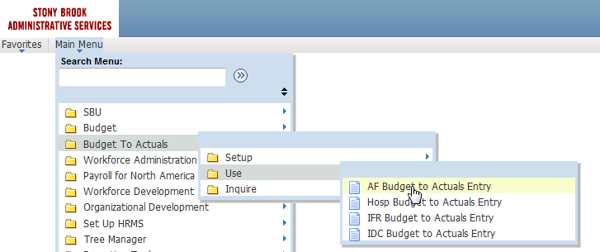

In the Search box, input the model year we are currently budgeting and an account number.
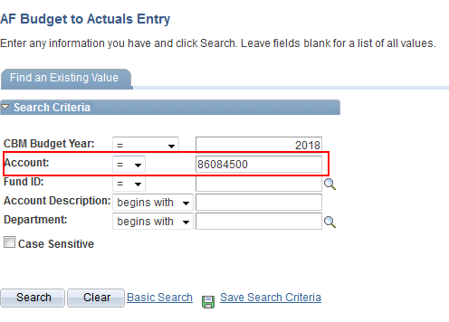

The panel below will be displayed. It shows the past 3 years of actual expenses followed by an average expense column, the Form 1 submission from the last budget cycle, and your CBM budget in progress. There is also a column for forecasting an additional out year and a column for inputting your comments. At the bottom of the panel, there is a “long” notes field. Don’t forget to save your work if you input data.
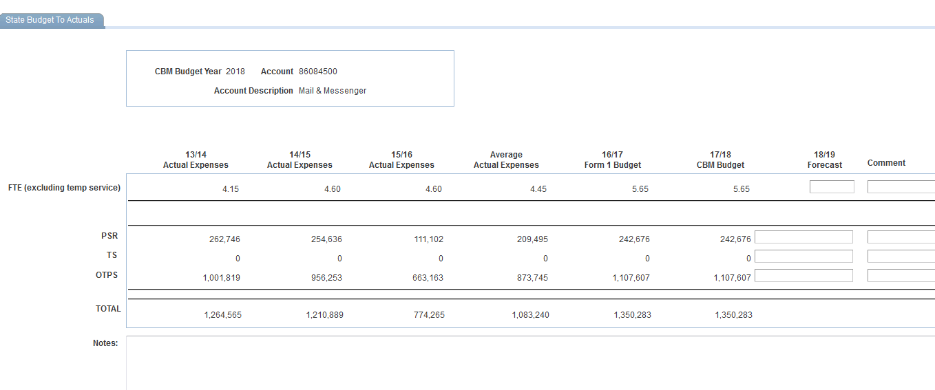

Accessing Accounts in Other Funds

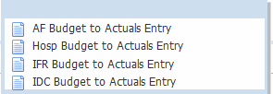

Note that accounts in different funds should be selected from the appropriate Use menu:
AF: to access a State (fund 10), Dorm (fund 30), or LISVH (fund 60) account
Hosp: To access a Hospital (fund 40) account
IFR: To access a General IFR (fund 20), SUTRA (fund 25), DIFR-IFR (fund 35), HIFR-IFR (fund 45), or Stabilization (fund 67) account
IDC: To access an IDC (fund 73) account

Note that the IFR panel that is displayed will include Revenue.

Note that the IDC panel that is displayed will include FTE in the Actuals columns. The Form 1 and CBM Budget columns will have FTE = 0 since this data is not captured in CBM. All IDC salary in the Form 1 and CBM Budget columns will be displayed as Temp Service (TS).

Accessing Information by Organization

You may view data by organizational area down to the parent level.
From the Main Menu, choose Budget to Actuals -> Inquire -> Inquiry.

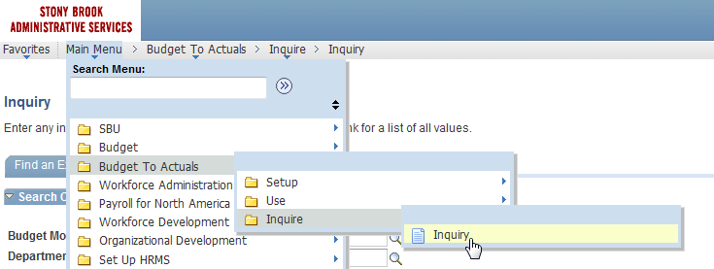

In the Search box, input the model year we are currently budgeting and a department (level1, level2, level3, or level4).
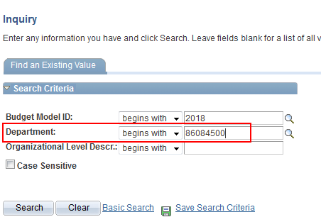
The read only panel group below will be displayed. It shows the organizational rollup of the past 3 years of actual expenses followed by the Form 1 submission from the last budget cycle and your CBM budget in progress. There is also a column which displays the forecast for an additional out year.
This group displays the following panels:
Totals – Total Expenses = PSR + TS + OTPS
PSR Inquiry – Personnel Services Regular
TS Inquiry – Temporary Services
OTPS Inquiry – Other Than Personnel Services (Supplies & Equipment)
FTE Inquiry – Full Time Equivalent for Employees
Revenue Inquiry – Revenue for IFR Accounts
