Interview
INTERVIEW
INTERVIEW
The Energy Value Chain

An Interview with Robert B. Catell, Chairman, Advanced Energy Research and Technology Center (AERTC)

The Advanced Energy Center at Stony Brook University

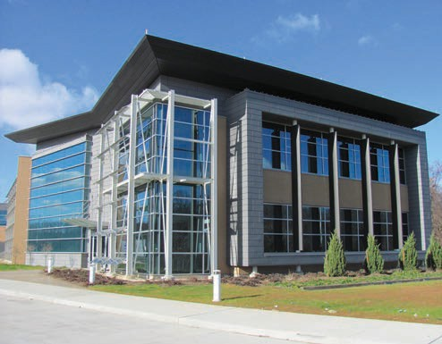

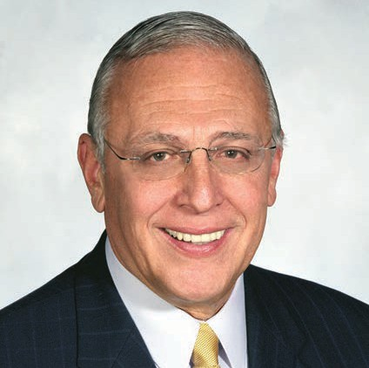
Robert B. Catell

EDITORS’ NOTE Bob Catell joined Brooklyn Union Gas Company (later merged into KeySpan Corporation) in 1958. His rise through the com-pany’s ranks culminated in his appointment as President and CEO in 1991 and Chairman and CEO in 1996. A registered professional engineer, Catell assumed his current post upon the acqui-sition of KeySpan by National Grid in August 2007. He earned his bachelor’s and master’s de-grees in mechanical engineering at the City College of New York.
ORGANIZATION BRIEF The Advanced Energy Center (www.aertc.org; AERTC) is a true part-nership of academic institutions, research in-stitutions, energy providers, and industrial corporations whose mission is innovative energy research, education and technology deployment with a focus on efficiency, conservation, renew-able energy, and nanotechnology applications for new and novel sources of energy.

How did AERTC develop and what is the vi-sion for the entity?
The concept for the energy center started ﬁve years ago when I, in collaboration with the stony brook dean of the College of engineering and applied sciences, Yacov shamash, felt there ought to be an entity created that was similar to the College of nanoscale science and engineering at albany state university, but that focused on energy. our idea was to have an energy research center that focused on the energy value chain, starting with generation and going down to the customer.
It encourages research to develop new tech-nologies that could eventually be commercialized and create business and jobs in the energy sector.

How has the process developed and what stage is the center at now?
We started by talking to a lot of the interested parties in business, in the industry, and in the po-litical sector, and it became obvious that the en-ergy ﬁeld presented some great opportunities to
develop technologies that could solve our energy problems from both an environmental and an ef-ﬁciency standpoint. Getting to where we are today with a beautiful platinum Leed-certiﬁed building in the research and development Park campus at stony brook university took a lot of hard work.

Is it important to focus on specific ar-eas in order to have impact?
We will do research in every aspect of energy, starting with generation, transmission, and distribu-tion, and getting down to the customer. but our particular niche is the energy delivery grid – what a lot of people refer to as the smart grid.

How important has it been to build part-nerships with business and the public sector?
It has been critical for a few reasons. When we started out, we were seeking state funding and we were eventually able to get $45 million from the state to build the building.
In order to secure this funding, we had to demonstrate that we had a coalition. We started by creating an advisory board that I chair, with repre-sentatives from the utility sector, large energy compa-nies, small companies, as well as from the academic community. That gave us the structure we needed to support the state capital investment, which was used to build the state of the art, platinum Leed-certiﬁed advanced energy Center facility.

Is there an effective awareness about the impact of energy on New York State’s economic challenges?
one of our biggest challenges is educating the general public on energy and the important role that energy plays in economic development, and in our quality of life. People are generally aware of the issues of climate change or global warming, as well as our dependency on imported oil for creating our power, and that we need to do things to clean up the environment. but people don’t focus on the solutions. The general pub-lic has become accustomed to lights coming on when they ﬂip a switch, tuning in to their favor-ite shows and sporting events on television, and being able to enjoy a cold refreshment from the refrigerator; in general, the only time people think about energy is when it’s not there to serve them. as an energy industry member working in academia, I believe we have an opportunity and a responsibility to educate the public on the need
to improve our energy delivery infrastructure.

How will you make sure the research at the center will drive action?
Part of that will come from public educa-tion. another part will come from demonstrating
that the new technologies that have been de-veloped at the energy Center will improve the reliability and security of our energy supply and reduce our dependence on fossil fuels, par-ticularly imported oil. We have a great deal of natural gas, both domestically and worldwide, which can be essential in solving our problems long term.
We need to create awareness that there are alternatives; that there is no one “silver bullet” to solve our energy problems. We have to look at renewables, solar, and wind – we need to com-bine those options with the development of new technologies and the use of natural gas, and fully develop a portfolio of solutions.

What role should nuclear play and how do you reassure the public of its safety?
nuclear energy needs to be part of the solu-tion. unfortunately, the terrible disaster that hap-pened in Japan has raised concerns about the future of nuclear power. some countries have even said that they’re discontinuing nuclear power long term, which is shortsighted. What happened in Japan was deeply tragic and nuclear power will suffer a setback for some time until we can reas-sure the public that it is safe. We can and should learn from the Fukushima nuclear accident. It will be challenging to educate the public that nuclear power is safe, but it is incumbent upon the leader-ship of the country to take on that challenge.

Is it fair for consumers to feel that new technologies will bring costs down?
There are two sides to that equation: ini-tially, the cost of development of some of the new technologies and upgrading the energy de-livery system will put some pressure on rates; it is impossible to do those things without spend-ing money related to a front-end cost.
In turn, developing new technologies and making the energy delivery grid more efﬁcient will result in lower costs long term. The front-end investment will enable the industry to pro-vide a more reliable, secure, and economical energy mix down the road.

What drives the passion that you have shown in this role?
Today, there are more opportunities to make an impact and affect real change than ever before. I see a bright future and it will be nice to look back someday and say that I made a posi-tive contribution while serving the utility industry for 50 years, and that I was able to contribute in some way toward helping our country solve its
energy problems long term.•

