



Robert Moses State Park | Fire Island

March Edition
N E W S L E T T E R

Long Island Power Authority’s
COMMUNITY ADVISORY BOARD






I hope this message finds you well. I would like to extend my heartfelt appreciation to those of you who attended our December Community Advisory Board Meeting. Your participation and insights are invaluable to us as we strive to enhance our collaboration and transparency.

A MESS AGE FROM OUR CEO
CAB Newsletter | March Edition

LIPA’s goal is to actively engage with our Community Advisory Board members, and we hope our recent efforts have helped keep you informed on our progress providing clean, reliable, and affordable electric service to our
1.2 million customers. The importance of the Community Advisory Board cannot be overstated; it serves as a vital link between LIPA and the communities we serve. Your voices and perspectives play a crucial role in our decision-making processes, ensuring that we align our initiatives with the needs and priorities of Long Island and the Rockaways.

Below are a few of my priorities for 2025:

Operations Services Request for Proposals
- Successful outcome of the process for a future service provider

Our Mission: Clean, Reliable, and Affordable Electric Service
- Continuing meaningful progress to provide clean, reliable, and affordable electric service

Storm Preparedness and Readiness
- Enhancing our preparation and readiness for major storms

Community Advisory Board
- Strengthening engagement with the Community Advisory Board

Community Partnerships
- Securing key partnership initiatives with our local communities

Once again, I thank you for your dedication and commitment to our mission. Together, we can drive meaningful change and foster a sustainable future for our communities.

Sincerely,

John Rhodes
John Rhodes Acting CEO





The December Community Advisory Board meeting was very productive. After Tracey Edwards and John Rhodes welcomed members, Chief Financial Officer Donna Mongiardo provided the CAB with a presentation on 2025 Budget highlights. This year, we are proud to state that the budget prioritizes affordability, keeping costs low while continuing to invest in the electric grid and clean energy. This budget provides a transparent look at our business operations and our efforts to continuously enhance our utility and the critical service we provide.
D ECEMBER MEETING SUMMA RY

The 2025 Operating Budget of $4.4 billion, funds delivery and power supply costs, energy efficiency and distributed energy programs, taxes, and debt service. The capital budget of $1.0 billion funds storm hardening and long-life infrastructure investments, such as transmission lines, substations, poles, and wires, as well as information technology, vehicle fleet, and other assets.

As the owner of the electric system on Long Island and the Rockaways, LIPA has the ultimate authority and control over the transmission and distribution system assets and specific responsibilities, including determining all rates and charges and reviewing and approving LIPA’s budget, among other critical utility initiatives.

In 2025, the typical residential customer bill is projected to be $7.27 (3.9%) higher than budgeted in 2024. Approximately $1.89 (1.1%) is due to an estimated increase in average electricity use per typical residential customer. LIPA projects that a typical residential customer will use approximately 723 kilowatt-hours (kWh) of electricity per month in 2025 compared to 715 kWh in 2024 due to improved economic assumptions and beneficial electrification, including the adoption of electric vehicles and heat pumps. Assuming no increased usage by a typical residential customer, the projected bill is estimated to increase by $5.38 (2.80%). Higher debt service requirements and related coverage are driving a significant portion of the projected increase, and these funds are used to support capital investments.

LIPA is also projecting higher power supply costs in the 2025 budget, which is contributing $1.97 to the monthly bill impact as LIPA purchases electricity, natural gas, and fuel oil to meet customer needs. LIPA budgets for power supply costs at prevailing market prices, which are reconciled to actual costs through a Power Supply Charge that changes each month and appears as a separate line item on customer bills. This ensures our customers only pay for the actual power supply costs.

Many thanks to PSEG Long Island for providing the Board with an update on PSEG’s operating performance and the status of the roll out for the Time-of-Day initiative. John Rhodes also announced the adoption of an exciting new policy change at LIPA. This change will facilitate underground transmission and distribution lines across LIPA territories.

Under the newly adopted policy, LIPA will require all new transmission lines over 65 kilovolts (kV) to be constructed underground, with overhead construction only considered when proper justification is provided. LIPA is also evaluating additional undergrounding on mainline distribution, particularly in areas with rear property lines and heavy tree conditions. Forty miles of underground bypass work has already been completed, with an additional nine miles planned over the next three years.

To oversee this effort, LIPA has directed staff to convene an underground working group of key internal and external stakeholders to ensure awareness of existing programs and maximize cost-savings by better coordinating planned work. Communities seeking to underground will have more opportunities to engage with LIPA.

Additionally, the LIPA Board has requested that new policy guidelines be considered to help inform future distribution-level undergrounding work based on reliability. Staff will explore undergrounding programs from other utilities to determine if there are cost-effective best practices that can be incorporated into LIPA’s service territory to drive customer reliability.

CAB Newsletter | March Edition

LIPA’s Community College Scholarship
C OMMUNITY PAR TNERSHIPS

LIPA’s Community College Scholarship covers full tuition, fees, and a book stipend for students at Nassau Community College and Suffolk County Community College. The program focuses on supporting students from underserved communities with household incomes below the Long Island median, enabling access to education in the electric utility and clean energy sectors.
New for 2025: LIPA has partnered with United Way of Long Island to administer the scholarship program. This collaboration ensures effective outreach and implementation, leveraging United Way’s expertise to maximize community impact and student success.

The Advanced Energy Research and Technology Center (AERTC) Internship Program

The AERTC at Stony Brook University is a partnership of academic institutions, research institutions, energy providers, and industrial corporations. The Center’s mission is to innovate energy research, education, and technology deployment with a focus on efficiency,
conservation, renewable energy, and nanotechnology applications for new and novel sources of energy.
New for 2025: LIPA is supporting the inaugural launch of the ‘CyberLearn’ program, which is designed to educate and develop a pipeline of highly skilled students for the energy sector, with a focus on cybersecurity and securing critical infrastructure.

The Idaho National Laboratory and the U.S. Department of Energy developed the CyberLearn program’s standardized curriculum, with the Brookhaven National Laboratory contributing funding and teaching resources as well.

As part of its commitment, LIPA has contributed $10,000 toward the program for 2025.
Furthermore, in 2025, LIPA will offer summer internship opportunities to three students enrolled in the program, providing hands-on experience and fostering industry readiness.



MEET LUIS VA Z QUEZ
Luis Vazquez, President
Long Island Hispanic Chamber of Commerce Supporting Hispanic Minority-Owned Small Businesses
Tell us a little about your organization. What’s the most exciting project or initiative you’re working on right now?
CAB MEMBER HIGHLIGHT
The Long Island Hispanic Chamber of Commerce (LIHCC), established in 1988, is the only bi-county Chamber of Commerce serving Nassau and Suffolk Counties. As a not-for-profit 501(c)(6) organization, LIHCC is dedicated to empowering Hispanic minority-owned small businesses by providing essential resources, networking opportunities, and advocacy.

One of the most exciting initiatives we are currently focused on is our ongoing effort to help businesses recover and thrive in the post-pandemic economy. Since the onset of COVID-19, the LIHCC has been at the forefront, collaborating with local, state, and federal agencies to deliver critical information and resources to our members. From securing Personal Protective Equipment (PPE) to navigating Small Business Administration grants, loans, and other relief programs, we have worked tirelessly to ensure our community has the support it needs to rebuild and prosper.
Throughout the year, LIHCC hosts networking and professional development events, including the Latina Hat Luncheon and Annual Gala Awards & Toy Drive, which recognize leaders and everyday champions for their outstanding contributions to the Hispanic community.

As a member of the United States Hispanic Chamber of Commerce, LIHCC continues to champion Hispanic-owned small businesses and drive economic growth across Long Island.to maximize community impact and student success.

As a leader on LIPA’s Community Advisory Board, what opportunities or initiatives do you believe are critical to reaching New York’s clean energy goals?
I believe achieving New York’s clean energy goals requires a strong focus on equitable access, workforce development, and community engagement—particularly within the Hispanic and minority-owned business communities.

One critical initiative is expanding clean energy job opportunities by investing in training programs that equip minority entrepreneurs and workers with the skills needed for careers in solar, wind, and energy efficiency sectors. Supporting small businesses in transitioning to sustainable practices through grants and incentives is also essential, ensuring they can participate in and benefit from the green economy.

Additionally, community education and outreach in relatable terms and in a language that the community understands, must be a priority. It is imperative to make clean energy solutions more accessible and affordable for families and businesses. By working together, we can drive economic growth, environmental justice, and energy affordability across Long Island while fostering a more sustainable future for all.

What’s something about you that might surprise people—any unique hobbies or hidden talents?
The one thing about me that might surprise people is that I enjoy gardening and landscaping. While much of my work is centered around business and community advocacy, I find that spending time working outdoors, provides a sense of balance and renewal and it’s something that is incredibly rewarding – nurturing growth, whether it’s in a garden or within the business community. Just like in business and leadership, success often comes from dedication, nurturing and long-term vision.

CAB Newsletter | March Edition

CL EAN, RE LIABL E , AFF OR D A BL E
SPREAD THE NEW S

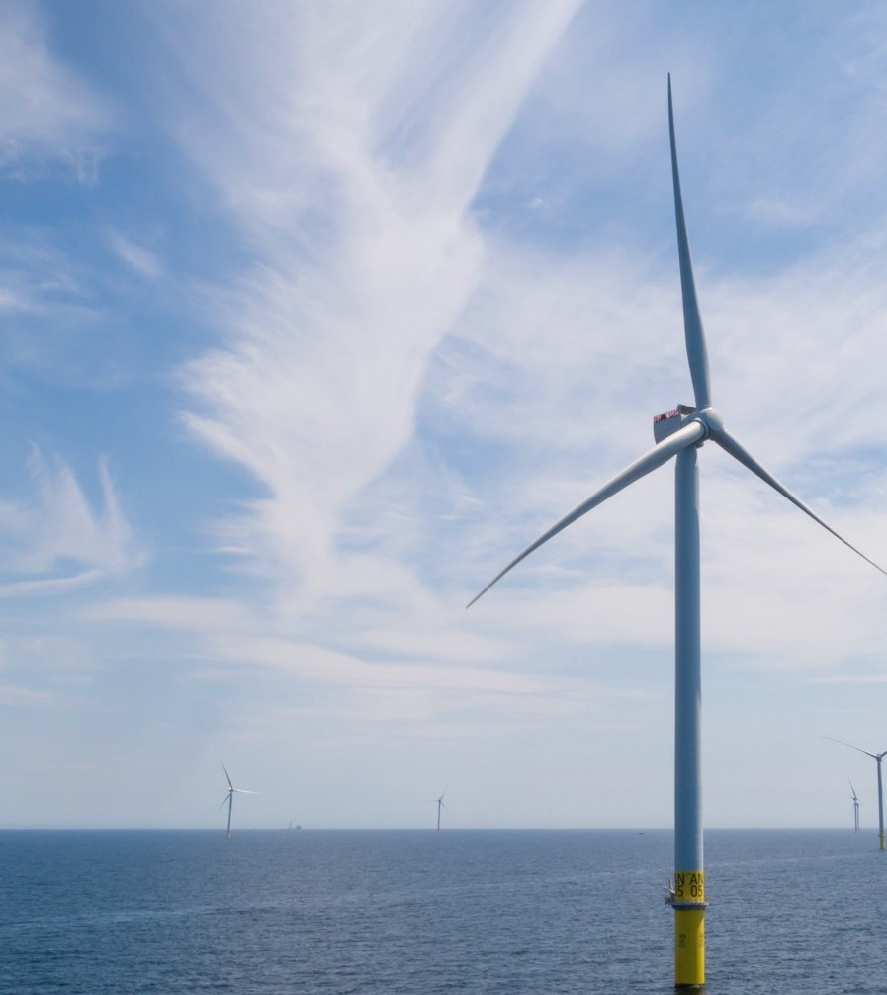
This month marks the 1-year anniversary of the first power of South Fork Wind. On March 14, 2024 construction was completed on all 12 turbines.
South Fork Wind Celebrates its 1-Year Anniversary

“When I broke ground on the South Fork project, I made a promise to build a cleaner, greener future for all New Yorkers. I’m keeping to that promise and South Fork Wind is now delivering clean energy to tens of thousands of homes and businesses on Long Island. With more projects in the pipeline, this is just the beginning of New York’s offshore wind future...” - Governor Kathy Hochul

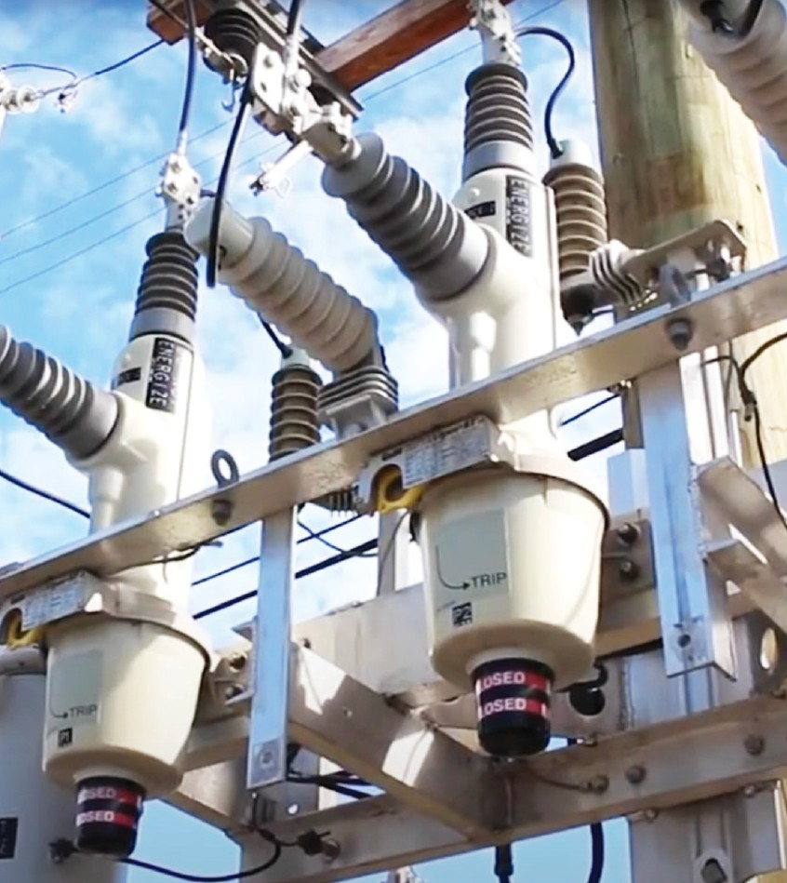
Together, LIPA and PSEG Long Island are working on new programs to improve the technology of our electric system. We’re adding thousands of new ‘smart devices’ and have automated hundreds of existing devices to make the grid more resilient and reliable.
New Technology on Distribution Equipment

These initiatives will:
- Significantly improve system reliability by reducing both the number and duration of outages for our customers.

- Have advanced technology with intelligence to automatically detect and restore power on temporary issues, such as a tree branch brushing against an electrical line, within seconds. Additionally, it will also reduce the number of customers impacted during an outage event.

- Distribution equipment will be deployed in accordance with LIPA’s cybersecurity requirements and any applicable North American Electric Reliability Corporation regulatory requirements.

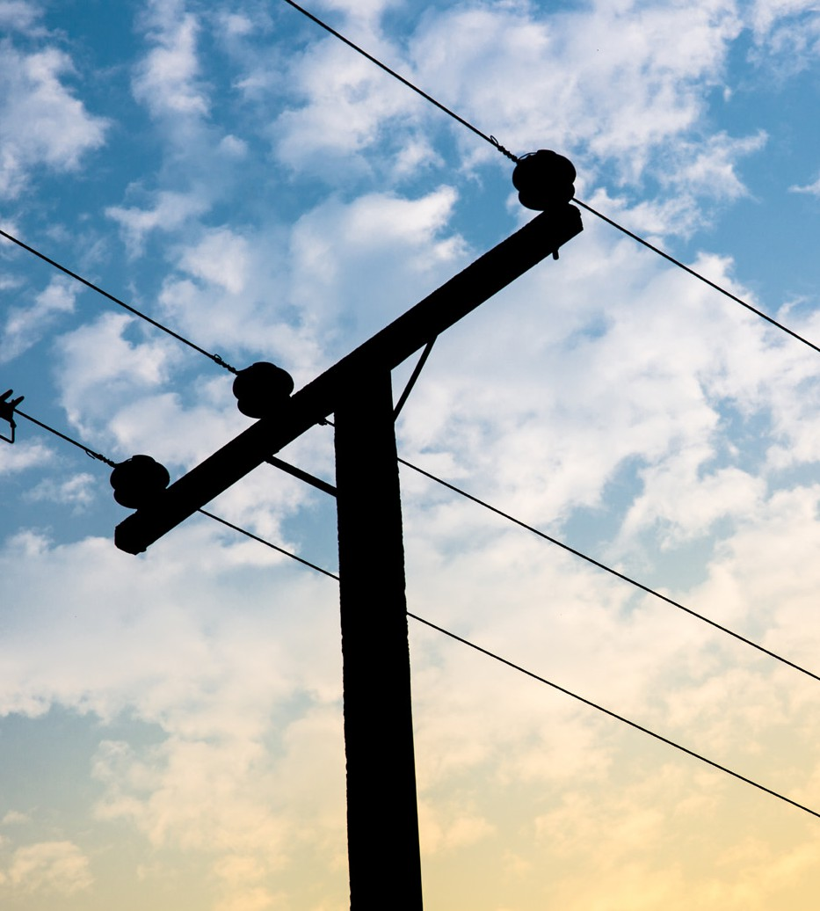

This month, LIPA received its second $5 million grant to replace at-risk poles in Disadvantaged Communities in Suffolk County.
FEMA Grant Work in Disadvantaged Communities

- In June 2022, LIPA filed two separate applications under FEMA’s Hazard Mitigation Grant Program – one for Suffolk County and another for Nassau/Queens. The Nassau/Rockaways (Queens) application was awarded in 2024, while Suffolk was just approved on January 15, 2025.

- Each grant will enable LIPA to replace approximately 385 poles in Nassau/Rockaways and Suffolk County.

- As these applications were filed under the COVID-19 disaster, LIPA is entitled to a 90% cost-share (FEMA pays 90%, LIPA pays 10%).

- Construction will begin later this year and should be completed in about one year.

CAB Newsletter | March Edition

L ET ’ S BU I LD OUR ENER GY
IN THE NEW S
f UTURE T OGETHER (OPINION)
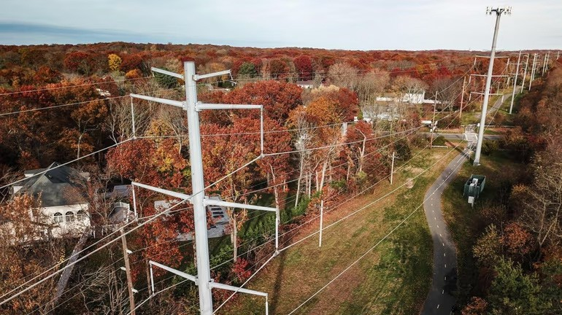

Though Long Island’s electrical grid infrastructure does need upgrades and reinforcement, undergrounding 100% of our transmission system is not the answer, the author writes. Credit: Newsday/Steve Pfost

The essay “Don’t rush Long Island’s electric grid update” [Opinion, Jan. 30] is a perplexing narrative that suggests, on one hand, upgrades to our region’s electrical transmission network under the name Propel NY isn’t necessary but later acknowledges that it does, in fact, need upgrading.

The writer also says that burying power cables underground isn’t the answer, but one suspects she would be very unhappy when the next storm takes down trees resulting in a power outage in her community.

The writer refuses to acknowledge that every day every family, business, and institution across Long Island is demanding more electricity on a grid that, in many cases, hasn’t been upgraded for nearly half a century.

What the region’s economy requires is safe, reliable, affordable power. Ambivalence, misinformation, and NIMBYism can’t build our energy future.

Opinion piece in Newsday by Kyle Strober, Executive Director, Association for a Better Long Island

B ATTE RY ST OR AG E W I LL HELP CRE AT E A STRONGER ELECTR I C GR I D

The Long Island Power Authority (LIPA) Board of Trustees has taken an essential step toward clean energy and reliability for our electric grid by approving two battery energy storage contracts with Key Capture Energy. This experienced New York-based developer can now move forward, working with the town of Brookhaven and Islip, to build and operate two lithium-iron-phosphate battery facilities under long-term contracts with the Long Island Power Authority (LIPA). These facilities include a 50 megawatt (MW) project in Shoreham and a 79 MW project in Hauppauge.

As the owner of our local electric grid, LIPA’s mission is to provide clean, reliable, and affordable energy for our 1.2 million customers on Long Island and the Rockaways, while working to ultimately achieve a 100% carbon-free grid. While it’s our responsibility to ensure that we have all the adequate resources necessary to serve our customers, we must also ensure that any new energy project is safe for our community and our local environment.

Battery energy storage systems, more commonly called BESS, store excess energy when electricity demand is low and release it when demand is high ensuring a consistent energy supply. Energy storage, along with renewables, help to stabilize and balance supply and demand on the electric grid.

These energy storage facilities will be critical as the local electric grid’s needs change in preparation for renewable energy, the electrification of cars and home heating systems, and the retirements of existing, older fossil fuel peaking plants. With all of these changes, the electric grid will need flexible solutions that respond quickly when required.

Today, less than 10% of Long Island’s electricity comes from renewable energy sources. By 2030, our research estimates that more than half of the energy could come from renewable sources, making battery storage critically essential to a successful transition to a clean energy future.

CAB Newsletter | March Edition

LIPA’s decisions regarding its power supply portfolio are based on long-term plans, research, and cost-benefit analysis. As with any newer technology, there is a learning curve. As more of this technology is developed and deployed, costs will likely continue to decline, and improved efficiencies and advances in safety will result from gained experience and refinement in design and production processes. Nearly 500 of these large systems have already been deployed successfully around the country.
IN THE NEW S

As required under state law, these two projects undertook extensive reviews that examined the potential environmental impacts and social and economic considerations. Fire incidents at smallery battery storage facilities on Long Island and New York State have highlighted the need to adequately address fire safety, including measures to prevent and respond to battery storage fires. Last year, to address these concerns, Gov. Kathy Hochul announced the creation of an Inter-Agency Fire Safety Working Group to ensure the safety and security of energy storage for our local communities. These projects will comply with all Working Group recommendations.

Additionally, the New York State Energy Research and Development Authority recently published an “Energy Storage Guidebook,” containing information and tools to support local governments in responsibly managing battery energy storage system development within their communities.

As we prepare for our clean energy future, we must continue identifying and investing in technologies that will meet our growing needs. Battery storage will provide an increasingly resilient, reliable, and sustainable electric grid.

We are proud to support these battery energy storage projects for our customers and to ensure that Long Island continues to lead the way in transitioning to a green energy future.

Op-Ed by Gary Stephenson
Senior Vice President of Power Supply, LIPA


10

S UNR I SE Wi ND I S THE f UTURE O f A MER I CA N CLEAN ENER GY, AND TH AT f UTURE I S BE I NG
CLEAN ENER GY SECTION
BU I LT BY N EW YOR K ERS, FOR N EW YOR K ERS.

Sunrise Wind, a 924MW offshore wind project, located 30 miles east of Montauk Point, will power nearly 600,000 homes with 100% renewable energy, and is slated to go online in 2027. The project has created hundreds of long-term jobs and thousands of in-direct jobs through its procurement of a local, New York-based supply chain.

Ørsted, the Denmark-based offshore wind developer responsible for the successful completion of the South Fork Wind, the first offshore wind farm in U.S. federal waters, has partnered with local and state community stakeholders to ensure Sunrise Wind has minimal impact on the environment and communities where construction has already begun.


As part of its $86 million state-wide investment in New York’s offshore wind economy, Ørsted and state leaders joined at its Port of Coeymans assembly hub in 2024 to celebrate the significant progress New York-based union workers are making on Sunrise Wind, with the construction of more than half of the advanced foundation components.

Sunrise Wind is creating opportunities for
women, people of color, and those from disadvantaged backgrounds – opportunities that can change lives for people like IBEW electrical apprentice Mary Linn.

As with the South Fork Wind Farm, electricity produced by the wind turbines, will be stepped-up by an offshore substation to reach its point of interconnection at Smith Point in Brookhaven Town. From there, an underground transmission corridor will be trenched, running parallel to William Floyd Parkway, and run along the service road of Sunrise Highway, north to I-495, and making its eventual connection to LIPA’s Holbrook substation, as shown in the map on the next page.

As of this week (March 10, 2025), trenching and conduit installation continues on William Floyd Parkway and Victory Avenue (CR-56), working parallelly to work on the Union Avenue onshore converter station, PSEG Long Island right-of-way, Holbrook substation, and equipment mobilization, installation of sheeting at the transition joint bay and continued trenching work at Smith Point County Park & Marina.
Click here for more information on Sunrise Wind Click here for construction updates
10

2019
- Ørsted and Eversource proposed major offshore wind farm for New York.

- Ørsted and Eversource announce supply chain and workforce investments on Long Island and Upstate New York Ports.

- Sunrise Wind wins bid for Large-scale New York Offshore Wind Farm.

2020
- Ørsted and Eversource announces purchase of a facility in East Setauket, to serve
as its Operations & Maintenance hub for Sunrise Wind.

2021

  - Ørsted and Eversource announce $5 million commitment to Stony Brook
University to support offshore wind research initiatives

  - Governor Kathy Hochul announces an $86 million supply chain contract,
the largest, single offshore wind supply chain contract award in New York State to support the Sunrise Wind offshore wind project.

  - Sunrise Wind invest
$300,000 to train Capital region workers for Union construction careers in offshore wind

2023
- Ørsted and Eversource announce submission of a join proposal
for New York State’s third round of OSW solicitations.
- Brookhaven Town to benefit from bulk of $169 million benefit package from Sunrise Wind project.

- Long Island-based Haugland Group receives
$200 million contract for transmission system construction of Sunrise Wind project.

2024

- Ørsted to acquire Eversource’s share of Sunrise Wind.

- Sunrise Wind receives final approval from the U.S.
Department of the Interior.

- Construction begins on Sunrise Wind.

- New York celebrates the construction of the Port of Coeymans
Assembly Hub.

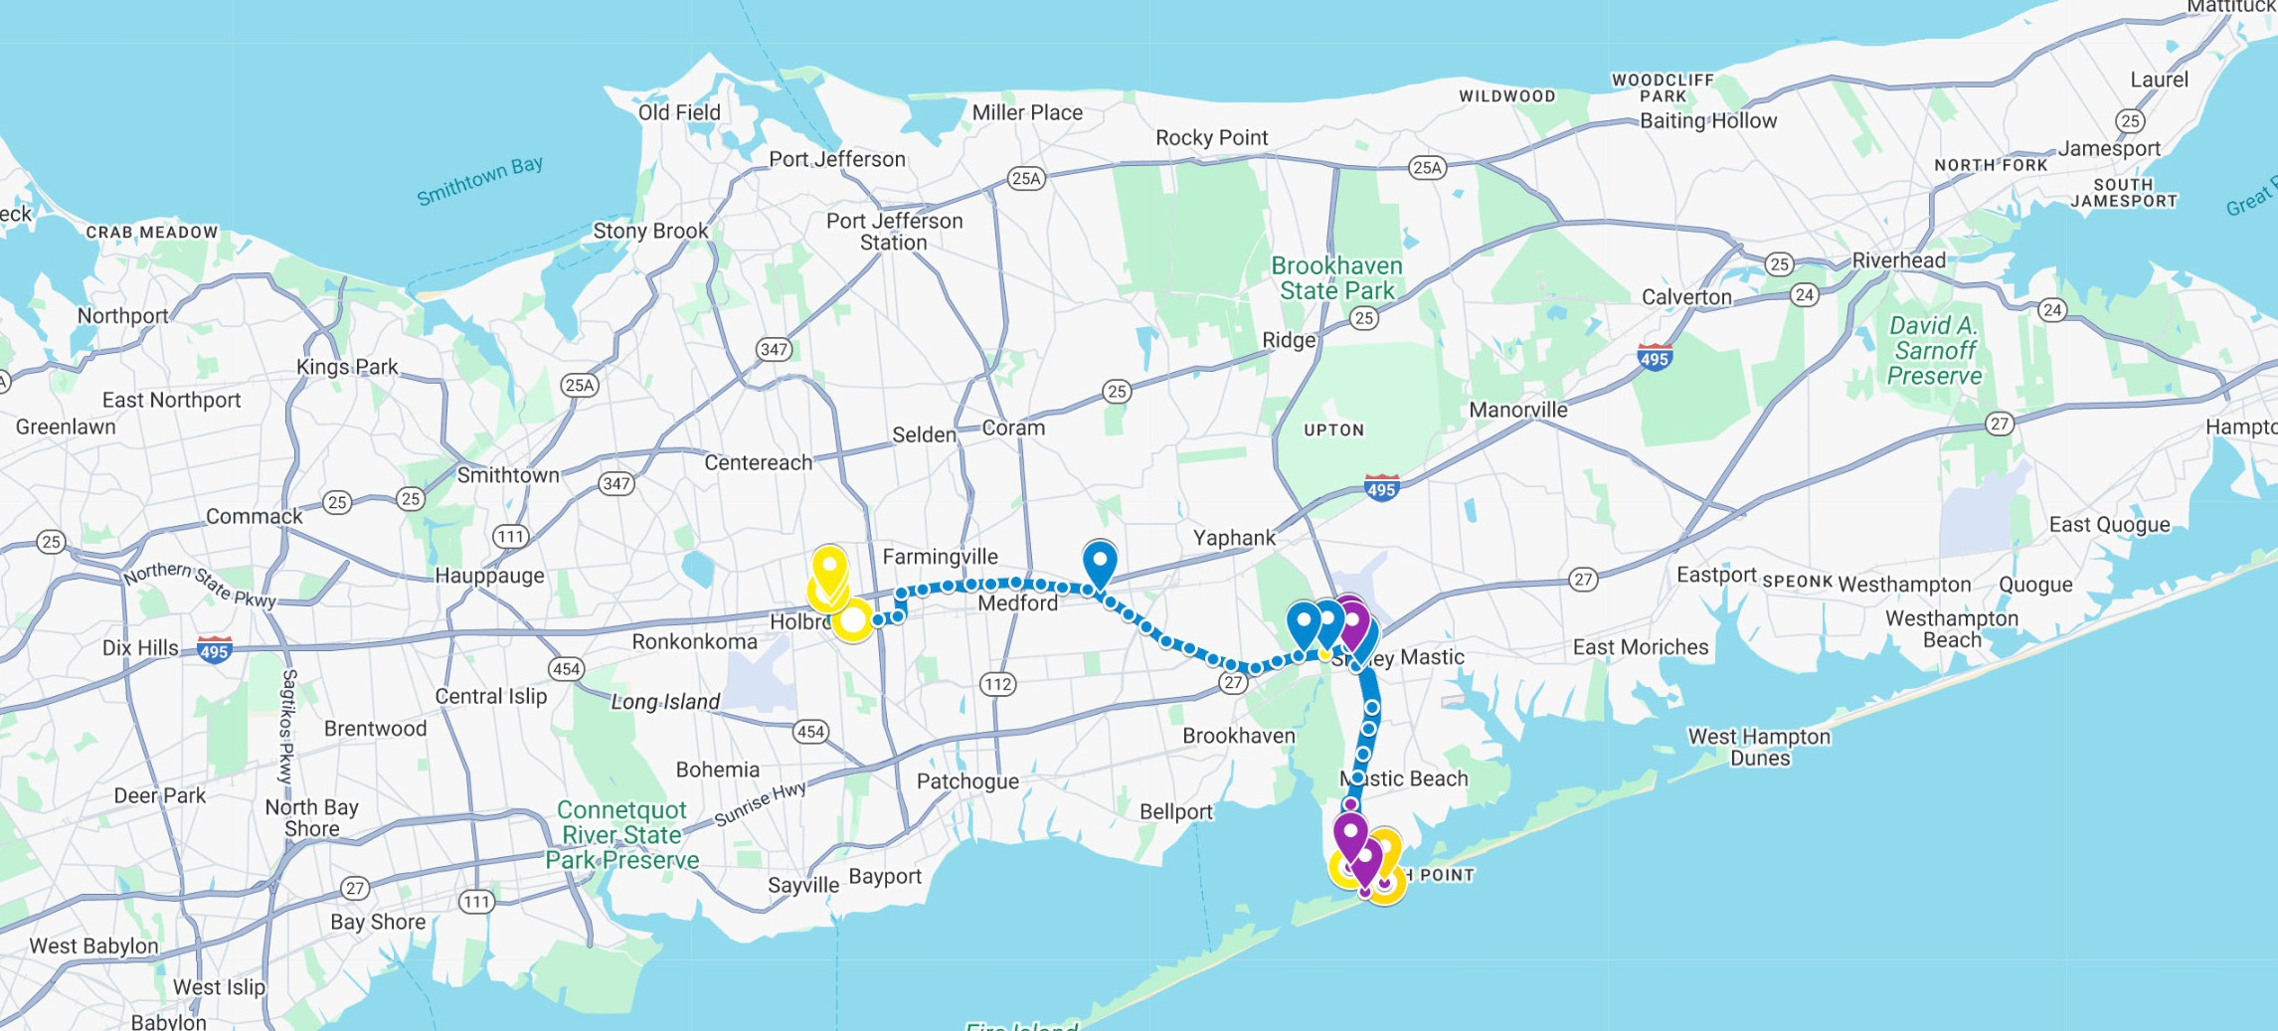
TIMELINE of SUNRISE WIND

11



lipower.org/community-advisory-board

